PROCUREMENT OF SMALL WORKS UNDER
NATIONAL OPEN COMPETITIVE PROCUREMENT
[to be used for contracts valued less than US$ 1 million]
(Two-Envelope Bidding Process with e-Procurement)

August 2024
GOVERNMENT OF WEST BENGAL
Water Resources Investigation & Development Department
Accelerated Development Minor Irrigation Project, Phase -II
Office of the Executive Engineer
District Project Management Unit, Jhargram ,WBADMIP
At – Vidyasagar Pally, P.O.-Jhargram, Dist. - Jhargram, Pin-721507,
Email: dpmujhargram@gmail.com

REQUEST FOR BIDS (RFB)
E-Procurement Notice
(Two-Envelope Bidding Process with e-Procurement)

NATIONALOPEN COMPETITIVE PROCUREMENT

FOR SMALL WORKS

Date: 01.02.2023
RFB No.:

1. The Government of India has received a loan from the International Bank for Reconstruction & Development towards the cost of WBADMI Project Phase –II and intends to be applied a part of the funds to cover eligible payments under the contracts for construction of works as detailed below. Bidding is open to all bidders from eligible source countries as defined in the “Procurement Regulations for IPF Borrowers, July 2016, Revised Nov 2020”. Bidders from India should, however, be registered with the Government of West Bengal or other State Governments/Government of India, or State/Central Government Undertakings. Bidders are advised to note the minimum qualification criteria specified in Clause 3 of the Instructions to Bidders to qualify for the award of the contract. In addition, please refer to paragraphs 3.14 and 3.15 of the “Procurement Regulations” setting forth the World Bank’s policy on conflict of interest.

2. The Executive Engineer,DPMU, Jhargram WBADMIP (Implementing Agency) invites online bids for the construction of works detailed in the table below. Each biddershould submit only one bid for the works indicated therein.

3. Bidding documents are available online free of cost in the websitewww.wbtenders.gov.in from 03.02.23.to.7.03.23. (dates). Bidders will be required to register on the website, and should have DSC key or token for registration in the aforesaid website and to participate for the tender. The bidders would be responsible for ensuring that any addenda available on the website is also downloaded and incorporated. Interested bidders may obtain further information at the address given below during office hours or may request clarifications online through e-procurement portal.

PERIOD OF AVAILABILITY OF BIDDING DOCUMENT ON WEBSITE https://wbtenders.gov.in:

:DATE FROM 03/02/2023 18:00 HOURS TO 7/03/2023
18:00 HOURS

SEEK CLARIFICATION START DATE & TIME : DATE 03/02/2023 TIME 18.00 HOURS

SEEK CLARIFICATION END DATE & TIME : DATE 10/02/2023 TIME 18.00 HOURS

ONLINE BID SUBMISSION START DATE & TIME : DATE 14/02/2023 TIME 18.00 HOURS

LAST DATE FOR ONLINE RECEIPT OF BIDS : DATE 07/03/2023 TIME 18.00 HOURS

TIME AND DATE OF OPENING OF TECHNICAL BID : DATE 11/03/2023 TIME 11.00 HOURS

OFFICER INVITING BIDS : Executive Engineer, DPMU Jhargram, WBADMIP

4. For submission of the bid, the bidder is required to have Digital Signature Certificate (DSC) from one of the Certifying Authorities authorized by Government of India for issuing DSC. Aspiring bidders who have not obtained the user ID and password for participating in e-procurement in this Project, may obtain the same from the website before the bid submission deadline i.e. before 07.03.23. (date).

5. Bids must be accompanied by a bid security (@ Rs. Given below at clause no.9). The bid security is specified for the work in the table below, drawn in favor of Executive Engineer, DPMU _____________ ,WBADMIP(depicted in the www.wbtenders.gov.in ) will have to be paid through online or Bank Guarantee and the Bank Guarantee shall have to be valid for 45 days beyond the validity of the bid. Bids should be valid for 120 days after the deadline date specified for bid submission. Procedure for submission of bid security is described in Para 7 below.
6. Bids, both Technical and Financial Parts, must be submitted online on www.wbtenders.gov.in (website) on or before18.00 hours on 07.03.23 (date) and the ‘Technical Part’ of the bids will be publicly opened online on the 11.03.23 at11.00 hours, in the presence of the bidders who wish to attend. Any bid or modifications to bid (including discount) received outside e-procurement system will not be considered. The “Financial Part” shall remain unopened in the e-procurement system until the second public Bid opening for the financial part. Record of bid opening will be electronically shared with bidders. If the office happens to be closed on the date of opening of the bids as specified, the technical part of bids will be opened on the next working day at the same time and venue. The electronic bidding system would not allow any late submission of bids.

7. The bidders are required to submit
(a) the copy of receipt of original bid security in the form of Bank Guarantee in approved format (Attached in Bid Security as Bank Guarantee) before the bid submission deadline during the office hours between 11:00 A.M. to 05:30 P.M (not in the holidays) either by registered post/speed post or by hand.If the hard copy of the original bid security in the form Bank Guarantee has not been received in the office of The Executive Engineer, DPMU ____________, WBADMIP before the stipulated Date and time(Before the last date of Bid Submission Date and Time) then the bid will be declared non-responsive and will not be opened. Any delay for submission of the original Bank Guarantee from the Bidder’s end is not permissible. The Bank Guarantee of the unsuccessful bidders will be released after Financial Evaluation upon submission of a Request of Release Letter from the bidder’s end.
Or
(b) the copy of receipt of original bid security through online (www.wbtenders.gov.in )in approved form before the bid submission deadline, If the bid security has not been submitted the bid will be declared non-responsive and will not be opened.

The L1 bidder’s bid security will be discharged upon submission of the 3% Performance Security deposit of the contract amount.

Bid Security Deposit (BSD): Online deposit mode:
Intending bidders desiring to make payment of Bid Security Deposit (BSD) on-line, should beforehand read the instructions carefully, particularly in the challan generated by the system of e-tender/e-procurement, if opted for BSD payment through RTGS/NEFT

A. Login by bidder:
a. A bidder desirous of taking part in an e-tender invited by a State Government shall login to the e-Procurement portal of the Government of West Bengal using his/her login ID and password using valid DSC.
b. He/she will select the e-tender to bid and initiate payment of pre-defined BSD for that e-tender by selecting from either of the following payments modes:
i. Net-Banking (any of the banks listed in the ICICI Bank Payment Gateway) in case of payment through ICICI Bank Payment Gateway;
ii. RTGS/NEFT in case of off-line payment through bank accounts in any Bank approved by RBI in India.
B. EMD payment procedure:
a. Payment by Net Banking (any listed bank) through ICICI Bank Payment Gateway:
i. On selection of net banking as the payment mode, the bidder will be directed to ICICI Bank Payment Gateway webpage (along with a string containing a Unique ID) where he/she will select the Bank through which he/she wants to do the BSD on-line transaction.
ii. Bidder will make the payment after entering his Unique ID and password of the bank to process the transaction.
iii. Bidder will receive a confirmation message regarding success/failure of the transaction.
iv. If the transaction is successful, the amount paid by the bidder will get credited in the respective Pooling account of the State Government maintained with the Focal Point Branch of ICICI Bank at R.N Mukherjee Road, Kolkata for collection of BSD against unique codes for identification of the tendering authority.
v. If the transaction is failure, the bidder will again try for payment by going back to the first step.

B. Payment through RTGS/NEFT:
i. On selection of RTGS/NEFT as the payment mode, the e-procurement portal will show a pre-filled challan having the details to process RTGS/NEFT transaction.
ii. The bidder will print the challan and use the pre-filled information to make RTGS/NEFT payment using his/her own Bank account.
iii. Once payment is made, the bank would provide an “UTR remittance number” for successful transaction with which the bidder will come back to the e-Procurement portal after expiry of 2 to 3 bank working days to enable the NEFT/RTGS process to complete, in order to verify the payment made and continue with his/her bidding process.
iv. If verification is successful, the fund get credited to the respective Pooling account of the State Government maintained with the Focal Point Branch of ICICI Bank at R.N Mukherjee Road, Kolkata for collection of BSD.
v. Hereafter, the bidder will go to e-Procurement portal for final e-submission of his/her bid within pre assigned last date of submission of e-tender.
vi. If the payment verification is unsuccessful, the amount will be returned automatically by the system to the bidder’s account.

Note: BSD payment made through RTGS/NEFT would require additional 2 to 3 bank working days after date of transaction in the bank before the procedure is completed for enabling the bidder to continue with the bidding process in the on-line e-tender final bid submission. Thus, the bidder is to take precaution in case of RTGS/NEFT transfers so that the entire process of submission of e-tender is completed within last date of on-line submission of his/her tender. However, Net-banking transaction through ICICI bank payment Gateway would be on real time basis.

EMD Exemption or Exemption of Bid Security is not permissible.

8. The Employer shall not be held liable for any delays due to system failure beyond its control. Even though the system will attempt to notify the bidders of any bid updates, The Employer shall not be liable for any information not received by the bidder. It is the bidders’ responsibility to verify the website for the latest information related to this bid.

9. Other details can be seen in the bidding document.

TABLE

Package  No. | Name of work | Bid Security (Rs.) | Cost of document for Bid Submission  (Rs.) | Period of completion
1. | Installation of 4 nos. of Tube Well (Solar) at Mouza-Raipal (Jl No. 160) under Nayagram Block in the district of Jhargram under DPMU, Jhargram, WBADMI Project | 1,00,000.00 | NIL | 6 months

Executive Engineer
DPMU, Jhargram
WBADMIP

Memo no – 22 Dated – 01.02.2023

Copy forwarded for information to:-
- The Project Director, WBADMI Project, ICMARD Building (5th Floor), Kolkata - 67.
- The District Magistrate, Jhargram.
- The Sabhadhipati, JhargramZillaParishad.
- The Additional Project Director, WBADMIP.
- The Controller of Finance, WBADMIP.
- The SE (A-I) & DPD (Technical) WBADMIP, PaschimMedinipur.
- The Divisional Accountant, DPMU Jhargram.
- The Procurement Engineer, DPMUJhargram
- The notice Board of the undersigned.

Executive Engineer
DPMU, Jhargram
WBADMIP

Instructions to Bidders

SECTION - A

1. Scope of Works

The Executive Engineer, DPMU, Jhargram WBADMIP, Phase II on behalf of the Project Director WBADMIP Phase II invites bids for the construction of works as detailed in the table given below through the e-procurement portal www.wbtenders.gov.in.

Package No. | Brief Description of the Works | Period of Completion
1. | Installation of 4 nos. of Tube Well (Solar)at Mouza-Raipal (Jl No. 160) under Nayagram Block in the district of Jhargram under DPMU, Jhargram, WBADMI Project | 6 months

The successful bidder will be expected to complete the works by the intended completion date specified above.
Location Details;

Sl No | Package No | Name of Scheme | Block | GP | Mouza (JL) | Plot No | Latitude | Longitude
1
2
3

2. Qualification of the bidder: The bidder shall provide qualification information which shall include:-

- total monetary value of construction works performed for each year of the last 3 years (Prior to the year of bid opening);

- Report on his financial standing for last three years (Prior to the year of bid opening); and

- Details of any litigation, current or during the last 3 years in which the bidder is involved, the parties concerned and disputed amount or awards in each case.

3. To qualify for award of the contract the bidder:-

- Should have satisfactorily completed as a prime contractor in the last 3 (three) years at least one work executed in the same / similar nature of work under the authority of State/ Central Govt., State / Central Govt. undertaking, Statutory Bodies constituted under the statute of the Central /State Government and having a magnitude of 40 (Forty) percent of the value of the work for which bids are being invited (as per table below)in a single work order.
- should have achieved in at least one year an annual financial turnover of(in works of similar nature only) value not less than usually the value of the work for which bids are being invited (as per table below) in the last three years;

(c)* should not have been debarred (or dealings suspended) on the dates of bid opening of the technical part and financial part of the bids by the Central/State Governments/Undertakings or by the World Bank Group (https://www.worldbank.org/en/projects-operations/procurement/debarred-firms ).

(d) no contract should have been suspended or terminated and/or performance security called by an employer(s) for reasons related to Environmental, Social (including sexual exploitation and abuse (SEA) and gender-based violence (GBV)), Health, or Safety (ESHS) requirements or safeguards in the past five years.

(e) availability of liquid assets and/or credit facilities, net of other contractual commitments and exclusive of any advance payments which may be made under the Contract, of not less than Rs. (As per table below).##

(## Credit lines/letter of credit/certificates from Banks or Bank Solvency Certificates for meeting the funds requirement etc.- usually the equivalent of the estimated cash flow for 3 months in peak construction period)

(f) should submit valid PF and ESI certificates.

Table :

Package No. | Brief Description of the Works | Credential value as per clause 3 (a) (Rs) | Annual financial turnover as per clause 3 (b) (Rs) | Required amount for credit facility as per clause 3 (e )in the form of Bank Solvency Certificate  (Rs)
1. | Construction of 4 nos. of Tube Well (Solar) at Mouza-Raipal (Jl No. 160) under Nayagram Block in the district of Jhargram under DPMU, Jhargram, WBADMI Project | 20,00,000.00 | 50,00,000.00 | 40,00,000.00

3.1 Eligibility - Conflict of Interest*

Any Bidder found to have a conflict of interest shall be disqualified. A Bidder may be considered to have a conflict of interest for the purpose of this bidding process, if the Bidder:
    - directly or indirectly controls, is controlled by or is under common control with another Bidder; or
    - receives or has received any direct or indirect subsidy from another Bidder; or
    - has the same legal representative as another Bidder; or
    - has a relationship with another Bidder, directly or through common third parties, that puts it in a position to influence the bid of another Bidder, or influence the decisions of the Employer regarding this bidding process; or
    - any of its affiliates has been hired (or is proposed to be hired) by the Employer or Borrower as Engineer for the Contract implementation;
    - has a close business or family relationship with the concerned professional staff of the Borrower or of the project implementing agency.
(* for further details refer to paragraphs 3.14 and 3.15 of the “Procurement Regulations” setting forth the World Bank’s policy on conflict of interest)

4. Bid Price

- The contract shall be for the whole works as described in drawings and technical specifications. Corrections, if any, can be carried out by editing the information before electronic submission on e-procurement portal.

- All duties, taxes and other levies payable by the contractor under the contract shall be included in the total price.

- The rates quoted by the bidder shall be fixed for the duration of the contract and shall not be subject to adjustment on any account.

- The Bidder shall fill on the e-procurement portal,the prices for the Works inconformity with the Bidding Documents, both in figures and words.

- The bidders shall make online entries to fill in rates in bill of quantities (BOQ). Upon numerical entry, the amount in words would automatically appear and upon entry of rates in all the items of work, total bid price would automatically be calculated by the system and would be displayed. Items for which no rate or price is entered by the bidder will not be paid for by the Employer when executed and shall be deemed covered by the other rates and prices in the Bill of Quantities.

5. Submission of Bids

5.1 The bidder is advised to visit the site of works at his own expense and obtain all information that may be necessary for preparing the bid.

5.2 Each bidder shall submit only one bid. Bidders should not contact other competing bidders in matters relating to this bid.

5.3 The set of bidding document comprise of the following:

i. Layout Drawings of the works;

ii. Structural Details;

iii. Bill of Quantities;

iv. Technical Specifications;

v. Instructions to Bidders; and

vi. Draft Contract Agreement format which will be used for finalizing the agreement for this Contract.

5.4 The e-procurement system provides for online clarifications.Clarifications requested through any other mode shall not be considered by the Employer. Response of the Employer including a description of the inquiry, but without identifying its source, shall be uploaded on the e-procurement portal for information of all Bidders. It is the bidder’s responsibility to check on the e- procurement portal, for any clarifications or amendments to the bidding documents.

5.5 The bid submitted by the bidder shall comprise two parts, namely the Technical Part and the Financial Part. These two Parts shall be submitted simultaneously.

5.5.1 The Technical Part shall contain the following: -

(a) Letter of Bid – Technical Part in the format given in Section B.

(b) Qualification information form given in Section B duly completed.

(c) Bidder’s confirmation to comply with (i) the applicable Laws/ Rules/ Regulations for protection of environment, public health and safety; (ii) the regulatory authority conditions (if any) attached to any permits or approvals for the project; and (iii) the Management Strategies and Implementation Plan (MSIP) to manage the Environmental, Social (including sexual exploitation and abuse (SEA) and gender based violence (GBV)), Health and Safety (ESHS) risks, and ESHS Code of Conduct, (if any prescribed by the Employer), that will apply to its employees and all subcontractors.

(d) Bid Security, for the amount Rs.-__as per _ ………., should be submitted through registered e-Tender online portal i.e. www.wbtenders.gov.in or in the form of Bank Guarantee in favor of The Executive Engineer, DPMU________________, WBADMIP before the Bid Submission Date otherwise the bid will be declared as non-responsive.

(e) NIT

5.5.2 The Financial Part shall contain the following:-

(a) Completed Bill of Quantities (BOQ).

5.5.3 The Technical Part shall not include any information related to the Bid price. Where material financial information related to the Bid price is contained in the Technical Part, the Bid shall be declared non-responsive.

5.5.4 Other Important Documents (OID):
Scanned copies of the following documents shall be uploaded on the website http://wbtenders.gov.in in the portal after converting the same to PDF and is to be arranged in the following manner.

Sl No. | Category Name | Sub Category Description | Documents to be uploaded
A. | Certificate(s) | Certificate(s) | 1) GST Registration Certificate  2) PAN  3) Latest IT Acknowledgement  4) Updated P Tax Deposit Receipt Challan  5) updated PF payment certificates.  6) updated ESI payment certificates  7) Last 3 years balance sheets from CA  8) NOC regarding litigation during last 3 years.  9) Availability of liquid assets and/or credit facilities
B. | Company Detail(s) | Company Details 1 | Proprietorship Firm (Trade License).  Partnership Firm (Partnership Deed, Trade License).  Limited Company (Incorporation Certificate, Trade License).  Society (Society Registration Copy, Trade License).  Power of Attorney of the signatory of the Bid to commit the Bidder.
C. | Credential | Credential-1 | Credential will be comprised with Completion Certificate, Work order and Schedule of works as a whole. Only Payment certificate will not be considered as credential.
D. | Declaration | Declaration File -1 | Bank Solvency Certificate of access to or availability of credit facilities.  Manufacturer’s Authorization for Pump Motor, Solar Panel and VFD

5.6 (a) The Letter of Bid– Technical Part, and all documents listed in Clause 5.5, shall be prepared using the relevant forms. The forms must be completed without any alterations to the text, and no substitutes shall be accepted. All blank spaces shall be filled in with the information requested. For this purpose, the bidders shall fill up online, the forms that are available for online filling on the e-procurement portal. The rest of the forms shall be download by the bidders and filled up.

(b) Bids, both Technical and Financial Parts, shall be simultaneously submitted online on the e-procurement system specified in ITB Clause-1. Detailed guidelines for viewing bids and submission of online bids are given on the website. Any bidder can logon to this website and view the RFB and details of works for which bids are invited.However, every bidder has toenrol/register in the website and should have valid Digital Signature Certificate (DSC) in the form of smart card/e-token obtained from any authorised certifying agencyfor class ofDSC (Class II / III). The bidder should register in the website using the relevant option available. Then the Digital Signature registration has to be done with the e-token, after logging into the website. The bidder can then login the website through the secured login by entering the password of the e-token & the user id/ password chosen during registration. After getting the bidding documents, the Bidder should go through them carefully and submit the specified documents,alongwith the respective technical and financial parts of the bid, otherwise the bid will be rejected.

(c) The completed bid, both Technical and Financial Parts,comprising of documents indicated in ITB 5.5, should be uploaded on the e-procurement portal along with scanned copies of requisite certificates and scanned copies of the bid securityand registration on e-procurement website. All documents are required to be signed digitally by the bidder. The system generates a unique bid identification number, time stamped as per server time, as the acknowledgement of bid submission.

(d) Any bid or modifications to bid (including discount) received outside e-procurement system will not be considered.

5.7 Bids, both Technical and Financial Parts, must be uploaded online not later than the deadline for submission of bids specified in the RFB viz. time 18 (hours) and date 07.03.2023 (day, month, year). A bidder may modify his bidany number of times by using the appropriate option for bid modification on the e-procurement portal, before the deadline for submission of bids. No additional payment towards the cost of bid document is required for bid modifications. A bidder may withdraw his bid by using the appropriate option for bid withdrawal, before the deadline for submission of bids. If a bid is withdrawn, re-submission of the bid is allowed/not allowed(select one option).

5.8 The e-procurement system would not allow any late submission of bids after due date & time as per server time.

5.9 Submission of Original Documents: The bidders are required to submit bid security in approved form, before the bid submission deadline, through registered e-Tender online portal i.e. www.wbtenders.gov.in or in the form of original Bank Guarantee in the favour of The Executive Engineer, DPMU ________________, WBADMIP, failing which such bids will be declared non-responsive, and shall be rejected. Hard copy of bids or any other documents except Bank Guarantee are not to be submitted.

6. Validity of Bid

Bid shall remain valid for a period not less than 120 days after the deadline date specified for bid submission. If Bidder withdraws/modifies/substitutes its bid during the period of bid validity specified by the Bidder on the Letter of Bid - Technical Part and repeated in the Letter of Bid - Financial Part, the Bid Security may be forfeited.

7. Online Public Opening of Technical Parts of Bids

The Technical Part of the Bids received in the e-procurement system will be publicly opened online in the office of the Executive Engineer, DPMU Jhargram WBADMIP Phase-II, in the presence of bidders or their representatives who choose to attend, on the date and time specified above. This could also be viewed by the bidders online. The Financial Part of the bids shall remain unopened in the e-procurement system, until the second online public opening, following the evaluation of Technical Parts of the Bids.

8. Evaluation of Bids – General provisions

8.1 Information relating to evaluation of bids and recommendations for the award of contract shall not be disclosed to bidders or any other persons not officially concerned with the process until the award to the successful bidder is announced.

9. Evaluation of Technical Parts of Bids

9.1 The Employer will evaluate the technical parts of the bids to determine to its satisfaction the Bidsthatareboth substantially responsive to the bidding documents and meet the qualification criteria i.e. which

(a) meet the qualification criteria specified in clause 3 above;

(b) are properly signed; and

(c) conform to the terms and conditions, specifications and drawings without material deviations.

  - If a Bid is not substantially responsive to the requirements of the bidding document and does not meet the qualifying criteria, it shall be rejected, and its Financial Part shall not be opened at the second public opening by the Employer.
  - During evaluation the Employer may request the bidder to come to employer’s office with the originals for the documents which is already submitted online and if they failed to produce the same within the stipulated time frame, their proposal may be liable for rejection.

10. Public Opening of Financial Parts of Bids

10.1 Following the completion of the evaluation of the Technical Parts of the Bids, the Employer shall notify through online e-Procurement System to those Bidders whose Bids were considered non-responsive to the bidding document or failed to meet the Qualification Criteria, advising them (a) the grounds on which their Technical Part of Bid failed to meet the requirements of the bidding document; and (b) that their Financial Part of Bid shall not be opened.

10.2 The Employer shall, simultaneously, notify through online e-Procurement System to those Bidders whose Technical Part of Bids have been evaluated as substantially responsive to the bidding document and met all Qualifying Criteria, advising them (a) that their Bid has been evaluated as substantially responsive to the bidding document and met the Qualification Criteria; and (b) that their Financial Part of Bid shall be opened at the second online public opening of the Financial Parts.

10.3 The Employer shall notify all bidders the date, time, and place of the second online public opening of the Financial Parts of the Bids. The opening date should allow Bidders sufficient time (normally not less than 7 days) to make arrangements for attending the opening.The Financial Parts of theBids referred to in Clause 10.2 will be publicly opened online in the presence of bidders or their representatives who choose to attend, and this could also be viewed by the bidders online.

In the event of the specified date of the bid opening of Financial parts being declared a holiday for the Employer, the bids will be opened at the appointed time and location on the next working day.

11. Evaluation of Financial Parts of Bids

11.1 Correction of Arithmetical Errors

Bids determined to be substantially responsive shall be checked for any arithmetic errors. Errors shall be corrected as follows:
(a) where there is a discrepancy between the amounts in figures and in words, the amount in words shall govern;
(b) where there is a discrepancy between the unit rate and the line item total resulting from multiplying the unit rate by the quantity, unit rate as quoted shall govern; and
(c) the amount stated in the Bid shall be adjusted in accordance with the above procedure for the correction of errors
If the Bidder does not accept the corrected amount, the Bid shall be rejected, and the Bid Security may be forfeited.

11.2 Comparison of Financial Parts

The Employer shall compare the evaluated costs of all substantially responsive bids to determine the Bidthat has the lowest evaluated cost.
12. Award of contract

The Employer will award the contract to the successful bidder whose bid has been determined to be the Most Advantageous Bid. This is the bid that meets the specified Qualification Criteria and has been determined to be (a) substantially responsive to the bidding document; and the lowest evaluated cost.

12.1 Notwithstanding the above, the Employer reserves the right to accept or reject any Bid and to cancel the bidding process and reject all Bids at any time prior to the award of contract.

12.2 The successful bidder will be notified of the award of contract by the Employer prior to expiration of the bid validity period.

12.3 The Bid security of unsuccessful bidders will be returned as promptly as possible upon the successful Bidder’s signing the contract and furnishing the performance security pursuant to ITB 13.
13. Performance Security
Within 15 days of receiving letter of acceptance, the successful bidder shall deliver to the Executive Engineer DPMU Jhargram WBADMIP (Employer) the performance security (either a bank guarantee or a bank draft in favor of the Employer) for an amount equivalent of 3% of the contract price. The Performance Security shall be valid until a date 28 days after the scheduled Completion period of works. Failure of the successful Bidder to furnish performance security and sign the agreement within the period stipulated shall constitute sufficient grounds for annulment of award and forfeiture of the Bid Security, in which case the Employer may make the award to the Bidder offering the next Most Advantageous Bid or issue a new RFB.The Performance Security will be discharged after issuance of Certificate of Completion of works.

14. Defects Liability:

The “Defects Liability Period” for the work is 12 (Twelve) months from the date of taking over possession.During this period, the contractor will be responsible for rectifying any defects in construction free of cost to the Employer. Annual Maintenance period 5 Yrs. from Date of Completion.

15. Supply of all construction materials including cement and steel as per the specifications (ISI certification marked goods wherever available) shall be the responsibility of the contractor.

16. Fraud and Corruption

The World Bank requires compliance with the Bank’s Anti-Corruption Guidelines and its prevailing sanctions policies and procedures as set forth in the WBG’s Sanctions Framework, as set forth in Section C. In further pursuance of this policy, bidders shall permit and shall cause their agents (whether declared or not), sub-contractors, sub-consultants, service providers, suppliers and their personnel, to permit the Bank to inspect all accounts, records and other documents relating to any initial selection process, prequalification process, bid submission, proposal submission, and contract performance (in the case of award), and to have them audited by auditors appointed by the Bank.

.......................

SECTION - B

- Format for Qualification Information.

- Format for Submission of Bid.

- Format of Letter of Acceptance.
Appendix to Technical Part

QUALIFICATION INFORMATION

1 For Individual Bidders

1.1 Principal place of business: ______________________________

Power of attorney of signatory of Bid.
[Attach copy]

1.2 Total value of Civil** Engineering 2021___ ____________________
construction work performed in the last 2022___ ____________________
three years (in Rs. Lakhs) 2023__ ____________________

1.3 Work performed as prime contractor (in the same name) on works of a similar nature over the last threefinancial years prior to the year of Bid Opening.

Project Name | Name of Employer | Description of work | Contract No. | Value of contract (Rs.Lakhs) | Date of issue of work order | Stipulated period of completion | Actual date of completion | Remarks explaining reasons for delay and work completed

Existing commitments and on-going works:

Description of Work  (1) | Place & State  (2) | Contract No. & Date  (3) | Value of Contract  (Rs. Lakh)  (4) | Stipulated period of completion  (5) | Value of works* remaining to be completed  (Rs. Lakhs)  (6) | Anticipated date of completion  (7)

* Enclose a certificate from Engineer concerned.
** Modify as appropriate.
1.4 Proposed subcontracts and firms involved.

Sections of the works | Value of Sub-contract | Sub-contractor (name & address) | Experience in similar work

1.5 Evidence of access to financial resources to meet the requirement of working capital: cash in hand, lines of credit, etc. List them below and attach copies of supporting documents.

1.6 Name, address, and telephone, telex, and fax numbers of the Bidders’ bankers who may provide references if contacted by the Employer.

1.7 Information on litigation history in which the Bidder is involved.

Other party(ies) | Employer | Cause of dispute | Amount involved | Remarks showing present status

1.8 Contract(s) suspended or terminated and/or Performance Security called by an employer(s) for reasons related to Environmental, Social (including sexual exploitation and abuse (SEA) and gender based violence (GBV)), Health, or Safety (ESHS) performance during the last five years.

Contract(s) suspended or terminated by an Employer(s)

Year | Contract Identification, Name and address of the Employer, and reasons for suspension or termination | Amount of suspended or terminated portion of contract (Rs) | Total Contract Amount (Rs)
Performance Security called by an employer(s)

Year | Contract Identification, Name and address of the Employer, and reasons for calling of performance security |  | Total Contract Amount (Rs)

LETTER OF BID – Technical Part

RFB No: …………………………………….
Date of Bid Submission: ……………….

To:

Subject : Construction of ....................................................................
.............................................................................................

Sir,

**We, the undersigned, hereby submit our bid, in two parts, namely:

- the Technical Part, and
- the Financial Part
In submitting our Bid, we make the following declarations:
We have no reservations to the Bidding Document, and offer to execute the Works referred above in accordance with the Conditions of Contract enclosed therewith.

We hereby certify that we have taken steps to ensure that no person acting for us or on our behalf engages in any type of Fraud and Corruption.

We hereby confirm that this bid is valid for 120 days as required in Clause 6 of the Instructions to Bidders.

We meet the eligibility requirements and have no conflict of interest in accordance with ITB 3.1

We have not been debarred/removed from approved list (dealings suspended) by the Central or any State Government orany Government Undertaking or by the World Bank Group.

Yours faithfully,

Authorized Signature : Date signed: ______________

Name & Title of Signatory : _____________________________________________
Name of Bidder : _____________________________________________
Address : _____________________________________________
** To be filled in by the Bidder, together with his particulars and date of submission at the bottom of this Form.
LETTER OF BID – Financial Part

RFB No: …………………………………….
Date of Bid Submission: ……………….

To:

Subject : Construction of ....................................................................
.............................................................................................

Sir,

We, the undersigned, hereby submit the second part of our Bid and the Bid Price. This accompanies the Letter of Bid - Technical Part. In submitting our Bid, we make the following declarations:
We hereby confirm that this bid is valid for 120 days as required in Clause 6 of the Instructions to Bidders.

We have not been debarred/removed from approved list (dealings suspended) by the Central or any State Government or any Government Undertaking or by the World Bank Group.

We have no reservations to the Bidding Documents, and offer to execute the Works in conformity with the Bidding Documents in accordance with the Conditions of Contract enclosed therewith at a total Fixed Contract Price of –

Rs.** ______________To be Quoted in BOQ______________ [in figures]
Rs. _______________To be Quoted in BOQ _________________ [in words].

(The agency should write here “Quoted in BOQ”)
Yours faithfully,

Authorized Signature : Date signed: ______________

Name & Title of Signatory : _____________________________________________
Name of Bidder : _____________________________________________
Address : _____________________________________________
** To be filled in by the Bidder, together with his particulars and date of submission at the bottom of this Form.

LETTER OF ACCEPTANCE
CUM NOTICE TO PROCEED WITH THE WORK

(LETTERHEAD OF THE EMPLOYER)

Dated: ____________________________

To : _________________________________ [Name and address of the Contractor]
_________________________________
_________________________________
_________________________________
_________________________________

Dear Sirs,

This is to notify you that your Bid dated ____________________ for execution of the _____________________________________________________________ for the contract price of Rupees __________________________________________ [amount in words and figures], is hereby accepted by us.

You are hereby requested to furnish performance security for an amount of Rs. ____________________ (equivalent to 3% of the contract price) within 15 days of the receipt of the letter. The Performance Security in the form of Bank guarantee or a Bank draft in favor of ..........................(Employer) shall be valid untila date 28 days after the date of issue of the Certificate of Completion i.e. upto ______________________. Failure to furnish the Performance Security will entail cancellation of the award of contract.

You are also requested to sign the agreement form and proceed with the work not later than ____________________________ under the instructions of the Engineer, ____________________________ and ensure its completion within the contract period.

With the issuance of this acceptance letter and your furnishing the Performance Security, contract for the above said work stands concluded.

Yours faithfully,

Authorized Signature
Name and title of Signatory
Draft Agreement form for
Construction through Item rate contract

ARTICLES OF AGREEMENT

1. This deed of agreement is made in the form of agreement on ________ day _______________ month ____________ 20 ___, between the _____________________________ (Employer) or his authorized representative (hereinafter referred to as the first party) and _____________________ (Name of the Contractor), S/O _______________ resident of ______________ (hereinafter referred to as the second party), to execute the work of construction of __________________________ (hereinafter referred to as works) on the following terms and conditions.

2. Cost of the Contract

The total cost of the works (hereinafter referred to as the “total cost”) is Rs. ____ as reflected in Annexure - 1.

3. Payments under the contract:
Payments to the second party for the construction work will be released by the first party in the following manner:-
For Tube Well Solar the payment milestone will be categorized into two different milestones

- Commissioning of Tube Well and other auxiliary structures according to bill of quantities with testing report of tube well yield as per required output.

Milestone 1 : 94% of payment should be released after commissioning of Tube Well and all construction related part with successful operation of Tube Well.

Milestone 2: 6% Retention money will be released after One Year successful operation of Tube Well. (Defect liability Period)

- Commissioning of Solar Systems with pumps complete Installation Solar panels and Solar related support structure as per specifications mentioned in BOQ.

Milestone 1: 60% of payment should be released after complete Installation of Solar panels and support structure as per specifications mentioned in BOQ. The tube well pumping data should be supported by RMS and after obtaining the First/ Primary data in the main server of RMS at the office of the Client /authorized personnel.

Milestone 2: 20% of payment will be released after Acquisition of pumping information with flow and working data on RMS including solar power plant energy data, running time and yield of tube well flow for at least 120 hours of pump running
.
Milestone 3: 6% Retention money will be released after One Year successful operation of Solar Panels with Tube Well. (Defect liability Period)

Milestone 4: Rest 14% would be paid in 4 (Four) installments after successful completion of operation and maintenance period at the end of every year @ 3.5 % per year after defective liability period covering warranty, insurance and all type comprehensive AMC conditions.In case the contractor does not provide service during the warranty & comprehensive maintenance period, the amount so held up will be forfeited.

(The above milestones can be changed as per the contract and upon the sole-discretion authority of Employer)

3.1 Deleted

3.2 The Employer shall retain (Retention Money) 6% of the amount from each payment due to the Contractor. The Performance Security shall be valid until a date of 28 days after the scheduled Completion period of works. Retention Money will be released as per Milestone.

3.3 Payments at each stage will be made by the first party:

- on the second party submitting an invoice for an equivalent amount;

(b) on certification of the invoice (except for the first installment) by the engineer nominated by the first party with respect to quality of works in the format in Annexure - 2; and

4. Notice by Contractor to Engineer

The second party, on the works reaching each stage of construction, shall issue a notice to the first party or the Engineer nominated by the first party [who is responsible for supervising the contractor, administering the contract, certifying payments due to the contractor, issuing and valuing variations to the contract, awarding extension of time etc.]to visit the site for certification of stage completion. Within 15 days of the receipt of such notice, the first party or the engineer nominated by it, will ensure issue of stage completion certificate after due verification.

5. Completion time

The works should be completed in 6(months) from the date of this Agreement. In exceptional circumstances, the time period stated in this clause may be extended in writing by mutual consent of both the parties.
The “Defects Liability Period” for the work is 12 (Twelve) months from the date of taking over possession. .During this period, the contractor will be responsible for rectifying any defects in construction free of cost to the Employer. Annual Maintenance period 5 Yrs.from Date of Completion.

6. If any of the compensation events mentioned below would prevent the work being completed by the intended completion date, the first party will decide on the intended completion date being extended by a suitable period:

- The first party does not give access to the site or a part thereof by the agreed period.

- The first party orders a delay or does not issue completed drawings, specifications or instructions for execution of the work on time.

- Ground conditions are substantially more adverse than could reasonably have been assumed before issue of letter of acceptance and from information provided to second party or from visual inspection of the site.

- Payments due to the second party are delayed without reason.

- Certification for stage completion of the work is delayed unreasonably.

7. Any willful delay on the part of the second party in completing the construction within the stipulated period will render him liable to pay liquidated damages. @ Rs. ____________ per day which will be deducted from payments due to him. The first party may cancel the contract and take recourse to such other action as deemed appropriate once the total amount of liquidated damages exceeds 5 % of the contract amount.

(@Note: The amount of liquidated damages per day should be determined at not less than 0.05 % of the contract value of the works and indicated here).

8. Duties and responsibilities of the first party

8.1 The first party shall be responsible for providing regular and frequent supervision and guidance to the second party for carrying out the works as per specifications. This will include written guidelines and regular site visit of the authorized personnel of the first party, for checking quality of material and construction to ensure that it is as per the norms.

8.2 The first party shall supply 3 sets of drawings, specifications and guidelines to the second party for the proposed works. The Bid Document is part of agreement.

8.3 Possession of the site will be handed over to the second party within 10 days of signing of the agreement.

8.4 The Engineer or such other person as may be authorized by the first party shall hold meeting once in a month where the second party or his representative at site will submit the latest information including progress report and difficulties if any, in the execution of the work. The whole team may jointly inspect the site on a particular day to take stock of activities.

8.5 The Engineer shall record his observations/instructions at the time of his site visit in a site register maintained by the second party. The second party will carry out the instructions and promptly rectify any deviations pointed out by the engineer. If the deviations are not rectified, within the time specified in the Engineer’s notice, the first party as well as the engineer nominated by it, may instruct stoppage or suspension of the construction. It shall thereupon be open to the first party or the engineer to have the deviations rectified at the cost of the second party.

8.6 The Engineer shall issue a Certificate of Completion of the Works on the request of the second party, and upon deciding that the whole of the Works is completed.

9. Duties and responsibilities of the second party

9.1 The second party shall:

- take up the works and arrange for its completion within the time period stipulated in clause 5;

- employ suitable skilled persons to carry out the works;

- regularly supervise and monitor the progress of work;

- abide by the technical suggestions/ direction of supervisory personnel including engineers etc. regarding building construction;

- be responsible for bringing any discrepancy to the notice of the representative of the first party and seek necessary clarification;

- ensure that the work is carried out in accordance with specifications, drawings and within the total of the contract amount without any cost escalation;

- keep the first party informed about the progress of work;

- correct the notified defects within the length of time specified by the Engineer;

- be responsible for all security and watch and ward arrangements at site till handing over of the works to the first party;

- maintain necessary insurance against loss of materials/cash, etc. or workman disability compensation claims of the personnel deployed on the works as well as third party claims from the start date to the end of defect liability period;

- pay all duties, taxes and other levies payable by construction agencies as per law under the contract (First party will effect deduction from running bills in respect of such taxes as may be imposed under the law);

- abide by the regulatory authority conditions (if any) attached to any permits or approvals for the project; and the ESHS Management Strategies and Implementation Plan and ESHS Code of Conduct, if any prescribed by the Employer;

- abide by all labour enactments and rules made there under, regulations, notifications and bye laws of the State or Central Government or local authorities;

- abide by all enactments on environmental protection and rules made there under, regulations, notifications and by-laws of the Sate or Central Government, or local authorities;

- be responsible for the safety of all activities on the Site.

10. Variations / Extra Items

The works shall be executed by the second party in accordance with the approved drawings and specifications. No variation in cost is acceptable. However, if the Engineer issues instructions for execution of extra items, the following procedure shall be followed:-

- The second party shall provide the Engineer with a quotation for carrying out the extra items when requested to do so by the Engineer. The Engineer shall assess the quotation, which shall be given within seven days of the request before the extra items are ordered.
- If the quotation given by the second party is unreasonable, the Engineer may order the extra items and make a change to the Contract Price which shall be based on Engineer’s own forecast of the effects of the extra items on the Contractor’s costs.
- The second party shall not be entitled to additional payment for costs, which could have been avoided by giving early warning.

11. Securities

The Performance Security shall be provided to the Employer no later than the date specified in the Letter of Acceptance and shall be issued in an amount and form and by a bank acceptable to the Employer. The Performance Security shall be valid until a date of 28 days after the scheduled Completion period of works, in the case of a Bank Guarantee.

12. Termination

12.1 The Employer may terminate the Contract if the other party causes a fundamental breach of the Contract.

12.2 Fundamental breaches of Contract include, but shall not be limited to the following:

(a) the contractor stops work for 28 days and the stoppage has not been authorized by the Engineer;

(b) the Contractor has become bankrupt or goes into liquidation other than for a reconstruction or amalgamation;

(c) the Engineer gives Notice that failure to correct a particular Defect is a fundamental breach of Contract and the Contractor fails to correct it within a reasonable period of time determined by the Engineer;

(d) the Contractor does not maintain a security which is required;

(e) the Contractor has engaged in Fraud and Corruption as defined in Section C, in competing for or in executing the Contract; and

(f) the contractor has delayed the completion of the Works by the number of days for which the maximum amount of liquidated damages can be paid

12.3 Notwithstanding the above, the Employer may terminate the Contract for convenience.

12.4 If the Contract is terminated the Contractor shall stop work immediately, make the Site safe and secure and leave the Site as soon as reasonably possible.

13. Payment upon Termination

13.1 If the Contract is terminated because of a fundamental breach of Contract by the Contractor, the Engineer shall issue a certificate for the value of the work done less advance payments received up to the date of the issue of the certificate, less other recoveries due in terms of the contract, less taxes due to be deducted at source as per applicable law.

13.2 If the Contract is terminated at the Employer’s convenience, the Engineer shall issue a certificate for the value of the work done, the reasonable cost of removal of Equipment, repatriation of the Contractor’s personnel employed solely on the Works, and the Contractor’s costs of protecting and securing the Works and less advance payments received up to the date of the certificate, less other recoveries due in terms of the contract and less taxes due to be deducted at source as per applicable law.

14. Dispute settlement

If over the works, any dispute arises between the two parties, relating to any aspects of this Agreement, the parties shall first attempt to settle the dispute through mutual and amicable consultation.

In the event of agreement not being reached, the matter will be referred for arbitration by a Sole Arbitrator not below the level of retired Chief Engineer / Superintending Engineer, (not connected in part or whole with this Project in his service) to be appointed by the first party. The Arbitration will be conducted in accordance with the Arbitration and Conciliation Act, 1996. The decision of the Arbitrator shall be final and binding on both the parties.

15. Fraud and Corruption

The World Bank requires compliance with the Bank’s Anti-Corruption Guidelines and its prevailing sanctions policies and procedures as set forth in the WBG’s Sanctions Framework, as set forth in Section C. In further pursuance of this policy, the Contractor shall permit and shall cause its sub-contractors, sub-consultants, service providers, suppliers, agent personnel, to permit the Bank to inspect all accounts ,records, and other documents relating to the procurement process, selection and/or contract execution, and to have them audited by auditors appointed by the Bank.

Appendix to Financial Part
Annexure I

BILL OF QUANTITIES (BOQ)
The approximate Bill of Quantities of is indicated below to give an idea of the work which should be executed in accordance with the approved drawings and specifications to enable the bidder to furnish the item wise rate. Bidders may, however, note that no variations in the item wise rate are acceptable.

Sl.No. | Description of Work | Unit | Qty.
 | Please see attached BOQ uploaded in e tenders

We agree to execute the works in accordance with the approved drawings and technicalspecifications at a total fixed contract price of Rs....as Quoted in Financial Bid Folder…………….....(amount in figures)
(Rs............ amount in words).

Signature of Contractor

Annexure - 2

Format of certificate

Certified that the works upto -------------------------------------------------- level in respect of construction of ------------------------------------- at ----------------------------------- have been executed in accordance with the approved drawings and technical specifications.

Signature
Name & Designation (Official address)
Place:
Date:

Office seal

SPECIFICATION OF SOLAR TUBE WELL

Item | Specification
Drilling | Drilling of bore hole 32.0cm dia through any kind of soil by adopting mechanized rotary Rig Machine drilling method(direct or reverse circulation rotary) up to required depth including digging trenches and pits etc. all complete.
 | The drilling mud to be used should be chosen be environmental friendly from bentonite/ polymer/bio-degradable material like Guar gum that can be easily washed after the drilling is completed. Use of Natural mud, cow dung should not be permitted at all.
Collection Of Strata Samples | Records of every day progress in respect of boring of Tube-wells and of strata passed through shall be kept by the contractor. Sufficient quantity of samples of lithographic formation shall have to be collected by the contractor at every 3 m. depth or often where the stratum changes and at every change of layer. The collected samples shall be preserved and kept in a suitable box with depth records and necessary description for the Engineer-in-charge or his authorized representative not below the ranks of Assistant Engineer for inspection & preparation of assembly chart. In addition at least 1 kg of samples of all the aquifer materials in proper sample boxes or polythene bags with detail description of depth, TW No., name, GPS location be handed over to Engineer-in Charge free of cost . Particular of tube well No. etc, should invariably be given along with the samples.  For any faulty collection of strata samples, the design of the Tube-wells may be faulty and the Tube-well may fail and in that case the agency shall be held responsible for failure of the Tube well owing to such faulty collection of strata and no payment will be made for the work to the contractor.  The samples are taken out of the bucket at every 3 meter interval laid out on a hard board, dried, washed and then studies using hand held lens. The site engineer/ geologist will prepare a detailed description of the samples with mention of color, texture, mineral component, fossils, and the pack it into a transparent bag for storing in the sample box. The sample description should be used to prepare the drillers litho logical log.
Resistivity Test | 1.Electro logging of bore hole of different dia of tube well for locating water bearing strata and saline aquifer, if any, after conducting relevant geophysical tests. All test reports, compiled data and raw data sheets should be submitted to the Engineer-in-Charge (Cost is inclusive for all charges for equipments, labour, data aquisition and compilation of data sheets as per direction of the Engineer-in-Charge).  2.Digital geophysical logging of bore hole of different diatubewell, using motor driven automatic standard digital logging machine, to precisely identify the aquifer depth zones and the clay beds encountered in the boreholes drilled for designing of the well assembly and assess the of water in the aquifer zones in terms of electrical conductivity through interpretation of logged parameters such as SP, 16” and 64” Normal Resistivity. The basic geophysical logging report in hard as well soft copy of the geophysical log with the depth details of aquifer and clay zones will have to be provided to the Engineer in charge or his representative from the concerned DPMU of WBADMIP immediately after logging at the site itself so that the well assembly designing starts immediately based on the logging findings and recommendations.  Subsequently a detailed geophysical log report and the soft copy of the log data will be  submitted by the Logging Consultant to the WBADMIP will be submitted for each borehole and it will be in accordance to the standards and guidelines set by the WBADMIP containing geophysical results, hydrogeological interpretations of the geophysical results includin geophysical logs and tables and the detailed recommendations based on logging. (Cost is inclusive for all charges for equipment, labour, data acquisition and compilation of data sheets as per direction of the Engineer-in-Charge).
Lowering of well assembly | Pipe of tube well assembly consisting of 150 mm nominal diameter of PVC (CM) casing pipes, 150 mm nominal diameter Ribbed/Plain screen pipes, 150 mm dia sockets, 150 mm dia PVC End cap ,MS center guide and Top Cap etc. and jointing of tube well assembly at sites by threading as per direction of Engineer-in-Charge.lowering of the tube-well assembly will be done in presence of the Engineer-in-charge or his authorized representative not below the rank of S.A.E.  The well assembly should be visible on the ground surface as 150 mm NB PVC casing pipe standing 0.9 m above the ground surface fitted with a threaded cap.  The tube well above the ground level should be protected by a 200 mm diameter MSERW pipe after cleaned of rust, dirt and painted both inside and outside with two coats bitumastic paint by the contractor at his own cost before installation. The ERW Pipe will be 1.10 meter above ground level and at least 0.75 meter below ground anchored nicely in concrete bedding around the protector at ground level and covered by a M.S. cap with clamping/locking arrangements.
Gravel treatment | After the tube well assembly has been placed in position, the gravel has to be inserted in the annular space between the well pipe and the borehole. The contractor shall make arrangement for gravel treatment with clean and washed gravel with uniformity co-efficient of two or less. Gravel size should match with the formation texture and sieve slot size. 90% of the gravel should be retained in sieve. The gravel filling should be started from the bottom of the borehole and should be continuously worked upto depth as advised by engineer on site. A check of the verticality of the housing pipe and necessary correction should be made at this stage.Care should be taken both by the contractor and the Supervising Engineer to see that gravel feeding is done all round the annular space properly during its entire operation. The contractor should be paid for gravel treatment for the quantity of gravel utilized by volumetric measurement. For this purpose the difference of stack measurement as per standard procedure of P.W. Department of Government of West Bengal, before and after work increased by 5% towards handling wastage will be the volumetric quantity admissible for payment. The diameter of the bore hole at top and bottom shall be of same size so as to leave at least 75 mm annular space around the tube well assembly. Gravel pack size should be such that it ensures sand free pumping, offers low entrance velocity, offers minimum head loss and is chemically neutral.
Test Of Verticality | The test of verticality will be carried out by actually installing a submersible pump arranged by the contractor and as per IS: 2800(part II)-1979.
Development of TW | This is done by a combination of chemical and jetting action. Development is done using rig and compressor with Designated wire line and jetting tool. After completion of the lowering of the well assembly the mud pit should be cleaned and water poured and mixed with sodium tripolyphosphate 3% which is equivalent of 4.5 Kg of sodium triphosphate mixed with 400 lts of water for a good concentrate. This solution needs to be pumped into the well and allowed to set for a minimum of 24 -36 hours to disaggregate the mud cake. This should be followed by development by operating a horizontal water jet inside the well in such a way that the high velocity of water stream shoots out through the screen openings, using jetting tool fixed to a 25mm GI pipe, for washing the screened portion and sump of the well. The tool needs to be rotated in the screened section, both raised and lowered in such a manner as to cover the entire surface of the screen. This jetting should be continued until the return water was is completely free of mud and fine sand. When the water is free of sand and mud the water should be developed by compressor combined pumping and airlift. This has to be continued till the yield stabilizes.The development should be continued for a minimum period of 2 days or as directed by the Engineer-in-charge. The development may be considered complete when sand free water is obtained with a tolerance of 10 PPM of sand by volume in sample collected after an hour of continuous run. After satisfactory completion of development of whole, the plug-cutter piece fitted at the bottom of the Tube-well should be appropriately closed. If the development of the Tube-well is not taken up within the period as mentioned above, the contractor will be liable for any eventual abandonment of the Tube-well and no payment for this will be made. Water level should be taken at the close of development after full recovery. Last water sample taken during development should be sent to laboratory for complete chemical and bacteriological analysis.  Apart from the above the contractor shall also have to measure the water quality for Conductivity, pH,TDS& mud viscosity chart for the water used in the drilling, development of the Tube well to ensure use of good quality water free from salinity or any other impurities which may hamper the process of drilling development or geophysical investigations of the Tube well. Complete as per direction of Engineer in charge
Tube well efficiency test (Step Draw Down test) | On completion of development the well should be fitted with an oversized submersible pump with control valve and orifice assembly. . The test should be powered by a generator Step drawn down test shall be carried out for 100 minutes each followed by 90% recovery measurement. The first step should be pumped at 30% of the discharge from the tube well (as calculated during development) for 100 minutes and recovery measurement taken, followed by second step at twice the discharge of the first step, and third step at thrice the discharge of first step.  The data should be analysed by a competent hydro geologist to calculate aquifer loss, well loss and thereby well efficiency. If the well efficiency is less than 50% then the well development needs to be repeated for another 48 hours. Well efficiency analysis will provide the correct discharge rate in which the well will perform efficiently without affecting the aquifers.
Calculation of aquifer parameters ( constant discharge test) | After completion of step drawn down test the well needs to be pumped for at least 1000 minutes or more as decided by the Site Engineer. The discharge should be same as the third step discharge. The water level should be measured in the pumping well and neighboring well if any. Measurement should be taken at very close interval for first hour and then every hour till close of test. There should be all arrangements for ensuring constant discharge. The primary objectives of the pumping tests are to obtain information about the performance and efficiency of the well and to collect data which are used to select the permanent pumping equipment to ensure maximum pump efficiency. The information is used to evaluate the success of the design and development procedures and provides the basis to make other performance judgements and evaluations. In some cases, this information indicates that further development is necessary. Well testing will also allow collection of data from which the hydraulic characteristics of the aquifer can be evaluated. Measurements of water table recovery at the end of a pumping test (rate at which the water table rises after pumping stops) is beneficial in evaluating performance of irrigation wells aquifer hydraulic characteristics.
Test of Verticality | The test of verticality will be carried out by actually installing a submersible pump arranged by the contractor and as per IS: 2800(part II)-1979.
Water sampling | The contractor shall measure groundwater quality for pH, Conductivity, TDS during step test as well as constant discharge test. The testing should be using field kits and sampling done at beginning, midway through and end of each test. They should collect duplicate sample (2 bottles of 500 ml) of water at the end of constant discharge test and send it to the lab for complete analysis.
Successful Tube well | The successful bore holes will be stipulated by the existence of about 12 m. of good granular aquifer, materials on an average with the expected minimum discharge27 cum/hr.
Un Successful Tube well | The Engineer-in-charge or his authorized representative not below the rank of Assistant Engineer reserves the right to order for lowering the Tube well assembly in to the bore holes where the length of available aquifer is less than 12 m or where the expected discharge may fall below prescribed limit particularly in dry areas where discharge below minimum is considered beneficial for the purpose of irrigation.  If in exceptional cases where lowering of the Tube well has been completed and the discharge actually available on yield test after carrying out all items of work strictly as per specification appears to be low for economic use for irrigation purposes, the tube wells may be declared abandoned by the Superintending Engineer on going through the records of the case and the contractor will not entitled for getting payment as per schedule for all items of work executed by him. In such case of abandoned tube wells the contractor should immediately arrange for withdrawal of pipe assembly to the maximum extent possible within 7 days from the date of intimation.  In case of less discharge or any other geophysical issues comes during tube well boring, authority has no liability or cannot allow any compensation for shifting of pin points as shown by the department.Responsibility of whole work completely bored upon agency

Materials Specification and other Specifications :
150 mm nominal diameter of PVC casing pipes | 150 mm N.D. with 7.5 mm minimum thick PVC pipes for Tube wells more than 80 meters depth screwed on both ends, one end socketed and other end protected with plastic protector, duly ISI certification marked., as per IS: 12818 with latest amendments thereof and threaded to match with GI pipes as per Is: 1239 (PART -1) with latest amends. CIPET (Central Institute of Plastic Engineering & Technology) or equivalent Test Certificate for PVC Pipe with all ISI Certification Conforming to ASTMD-1785 is to be submitted at the time of supply of material.
150mm nominal diameter Ribbed PVC screens | 150 mm N.D (6'' ND) , with minimum thickness of 7.5 mm and slot width in the range of 0.5 mm to 1.5 mm , ribbed PVC screen pipe of effective length 2 or 3 m as per IS 12818 with latest amendments.CIPET (Central Institute of Plastic Engineering & Technology) or equivalent Test Certificate for PVC Strainer IS-12818 is to be submitted at the time of supply of material.
MS Protection Pipe with MS Cap | 200 mm N.B.(6.4mm) 33.1 Kg / m E.R.W. Casing pipe lSI marked-IS  4270 with latest amendments of 1.85 m length should be used to protect the well assembly at the surface, to take the load of submersible pump also be well anchored in the ground to prevent into the well. The whole arrangement should be painted with anticorrosive paints.
END Cap and Centre Guide | 1. Supplying, fitting, fixing of 150 mm DN PVC-U end cap conforming to IS: 12818 & lowering in position etc. as directed by the Engineer-in-Charge.  2. Supplying, fitting, fixing including fabrication (IS -2800 Part - I with latest amendments) with required materials as directed by the EIC and lowering in position etc. M.S. Centre guide.
Protective RCC structure | Protective RCC Structure - The tube well should be protected by a 1m x 1 m x 0.15 mr RCC structure on the ground to protect seepage in the well.
Column Pipes | (i) 80 mm dia MS galvanized pipe ( ISI marked -1239, Galv IS 4736) both end screwed and one end socketted 3 m long.(Bottom & Middle)  (ii) 80 mm dia M S glavanised pipe ( ISI marked -1239, Galv- IS4736 ) one end screwed & other end standard flanged 3m long (top)
MS Top Cap | Supplying, fitting & fixing of M.S. plate of size 20 cm x 20 cm,thickness 6 mm, make of two halves (20 cm x 10 cm), placed over Housing Pipe of TW to rest the supporting clamps, with semi circular hole of 90 mm dia. at centre including locking arrangement between the two halves on both sides, including fitting, fixing of 2 nos 25 mm dia. G.I. bend by making hole on plate for passing submersible cable smoothly and water depth measuring tape and complete in all respect.
MS Holding Clamp | Supplying ,Fitting ,Fixing 80 mm dia MS Galvanised Holding Clamp as  per IS 1239, Galv- IS4736.
Flat Cable | 3Core Flat water proof cables lSI marked-IS 694 3C X 4 sq. mm.
Other Fittings | 1.90 degree G.I Bend (both end flanged) ISI marked-IS 1239, Galv- IS 4736 . 80 mm dia.  2.Supply of G.I. reducing tee of approved brand and make 80 mm X 50 mm  3.Supplying , fitting and fixing of PVC Control Valve of approved make and quality all complete as per direction of Engineer-in-Charge . PVC Control Valve 40 mm.
Water Meter | Supplying ,fitting and fixing of 80 mm dia water meter as per IS specification.
Lay flat Hose pipe | Supply of 100 mm dia PVC Lay flat Hose Pipe for water distribution
Earthing | Earthing with 50 mm (2") dia Galvanized iron pipe 3.64 mm thick X 3.04 mtr.(10ft) long and 1X4 SWG G.I.(Hot Dip) Wire (4 mtr. Long ) 13 mm (1/2") dia X80 mm (3") long G.I. Bolts, double nuts and double washer including S&F 15 mm dia G.I. Pipe protection (1 mtr) long to be fitted with bitumen partly under the ground level and partly above the ground level driven to an average depth of 3.56 mtr. (12") below the ground level and restoring the surface duly rammed for Soft/Morrum soil by ISI-Medium G.I. Pipe. The G.I. pipe electrode shall be cut tapered at the bottom and provided with holes of 12mm dia drilled not less than 75mm from each other in zigzag manner upto 500mm from the top of the electrode. A pair of 50mm x 6mm G.I. flat clamp with 2 nos 18mm dia drilled holes on either side shall be welded to the electrode at about 150mm below the top of the pipe.Earting Certificate is required to be submitted.
Submersible Pump Motor Set | Supply and installation of 3 phase AC electromotor pump-motor set with speed of 3000 r.p.m (synchronous speed) suitable for Solar applications and shall have 60 months guarantee for the following conditions including loading, unloading, transportation etc.:-(Refer technical specification for more detail)  5HP 3 phase AC Submersible Pump motor set for TW with external part made of stainless steel of grade 304 or higher as per IS 6911 and IS 3444 with discharge of 7.5 -5.83 LPs at 30 mtrs.-35 mts total head with cable 3 m , The pump mortor should be tested as per IS 8034 - 2048 (Third revision).
Civil Construction and Materials | For any type of Civil construction and supply of Materials Specification have to be followed as laid down in West Bengal PWD SOR.
Sign Board | Supplying, fitting and fixing including transportation of sign board for identifying the exact location of scheme , the board will be made 1.5 mm thick MS plate of size 1000 mm x 750 mm and fitted and fixed on 50 mm GI Pipe of IS 1239/90 (part-1) including cutting, welding and pasting printed digital display and bottom end of the stands pipe will be grouted in 1:2:4 CC as per drawing and direction of E.I.C.
Site Clearance | After completion of work the Contractor should remove his plant and machinery and dress, level and ground as per direction of Engineer-incharge.

TECHNICAL SPECIFICATION OF SOLAR SYSTEM

SUPPLY INSTALLATION OF SOLAR IRRIGATION PUMPING SYSTEM INCLUDING SUPPLY OF ALL MATERIALS FOR COMMISIONING 2/3/5/10/15/17.5/20HP SCHEME and COMPREHENSIVE MAINTENANCE FOR 5 YEARS.

Broad objective of the project is to supply water for irrigation through electrically operated Surface mounted / Submersible electromotor pump sets, which will be driven by solar power.
The data logger will store specified parameters and transfer them on-line to a central server and display through a web application. Remote monitoring through internet without any necessity to visit the site would be an added requirement.

Internet
GSM/GPRS

Report generation at Authority’s end thru internet
Data Logger with memory device and RMS

Server
Database

DC SPD

DC MCBMCB
Solar Panel

Submersible/ open well submersible/ Surface mounted 3Φ motor.
4 pole Change over Switch for selection of solar/grid power or Hybrid (for 5HP and above)

Variable Speed Drive with protective features
AC SPD
3Φ , 415 V Grid Powerthrough 3Φ meter
AC MCBMCB

to be provided only for AC / DC or Hybrid PCU

1.0 General

1.1 SPV Water Pumping System set uses the solarirradiance available through SPV array. TheSPV array producesDC power, which can be utilized to drive a DC or an AC pump set using pump controller.

1.2 A SPV Water Pumping system typically consists of:
1.2.1 Pump Set
Pump set may be of any one of the following types:
i) Mono-set pump;
ii) Open well submersible pump;
iii) Submersible pump;

1.2.2 Motor
The motor of the pump set consists of:
i) AC Induction Motor.

1.2.3 SPV Controller
Pump Controller converts the DC voltage of the SPV array / GRID power supply into a suitable DC or AC, single or multi-phase power and also include equipment for MPPT, protection devices and remote monitoring.

1.2.4 Remote monitoring for the pumps must be provided in the pump controller through an integral arrangement having following basic functions:
- Controller must be assigned with a unique serial number and its live status mustbe observed remotely on online portal through login credentials.
- Live status must indicate whether controller is ON/ OFF
- The parameter i.e. the water output, water flow rate, in fault condition, array input voltage/ current, power and motor frequency should at logged at an interval of 10minutes
- Controller must have a back up to store the data locally ( at least for 1 year)

2.1 Solar Photo Voltaic (SPV) Array:

The Solar Modules ofshould be of Indigenous mono crystalline silicon SPV cells with PERC technology and ISI markedas per IS 14286.

2.2 Standards &Certifications:All SPV modules should have following certifications(read with latest amendments)

Sr.no. | Applicable Standards | Description
a) | IS 14286/ IEC 61215/ | Design qualification and type of approval for crystalline silicon Terrestrials photovoltaic Modules
b) | IEC 61853-1/  IS16170-1 | Photovoltaic (PV) module performance testing andenergy rating-Irradiance and temperatureperformance measurements and power rating
c) | IS/ IEC 61730-1,2 | Photovoltaic (PV) Module safety Qualifications
d) | IEC 61701: | Salt Mist Corrosion Testing of Photovoltaic (PV) Modules

2.2.1 SPV arrays contain specified number of same capacities, type and specification modulesconnected in series or parallel to obtain the required voltage or current output. The SPV water pumping system should be operated with a PV array minimum capacity in the range of 900 Watts peak to 22500 Watts peak, measured under Standard Test Conditions (STC). Sufficient number of modules in series and parallel could be used to obtain the required voltage or current output. The power output of individual PV modules used in the PV array, under STC, should be a minimum of 300-Watt peak, with adequate provision for measurement tolerances. Use of PV modules with higher power output is preferred.

2.2.2 Modules supplied with the SPV water pumping systems shall have certificate as per IS14286/IEC 61215 specifications or equivalent National or International/ Standards. STC performance data supplied with the modules shall not be more than one year old.

2.2.3 Modules must qualify to IS/IEC 61730 Part I and II for safety qualification testing.

2.2.4 The minimum module efficiency should be minimum 19.5 percent and fill factor shall bemore than 75
Percent .

2.2.5 Modules must qualify to IS 170210 (Part 1) for the detection of potential-induced degradation - Part 1: Crystalline silicon (Mandatory in case the SPV array Open Circuit voltage is more than 600 V DC)

2.2.6 In case the SPV water pumping systems are intended for use in coastal areas the solar modules must qualify to IEC TS 61701:2011 for salt mist corrosion test.

2.2.7 The name plate shall conform the IS 14286/IEC 61215

2.2.8 Module to Module wattage mismatch in the SPV array mismatch shall be within ± 3percent.

2.2.9 Variation in overall SPV array wattage from the specified wattages shall be within zeropercent to +10 percent.

2.2.10 The PV Modules must be warranted for output wattage, which should not be less than90% of the rated wattage at the end of 10 years and 80% of the rated wattage at the end of 25 years.

2.2.11 The terminal box on the module should be IP 65 protected have a provision for “Opening” for replacing the cable, if required.
2.2.12 RFID Tag
Each PV module must use a RF identification tag (RFID), mandatorily placed inside the module laminate, which must contain the followinginformation:
a. Name of the manufacturer of PV Module
b. Model No
c. Serial No.
d. Month and year of the manufacture (separately for solar cells and module)
e. Country of origin (separately for solar cells and module)
f. I-V curve for the module
g. Peak Wattage of the module Pm, Im, Vm and FF for the module
h. Date and year of obtaining IEC PV module qualification certificate
i. Name of the test lab issuing IEC certificate
j. Other relevant information on traceability of solar cells and module as per ISO 9000 series.

k. Adistinactiveserialnumbershallbeengravedontheframeof the moduleor screen printed on the tedlarsheetofthemodule.Content of the RFID tag in printed form must be supplied as a part of documentation.
2.2.13 Modules only with the same rating and manufacturer shall be connected to anysingle inverter.

3.1 PV System Capacity
The AC and DC Capacity of the PV system shall be based on the pump connection capacity as follows:

Sl.no. | Sanctioned load | Min. AC Inverter capacity | Min. PV Module Capacity
 | HP | KW | KWp@STC
1. | 1HP | 1.5 | 1.0
2. | 2HP | 2.5 | 2.0
3. | 3HP | 4.5 | 3.0
4. | 5HP | 7.5 | 5.0
5. | 10HP | 15.0 | 11.0
6. | 15HP | 17.5 | 17.0
7. | 17.5P | 20 | 20.0
8. | 20HP | 25.0 | 22.0

4.1Motor-Pump Set

4.1.1 The SPV water pumping systems may use any of the following types of motor pump sets:
a) Surface mounted motor-pump set
b) Submersible motor-pump set
c) Floating motor-pump set
d) Any other type of motor pump set after approval from TIA/EIC.
4.1.2 The “Motor-Pump Set” should have a capacity in the range of 1 HP to 10 HP and should have the following features:
a) The mono block AC centrifugal motor pump set with the impeller mounted directly on the motor shaft and with appropriate mechanical seals which ensures zero leakage.
b) The motor of the capacity ranging from 1 HP to 10 HP should be AC. The suction and delivery head will depend on the site specific condition of the field.
c) Submersible pumps could also be used according to the dynamic head of the site at which the pump is to be used.

4.1.3 The motor pump set shall have 60 months guarantee and therefore, it is essential that the construction of the motor and pump shall be made using parts which have a much higher durability and do not need replacement or corrode for at least 60 months of operation after installation.

4.1.4 The suction/ delivery end shallconsist of flexible PVC pipe of appropriate size, electric cables, floating assembly, civil work and other fittings required to install the Motor Pump set. Flexible PVC pipe shall be as per IS 15265 (read with latest amendment).
4.1.5 List of Indian standard to be followed:

Sr.no. | Applicable Standards | Description
a) | 8034:2018 | Submersible pump sets - Specification (third revision)
b) | 9079:2018 | Monoset pumps for clear, cold water for agricultural and water supply purposes - Specification (third revision)
c) | 9283:2013 | Motors for submersible pump sets
d) | 14220:2018 | Open well submersible pump sets - Specification (first revision)

The AC motor-pump set shall be tested independently for hydraulic and electrical performance as per the relevant IS specification including the following test:
a) Constructional requirements/features
b) General requirements
c) Design features
d) Insulation resistance test
e) High voltage test f) Leakage current test

4.1.6Submersible Motor and Pump Set:
The pump and all external parts of motor used in submersible pump which are in contact with water, shall be of stainless steel of grade 304 or higher as per IS 6911 and IS 3444.. The pump enclosure should be provided with specially developed mechanical seals so as to ensure zero leakage.

i) 5 HP for LDTW(Low Duty Tube Well) schemes with 150mm housing Bore
Wet type water filled totally enclosed water lubricated submersible pump set with following
specifications:
Motor:Submersible type 3 phase AC Squirrel Cage Induction Motor of 5 HP capacity.
PumpCapacity: 27- 21 Cum./ hour discharge at 30 –35 m total dynamic head.

4.1.7Open well submersible pump set for PDW(Pump Dug Well):
The equipment shall be openwell centrifugal submersible pump set, The pump and all external parts of motor used in submersible pump which are in contact with water, shall be of stainless steel of grade 304 or higher as per IS 6911 and IS 3444. The Motor shall have a speed of 3000 r.p.m(synchronous speed) and suitable for operation in 3 phase power supply system
i)5HPOpen well submersible pump set for PDW
ii) 3 HP Open well submersible pump set for PDW
iii) 2 HP Open well submersible pump set for PDW
The required parameters for Electricmonoset pump is as below:

- Horse Power rating : 5 HP, 3HP and 2HP
- Discharge : 13.8lps at 18m for 5 HP
6.5-7.14lps at 18m for 3 HP
2.5 lps at 20m for 2HP
3. Delivery size : Compatible to be fitted with 100/80/65/50mmPVC flexible
pipe.

4.1.8 Monoblock Surface Pump sets:
The equipment shall be surface monoset, horizontal, single stage centrifugal pump, as per IS:9079/2002 and shall have 60 months guarantee. The Motor shall have a speed of 3000 r.p.m(synchronous speed). It should be screen protected drip proof, TEFC, Squirrel cage induction Motor with class ‘B’ insulation, suitable for operation in 3 phase AC power supply system. The required parameters for Electric monoset pump is as below:
i) 1HP Surface Pump Set
- Horse Power rating : 1 HP
- Discharge : 4.0 to 5.0 lps at 8m.
- Delivery size : Compatible to be fitted with 50mm pipe.

- 2 HP for 1.75/2.0 Ha Sprinkler Irrigation
- Horse Power rating : 2 HP
- Discharge :2.6-2.78 lps at 26m total head
- Delivery size :Compatible to be fitted with 65/80mm pipe.

- 3 HP for 2.6/3.0 Ha Sprinkler Irrigation
- Horse Power rating :3 H.P
- Discharge :3.80lps at 28m total head.
- Delivery size :Compatible to be fitted with 65/80mm pipe.

iv) 3HP for STW
- Horse Power rating :3 H.P
- Discharge :6.5 – 7.14lps at 16m.
- Delivery size :Compatible to be fitted with 65/80mm pipe.

- 5HP for Mini RLI and 4Ha Sprinkler Irrigation.

- Horse Power rating : 5 HP
- Discharge : 13.8lps at 18m for Mini RLI
5.80 lps at 35m for Sprinkler of 5 HP
- Delivery size : Compatible to be fitted with 75/80mm pipe for Sprinkler and 100mm for Mini RLI scheme.

vi) 10HP for Mini RLI and Midi RLI

- Horse Power rating : 10 HP
- Discharge : 24 lps at 18m.
- Delivery size : Compatible to be fitted with 100mm pipe.

4.5 PERFORMANCE REQUIREMENTS

4.5.1 Under the “Average Daily Solar Radiation” condition of 7.15KWh /m² on the surface of PV array (i.e. coplanar with the PV Modules) on a clear sunny day the minimum water output from a Solar PV Water Pumping System at different “Total Dynamic Heads” should be as specified below :

Daily minimum discharge requirement for different type of installations:
Type of  structure | LDTW |  |  |  |  | Surface Pump | PDW | STW | PDW | Mini RLI | Mini/ MIDI RLI
Motor capacity | 5 HP  (Submersible) |  |  |  |  | 1 HP | 2 HP (Open well submersible | 3 HP (Surface Monoblock) | 5 HP (Open well submersible) | 5 HP x 2nos  (Surface Monoblock) | 10 HP  (Surface Monoblock)
Total dynamic head | 22.5m | 25m | 30m | 35m | 40m | 08m | 20m | 16m | 15m | 18m | 18
Minimum water output / Day | 205000 LPD | 185000 LPD | 160000 LPD | 135000 LPD | 120000 LPD | 85000 LPD | 54,000 LPD | 1,50,000 LPD | 3,00,000 LPD | 4,50,000 LPD | 5,00,000 LPD

Daily minimum discharge requirement for Sprinkler Irrigation:
Type of  structure | Solar Powered Sprinkler Irrigation  For- 4 Ha | Solar Powered Sprinkler Irrigation  For- 1.75-2.0 Ha | Solar Powered Sprinkler Irrigation  For- 2.6 -3.0 Ha
Motor capacity | 5HP  (Monoblock) | 2 HP  (Monoblock) | 3 HP  (Monoblock)
Total dynamic head | 35m | 26m | 28m
Minimum water output / Day | 120000-125000 LPD | 55000 LPD | 75000 LPD
Operating pressure of sprinkler | 1.4 /2.0 kg/cm² | 1.4-2.0 kg/cm² | 1.4-2.0 kg/cm²
Spray diameter | 26-28m | 26-28m | 26-28m
No. of operating sprinkler at any point of time | 12nos | 05 nos | 08 nos

4.5.2 The SPV Water Pumping Systems shall be guaranteed for their performance of the nominal volume rate of flow and the nominal head at the guaranteed duty point as specified in 4.5 under the “Average Daily Solar Radiation” condition of7.15KWh/m² on the surface of SPV array (i.e. coplanar with the Photo Voltaic (PV) Modules). The actual duration of pumping of water on a particular day and the quantity of water pumped could vary depending on the solar intensity, location, season, etc.
4.5.3 Solar Photo Voltaic Water Pumping Systems shall be guaranteed by the manufacturer against the defects in material and workmanship under normal use and service for a period of at least 60 months from the date of commissioning.
4.5.4 Sufficient spares for trouble free operation during the Warrantee period should be made available as and when required.
4.5.5 The motor pump-set used in SPV Water Pumping Systems shall be securely marked with the following parameters declared by the manufacturer:
a) Manufacturer’s name, logo or trade-mark;
b) Model, size and SI No of pump-set;
c) Motor Rating (kW / HP);
d) Total head, m, at the guaranteed duty point;
e) Capacity (LPD) at guaranteed head;
f) Operating head range, m;
g) Maximum Current (A);
j) Voltage Range (V) and;
k) Type - AC or DC Pump set; &
l) Photo Voltaic (PV) Array Rating in Watts peak (Wp)

5.1 Module Mounting Structures Tracking / Fixed System

Applicable Standards &Certifications (read with latest amendments):

Sr.no. | Applicable Standards | Description
a) | IS –2062 | Hot Rolled Medium and High Tensile Structural Steel .
b) | IS – 1161 | Steel Tubes for Structural Purposes  .
c) | IS- 4923 | HOLLOW STEEL SECTIONS FOR STRUCTURAL USE
d) | IS - 808 | DIMENSIONS FOR HOT ROLLED STEEL BEAM, COLUMN, CHANNEL AND ANGLE SECTIONS
e) | IS - 5624 | FOUNDATION BOLTS
f) | IS - 1079 | HOT ROLLED CARBON STEEL SHEET AND STRIP
g) | IS - 4759 | Hot-dip zinc coatings on structural steel and other allied products
h) | IS - 7215 | Tolerances for fabrication of steel structures.
i) | IS- 822 | CODE OF PROCEDURE FOR INSPECTION OF WELDS
j) | ER 70S-6 | General purpose welding wire for fabrication of mild steel

5.1.1 The PV modules should be mounted on metallic structures as per drawing, to withstand high wind velocities up to 170 km per hour. The raw material used and process for manufacturing of module mounting structure including welding of joints should conform to applicable IS. The module mounting structure should be hot dip galvanized according to IS 4759. Zinc content in working area of the hot dip galvanizing bath should not be less than 99.5% by mass.

5.1.2 To enhance the performance of SPV water pumping systems arrangement for seasonal tilt angle adjustment and three times manual tracking in a day has been provided in the drawing which should be strictly followed (for tracking system)

5.1.3 The general hardware for structure fitment should be either SS 304 or 8.8 grade. Modules should be locked with antitheft bolts of SS 304 Grade. Foundation should be constructed with foundation bolt as per drawing.

5.1.4 Detail of Module Mounting Structure and specification for different capacity of SPV pumps is mentioned below in subsequent clauses. The MS sections should be at least as per Bill of Materials attached. These are indicative of minimum standards and an Implementing Agency may specify higher standards.

The no. of structures should be as follows:
1) For 2 HP – 1 no Standard MMS of 4 Modules/ 6 Modules
2) For 3 HP - 1 no Standard MMS of 4 Modules/ 6 Modules
3)For 5 HP - Combination of two standard MMS of 6Modules and 4 Modules /6 Modules.

The weight of each structure should be approx. as follows

Manual Tracking Structure | Fixed Structure
280 Kg- For 4 module structure. | 255 Kg- For 4 module structure.
350 Kg- For 6 module structure | 325 Kg- For 6 module structure

5.2 Foundation for MMS
R.C.C foundation for holding MMS should be as per drawing and procedure for RCC foundation is to followed as detailed in later part of the technical specification.

6.1 SPV Controller

Standards &Certifications: All SPV controllers should comply with thefollowing IEC/ BIS standard (read with latest amendments.
Sr.no. | Applicable Standards | Description
a) | IS 16221-1,2 / IEC 62109-1,2 | Safety of power converters for use in photovoltaic power systems
b) | IEC 62891 | Overall efficiency of grid connected photovoltaic inverters
c) | IEC 61683 | Photovoltaic Systems –Power conditioners:  Procedure for Measuring Efficiency (10%, 25%, 50%, 75% & 90-100% Loading Conditions)
d) | IEC 600682(1,2,14,27,30,64) | Environmental testing of PV system –Power Conditioners and inverters
e) | IEC 60529 | Degree of protection provided by the enclosure
f) | IS/IEC 60947(1,2,3), | General Requirements for connectors, switches, circuit breakers(AC/DC)
g) | IEC 60255-27:2013 | Measuring relays and protection equipment - Part 27:  Product safety requirements
h) | IEC 60269-6 | Supplementary requirements for fuse-links for the protection of solar photovoltaic energy systems
i) | IEC 61643-11/IS 15086-5 | Low voltage surge and protection devices, requirements and test methods
j) | IEC 62093 | Balance-of-system components for photovoltaic systems - Design qualification natural environments

6.1.1 Components andFeatures:
a) Variable frequency Drive with inbuilt MPPT, voltage range suitable for 1HP to 10 HP.
b) Power input: DC source for 1HP,2HP and 3HP.
c) Power input : AC / DC source or hybrid for 5HP and above.
d) Incomer: DC MCB 2 Pole 16 amp(upto 7.5 HP), 25 amp (for 10 HP),40 amp (for 15 to 20 HP) as per
IS/IEC 60947-2
e) Incomer: AC MCB 4 pole 16 amp(upto 5.0 HP), 25 ampupto 10 HP, 40 amp (for 15 to 20 HP) as per
IS/IEC 60947-2
f) Type II DC SPD of 40 KA.
g) Type II AC SPD of 40 KA for AC/ DC or Hybrid input.
h) Dual input (solar/Grid) 25 amp changeover switch (5HP and 7.5 HP), 40 amp for 10 HP and 63 amp
for 15 to 20 HP, for AC / DC or Hybrid input
i) Reverse protection diode 1600 VDC with heat sink.
j) Data Logger.
k) Remote monitoring system.
l) Should have built –in EMC filters .
m) IP 65 glands for cable in and out.

6.1.2 The SPV Controller must have IP (65) protection or shall be housed in a cabinet having at least IP 65 protection.
6.1.3 Adequate protections shall be provided in the SPV Controller to protect the solar powered pump set against the following:
a) Dry running;
b) Open circuit;
c) Accidental output short circuit;
d) Over voltage, Under voltage, Over load
e) Reverse polarity;
f) SPD to arrest high current surge; and
g) Lightning.
    - Maximum Power Point Tracker (MPPT) shall be included to optimally use the poweravailable from the SPV array and maximize the water discharge.The MPPT unit shall confirm to IEC 62093. Static MPPT efficiency should be equal or more than 98% duringoperation of 10 to 100% of rated STC PV power, and average MPPT tracking efficiency in the dynamic condition should be greater than 97 % with hot and cold profiles when feeding the water pumping loads, so as to maintain MPPT irrespective of variation in solar energy or irradiance.DC input terminals must be in enough numbers so as each terminal is connected todedicated single input from the PV string. Two DC inputs cannot be connected to asingle input DC terminal of the inverter. If adequate number of inputs arenotavailable in the selected inverter, then a DC junction box shall beincorporated into the design.
    - Display: The controller shall have local LCD (Liquid crystal display) and keypad for monitoring instantaneous parameters, event logs and data logs. Display should be simple and self-explanatory, and should indicate:
(a) Instantaneous DC power input
(b) DC input voltage
(c) DC Current
(d) Instantaneous active AC power output
(e) AC voltage (all the 3 phases and line)
(f) AC current (all the 3 phases and line)
(g) Motor frequency
(h) Cumulative energy generation during entire day, for a month, year and 5 years.
    - The inverter shall have an RS-485 interface and support communication of itsoperational parameters and logs over Modbus protocol. The register mapping/memory mapping of the inverter data shall be made available by the Contractorfrom the inverter supplier and the Contractor/ inverter supplier shall provide fullsupport for integration of inverter’s communication data with third- partysoftware and hardware for data logger.
6.1.10 Remote monitoring for the pumps must be made in the Solar pump controller through an integral arrangement having following basic functions:
- Controller must be assigned with a unique serial number and its live status mustbe observed remotely on online portal through login credentials.
- Live status must indicate whether controller is ON/ OFF.
- The parameter i.e. the water output(calculated), water flow rate(calculated), in fault condition, array input voltage, current, power and output voltage, current &motor frequency should at logged at an interval of 10minutes
- Controller must have a back up to store the data locally ( at least for 1 year)
    - Should be windows plug and play device withEthernet/Bluetooth/USB/Wi-Fi connectivity to configure parameters, notifications, communication interval, set points etc. or to retrieve locally stored data. Controller should have support of sufficient Internal memory/ SD card / memory card to support remote monitoring.
6.1.12 The controller shall be tested from MNRE approved test centers/NABL/BIS/IEC- accredited testing/ calibration laboratories.
6.1.13SPV controller shall conform to the following details:

Sl.no. | Description | Desired requirement
1. | Nominal AC Output Voltage | 60-70V(for 1HP), 110-120V(for 2HP), 160-170V(for 3HP),250-280V(for 5HP and 10HP) and 370-400V for 15HP to 20HP ±5%, 3 phase
2. | Output frequency | 50 Hz +3% to - 5% Hz
3. | Characteristic of voltages | Pure sinusoidal or Filtered AC output voltage at motor terminal. No PWM pulses allowed at the motor terminal, as it generates pronounced voltage spikes. The voltage output is intended to use for the traditional induction motors based applications which are design for sinusoidal grid supply.
4. | Total Harmonic Distortion(THD) of motor terminal voltages | Below 3%.
5. | THD of motor current (in case of balance/linear motor) | Below 5%
6. | Balance supply | Three phases should be balanced and no negative  sequence components to be allowed
7. | Desired motor operation | Constant V by F or constant motor flux control
8. | Switching Devices | MOSFET/ IGBT-based
9. | Maximum Input Voltage | Not more than 1000 VDC
10. | Power Factor | 0.8 lag- 0.8 lead
11. | Controller power efficiency | ≥ 93%
12. | Ambient dry bulb temperature range | 0 to 50˚ deg C
13. | Humidity | 15% to 95 % non- condensing
14. | Enclosure | At least IP21 for indoor installation and at least IP54 for outdoor installation.
15. | Alarms and Protections | Output voltage low, Output frequency low/high, Low  irradiance/PV power, Current overload, Peak Torqueoverload
16. | Communication protocol and  interface | Modbus protocol over RS-485 interface

6.1.14 Controller shall be integrated with GSM/GPRS Gateway with Geo tagging. GSM/ GPRS Charges to be included in the Costing till the end of Warranty period of the Pumping system.

7.1 Remote Monitoring System (RMS)
7.1.1 There will be a State Implementing Agency (SIA), which will have a common SWPS (Solar WaterPumping System) Management platform for monitoring of operation andperformance of SWPS installations.

7.1.2 Remote Monitoring System (RMS) of SWPS should have following minimumfeatures or modules:
a) Solar System Performance: Array input voltage, current, power and output voltage, current & motor frequency, etc.
b) Pump Performance: Running Hours, Water Discharge (Output)inLPS, LPD(calculated) etc.
c) RMS Performance: %Device Connectivity, %Data Availability, etc.
d) Geo Location: Real time latitude and longitude should be captured. This is required to ensure that system is not moved from its original location.
e) Events and Notifications: Faults related to Pump Operation, Solar generation, Controller/Drive faults like overload, dry run, short circuit, etc.
f) Consumer Management: Name, Agriculture details, Service No. Contact Details, etc.
g) Asset Management: Ratings, Serial Number, Make, Model Number of Pump, Panel and Controller, Geo Location, IMEI number (of communication module) and ICCID (of SIM).
h) Complaint and Ticket Management: Complaint management system is a part of centralized monitoring software platform – State Level Solar Energy Management Platform to be operated and maintained by the State implementing agency (SIA).
i) Consumer Mobile Application: Generation, Running Hours, Water Discharge, Complaint logging, etc.

7.1.3 RMS provided by all bidder, should connect to State Level Solar Energy DataManagement platform, which will have interface with National Level Solar Energy Data Management platform. All vendors should provide SIM card of suitable ISP having maximum Signal Strength in the respective location of SWPS and ensure connectivity as well as pushing of data to centralized platform as mentioned in specifications.

7.1.4 Communication Architecture should be as per following:

a) Communication Connectivity:
i. Pump Controller Connectivity: Communication between RMS and Pump Controller( through data logger) should be on UART/RS485 MODBUS RTU protocol to ensure interoperability irrespective of make and manufacturer.
ii. Remote Connectivity: RMS of SWPS should be using GSM/GPRS/2G/3G/4Gcellular connectivity
iii.Local Connectivity: Ethernet/Bluetooth/USB/Wi-Fi connectivity to configure parameters, notifications, communication interval, set points etc. or to retrieve locally stored data.
iv. Sensor Connectivity: RMS should have provision for at least two Analog/Digital inputs with 0.1% accuracy to address the requirement of local sensors connectivity if required by SIA/Consumer for applications such as irradiation, flow meter for water discharge, moisture sensor for micro irrigation, etc. Analog/digital sensor inputs will be required for integration of flow meter for water discharge, moisture sensor for micro irrigation, level sensor for overhead tank water storage etc. Only provision for Analog/digital inputs with 0.1% accuracy of Full Scale Range is required. Sensors will not be in scope of bidder.
v.Option for digital Input for authentication of the door opening for theft protection with battery backup at night.(optional)
vi. RMS should have provision to give remote On/Off command to pump throughfarmer mobile app. To save ground water.

b) Communication Modes:
i. Push Data on Event/Notification: such as pump on, pump off, protection operated, etc.
ii.PushData Periodically: important parameters of solar pump (as mentioned above) should be pushed to central server on configurable interval. Interval should be configurable for 15 mins. However, if required, it should be possible to configure the periodic interval in multiple of 1 minute starting from 1 minute and up to 15 minutes. Further, in case of any abnormalities or event, RMS should push on event immediately.
iii. Command On Demand : It should be possible to send commands via GSM or GPRS to RMS either to control pump operations or to update configuration.

c) Communication Protocol: RMS should provide data on MQTT protocol to establish communication with thousands of systems.

d) Security:
i) Communication between RMS and Server should be secured and encrypted using TLS/SSL/X.509 certificate etc.
ii) As a part of IoT protocol, Authentication and Authorization should be implemented using token/password mechanism
e) Message Format: RMS should provide data in a JSON message format as required by respective SNA

f) Data Storage:In case of unavailability of cellular network, RMS should store data locally and on availability of network it should push data to central Server. Local data storage in Internal memory/ SD card / memory cardshould be possible for at least one year in case of unavailability of cellular network.

g) Configuration updateover the Air of multiple parameters such as IP, APN, Data logging Interval, Set Points etc. is essential. Software updating should be possible with 2G and even without the presence of SD card. Software updating process and/or failure to update software shouldn’t disrupt pumping operations

Use of indigenous components:
It will be mandatory to use indigenously manufactured solar modules with indigenous mono/multicrystalline silicon solar cells. Further, the motor-pump-set, controller and balance of system should also be manufactured indigenously. The vendor has to declare the list of imported components used in the solar water pumping system.

- Enclosure Standard (IP) :
IP65/IP54 Metallic Enclosure with test certificate from CPRI/ERDA/ MNRE accredited test house (issued not more than 10(ten) years from the date of this NIT)to be installed at a suitable position on civil structure / Solar module structure.
- IP65 cable glands and louver filters with cover must be used
- Canopy arrangement to be provided for protection from rain water
- Enclosure should have padlock / lock & key arrangement.

If Stainless Steel enclosure then it must be minimum SS 304 grade.

If Power coated, enclosure must have followingPaint Process:
Triple surface treatment painting on enclosure surface – pass salt spray test upto 760Hrs.
1st Phase: Nano ceramic coating: A pre-treatment procedure for spray coat-priming-the nano ceramic coating.
2nd phase Electrophoretic dip coat-priming: thickness approx. 20 µm
3rd phase - Textured powder-coating: thickness approx. 80 µm

9.1 Cabling
9.1.1 DC Cable
a) Standard: UL-1581 (UV Rated).
b) Working voltage: Up to 1100V.
c) Temperature range: -15 Deg C to +70 Deg C.
d) Outdoor Suitability: UV Resistant.

9.1.2 AC Cable :All cables shall be of the following specifications and shall be of sufficient length for inter-connection between the SPV array to SPV Controller and the SPV Controller to solar powered pump set:
a)PVC insulated (Heavy Duty) 1.5, 2.5 sq.mm. electric cable duly ISI marked as per IS- 694/1990 with latest amendments.
b) Electrical wire: 1.1 KV single core stranded FR PVC insulated & unsheathed single core stranded copper wire as per IS: 2551-1963 &IS: 9823-1978 / IS 694 / 1990; BS 2004 (1861)

9.1.3 Electronic Signal Cable:Cat 6 or better and should be protected from mutual interference.

9.2 Cable Conduit
- All DC & AC cable must be laid underground through HDPE PLB cable conduit while goes from one stand to another stand
- This HDPE pipe must be PE63 grade
- Cable sealing plug must be used for cable entry and exit into the conduit
- In case of pipe joint, pipe coupler must be used
- Underground cable must be laid inside the ground at a trench depth of minimum 600mm

  - Surge Protection Device :
- IEC 61643-1 ,Class-II
- Recommended discharge current 40KA

11.1 Solar Lighting
- The system shall have dusk to dawn lighting arrangement in lighting pole with 12 V, 15Ah 2-in-1 Lithium ion/ Ferro- Phosphate battery with in-built 7-11 watt LED lamp , 50 Wp solar panel(min 19% efficiency) to cover the scheme area. The lighting system should be warranted for 5years from the date of installation.

12.1 Earthing: Installation of electrode and connection of grounding conductor:
Earthing of the motor shall be done in accordance with the relevant provisions of IS 3043. Separate earthing shall be provided for Controller, pump and SPV array.For safety purpose, it shall be ensured during installation that the earthing is capable of taking care of leakage current.In case of uPVC/HDPE pipes used as discharge pipe, a separate non-corrosive, low resistance conductor from motor earth terminal to control panel earth terminal shall be provided for earthing.
Earthing with 50 mm dia GI pipe 3.64 mm thick x 3.04 Mts. long and 1 x 4 SWG GI (Hot Dip) wire (4 Mts. long), 13 mm dia x 80 mm long GI bolts, double nuts, double washers incl. S & F 15 mm dia GI pipe protection (1 Mts. long) to be filled with bitumen partly under the ground level and partly above ground level driven to an average depth of 3.65 Mts. below the ground level as per attached drawing.
The electrode shall be buried in the ground vertically with its top not less than 200mm below the ground level. The pipe earth electrode shall be surrounded by, either salt & charcoal in alternate layers or a homogeneous mixture of the both, for a radius of about 150mm and up to a height of about 350mm below the top of the electrode. The balance portion of the excavated pit shall be filled with good quality soil and properly compacted.
The earthing lead connecting the earth electrode to the apparatus or installation directly shall be of the same material as earth electrode. The earthing leads shall be either wires or strips of adequate size as specified and of either G.I. or tinned copper. The G.I. leads shall be connected to the electrode by means of 16mm dia G.I. nut bolts with flat & spring washer.
The earthing lead from electrode onwards shall be suitably protected from mechanical injury by means of 15mm dia G.I. pipe for G.I. wires. The portion of this protection pipe within ground shall be buried at least 350 mm deep from ground level.
An earthing electrode shall not be situated within a distance of 2 meter from the building whose installation system is being earthed. The cross sectional area of earth continuity conductor in electrical installation shall be of 8swg GI wire. The earth resistance for various installations shall be within 5(five) ohm for installation capacity up to 5 KW and 1(one) ohm for installation of higher capacity.
All three-phase medium voltage equipment’s shall be earthed by two separate and distinct connections with earth through earth electrodes. Single phase equipment’s shall be earthed at least at one point. Pipe electrode earthing should be provided for the system.

Earth bus bar:
Supplying and fixing earth bar of galvanized M.S. Flat 40 mm × 5 mmx250mm on wall having clearance of 25 mm. from wall including providing 10mm drilled holes (on busbar) about 30 mm. apart complete with G.I. bolts, nuts, washers etc. as required for tapping.

Testing of electrical installation.
Before the completed installation is put into service, the following tests shall be carried out by the contractor in presence of the Engineer-in-Charge or his representative.
a) Polarity of switches
It must be ensured by test that all single pole switches have been fitted on the live side of the circuits they control.
b) Insulation Test :
i) By applying a 500 volt meter between earth and the whole system of conductors or any section thereof, with all fuses in place and all switches closed, all lamps in position or both poles of installation otherwise electrically connected together:- The result in mega ohm shall not be less than 50 divided by the number of points on the circuit, and should not be less than 1 mega ohm.
ii) Between all conductors connected to one phase and all such conductors connected to the neutral or to the other phase conductors of the supply after removing all metallic connections between the two poles of the installation and switching on all switches. The insulation resistance shall be as in (i) above.
c) Earth continuity Test
The earth continuity conductor including metal conduits, and metal sheaths of cables in all cases shall be tested for electrical continuity. Electrical resistance of the above along with the earthinglead , measured from the connection with the earth electrode to any point in the earth continuity conductor in the completed installation shall not exceed 1 (one)ohm.
d)Earth Resistance Test
To ensure effectiveness of installation earth, the value of earth resistance shall be within 5(five) ohm for installation capacity up to 5 KW and 1(one) ohm for installation of higher capacity.
The completed work will be taken over only if the results obtained in above tests are within the limits mentioned above, and in accordance with I.E. Rules.

13.1 Lightning Protection(pole mounted ): The Bidder has to setup lightning protection system including lightning rod, ground rod and conductors to protect the entire system. A lightening arrestor shall be provided with every SPV Water Pumping System.

Lightning protection with 3" X 1.5" G.I pipe with base flange in proper RCC foundation and S & F Lightning Conductor Air Terminal made of 20 mm dia 1000 mm long GI pipe (ISI Medium) having five discharge prongs of 4 SWG GI (Hot Dip) wire at top . Earthing with 65 mm dia GI pipe (Medium) 3.0 Mts. long and 1 x 19/10 stranded GI (Hot Dip) wire (4 Mts. long), 20 mm dia x 125 mm long galvanized bolt, double nuts, double washers including socketing at both ends of stranded GI (Hot Dip) wire by crimping sockets/ thimbles and S & F 65 mm dia GI pipe (ISI-Medium) protection (3 Mts. long) to be filled with bitumen partly under the ground level and partly above ground level to an average depth of 3.65 Mts.

14.1 License/Certification
In case the equipment needs any special licence or certification (e.g. license for radio transmission in certain frequency bands), it will be the Bidder’s responsibility to comply with the requirement.

15.1. HDPE Pipes and fittings : All materials should be BIS marked as per guidelines ofPradhanMantriKrishiSinchaiYojana and as per detail noted in BOQ.

16.1 Temporary Flooding
All the subsystems and wiring will be installed at a minimum height from ground to avoid damage due to temporary flooding and also convenient for human operation.

17.1 Documentation

Full documentation for installation, operation and maintenance of the system in both in English and Bengali language, should be provided with each of the solar PV pumping system.The Manual should have information about solar energy, photovoltaic, modules, motor pump set, mounting structures, electronics and switches. It should also have clear instructions about mounting of PV module, DO's and DONT's and on regular maintenance and Trouble Shooting of the pumping system. Two hardcopies (in printed form) and two softcopies in separate media in CDROM/DVD of each manual will be a part of deliverables.
Manuals shall be for the system and each subsystem as detailed in the following sections.
Documentation shall include System Block Diagrams, Layout Diagrams, and Line Diagrams and Wiring Diagrams for external connections, Interface Specifications, Protocols supported and configuration procedures, as applicable.
Diagnostic Programs and Tools - Diagnostic Hardware and Software (including all necessary tools and tackles) required for maintenance shall have to be explained in detail in the documentation.
Installation manual of system and each subsystem supplied by the respective manufacturers (solar panel, pump, motor, data logger etc.) shall be a part of documentation. Installation procedure/guidelines recommended shall have to be followed during the installation process. Name and address of the person or Centre to be contactedin case of failure or complaint, should also be provided. A warranty card for the modules and controlling unit should also be provided to the beneficiary.

18.1 Training
Scope of work includes training the users on operation and maintenance of the system. Apart from departmental staff, the training should include the local WUA, who should be able to take care of minor day-to-day problems. They should also be able to report the problem properly to the appropriate authorities in proper format. Training plan indicating course outline, brief contents and schedules shall have to be submitted at time of execution of agreement.
Training will be repeated each year during the Warranty and CMC periods for refreshing the trained staff and training additional staff.

19.1 Warranty and Comprehensive Maintenance for 5 years.
The entire system should be covered under a warranty for a period of 5 years for satisfactory operation after commissioning.
All goods supplied for installation and commissioning of the project should be new, unused, and most recent or current models and incorporate all recent improvement in drawing and technical specification unless provided otherwise in the contract. The PV Modules must be warranted for 25 years. However, the PV modules must be warranted for output wattage, which should not be less than 90% at the end of 10 years and 80% at the end of 25 years
The PCU should have free replacement warranty of 5(five) years. The warranty shall cover the following:
- Complaints about fault (s) received by courier , telephone, fax, email or SMS or whatever communication method shall be attended by the supplier within three (3) working days by site visit etc.
- Adequate stock of spare parts should be maintained so that unit becomes operational within maximum 3(three) days of complaint.
- Technical backup to the beneficiaries: They shall have to provide training to the beneficiaries regarding capacity building in all the aspects of the system like use and maintenance of PV modules and associated electrical controlling units for optimum output etc.
- Monthly checking up of the system as per requirement, for proper operation of the system.
- The scope of work includes repairing /replacement to make the system functional within comprehensive warranty period whenever a complaint is lodged by the user. The contractor shall attend the same within a reasonable period of time and in any case a breakdown shall be rectified within a period not exceeding 3(three)days.
Day-to-day operation will be done by the beneficiaries.

Note: Total comprehensive maintenance charge is to be withheld in addition to Security Deposit . Comprehensive maintenance charges will be released @ (i) Rs 0.8 for 2 HP,3 HP ii) Rs 0.6 for 5 HP & 10 HP submersible & surface per Wp per year at the end of each maintenance period i.e. at the end of Ist year, 2nd year, 3rd year, 4th year, 5th year. In case the “Bidder” does not provide service during the warranty & comprehensive maintenance period, the amount so held up will be forfeited.

19.2 Cleaning and washing of Solar Modules
Cleaning and washing of modules once in month with clear water to remove deposited dust and dirt on the module surface and keep the modules clean throughout the year. The activity to be performed for 08(eight) months in a year excluding the 04 (four) monsoon months. A log book should be maintained at the scheme site for the said purpose. A GPS photograph with date and time stamping, before and after cleaning should be submitted to the Engineer-in-Charge for verification.
Note: Total cleaning and washing charge is to be withheld in addition to Security Deposit. cleaning and washing charge s will be released @ 20% per year at the end of Ist year, 2nd year, 3rd year, 4th year, 5th year. In case the “Bidder” does not provide service during the period, the amount so held up will be forfeited.

20.1Insurance : Insurance coverage shall have to be provided to cover theft and natural calamity, and acceptance for replacement or repair of any part of the system due to damage or loss for a period of 5 years after satisfactorycommissioning. The insurance is to be executed in the name of the bidder.
Note: Ist Year's Insurance charge is to be paid on production of Original Receipt of Premium Payment. Remaining 4 Years Insurance Payment is to be withheld as additional securities Deposit which will be released during 2nd , 3rd, 4th & 5th year on production of original Receipt of premium payment.

21.1. Performance Criteria
The following performance parameters must be strictly maintained.

i) Average uptime – 99% computed over one year
ii) MTBF (Mean Time Between Failures) - 6 months
iii) MTTR (Maximum Time To Repair): 72 hours
Down time will be computed on 24x7 basis from the time Authority communicates the problem to the bidder over telephone, SMS, email, courier, written report or any other mode of communication.

DRAWINGS(To be inserted by the Employer)
BILL OF MATERIALS For structure holding 6 & 4 nosMonoperc Modules
(FIXED TYPE)
 |  |  |  |  | 6 modules (PERC) |  | 4 modules (PERC)
Sl.  No. | Description of items | Qty | unit weight | unit | L(m)  /A(m²)/ nos | Wt. in Kg | L(m)  /A(m²)/ nos | Wt. in Kg
1 | Main Pole OD (168.3 X 4.5), IS 1161, 6 & 4 Mod | 1 | 17.8 | Kg/m | 2.137 | 38.04 | 2.137 | 38.04
2 | Rafter Tube 50 x 50 x 3 6 Mod | 3 | 4.33 | Kg/m | 4.15 | 53.91
3 | Purlin Tube 40 x 40 x 3 6 Mod | 6 | 3.43 | Kg/m | 3.87 | 79.64
4 | Rafter Tube 40 x 40 x 3 4 Mod | 3 | 3.43 | Kg/m |  |  | 4.15 | 42.70
5 | Purlin Tube 40 x 40 x 3 4 Mod | 4 | 3.43 | Kg/m |  |  | 2.53 | 34.71
6 | Main Support OD (88.9 X 4.0 thk), IS 1161, (6 & 4 Mod) | 1 | 8.36 | Kg/m | 3.24 | 27.09 | 1.9 | 15.88
7 | Cleat for fixing rafters with purlins (ISA 40 x 40 x 5x 100 long) -6 & 4 Mod | 36 | 3 | Kg/m | 0.1 | 10.80 | 0.1 | 10.80
8 | Long Bracket (Rafter-pole Tie) Tube 50 x 50 x 3 (Back) | 1 | 4.33 | Kg/m | 2.685 | 11.63 | 2.685 | 11.63
9 | Short Bracket (Rafter-pole Tie) Tube 50 x 50 x 3 (Front) | 1 | 4.33 | Kg/m | 1.725 | 7.47 | 1.725 | 7.47
10 | Bracket (Rafter-pole Tie) Tube 50 x 50 x 3 (SIDE) 6 Mod | 2 | 4.33 | Kg/m | 2.085 | 18.06
11 | Bracket (Rafter-pole Tie) Tube 50 x 50 x 3 (SIDE) 4 Mod | 2 | 4.33 | Kg/m |  |  | 1.685 | 14.59
12 | Base plate (0.41 x 0.41 x .015) | 1 | 19.79 | Kg/no | 1 | 19.79 | 1 | 19.79
13 | Base Plate Stiffeners (0.180 x 0.121 x 0.008) (Trapezoi) | 1 | 1.37 | Kg/no | 4 | 5.48 | 4 | 5.48
14 | Top plate (0.5 x 0.2 x .012thk), 6 Mod | 1 | 9.42 | Kg/no | 1 | 9.42
15 | Top plate (0.5 x 0.2 x .010thk), 4 Mod | 1 | 7.85 | Kg/no |  |  | 1 | 7.85
16 | Top plate stiffners (0.15 x 0.15 x 8 thk) | 1 | 0.7 | Kg/no | 2 | 1.40 | 2 | 1.40
17 | Slotted plate (0.32 x 0.070 x 8thk) fixed on Main Pole for holding Front & Rear Brackets, 6 & 4 Mod | 1 | 1.41 | Kg/no | 4 | 5.64 | 4 | 5.64
18 | Plate (0.1 x 0.070 x 8thk) fixed on Main Pole for holding Side Brackets 6 & 4 Mod | 1 | 0.44 | Kg/no | 4 | 1.76 | 4 | 1.76
19 | Ring/Metal strip ,15x3 mm | 1 | 0.37 | Kg/no | 0.2 | 0.07 | 0.2 | 0.07
20 | Round clamp from 75 x 8mm M S flat, 350mm long with 4 nos 14Ø bolts for holding 88.9mm dia Main Support Pipe. 6 & 4 Mod | 1 | 1.65 | Kg/no | 2 | 3.30 | 2 | 3.30
21 | Round clamp from 50 x 5mm M S flat, 310mm long with 2 nos 14Ø bolts for holding Side Brackets with 88.9mm dia Main Support Pipe. 6 & 4 Mod | 1 | 0.61 | Kg/no | 2 | 1.22 | 2 | 1.22
 |  |  |  |  | 6 modules (PERC) |  | 4 modules (PERC)
Sl.  No. | Description of items | Qty | unit weight | unit | L(m)  /A(m²)/ nos | Wt. in Kg | L(m)  /A(m²)/ nos | Wt. in Kg
22 | Plates 180 x 50 x 5 thk for holding Round Clamp 50 x 5mm with 88.9mm dia Main Support Pipe for holding Side Brackets, 6 & 4 Mod | 1 | 0.353 | Kg/no | 2 | 0.71 | 2 | 0.71
23 | Plates 50 x 50 x 5 thk for holding Side Brackets welded with plate (180x50x5) fixed on Main Support Pipe , 6 & 4 Mod | 1 | 0.1 | Kg/no | 4 | 0.40 | 4 | 0.40
24 | Plates on main pole for holding rafters, (0.100 x 0.25 x 10thk), 6 & 4 Mod | 1 | 1.96 | Kg/no | 3 | 5.88 | 3 | 5.88
25 | U-Clip 50 x5 M S flat, 270 mm long with 2 nos 12Ø bolts for holding Front & Rear Brackets . | 1 | 0.53 | Kg/no | 2 | 1.06 | 2 | 1.06
26 | Nut Bolt M14 x 40 mm for fixing the top Plate with Clamp for holding Main Support Pipe ( Marked- A) | 1 | 0.068 | Kg/no | 8 | 0.54 | 8 | 0.54
27 | Nut Bolt M12 x 70 mm for Rafter,Purlin, Plate & Bracket Connection ( Marked-B) | 1 | 0.093 | Kg/no | 154 | 14.32 | 166 | 15.44
28 | Nut Bolt M12 x 75mm for Rafter,Purlin, Plate (Marked-C) | 1 | 0.098 | Kg/no | 12 | 1.18
29 | Nut Bolt M14 x 20mm for fixing the Clamp with Main Support Pipe for holding side Brackets ( Marked D) | 1 | 0.033 | Kg/no | 4 | 0.13 | 4 | 0.13
30 | Foundation holding bolts (25mm) 1525mm | 2 | 3.85 | Kg/m | 1.525 | 11.74 | 1.525 | 11.74
31 | Foundation holding bolts (25mm)1375mm | 2 | 2.47 | Kg/m | 1.375 | 6.79 | 1.375 | 6.79
 |  |  |  |  |  | 337.47 |  | 265.03
 |  |  |  |  | 3.7 % less | 324.98 |  | 255.23
 |  |  |  |  | Say | 325.00 |  | 255.00
Note: 1. All drilling and cutting edges if any aftergalvanisation should be protected from rusting.
2. The pipe material grade should be of Yst 240 as per IS 1161/1239 and E250 as per 1079/2062
3. Plate material grade should be E250 as per: - IS: 1079 / 2062
4. Rafters and purlins should be of E250 as per IS 4923, read with latest ammendment.
5. All structural steel should be Hot Dip Galvanized as per: - IS: 4759. Preece test- CuSO4 dip test as per IS 2633 may be conducted if required.
6. Welding should be done as per IS: -822 & grade of welding wire should be (ER70S-6).
7. Tolerances applicable as per respective IS.
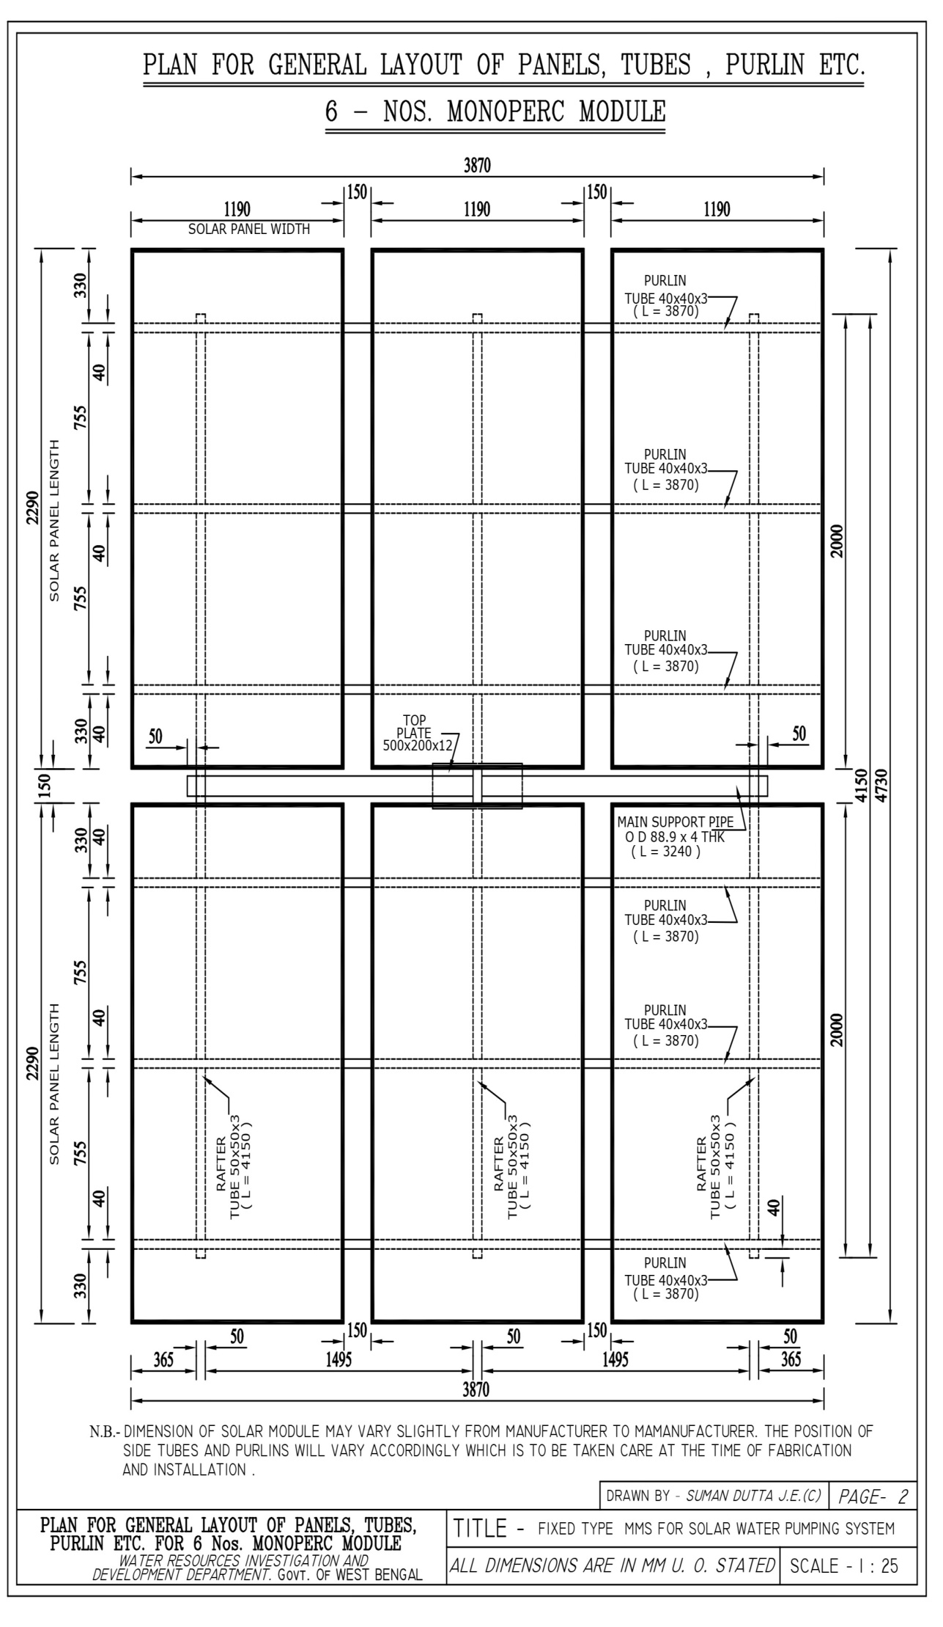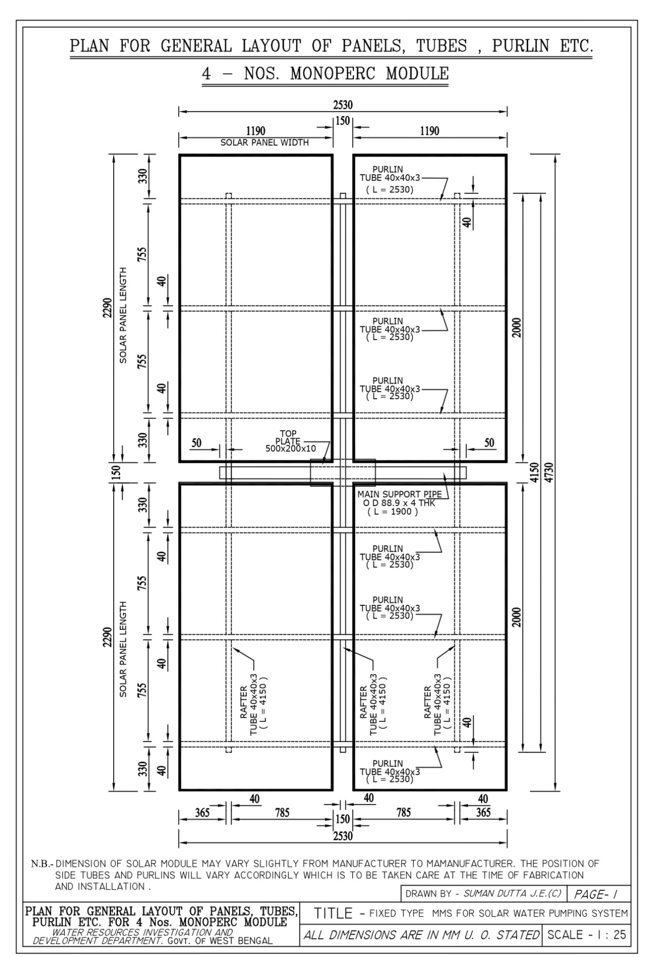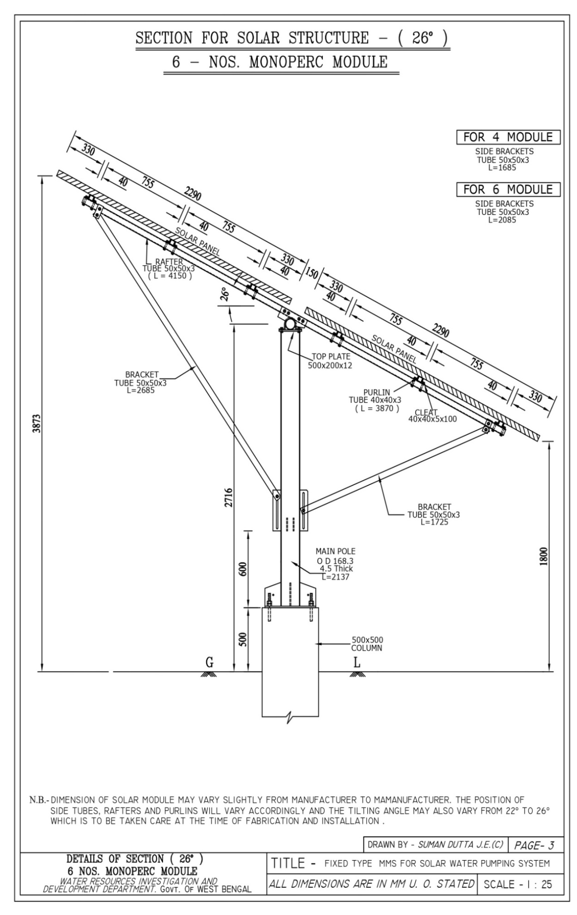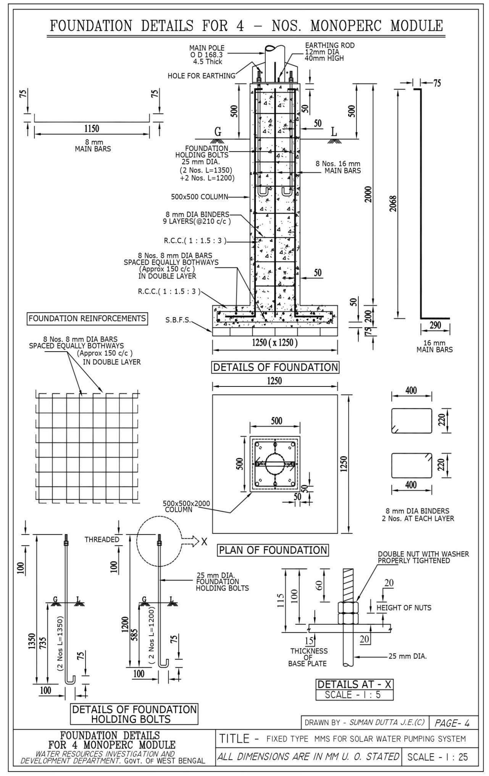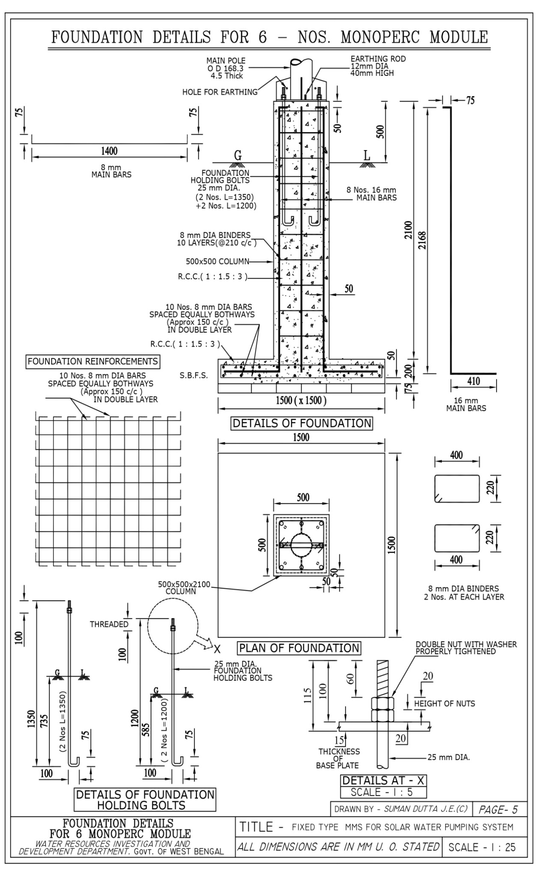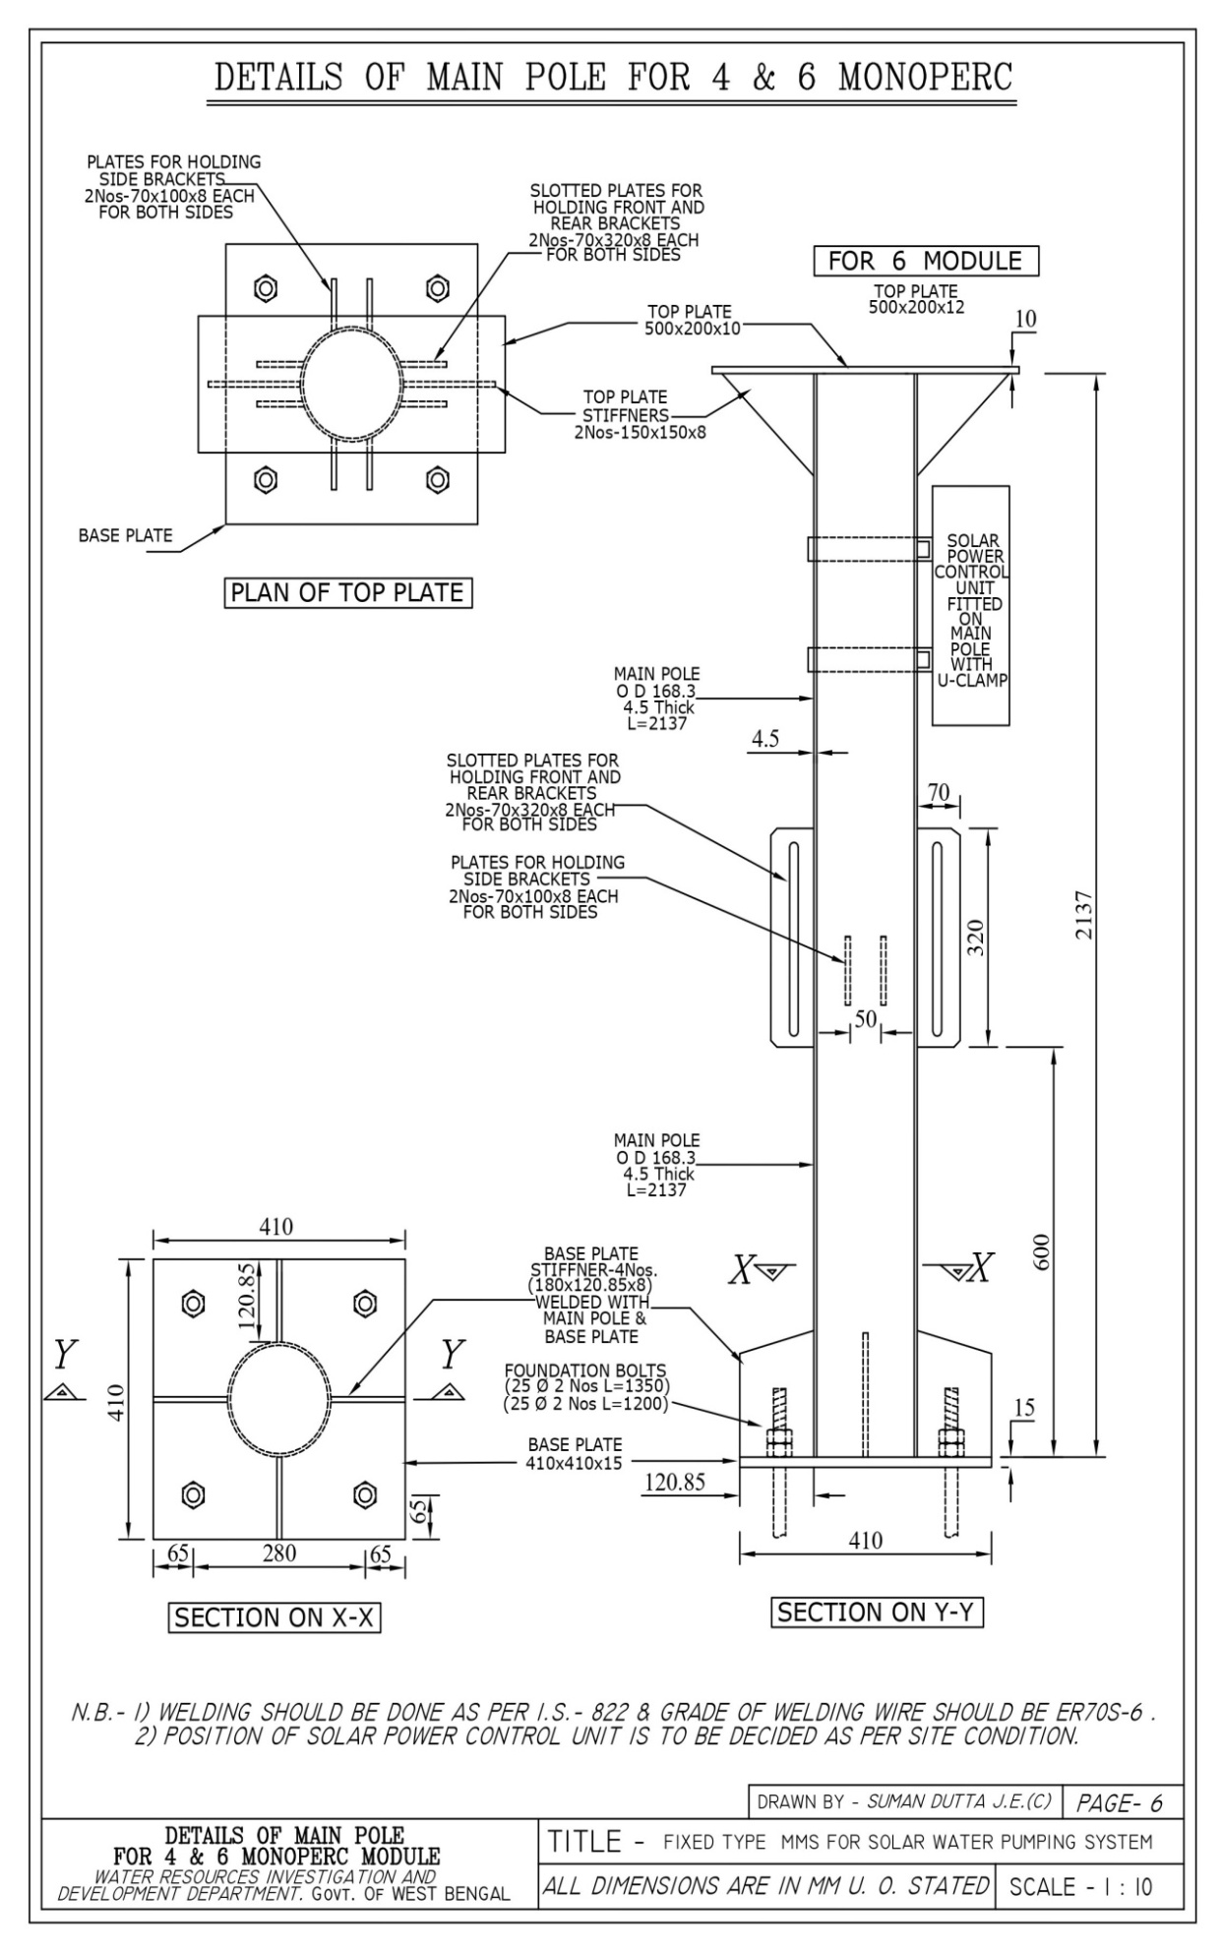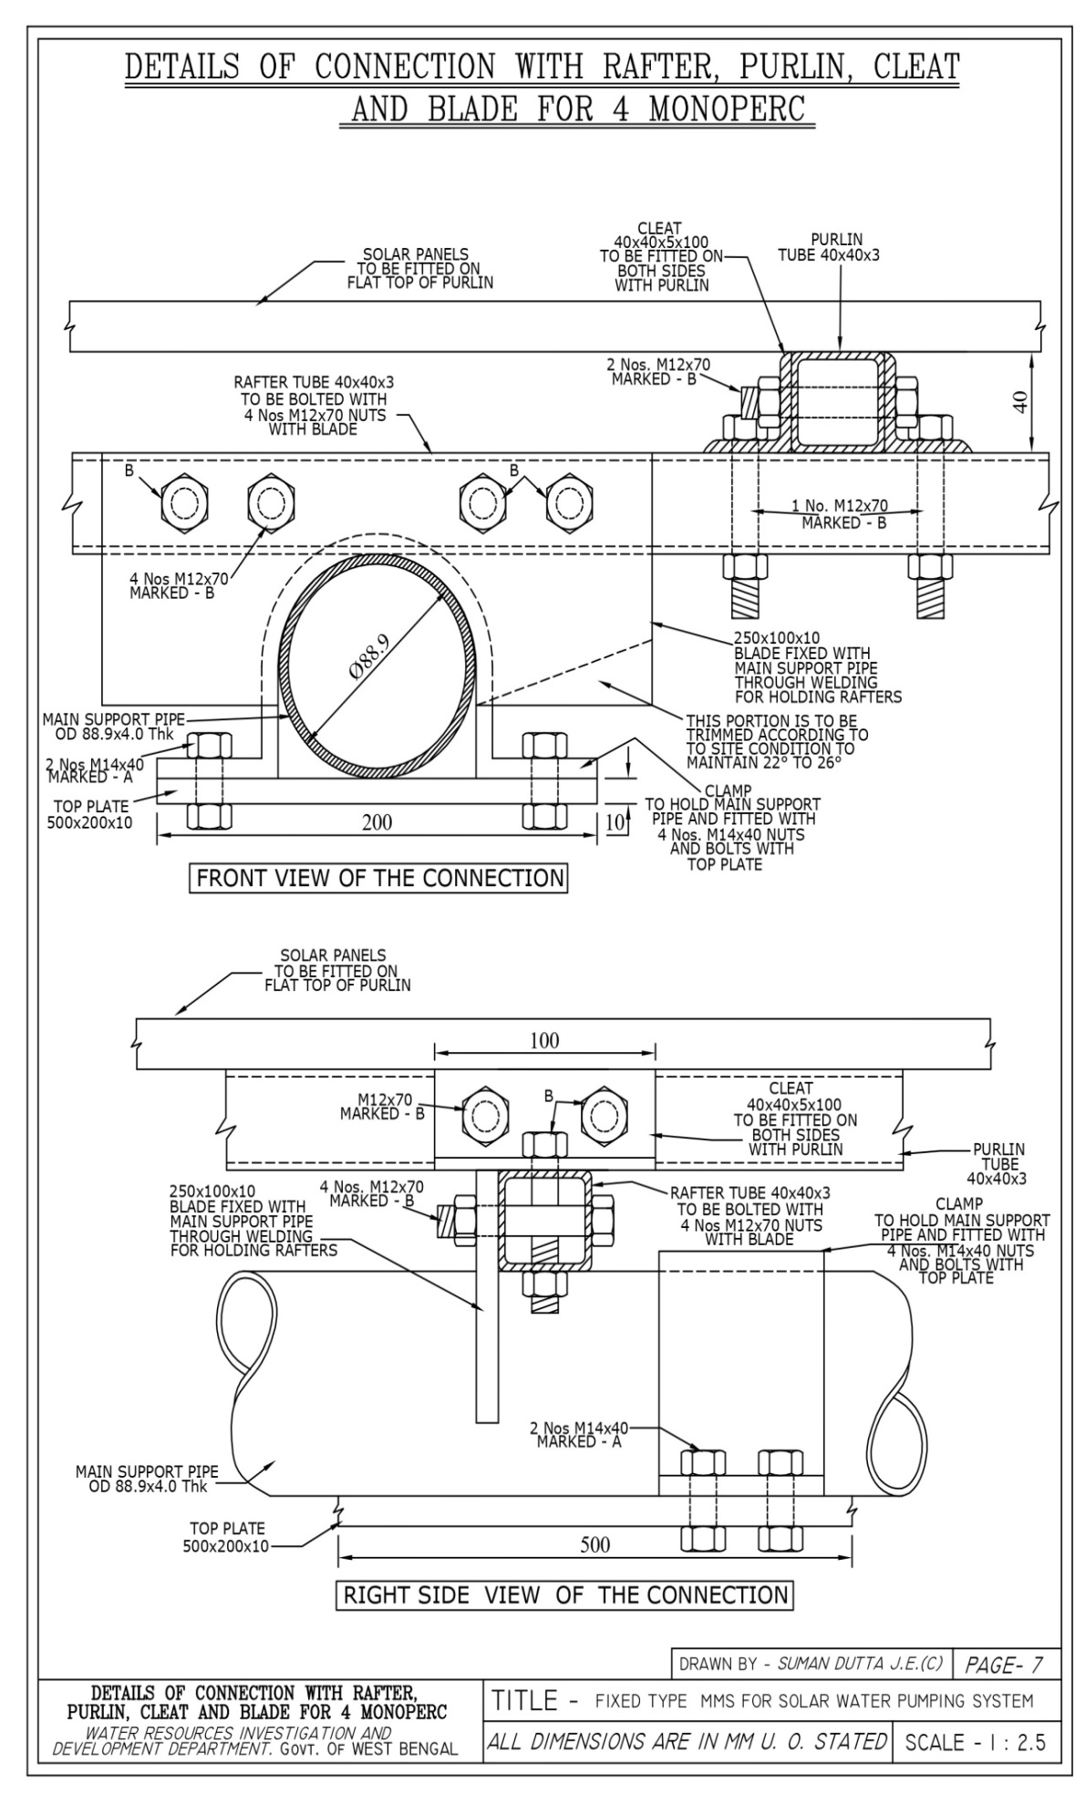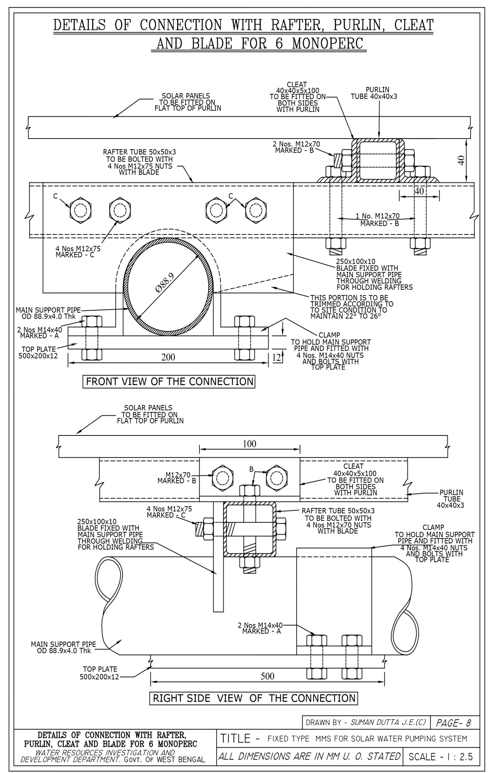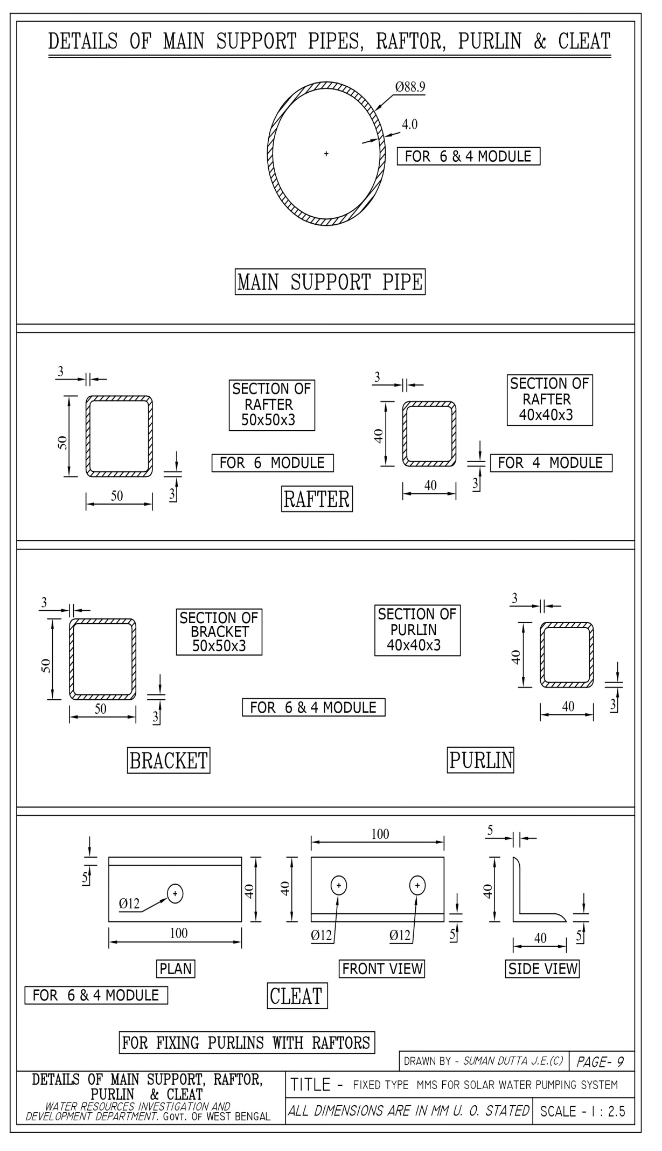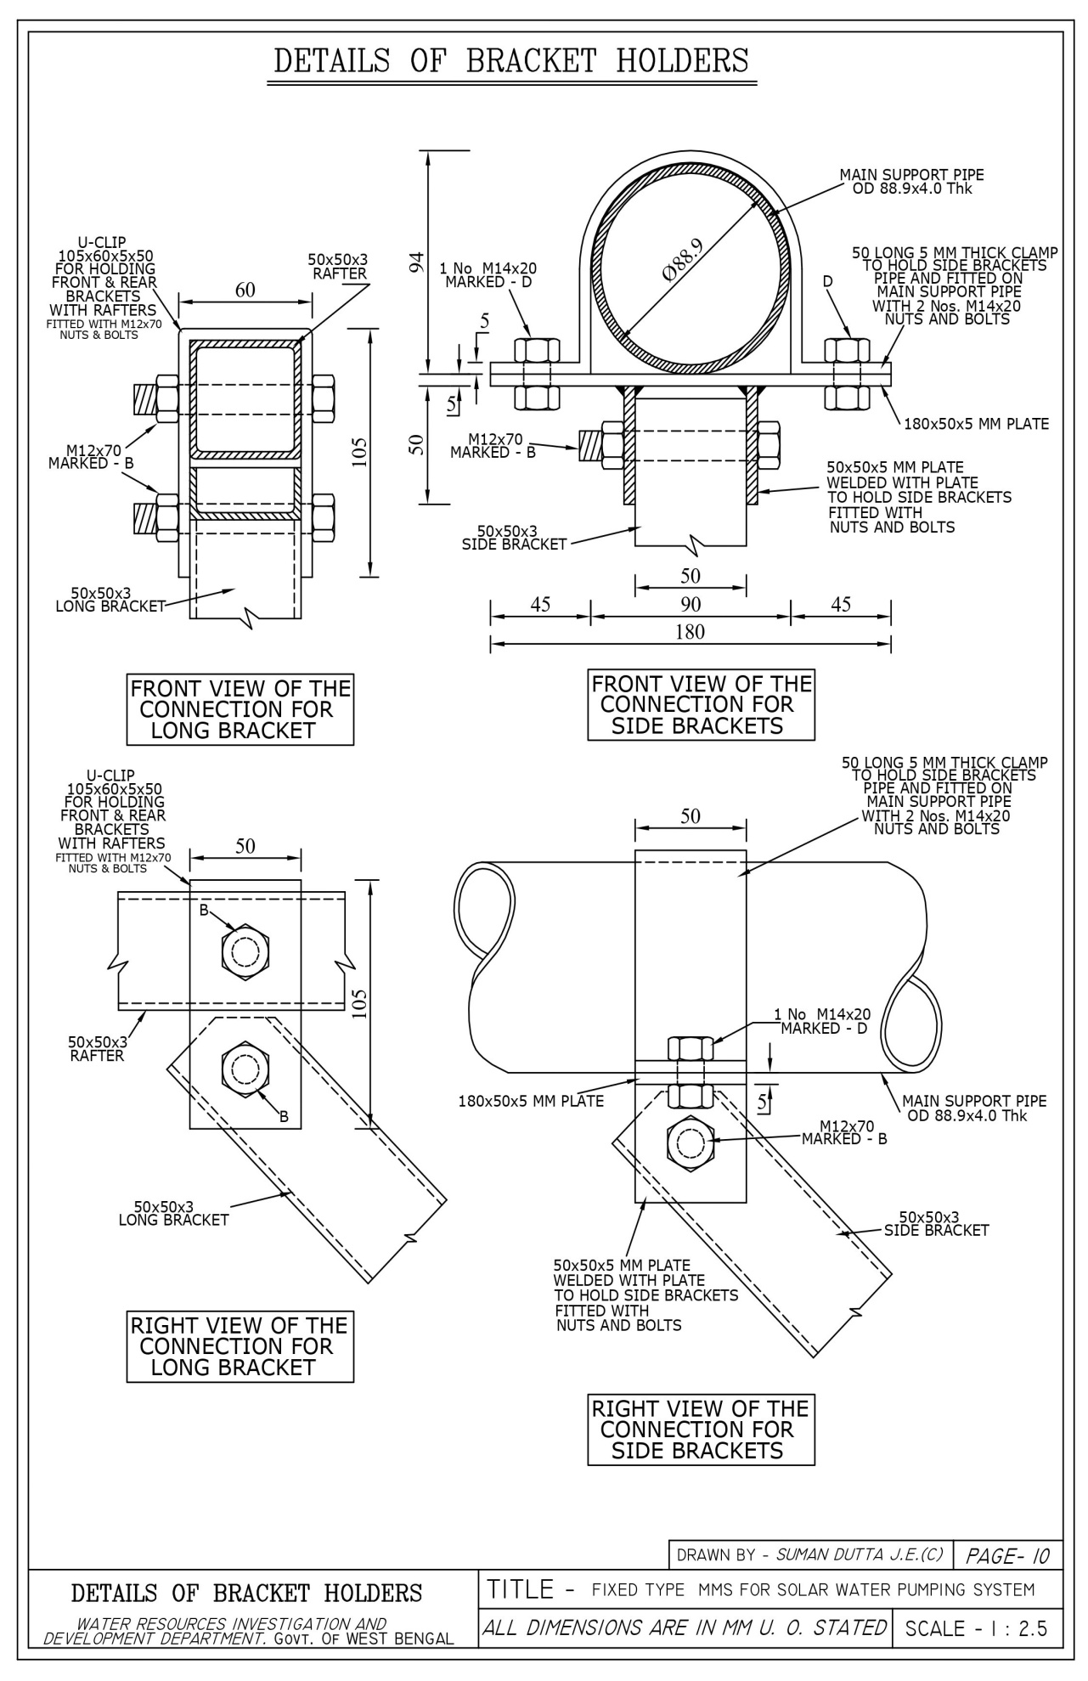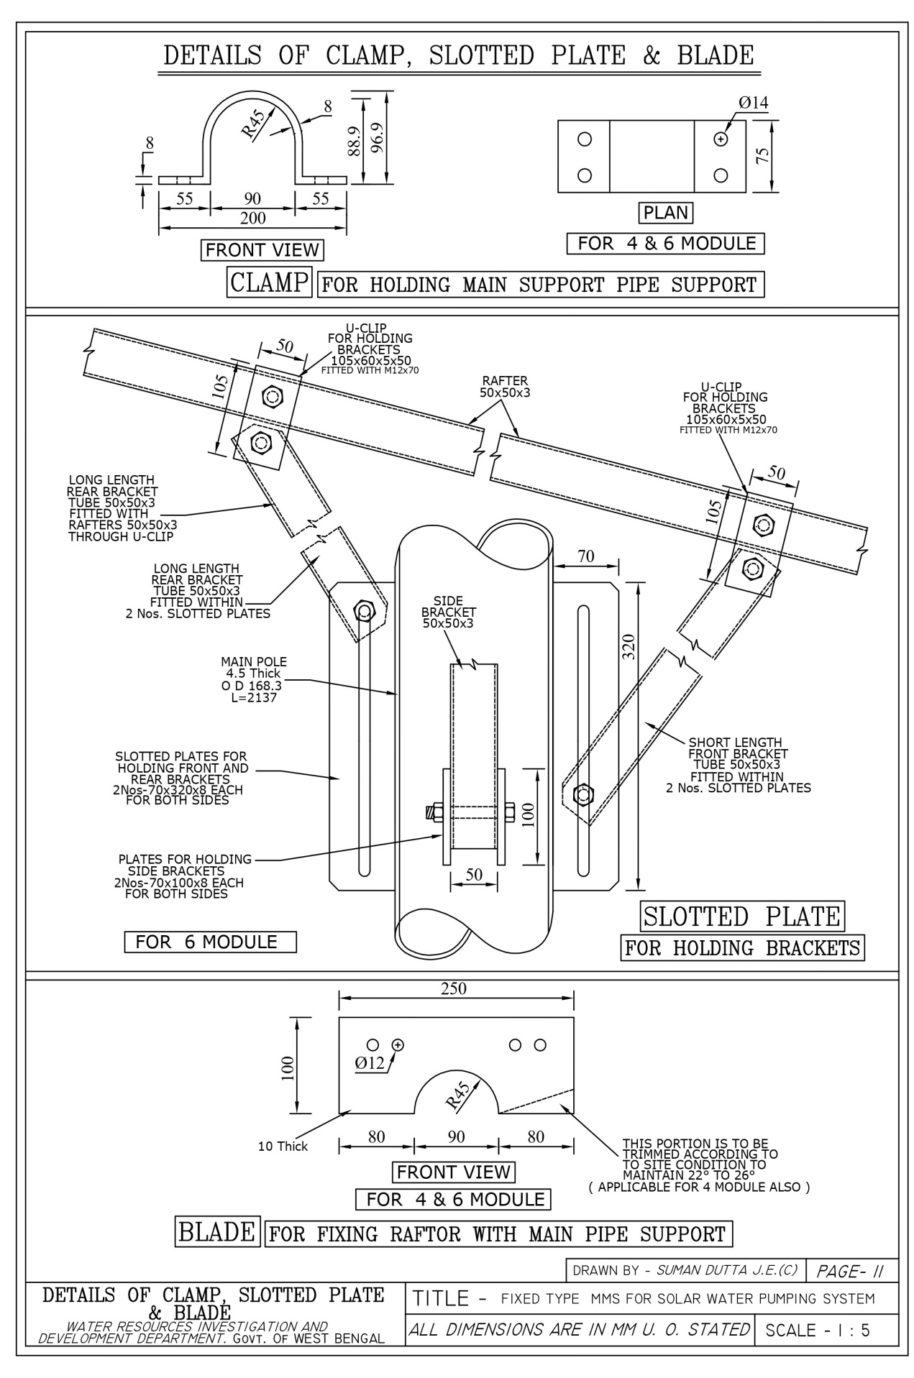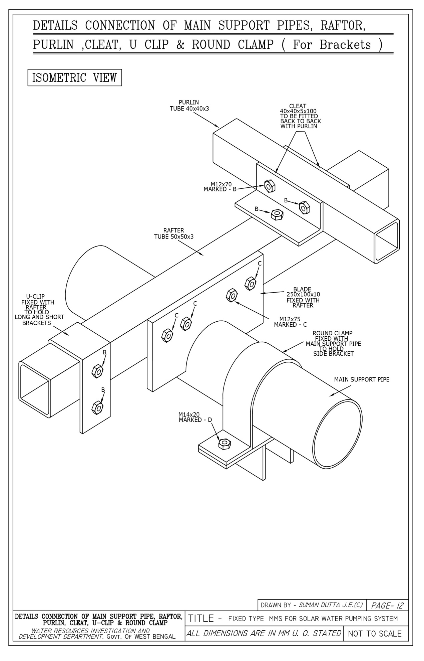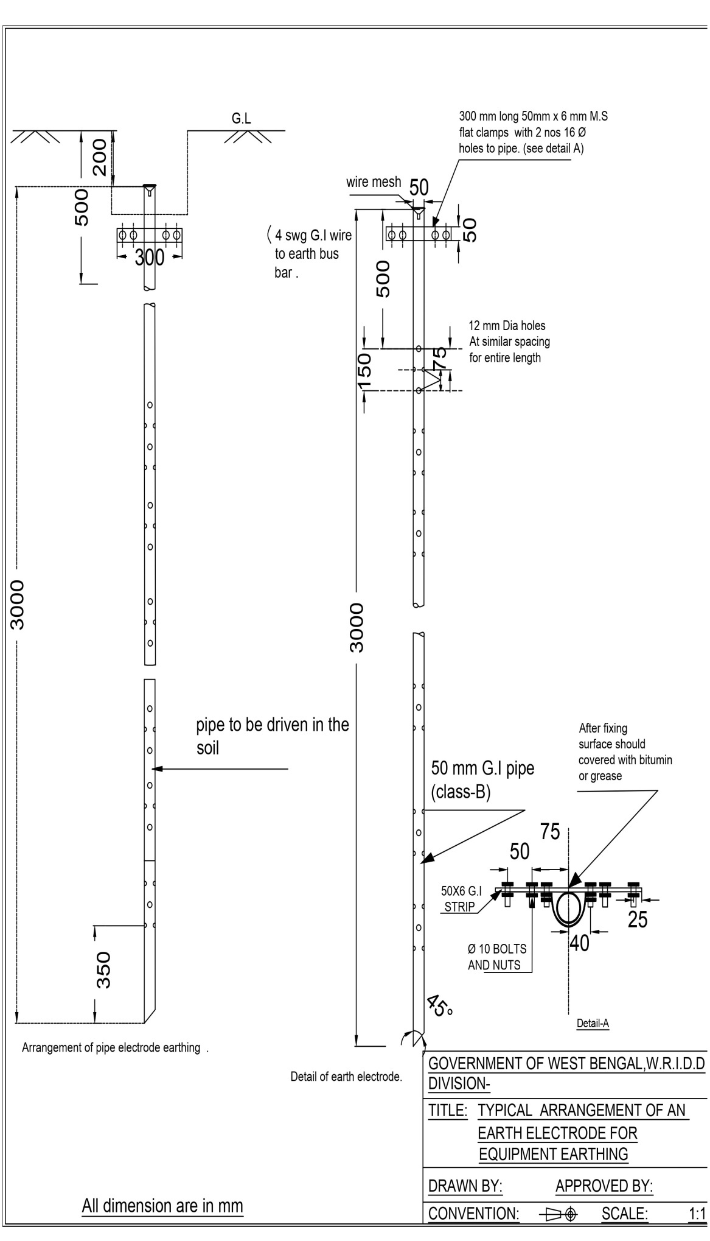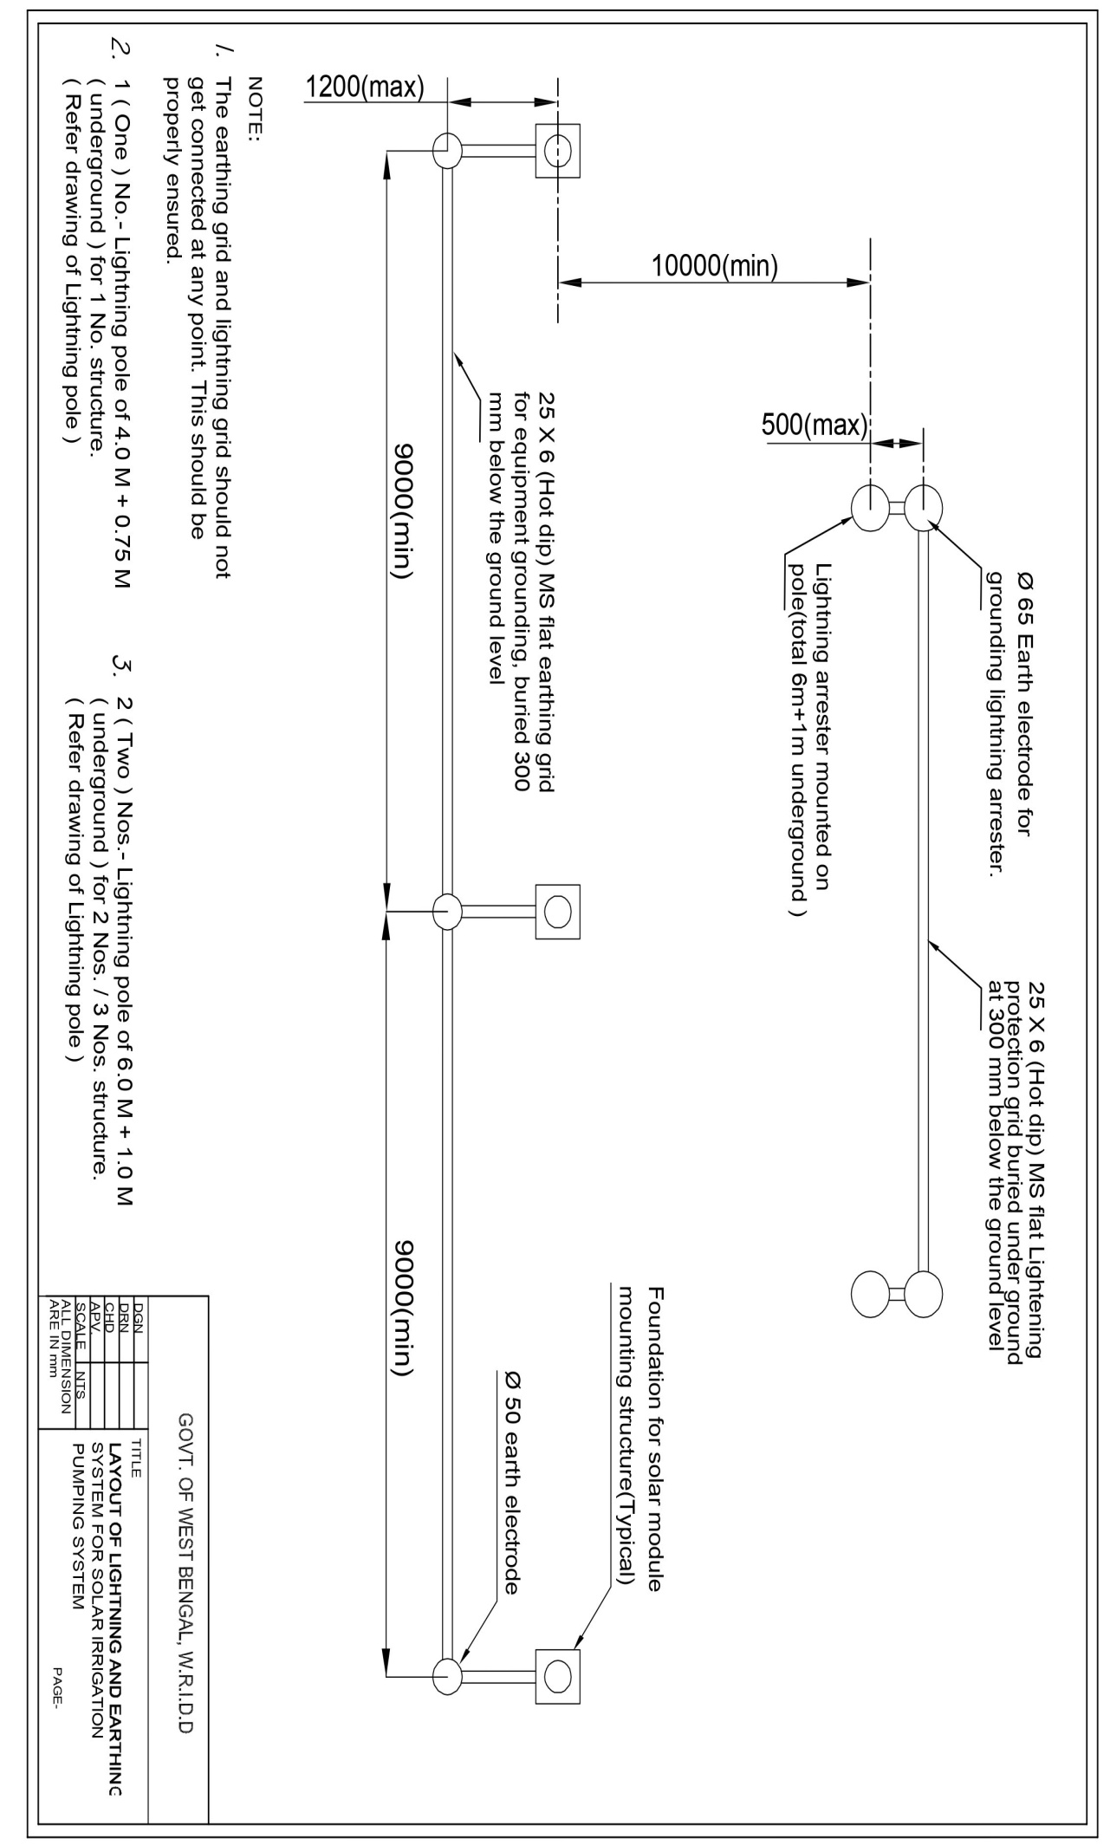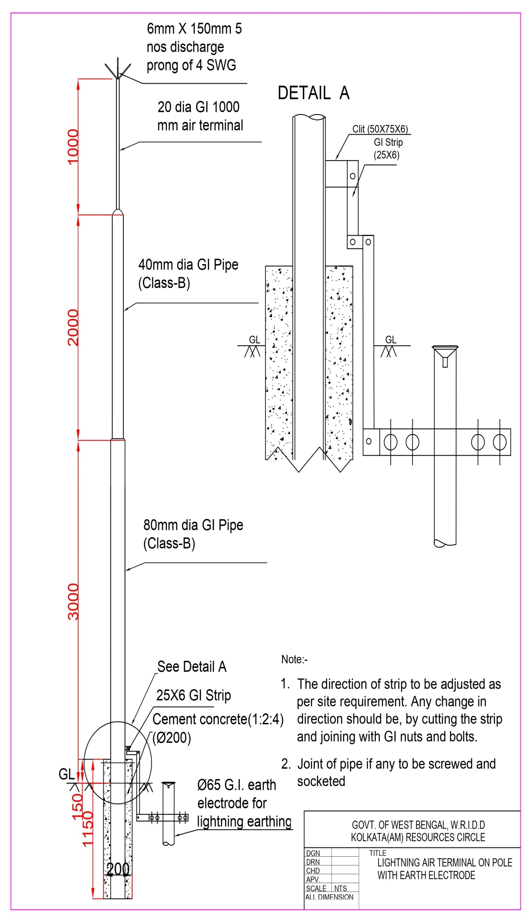

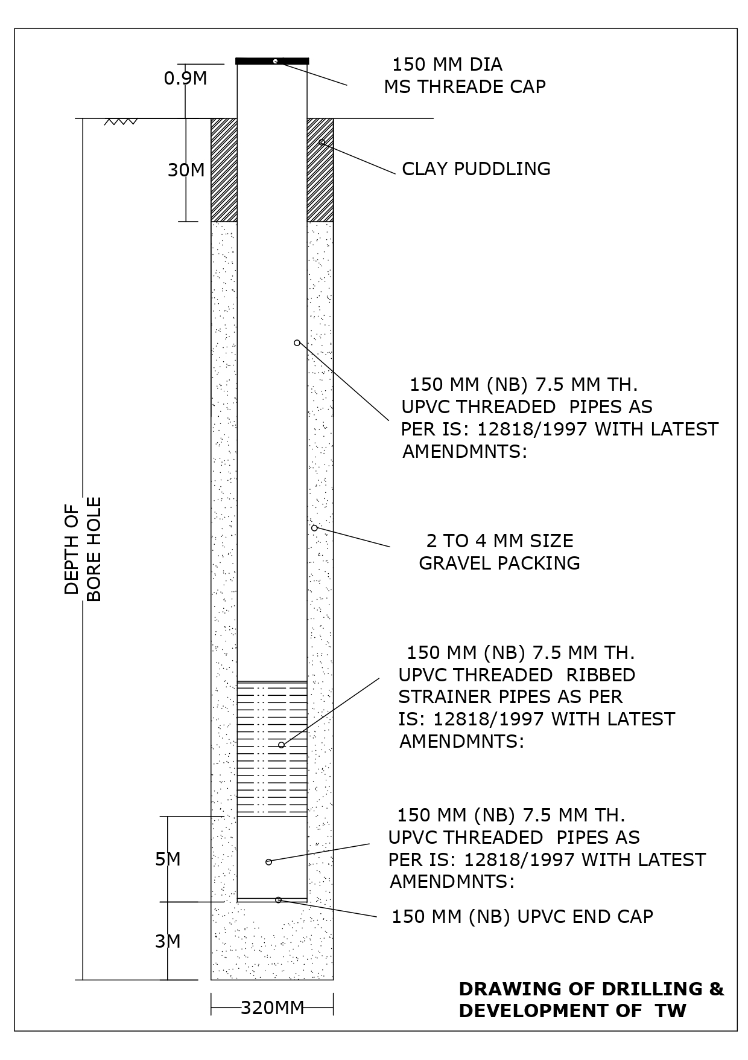

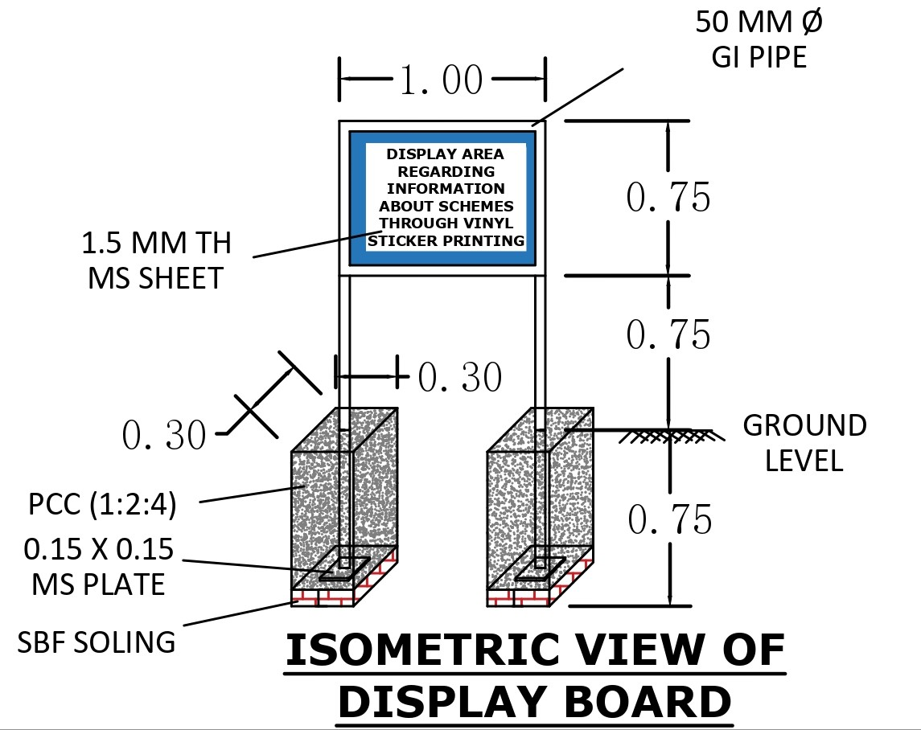

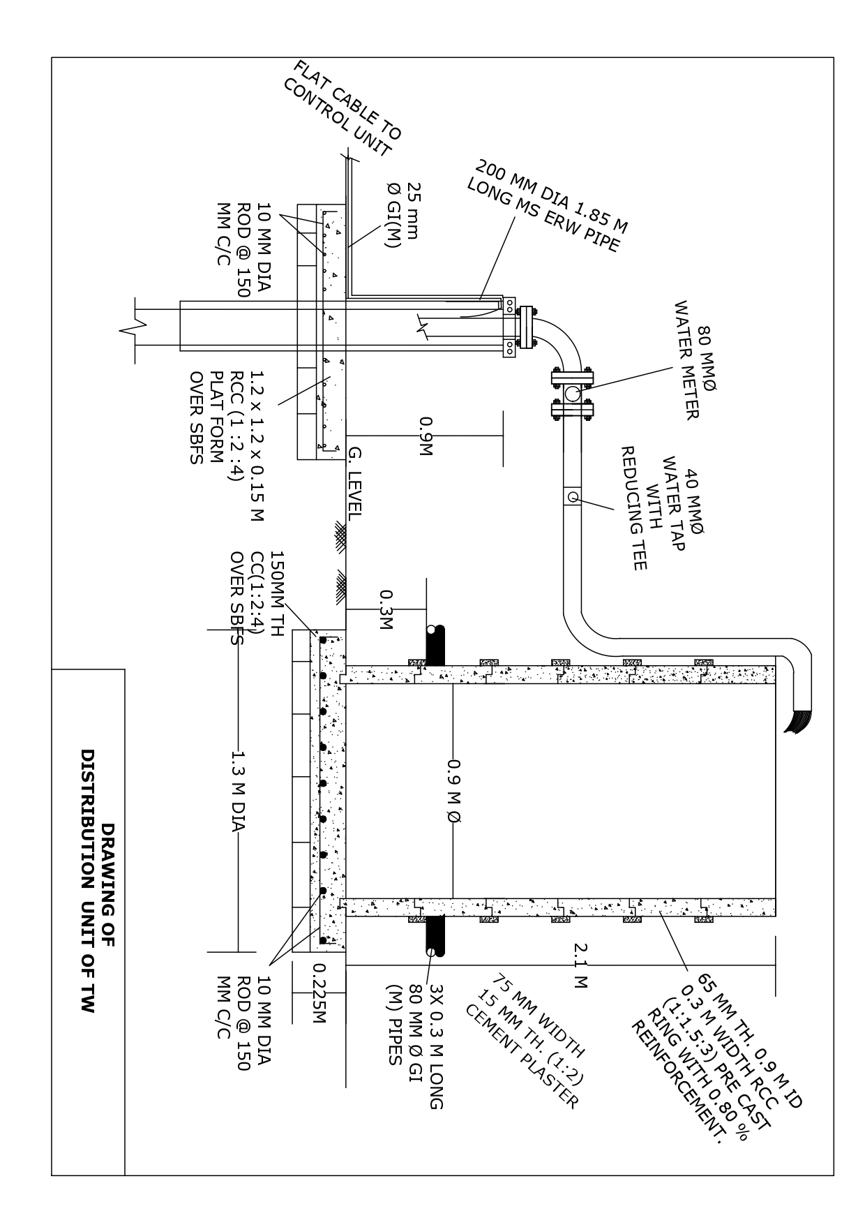

Form of Bid Security - Bank Guarantee
[Guarantor letterhead or SWIFT identifier code]
Bid Guarantee No…………………….[insert guarantee reference number]
Date………………………….[insert date of issue of the guarantee]
WHEREAS, _______________________ [name of Bidder]5(hereinafter called "the Bidder") has submitted his Bid dated _______________________ [date] or will submit his Bid for the construction of _____________________________________ [name of Contract] (hereinafter called "the Bid") under Request for Bids No……………………….[insert number] (hereinafter called “the RFB”)
5 Insert name of the Bidder, which in the case of a joint venture shall be (a) the name of the joint venture that submits the bid if the JV has been constituted into a legally enforceable JV, or (b) the names of all future members of the JV as named in the letter of intent to execute the JV Agreement submitted by the bidder alongwith its bid.
6 The Guarantor should insert the amount of the guarantee in words and figures denominated in Indian Rupees. This figure should be the same as shown in Clause 5.5 of the Instructions to Bidders.
KNOW ALL PEOPLE by these presents that We ______________________________ [name of bank] of ____________________________ [name of country] having our registered office at ___________________________________ (hereinafter called "the Bank") are bound unto ______________________________[name of Employer] (hereinafter called "the Employer") in the sum of ___________________6 for which payment well and truly to be made to the said Employer the Bank binds itself, his successors and assigns by these presents.
SEALED with the Common Seal of the said Bank this _________ day of __________ 20____.
THE CONDITIONS of this obligation are:
(1) If after Bid opening the Bidder (a) withdraws his bid during the period of Bid validity specified in the Letters of Bid, or any extension thereto provided by the Bidder; or (b) does not accept the correction of the Bid Price pursuant to ITB 11.1;
or
(2) If the Bidder having been notified of the acceptance of his Bid by the Employer during the period of Bid validity:
(a) fails or refuses to execute the Form of Agreement in accordance with the Instructions to Bidders, if required; or
(b) fails or refuses to furnish the Performance Security, in accordance with the Instruction to Bidders.
we undertake to pay to the Employer up to the above amount upon receipt of his first written demand, without the Employer having to substantiate his demand, provided that in his demand the Employer will note that the amount claimed by him is due to him owing to the occurrence of one or any of the four conditions, specifying the occurred condition or conditions.

This Guarantee will remain in force up to and including the date ____________________45 days beyond the validity of the bid as such deadline is stated in the Instructions to Bidders or as it may be extended by the Employer, notice of which extension(s) to the Bank is hereby waived. Any demand in respect of this guarantee should reach the Bank not later than the above date.

DATE _______________ SIGNATURE OF THE BANK _________________________
WITNESS ____________ SEAL _______________________________________
_________________________________________________________________
[signature, name, and address]
Note: All italicized text (including footnotes) is for use in preparing this form and shall be deleted from the final product.

Performance Security - Bank Guarantee
[Guarantor letterhead or SWIFT identifier code]

Performance Guarantee No…………………….[insert guarantee reference number]
Date………………………….[insert date of issue of the guarantee]

To: ______________________________________________ [name of Employer]
_________________________________________ [address of Employer]

WHEREAS _________________________ [name and address of Contractor] (hereinafter called "the Contractor") has undertaken, in pursuance of Contract No. _____ dated ________________ to execute __________________________ [name of Contract and brief description of Works] (hereinafter called "the Contract");

AND WHEREAS it has been stipulated by you in the said Contract that the Contractor shall furnish you with a Bank Guarantee by a recognized bank for the sum specified therein as security for compliance with his obligations in accordance with the Contract;

AND WHEREAS we have agreed to give the Contractor such a Bank Guarantee;

NOW THEREFORE we hereby affirm that we are the Guarantor and responsible to you, on behalf of the Contractor, up to a total of ____________________ [amount of guarantee] ___________________________ [in words], such sum being payable in the types and proportions of currencies in which the Contract Price is payable, and we undertake to pay you, upon your first written demand and without cavil or argument, any sum or sums within the limits of ____________________ [amount of guarantee] as aforesaid without your needing to prove or to show grounds or reasons for your demand for the sum specified therein.

We hereby waive the necessity of your demanding the said debt from the Contractor before presenting us with the demand.

We further agree that no change or addition to or other modification of the terms of the Contract or of the Works to be performed thereunder or of any of the Contract documents which may be made between you and the Contractor shall in any way release us from any liability under this guarantee, and we hereby waive notice of any such change, addition or modification.

This guarantee shall be valid until 28 days after the date of issue of the Certificate of Completion, and any demand for payment under it must be received by us at this office on or before that date.

Signature and seal of the guarantor _____________________________
Name of Bank ____________________________________________
Address ____________________________________________
Date ____________________________________________

Advance Payment Security
Demand Guarantee
[Guarantor letterhead or SWIFT identifier code]

DELETED

Retention Money Security
Demand Guarantee
[Guarantor letterhead or SWIFT identifier code]

_____________________________ [Bank’s name and address of issuing branch or office]

Beneficiary: ______________________ [Name and Address of Employer]

Date: ____________________________

RETENTION MONEY GUARANTEE NO.: _________________

We have been informed that ______________[name of contractor](hereinafter called “the Contractor”) has entered into Contract No. _________________ [reference number of the contract] dated ______________________ with you, for the execution of __________________ [name of contract and brief description of Works] (hereinafter called “the Contract”).

Furthermore, we understand that, according to the conditions of the Contract, when the Taking-Over Certificate has been issued for the Works and the first half of the Retention Money has been certified for payment, payment of ___________ [insert the second half of the Retention Money] is to be made against a Retention Money guarantee.

At the request of the contractor, we _________________ [name of Bank] hereby irrevocably undertake to pay you the sum or sums not exceeding in total an amount of _____________________ [amount in Rupees] (______________________) [amount in words] upon receipt by us of your first demand in writing accompanied by a written statement stating that the Contractor is in breach of its obligation under the Contract without cavil or argument.

It is a condition for any claim and payment under this guarantee to be made that the payment of the second half of the Retention Money referred to above must have been received by the Contractor on its account number _________ at ___________ [name and address of Bank].

This guarantee shall expire, at the latest, 21 days after the date when the Employer has received a copy of the Defects Liability Certificate issued by the Engineer. Consequently, any demand for payment under this guarantee must be received by us at this office on or before that date.

_____________________
[Signature(s) and seal of the guarantor]

Note: All italicized text (including footnotes) is for use in preparing this form and shall be deleted from the final product.

SAMPLE FORMAT FOR EVIDENCE OF ACCESS TO OR AVAILABILITY OF CREDIT
BANK SOLVENCY CERTIFICATE

This is to certify that M/s. …………………………… is a reputed company with a good financial standing.
If the contract for the work, namely …………………………………………………………. [funded by the World Bank] is awarded to the above firm, we shall be able to provide overdraft/credit facilities to the extent of Rs. …………… to meet their working capital requirements for executing the above contract.
__ Sd. __
Name of Bank
Senior Bank Manager
Address of the Bank

Section C. Fraud and Corruption
(Text in this Section shall not be modified)
- Purpose
  - The Bank’s Anti-Corruption Guidelines and this annex apply with respect to procurement under Bank Investment Project Financing operations.
- Requirements
- The Bank requires that Borrowers (including beneficiaries of Bank financing); bidders(applicants/proposers), consultants, contractors and suppliers; any sub-contractors, sub-consultants, service providers or suppliers; any agents (whether declared or not); and any of their personnel, observe the highest standard of ethics during the procurement process, selection and contract execution of Bank-financed contracts, and refrain from Fraud and Corruption.
- To this end, the Bank:
- Defines, for the purposes of this provision, the terms set forth below as follows:
- “corrupt practice” is the offering, giving, receiving, or soliciting, directly or indirectly, of anything of value to influence improperly the actions of another party;
- “fraudulent practice” is any act or omission, including misrepresentation, that knowingly or recklessly misleads, or attempts to mislead, a party to obtain financial or other benefit or to avoid an obligation;
- “collusive practice” is an arrangement between two or more parties designed to achieve an improper purpose, including to influence improperly the actions of another party;
- “coercive practice” is impairing or harming, or threatening to impair or harm, directly or indirectly, any party or the property of the party to influence improperly the actions of a party;
- “obstructive practice” is:
- deliberately destroying, falsifying, altering, or concealing of evidence material to the investigation or making false statements to investigators in order to materially impede a Bank investigation into allegations of a corrupt, fraudulent, coercive, or collusive practice; and/or threatening, harassing, or intimidating any party to prevent it from disclosing its knowledge of matters relevant to the investigation or from pursuing the investigation; or
- acts intended to materially impede the exercise of the Bank’s inspection and audit rights provided for under paragraph 2.2 e. below.
- Rejects a proposal for award if the Bank determines that the firm or individual recommended for award, any of its personnel, or its agents, or its sub-consultants, sub-contractors, service providers, suppliers and/ or their employees, has, directly or indirectly, engaged in corrupt, fraudulent, collusive, coercive, or obstructive practices in competing for the contract in question;
- In addition to the legal remedies set out in the relevant Legal Agreement, may take other appropriate actions, including declaring misprocurement, if the Bank determines at any time that representatives of the Borrower or of a recipient of any part of the proceeds of the loan engaged in corrupt, fraudulent, collusive, coercive, or obstructive practices during the procurement process, selection and/or execution of the contract in question, without the Borrower having taken timely and appropriate action satisfactory to the Bank to address such practices when they occur, including by failing to inform the Bank in a timely manner at the time they knew of the practices;
- Pursuant to the Bank’s Anti- Corruption Guidelines and in accordance with the Bank’s prevailing sanctions policies and procedures, may sanction a firm or individual, either indefinitely or for a stated period of time, including by publicly declaring such firm or individual ineligible (i) to be awarded or otherwise benefit from a Bank-financed contract, financially or in any other manner; (ii) to be a nominated sub-contractor, consultant, manufacturer or supplier, or service provider of an otherwise eligible firm being awarded a Bank-financed contract; and (iii) to receive the proceeds of any loan made by the Bank or otherwise to participate further in the preparation or implementation of any Bank-financed project;
- Requires that a clause be included in bidding/request for proposals documents and in contracts financed by a Bank loan, requiring (i) bidders(applicants/proposers), consultants, contractors, and suppliers, and their sub-contractors, sub-consultants, service providers, suppliers, agents personnel, permit the Bank to inspect all accounts, records and other documents relating to the procurement process, selection and/ or contract execution, and to have them audited by auditors appointed by the Bank.

EMP CLAUSE

- The Contractor setting up camp for the accommodation of workers shall follow the IFC/EBRD guidance on Worker Accommodation(Workers’ accommodation: processes and standards (ifc.org)). For guidance on site selection of camps, planning of living conditions etc. please refer to the Guidance in Section 6.1.13Labor Influx and Construction Workers’ Camp Management Plan of the ESMF. (ESMF is available in www.wbadmip.org )
- The Contractor shall ensure that :
  - The contractor shall make adequate provisions for drinking water supply ( conforming to IS 10500:2012 ).
  - The contractor shall ensure that the campsite/s is/are equipped with sanitary facilities approved by the Government of India ( Swacchh Bharat Mission Phase (Grameen) II, Operational Guidelines, 2020; SBM(G) ODF Plus Phase-II MIS App (swachhbharatmission.gov.in). The toilets, soak pit sanitary facilities should not be located nearwithin 15 m of drinking water sources either within or outside the camp.
  - Firewood shall not be used for cooking purposes.
  - First Aid Facilities must be always provided in Contractor Camp and worksites.
  - Adequate Fire safety electrical safety measures shall be provided at both locations .
  - All Fuel and Chemical shall be stored on the impervious ground, and measures are taken to prevent contamination of soil and groundwater
  - For guidance on Living Conditions, Drinking-Water, Cooking Arrangement, Washing and bathing facilities, Toilets Facilities, Wastewater Handling, First Aid, `Fire Fighting, Fuel and Chemical Storage, Vehicle Maintenance and Repairs, and Transportation of Project workers etc, please consider the guidance provided in Section 6.1.13: Labor Influx and Construction Workers’ Camp Management Plan of the ESMF.
- The Contractor is responsible for making safe working conditions and a safe work environment for all labors. All labour must be provided with the required PPE, and its compliance is ensured. He shall also ensure the safety of the local public during the working
- All material required for construction activities, e.g. sand and aggregate, should be procured from quarries with valid environmental clearance and comply with other statutory requirements, e.g. payment of royalty. The Contractor shall submit to the DPMU the necessary documentation as directed by the DPMU.
- The contractor shall adhere to good construction practices with respect to general safety, worksite safety, traffic safety, and electrical safety. Detailed guidance on these is provided in 6.1.10Environment Management Plan: Good Construction Practices and 6.1.11 Topsoil and Spoils Management Plan of the ESMF.
- The Contractor should restore any site used for temporary purposes, e.g. vehicle parking and maintenance, material storage, labour accommodation etc. and repair all damages before decommissioning.
- The contractor shall prepare a Labour Management Plan and Contractor Environment Management Plan for the sub-project along with the Method Statement in consultation with and also approved by concerned Executive Engineer.
- The Executive Engineer shall, after appropriate notice, ensure that in case of failure by the Contractor to comply with the requirement of the EMP, execute the work at the Contractor’s own cost.

Special Terms and Condition

Bidders are requested to engage unskilled labourers under “Karmashree” Scheme of Govt. of WB, having Job Card underMahatma Gandhi NREGS/as per guideline given in the following Kolkata Gazette Notification during execution of the subject mentioned work. The detailed report of the engagement of labourer has to be submitted to the undersigned as per the given format in the Gazette Notification& to be duly signed by the bidder following necessary guidelines vide The Kolkata Gazette Notification 07/03/24, Registered No. WB/SC-247, Notification No. 1140 PRD-33011/1/2024-MGNREGA SEC Dtd. 07-03-2024of Secretary to the Govt. of WB, Panchayats& Rural Development Department by the order of the Governor of Govt. of WB. Annexure Form No-VI Sample Copy enclosed.
FinancialYear |  | District
WorkCode(system-generated) |  | Work Sector
WorkName
WorksiteLocation
Block/Municipality |  | GP(forBlock)
FundingDept. (tobefilledby  the Office) |  | ImplementingDept.
ImplementingAgency(Office)
OftheDept.
WorkOrderNo.
Contractor/ AgencyName |  | ContactNo.of  Contractor/Agency

KARMASHREE:EMPLOYMENTSHEET
(tobeusedbytheimplementingagencyforrecordingtheemploymentprovided)

WORK DETAILS. Form –VI (Pg 1)

Sl.  No. | Nameof  Worker | JobCard  No.  (full) | Gender ( (M/F) | Age | Caste(SC  /ST/OBC  /Gen) | Whether  Minority  (Y/N) | Whether Migrant  Worker  (Y/N) | Mobile No. | AadhaarNo.  (not  mandatory)
[1] | [2] | [3] | [4] | [5] | [6] | [7] | [8] | [9] | [10]
1
2
3
…
…
10
etc.

WORKER DETAILS

CountersignatureofEngineer
withOfficeSealName&Signatureof
Contractor/ Agency

KARMASHREE:EMPLOYMENTSHEET
(tobeusedbytheimplementingagencyforrecordingtheemploymentprovided)

FORM-VI
(Page 2)

EMPLOYMENT DETAILS;
Sl.  No. | Name  of Worker | Date of  application  Forwork* | Noof  Days  work  demanded** | Work  allocated  from  (date) | Work  allocated  upto  (date) | Work  provided  from  (date) | Work provided  Upto  (date) | No. of  Days  work  provided | Total  Wage  Paid  (Rs.) | Date  of  payment
[1] | [2] | [11] | [12] | [13] | [14] | [15] | [16] | [17] | [18] | [19]
1
2
3
…
…
10
etc.

CountersignatureofEngineerwithOfficeSeaName&Signatureof Contractor/ Agency

*Dateofapplicationforwork:-Asperapplicationofworkers/Firstdayofreportingforwork,ifnotPreviouslyappliedforwork
**No.ofdaysworkdemanded=No.ofdaysworkallotted(ifnotpreviouslyappliedfor)

This document is drafted for construction of small works paid on lump sum basis; modify it suitably if works are to be paid on item rate basis.
If considered necessary, the Employer may attach minimum requirements for ESHS Management Strategies and Implementation Plans and ESHS Code of Conduct.A sample guidance note is attached at the end of the document.
If debarred/removed, please provide further details.
If debarred/removed, please provide further details.
In case of a firm insert ‘complete address of the firm’. In case of an individual contractor insert identification like ‘son of and resident of’ etc.
An amount shall be inserted by the Guarantor, representing the percentage of the Contract Price specified in the Contract and denominated in Indian Rupees.
The Guarantor shall insert an amount representing the amount of the second half of the Retention Money.
For the avoidance of doubt, a sanctioned party’s ineligibility to be awarded a contract shall include, without limitation, (i) applying for pre-qualification, expressing interest in a consultancy, and bidding, either directly or as a nominated sub-contractor, nominated consultant, nominated manufacturer or supplier, or nominated service provider, in respect of such contract, and (ii) entering into an addendum or amendment introducing a material modification to any existing contract.
A nominated sub-contractor, nominated consultant, nominated manufacturer or supplier, or nominated service provider (different names are used depending on the particular bidding document) is one which has been: (i) included by the bidder in its pre-qualification application or bid because it brings specific and critical experience and know-how that allow the bidder to meet the qualification requirements for the particular bid; or (ii) appointed by the Borrower.
Inspections in this context usually are investigative (i.e., forensic) in nature. They involve fact-finding activities undertaken by the Bank or persons appointed by the Bank to address specific matters related to investigations/audits, such as evaluating the veracity of an allegation of possible Fraud and Corruption, through the appropriate mechanisms. Such activity includes but is not limited to: accessing and examining a firm's or individual's financial records and information, and making copies thereof as relevant; accessing and examining any other documents, data and information (whether in hard copy or electronic format) deemed relevant for the investigation/audit, and making copies thereof as relevant; interviewing staff and other relevant individuals; performing physical inspections and site visits; and obtaining third party verification of information.

