**PROCUREMENT OF SMALL WORKS UNDER**

NATIONAL OPEN COMPETITIVE PROCUREMENT

**[to be used for contracts[1] valued less than US$ 1 million]**

**(Two-Envelope Bidding Process with e-Procurement)**

**August 2024**

GOVERNMENT OF WEST BENGAL

**Water Resources Investigation & Development Department**

**Accelerated Development Minor Irrigation Project, Phase -II**

**Office of the Executive Engineer**

**District Project Management Unit, Jhargram ,WBADMIP**

**At – Vidyasagar Pally, P.O.-Jhargram, Dist. - Jhargram, Pin-721507,**

**Email: dpmujhargram@gmail.com**

REQUEST FOR BIDS (RFB)

**E-Procurement Notice**

**(Two-Envelope Bidding Process with e-Procurement)**

**NATIONALOPEN COMPETITIVE PROCUREMENT**

# FOR SMALL WORKS

Date: 01.02.2023

RFB No.:

1. The Government of India has received a loan from the International Bank for Reconstruction & Development towards the cost of WBADMI Project Phase –II and intends to be applied a part of the funds to cover eligible payments under the contracts for construction of works as detailed below. Bidding is open to all bidders from eligible source countries as defined in the “Procurement Regulations for IPF Borrowers, July 2016, Revised Nov 2020”*.* Bidders from India should, however, be registered with the Government of West Bengal or other State Governments/Government of India, or State/Central Government Undertakings. **Bidders are advised to note the minimum qualification criteria specified in Clause 3 of the Instructions to Bidders to qualify for the award of the contract.** In addition, please refer to paragraphs 3.14 and 3.15 of the “Procurement Regulations” setting forth the World Bank’s policy on conflict of interest.

2. The Executive Engineer, DPMU, Jhargram WBADMIP (Implementing Agency) invites online bids for the construction of works detailed in the table below. Each biddershould submit only one bid for the works indicated therein.

3. Bidding documentsare available online free of cost in the website[www.wbtenders.gov.in](http://www.wbtenders.gov.in)from 03.02.23.to.7.03.23. (dates). Bidders will be required to register on the website, and should have DSC key or token for registration in the aforesaid website and to participate for the tender. The bidders would be responsible for ensuring that any addenda available on the website is also downloaded and incorporated. Interested bidders may obtain further information at the address given below during office hours or may request clarifications online through e-procurement portal.

PERIOD OF AVAILABILITY OF BIDDING

DOCUMENT ON WEBSITE

<https://wbtenders.gov.in> : DATE FROM 03/02/2023 18:00 HOURS TO

07/03/2023 18:00 HOURS

SEEK CLARIFICATION START DATE & TIME : DATE 03/02/2023 TIME 18.00 HOURS

SEEK CLARIFICATION END DATE & TIME :DATE13/02/2023 TIME 18.00 HOURS

ONLINE BID SUBMISSION START DATE & TIME :DATE15/02/2023 TIME 18.00 HOURS

LAST DATE FOR ONLINE RECEIPT OF BIDS : DATE 07/03/2023 TIME 18.00 HOURS

TIME AND DATE OF OPENING OF TECHNICAL BID : DATE 10/03/2023 TIME 11.00 HOURS

OFFICER INVITING BIDS : Executive Engineer, DPMU Jhargram, WBADMIP

4. For submission of the bid, the bidder is required to have Digital Signature Certificate (DSC) from one of the Certifying Authorities authorized by Government of India for issuing DSC. Aspiring bidders who have not obtained the user ID and password for participating in e-procurement in this Project, may obtain the same from the website before the bid submission deadline i.e. before 07.03.23. (date).

5. Bids must be accompanied by a bid security(@ Rs. Given below at clause no.9).The bid security is specified for the work in the table below, drawn in favor of Executive Engineer, DPMU_____________,WBADMIP (depicted in the [www.wbtenders.gov.in](http://www.wbtenders.gov.in) ) will have to be paid through online or Bank Guarantee and the Bank Guarantee shall have to be valid for 45 days beyond the validity of the bid.Bids should be valid for180 days after the deadline date specified for bidsubmission. Procedure for submission of bid security is described in Para 7 below.

6. Bids, both Technical and Financial Parts, must be submitted online on [www.wbtenders.gov.in](http://www.wbtenders.gov.in) (website) on or before18.00hours on 07.03.23(date) and the ‘Technical Part’ of the bids will be publicly opened online on the 10.03.23 at11.00 hours, in the presence of the bidders who wish to attend. Any bid or modifications to bid (including discount) received outside e-procurement system will not be considered. The “Financial Part” shall remain unopened in the e-procurement system until the second public Bid opening for the financial part. Record of bid opening will be electronically shared with bidders. If the office happens to be closed on the date of opening of the bids as specified, the technical part of bids will be opened on the next working day at the same time and venue. The electronic bidding system would not allow any late submission of bids.

7. The bidders are required to submit

(a) the copy of receipt of original bid security in the form of Bank Guarantee in approved format (Attached in Bid Security as Bank Guarantee) before the bid submission deadline during the office hours between 11:00 A.M. to 05:30 P.M (not in the holidays) either by registered post/speed post or by hand.If the hard copy of the original bid security in the form Bank Guarantee has not beenreceivedin the office of The Executive Engineer, DPMU ____________, WBADMIP before the stipulated Date and time(Before the last date of Bid Submission Date and Time) then the bid will be declared non-responsive and will not be opened. Any delay for submission of the original Bank Guarantee from the Bidder’s end is not permissible. The Bank Guarantee of the unsuccessful bidders will be released after Financial Evaluation upon submission of a Request of Release Letter from the bidder’s end.

Or

(b) the copy of receipt of original bid security through online ([www.wbtenders.gov.in](http://www.wbtenders.gov.in) )in approved form before the bid submission deadline, If the bid security has not been submitted the bid will be declared non-responsive and will not be opened.

The L1 bidder’s bid security will be discharged upon submission of the 3% Performance Security deposit of the contract amount.

Bid Security Deposit (BSD)- Online deposit mode:

Intending bidders desiring to make payment of Bid Security Deposit (BSD) on-line, should beforehand read the instructions carefully, particularly in the challan generated by the system of e-tender/e-procurement, if opted for BSD payment through RTGS/NEFT

A. Login by bidder:

a. A bidder desirous of taking part in an e-tender invited by a State Government shall login to the e-Procurement portal of the Government of West Bengal using his/her login ID and password using valid DSC.

b. He/she will select the e-tender to bid and initiate payment of pre-defined BSD for that e-tender by selecting from either of the following payments modes:

i. Net-Banking (any of the banks listed in the ICICI Bank Payment Gateway) in case of payment through ICICI Bank Payment Gateway;

ii. RTGS/NEFT in case of off-line payment through bank accounts in any Bank approved by RBI in India.

B. EMD payment procedure:

a. Payment by Net Banking (any listed bank) through ICICI Bank Payment Gateway:

i. On selection of net banking as the payment mode, the bidder will be directed to ICICI Bank Payment Gateway webpage (along with a string containing a Unique ID) where he/she will select the Bank through which he/she wants to do the BSD on-line transaction.

ii. Bidder will make the payment after entering his Unique ID and password of the bank to process the transaction.

iii. Bidder will receive a confirmation message regarding success/failure of the transaction.

iv. If the transaction is successful, the amount paid by the bidder will get credited in the respective Pooling account of the State Government maintained with the Focal Point Branch of ICICI Bank at R.N Mukherjee Road, Kolkata for collection of BSD against unique codes for identification of the tendering authority.

v. If the transaction is failure, the bidder will again try for payment by going back to the first step.

B. Payment through RTGS/NEFT:

i. On selection of RTGS/NEFT as the payment mode, the e-procurement portal will show a pre-filled challan having the details to process RTGS/NEFT transaction.

ii. The bidder will print the challan and use the pre-filled information to make RTGS/NEFT payment using his/her own Bank account.

iii. Once payment is made, the bank would provide an “UTR remittance number” for successful transaction with which the bidder will come back to the e-Procurement portal after expiry of 2 to 3 bank working days to enable the NEFT/RTGS process to complete, in order to verify the payment made and continue with his/her bidding process.

iv. If verification is successful, the fund get credited to the respective Pooling account of the State Government maintained with the Focal Point Branch of ICICI Bank at R.N Mukherjee Road, Kolkata for collection of BSD.

v. Hereafter, the bidder will go to e-Procurement portal for final e-submission of his/her bid within pre assigned last date of submission of e-tender.

vi. If the payment verification is unsuccessful, the amount will be returned automatically by the system to the bidder’s account.

Note: BSD payment made through RTGS/NEFT would require additional 2 to 3 bank working days after date of transaction in the bank before the procedure is completed for enabling the bidder to continue with the bidding process in the on-line e-tender final bid submission. Thus, the bidder is to take precaution in case of RTGS/NEFT transfers so that the entire process of submission of e-tender is completed within last date of on-line submission of his/her tender. However, Net-banking transaction through ICICI bank payment Gateway would be on real time basis.

EMD Exemption or Exemption of Bid Security is not permissible.

8. The Employer shall not be held liable for any delays due to system failure beyond its control. Even though the system will attempt to notify the bidders of any bid updates, The Employer shall not be liable for any information not received by the bidder. It is the bidders’ responsibility to verify the website for the latest information related to this bid.

9. Other details can be seen in the bidding document.

# TABLE

|  |  |  |  |  |
| --- | --- | --- | --- | --- |
| Package  No. | Name of work | Bid Security (Rs.) | Cost of document for Bid Submission  (Rs.) | Period of completion |
| 1 | Construction of 12 nos. Pump Dug Well (Solar) at Mouza-Raipal (Jl No. 160) under Nayagram Block in the district of Jhargram under DPMU, Jhargram, WBADMI Project | 2,00,000.00 | NIL | 6 months |

For Location details – Please see Description of Works.

Executive Engineer

DPMU, Jhargram

WBADMIP

Memo no – 22 Dated – 01.02.2023

Copy forwarded for information to:-

1. The Project Director, WBADMI Project, ICMARD Building (5th Floor), Kolkata - 67.
2. The District Magistrate, Jhargram.
3. The Sabhadhipati, JhargramZillaParishad.
4. The Additional Project Director, WBADMIP.
5. The Controller of Finance, WBADMIP.
6. The SE (A-I) & DPD (Technical) WBADMIP, PaschimMedinipur.
7. The Divisional Accountant, DPMU Jhargram.
8. The Procurement Engineer, DPMU, Jhragram
9. The notice Board of the undersigned.

Executive Engineer

DPMU, Jhargram

WBADMIP

## 

**Instructions to Bidders**

# SECTION - A

1. Scope of Works

The Executive Engineer, DPMU, Jhargram WBADMIP, Phase II on behalf of the Project Director /District Project Director, WBADMIP Phase II invites bids for the construction of works as detailed in the table given below through the e-procurement portal [www.wbtenders.gov.in](http://www.wbtenders.gov.in).

|  |  |  |
| --- | --- | --- |
| Package No. | Brief Description of the Works | Period of Completion |
| 1. | Construction of 12 nos. Pump Dug Well (Solar)at -Raipal (Jl No. 160) under Nayagram Block in the district of Jhargram under DPMU, Jhargram, WBADMI Project | 6 months |

The successful bidder will be expected to complete the works by the intended completion date specified above.

Location Details:

|  |  |  |  |  |  |  |  |  |
| --- | --- | --- | --- | --- | --- | --- | --- | --- |
| Sl No | Package No | Name of Scheme | Block | GP | Mouza (JL) | Plot No | Latitude | Longitude |
| 1 |  |  |  |  |  |  |  |  |
| 2 |  |  |  |  |  |  |  |  |
| 3 |  |  |  |  |  |  |  |  |

2. Qualification of the bidder: The bidder shall provide qualification information which shall include: -

1. total monetary value of construction works performed for each year of the last 3 years (Prior to the year of bid opening);
2. Report on his financial standing for last three years (Prior to the year of bid opening); and
3. Details of any litigation, current or during the last 3 years in which the bidder is involved, the parties concerned and disputed amount or awards in each case.

3. To qualify for award of the contract the bidder:-

1. Should have satisfactorily completed as a prime contractor in the last 3 (three) at least one work executed in the same / similar nature of work under the authority of State/ Central Govt., State / Central Govt. undertaking, Statutory Bodies constituted under the statute of the Central /State Government and having a magnitude of 40 (Forty) percent of the value of the work for which bids are being invited (as per table below)in a single work order.
2. should have achieved in at least one year an annual financial turnover of (in works of similar nature only) value not less than usually the value of the work for which bids are being invited (as per table below) in the last three years;

(c)* should not have been debarred (or dealings suspended) on the dates of bid opening of the technical part and financial part of the bids by the Central/State Governments/Undertakings or by the World Bank Group (<https://www.worldbank.org/en/projects-operations/procurement/debarred-firms> ).

(d) no contract should have been suspended or terminated and/or performance security called by an employer(s) for reasons related to Environmental, Social (including sexual exploitation and abuse (SEA) and gender-based violence (GBV)), Health, or Safety (ESHS) requirements or safeguards in the past five years.

(e) availability of liquid assets and/or credit facilities, net of other contractual commitments and exclusive of any advance payments which may be made under the Contract, of not less than Rs. (As per table below).##

(## Credit lines/letter of credit/certificates from Banks or Bank Solvency Certificates for meeting the funds requirement etc.- usually the equivalent of the estimated cash flow for 3 months in peak construction period)

(f) should submit valid PF and ESI certificates.

Table:

|  |  |  |  |  |
| --- | --- | --- | --- | --- |
| Package No. | Brief Description of the Works | Credential value as per clause 3 (a) (Rs) | Annual financial turnover as per clause 3 (b) (Rs) | Required amount for credit facility as per clause 3 (e )in the form of Bank Solvency Certificate  (Rs) |
| 1. | Construction of 12 nos. Pump Dug WellSolarat Mouza-Raipal (Jl No. 160) under Nayagram Block in the district of Jhargram under DPMU, Jhargram, WBADMI Project | 20,00,000.00 | 50,00,000.00 | 40,00,000.00 |

3.1 Eligibility - Conflict of Interest*

Any Bidder found to have a conflict of interest shall be disqualified. A Bidder may be considered to have a conflict of interest for the purpose of this bidding process, if the Bidder:

* + 1. directly or indirectly controls, is controlled by or is under common control with another Bidder; or
    2. receives or has received any direct or indirect subsidy from another Bidder; or
    3. has the same legal representative as another Bidder; or
    4. has a relationship with another Bidder, directly or through common third parties, that puts it in a position to influence the bid of another Bidder, or influence the decisions of the Employer regarding this bidding process; or
    5. any of its affiliates has been hired (or is proposed to be hired) by the Employer or Borrower as Engineer for the Contract implementation;
    6. has a close business or family relationship with the concerned professional staff of the Borrower or of the project implementing agency.

(* for further details refer to paragraphs 3.14 and 3.15 of the “Procurement Regulations” setting forth the World Bank’s policy on conflict of interest)

4. Bid Price

1. The contract shall be for the whole works as described in drawings and technical specifications. Corrections, if any, can be carried out by editing the information before electronic submission on e-procurement portal.
2. All duties, taxes and other levies payable by the contractor under the contract shall be included in the total price.
3. The rates quoted by the bidder shall be fixed for the duration of the contract and shall not be subject to adjustment on any account.
4. The Bidder shall fill on the e-procurement portal,the prices for the Works inconformity with the Bidding Documents, both in figures and words.
5. The bidders shall make online entries to fill in rates in bill of quantities (BOQ). Upon numerical entry, the amount in words would automatically appear and upon entry of rates in all the items of work, total bid price would automatically be calculated by the system and would be displayed. Items for which no rate or price is entered by the bidder will not be paid for by the Employer when executed and shall be deemed covered by the other rates and prices in the Bill of Quantities.

5. Submission of Bids

5.1 The bidder is advised to visit the site of works at his own expense and obtain all information that may be necessary for preparing the bid.

5.2 Each bidder shall submit only one bid. Bidders should not contact other competing bidders in matters relating to this bid.

5.3 The set of bidding document comprise of the following:

i. Layout Drawings of the works;

ii. Structural Details;

iii. Bill of Quantities;

iv. Technical Specifications;

v. Instructions to Bidders; and

vi. Draft Contract Agreement format which will be used for finalizing the agreement for this Contract.

5.4 The e-procurement system provides for online clarifications. Clarifications requested through any other mode shall not be considered by the Employer. Response of the Employer including a description of the inquiry, but without identifying its source, shall be uploadedon the e-procurement portal for information of all Bidders. It is the bidder’s responsibility to check on the e- procurement portal, for any clarifications or amendments to the bidding documents.

5.5 The bid submitted by the bidder shall comprise two parts, namely the Technical Part and the Financial Part. These two Parts shall be submitted simultaneously.

5.5.1 The Technical Part shall contain the following: -

(a) Letter of Bid – Technical Part in the format given in Section B.

(b) Qualification information form given in Section B duly completed.

(c) Bidder’s confirmation to comply with (i) the applicable Laws/ Rules/ Regulations for protection of environment, public health and safety; (ii) the regulatory authority conditions (if any) attached to any permits or approvals for the project; and (iii) the Management Strategies and Implementation Plan (MSIP) to manage the Environmental, Social (including sexual exploitation and abuse (SEA) and gender based violence (GBV)), Health and Safety (ESHS) risks, and ESHS Code of Conduct, (if any prescribed by the Employer[2]), that will apply to its employees and all subcontractors.

(d) Bid Security, for the amount Rs.-__as per Table, should be submitted through registered e-Tender online portal i.e. [www.wbtenders.gov.in](http://www.wbtenders.gov.in) or in the form of Bank Guarantee in favor of The Executive Engineer, DPMU________________,WBADMIP before the Bid Submission Date otherwise the bid will be declared as non-responsive.

(e) NIT

**5.5.2** The **Financial Part** shall contain the following:-

1. Completed Bill of Quantities (BOQ).

**5.5.3** The Technical Part shall not include any information related to the Bid price. Where material financial information related to the Bid price is contained in the Technical Part, the Bid shall be declared non-responsive.

5.5.4 Other Important Documents (OID):

Scanned copies of the following documents shall be uploaded on the website <http://wbtenders.gov.in> in the portal after converting the same to PDF and is to be arranged in the following manner.

|  |  |  |  |
| --- | --- | --- | --- |
| Sl No. | Category Name | Sub Category Description | Documents to be uploaded |
| A. | Certificate(s) | Certificate(s) | 1) GST Registration Certificate  2) PAN  3) Latest IT Acknowledgement  4) Updated P Tax Deposit Receipt Challan  5) updated PF payment certificates.  6) updated ESI payment certificates  7) Last 3 years balance sheets from CA  8) NOC regarding litigation during last 3 years.  9) Availability of liquid assets and/or credit facilities |
| B. | Company Detail(s) | Company Details 1 | Proprietorship Firm (Trade License).  Partnership Firm (Partnership Deed, Trade License).  Limited Company (Incorporation Certificate, Trade License).  Society (Society Registration Copy, Trade License).  Power of Attorney of the signatory of the Bid to commit the Bidder. |
| C. | Credential | Credential-1 | Credential will be comprised with Completion Certificate, Work order and Schedule of works as a whole. Only Payment certificate will not be considered as credential. |
| D. | Declaration | Declaration File -1 | Bank Solvency Certificate of access to or availability of credit facilities. |

**5.6** (a) The Letter of Bid– Technical Part, and all documents listed in Clause 5.5, shall be prepared using the relevant forms. The forms must be completed without any alterations to the text, and no substitutes shall be accepted. All blank spaces shall be filled in with the information requested. For this purpose, the bidders shall fill up online, the forms that are available for online filling on the e-procurement portal. The rest of the forms shall be download by the bidders and filled up.

(b) Bids, both Technical and Financial Parts, shall be simultaneously submitted online on the e-procurement system specified in ITB Clause-1. Detailed guidelines for viewing bids and submission of online bids are given on the website. Any bidder can logon to this website and view the RFB and details of works for which bids are invited. However, every bidder has to enrol/register in the website and should have valid Digital Signature Certificate (DSC) in the form of smart card/e-token obtained from any authorised certifying agency for class of DSC(Class II / III). The bidder should register in the website using the relevant option available. Then the Digital Signature registration has to be done with the e-token, after logging into the website. The bidder can then login the website through the secured login by entering the password of the e-token & the user id/ password chosen during registration. After getting the bidding documents, the Bidder should go through them carefully and submit the specified documents, along with the respective technical and financial parts of the bid, otherwise the bid will be rejected.

(c) The completed bid, both Technical and Financial Parts, comprising of documents indicated in ITB 5.5, should be uploaded on the e-procurement portal along with scanned copies of requisite certificates and scanned copies of the bid securityand registration on e-procurement website. All documents are required to be signed digitally by the bidder. The system generates a unique bid identification number, time stamped as per server time, as the acknowledgement of bid submission.

(d) Any bid or modifications to bid (including discount) received outside e-procurement system will not be considered.

**5.7** Bids, both Technical and Financial Parts,must be uploaded online not later than the deadline for submission of bids specified in the RFBviz. time 18 (hours) and date 07.03.2023 (day, month, year). A bidder may modify his bid any number of times by using the appropriate option for bid modification on the e-procurement portal, before the deadline for submission of bids. No additional payment towards the cost of bid document is required for bid modifications. A bidder may withdraw his bid by using the appropriate option for bid withdrawal, before the deadline for submission of bids. If a bid is withdrawn, re-submission of the bid is allowed/not allowed*(select one option)*.

**5.8** The e-procurement system would not allow any late submission of bids after due date & time as per server time.

**5.9** Submission of Original Documents: The bidders are required to submit bid security in approved form, before the bid submission deadline, through registered e-Tender online portal i.e. [www.wbtenders.gov.in](http://www.wbtenders.gov.in) or in the form of original Bank Guarantee in the favour of The Executive Engineer, DPMU ________________, WBADMIP, failing which such bids will be declared non-responsive, and shall be rejected. Hard copy of bids or any other documents except Bank Guarantee are not to be submitted.

**6.** **Validity of Bid**

Bid shall remain valid for a period not less than 120 days after the deadline date specified for bid submission. If a Bidder withdraws/modifies/substitutes its bid during the period of bid validity specified by the Bidder on the Letter of Bid - Technical Part and repeated in the Letter of Bid - Financial Part, the Bid Security may be forfeited.

**7.** **Online Public Opening of Technical Parts of Bids**

The Technical Part of the Bids received in the e-procurement system will be publicly opened online in the office of the Executive Engineer, DPMU Jhargram WBADMIP Phase-II, in the presence of bidders or their representatives who choose to attend, on the date and time specified above. This could also be viewed by the bidders online. The Financial Part of the bids shall remain unopened in the e-procurement system, until the second online public opening, following the evaluation of Technical Parts of the Bids.

**8.** **Evaluation of Bids – General provisions**

**8.1 Information** relating to evaluation of bids and recommendations for the award of contract shall not be disclosed to bidders or any other persons not officially concerned with the process until the award to the successful bidder is announced.

**9.** **Evaluation of Technical Parts of Bids**

**9.1** The Employer will evaluate the technical parts of the bids to determine to its satisfaction the Bidsthatareboth substantially responsive to the bidding documents and meet the qualification criteria i.e. which

(a) meet the qualification criteria specified in clause 3 above;

(b) are properly signed; and

(c) conform to the terms and conditions, specifications and drawings without material deviations.

* 1. If a Bid is not substantially responsive to the requirements of the bidding document and does not meet the qualifying criteria, it shall be rejected, and its Financial Part shall not be opened at the second public opening by the Employer.
  2. During evaluation the Employer may request the bidder to come to employer’s office with the originals for the documents which is already submitted online and if they failed to produce the same within the stipulated time frame, their proposal may be liable for rejection.

**10. Public Opening of Financial Parts of Bids**

10.1 Following the completion of the evaluation of the Technical Parts of the Bids, the Employer shall notify through online e-Procurement System to those Bidders whose Bids were considered non-responsive to the bidding document or failed to meet the Qualification Criteria, advising them (a) the grounds on which their Technical Part of Bid failed to meet the requirements of the bidding document; and (b) that their Financial Part of Bid shall not be opened.

10.2 The Employer shall, simultaneously, notify through online e-Procurement System to those Bidders whose Technical Part of Bids have been evaluated as substantially responsive to the bidding document and met all Qualifying Criteria, advising them (a) that their Bid has been evaluated as substantially responsive to the bidding document and met the Qualification Criteria; and (b) that their Financial Part of Bid shall be opened at the second online public opening of the Financial Parts.

**10.3** The Employer shall notify all bidders the date, time, and place of the second online public opening of the Financial Parts of the Bids. The opening date should allow Bidders sufficient time (normally not less than 7 days) to make arrangements for attending the opening. The Financial Parts of theBids referred to in Clause 10.2 will be publicly opened online in the presence of bidders or their representatives who choose to attend, and this could also be viewed by the bidders online.

In the event of the specified date of the bid opening of Financial parts being declared a holiday for the Employer, the bids will be opened at the appointed time and location on the next working day.

**11. Evaluation of Financial Parts of Bids**

**11.1 Correction of Arithmetical Errors**

Bids determined to be substantially responsive shall be checked for any arithmetic errors. Errors shall be corrected as follows:

(a) where there is a discrepancy between the amounts in figures and in words, the amount in words shall govern;

(b) where there is a discrepancy between the unit rate and the line item total resulting from multiplying the unit rate by the quantity, unit rate as quoted shall govern; and

(c) the amount stated in the Bid shall be adjusted in accordance with the above procedure for the correction of errors

If the Bidder does not accept the corrected amount, the Bid shall be rejected, and the Bid Security may be forfeited.

**11.2** **Comparison of Financial Parts**

The Employer shall compare the evaluated costs of all substantially responsive bids to determine the Bidthat has the lowest evaluated cost.

**12. Award of contract**

The Employer will award the contract to the successful bidder whose bid has been determined to be the Most Advantageous Bid. This is the bid that meets the specified Qualification Criteria and has been determined to be (a) substantially responsive to the bidding document; and the lowest evaluated cost.

**12.1** Notwithstanding the above, the Employer reserves the right to accept or reject any Bid and to cancel the bidding process and reject all Bids at any time prior to the award of contract.

**12.2** The successful bidder will be notified of the award of contract by the Employer prior to expiration of the bid validity period.

**12.3** The Bid security of unsuccessful bidders will be returned as promptly as possible upon the successful Bidder’s signing the contract and furnishing the performance security pursuant to ITB 13.

**13. Performance Security**

Within 15 days of receiving letter of acceptance, the successful bidder shall deliver to the Executive Engineer DPMU Jhargram WBADMIP (Employer) the performance security (either a bank guarantee or a bank draft in favor of the Employer) for an amount equivalent of 3% of the contract price. The Performance Security shall be valid until a date28 days after thescheduled Completion period of works. Failure of the successful Bidder to furnish performance security and sign the agreement within the period stipulated shall constitute sufficient grounds for annulment of award and forfeiture of the Bid Security, in which case the Employer may make the award to the Bidder offering the next Most Advantageous Bid or issuea new RFB.The Performance Security will be discharged after issuance of Certificate of Completion of works.

**14.** **Defects Liability**:

The “Defects Liability Period” for the work is 12 (Twelve)months from the date of taking over possession. During this period, the contractor will be responsible for rectifying any defects in construction free of cost to the Employer. Annual Maintenance period 5 Yrs.from Date of Completion.

**15.** Supply of all construction materials including cement and steel as per the specifications (ISI certification marked goods wherever available) shall be the responsibility of the contractor.

**16.** **Fraud and Corruption**

The World Bank requires compliance with the Bank’s Anti-Corruption Guidelines and its prevailing sanctions policies and procedures as set forth in the WBG’s Sanctions Framework, as set forth in Section C. In further pursuance of this policy, bidders shall permit and shall cause their agents (whether declared or not), sub-contractors, sub-consultants, service providers, suppliers and their personnel, to permit the Bank to inspect all accounts, records and other documents relating to any initial selection process, prequalification process, bid submission, proposal submission, and contract performance (in the case of award), and to have them audited by auditors appointed by the Bank.

.......................

### SECTION - B

1. **Format for Qualification Information.**
2. **Format for Submission of Bid.**
3. **Format of Letter of Acceptance.**

**Appendix to Technical Part**

**QUALIFICATION INFORMATION**

**1** **For Individual Bidders**

**1.1** Principal place of business: ______________________________

Power of attorney of signatory of Bid.

***[Attach copy]***

**1.2** Total value of Civil** Engineering 2021___ ____________________

construction work performed in the last 2022___ ____________________

three years (in Rs. Lakhs) 2023__ ____________________

**1.3** Work performed as prime contractor (in the same name) on works of a similar nature over the lastthreefinancial years prior to the year of Bid Opening.

|  |  |  |  |  |  |  |  |  |
| --- | --- | --- | --- | --- | --- | --- | --- | --- |
| **Project Name** | **Name of Employer** | **Description of work** | **Contract No.** | **Value of contract (Rs.Lakhs)** | **Date of issue of work order** | **Stipulated period of completion** | **Actual date of completion** | **Remarks explaining reasons for delay and work completed** |
|  |  |  |  |  |  |  |  |  |
|  |  |  |  |  |  |  |  |  |
|  |  |  |  |  |  |  |  |  |
|  |  |  |  |  |  |  |  |  |

Existing commitments and on-going works:

|  |  |  |  |  |  |  |
| --- | --- | --- | --- | --- | --- | --- |
| **Description of Work**  **(1)** | **Place & State**  **(2)** | **Contract No. & Date**  **(3)** | **Value of Contract**  **(Rs. Lakh)**  **(4)** | **Stipulated period of completion**  **(5)** | **Value of works* remaining to be completed**  **(Rs. Lakhs)**  **(6)** | **Anticipated date of completion**  **(7)** |
|  |  |  |  |  |  |  |
|  |  |  |  |  |  |  |
|  |  |  |  |  |  |  |
|  |  |  |  |  |  |  |

* Enclose a certificate from Engineer concerned.

** Modify as appropriate.

**1.4** Proposed subcontracts and firms involved.

|  |  |  |  |
| --- | --- | --- | --- |
| **Sections of the works** | **Value of Sub-contract** | **Sub-contractor (name & address)** | **Experience in similar work** |
|  |  |  |  |
|  |  |  |  |
|  |  |  |  |

**1.5** Evidence of access to financial resources to meet the requirement of working capital: cash in hand, lines of credit, etc. List them below and attach copies of supporting documents.

**1.6** Name, address, and telephone, telex, and fax numbers of the Bidders’ bankers who may provide references if contacted by the Employer.

**1.7** Information on litigation history in which the Bidder is involved.

|  |  |  |  |  |
| --- | --- | --- | --- | --- |
| **Other party(ies)** | **Employer** | **Cause of dispute** | **Amount involved** | **Remarks showing present status** |
|  |  |  |  |  |
|  |  |  |  |  |
|  |  |  |  |  |
|  |  |  |  |  |

**1.8** Contract(s) suspended or terminated and/or Performance Security called by an employer(s) for reasons related to Environmental, Social (including sexual exploitation and abuse (SEA) and gender based violence (GBV)), Health, or Safety (ESHS) performance during the last five years.

|  |  |  |  |
| --- | --- | --- | --- |
| **Contract(s) suspended or terminated by an Employer(s)** | | | |
| Year | Contract Identification, Name and address of the Employer, and reasons for suspension or termination | Amount of suspended or terminated portion of contract (Rs) | Total Contract Amount (Rs) |
|  |  |  |  |
|  |  |  |  |
| **Performance Security called by an employer(s)** | | | |
| Year | Contract Identification, Name and address of the Employer, and reasons for calling of performance security | | Total Contract Amount (Rs) |
|  |  | |  |
|  |  | |  |

**LETTER OF BID – Technical Part**

RFB No: …………………………………….

Date of Bid Submission: ……………….

To:

Subject : Construction of ....................................................................

.............................................................................................

Sir,

**We, the undersigned, hereby submit our bid, in two parts, namely:

1. the Technical Part, and
2. the Financial Part

In submitting our Bid, we make the following declarations:

We have no reservations to the Bidding Document, and offer to execute the Works referred above in accordance with the Conditions of Contract enclosed therewith.

We hereby certify that we have taken steps to ensure that no person acting for us or on our behalf engages in any type of Fraud and Corruption.

We hereby confirm that this bid is valid for 120 days as required in Clause 6 of the Instructions to Bidders.

We meet the eligibility requirements and have no conflict of interest in accordance with ITB 3.1

We have not been debarred/removed[3] from approved list (dealings suspended) by the Central or any State Government orany Government Undertaking or by the World Bank Group.

Yours faithfully,

Authorized Signature : Date signed: ______________

Name & Title of Signatory : _____________________________________________

Name of Bidder : _____________________________________________

Address : _____________________________________________

** To be filled in by the Bidder, together with his particulars and date of submission at the bottom of this Form.

**LETTER OF BID – Financial Part**

RFB No: …………………………………….

Date of Bid Submission: ……………….

To:

Subject : Construction of ....................................................................

.............................................................................................

Sir,

We, the undersigned, hereby submit the second part of our Bid and the Bid Price. This accompanies the Letter of Bid - Technical Part. In submitting our Bid, we make the following declarations:

We hereby confirm that this bid is valid for 120 days as required in Clause 6 of the Instructions to Bidders.

We have not been debarred/removed[4] from approved list (dealings suspended) by the Central or any State Government or any Government Undertaking or by the World Bank Group.

We have no reservations to the Bidding Documents, and offer to execute the Works in conformity with the Bidding Documents in accordance with the Conditions of Contract enclosed therewith at a total Fixed Contract Price of –

Rs.** ______________To be Quoted in BOQ______________ [in figures]

Rs. _______________To be Quoted in BOQ _________________ [in words].

(The agency should write here “Quoted in BOQ”)

Yours faithfully,

Authorized Signature : Date signed: ______________

Name & Title of Signatory : _____________________________________________

Name of Bidder : _____________________________________________

Address : _____________________________________________

** To be filled in by the Bidder, together with his particulars and date of submission at the bottom of this Form.

**LETTER OF ACCEPTANCE**

**CUM NOTICE TO PROCEED WITH THE WORK**

**(LETTERHEAD OF THE EMPLOYER)**

Dated: ____________________________

To : _________________________________ [Name and address of the Contractor]

_________________________________

_________________________________

_________________________________

_________________________________

Dear Sirs,

This is to notify you that your Bid dated ____________________ for execution of the _____________________________________________________________ for the contract price of Rupees __________________________________________ [amount in words and figures], is hereby accepted by us.

You are hereby requested to furnish performance security for an amount of Rs. ____________________ (equivalent to 3% of the contract price) within 15 days of the receipt of the letter. The Performance Security in the form of Bank guarantee or a Bank draft in favor of ..........................(Employer) shall be valid untila date 28 days after the date of issue of the Certificate of Completion i.e. upto ______________________. Failure to furnish the Performance Security will entail cancellation of the award of contract.

You are also requested to sign the agreement form and proceed with the work not later than ____________________________ under the instructions of the Engineer, ____________________________ and ensure its completion within the contract period.

With the issuance of this acceptance letter and your furnishing the Performance Security, contract for the above said work stands concluded.

Yours faithfully,

**Authorized Signature**

**Name and title of Signatory**

**Draft Agreement form for**

**Construction through Item rate contract**

**ARTICLES OF AGREEMENT**

**1.** This deed of agreement is made in the form of agreement on ________ day _______________ month ____________ 20 ___, between the _____________________________ (Employer) or his authorized representative (hereinafter referred to as the first party) and _____________________ (Name of the Contractor), S/O _______________ resident of ______________ [5] (hereinafter referred to as the second party), to execute the work of construction of __________________________ (hereinafter referred to as works) on the following terms and conditions.

**2. Cost of the Contract**

The total cost of the works (hereinafter referred to as the “total cost”) is Rs. ____ as reflected in Annexure - 1.

3. Payments under the contract:

Payments to the second party for the construction work will be released by the first party in the following manner:-

For PumpDug Well (Solar) the payment milestone will be categorized into two different milestones

1. Construction ofDug Well and other auxiliary structures according to bill of quantities with testing report of well yield as per required output.

Milestone 1 : 94% of payment should be released after construction of Dug Well and all construction related part with successful well yield of Dug Well.

Milestone 2: 6% Retention money will be released after One Year successful operation of Dug Well. (Defect liability Period)

1. Commissioning of Solar Systems with pumps complete Installation Solar panels and Solar related support structure as per specifications mentioned in BOQ.

Milestone 1: 60% of payment should be released after complete Installation of Solar panels and support structure as per specifications mentioned in BOQ. The Dug well pumping data should be supported by RMS and after obtaining the First/ Primary data in the main server of RMS at the office of the Client /authorized personnel.

Milestone 2: 20% of payment will be released after Acquisition of pumping information with flow and working data on RMS including solar power plant energy data, running time and yield of Dug well flow for at least 120 hours of pump running

.

Milestone 3: 6% Retention money will be released after One Year successful operation of Solar Panels with Dug Well. (Defect liability Period)

Milestone 4: Rest 14% would be paid in 4 (Four) installments after successful completion of operation and maintenance period at the end of every year @ 3.5 % per year after defective liability period covering warranty, insurance and All type comprehensive AMC conditions.In case the contractor does not provide service during the warranty & comprehensive maintenance period, the amount so held up will be forfeited.

(The above milestones can be changed as per the contract and upon the sole-discretion authority of Employer)

**3.1 Deleted**

* 1. The Employer shall retain (Retention Money) 6% of the amount from each payment due to the Contractor. The Performance Security shall be valid until a date of 28 days after the scheduled Completion period of works. Retention Money will be released as per Milestone.

**3.3** Payments at each stage will be made by the first party:

1. on the second party submitting an invoice for an equivalent amount;

(b) on certification of the invoice (except for the first installment) by the engineer nominated by the first party with respect to quality of works in the format in Annexure - 2; and

**4. Notice by Contractor to Engineer**

The second party, on the works reaching each stage of construction, shall issue a notice to the first party or the Engineer nominated by the first party [who is responsible for supervising the contractor, administering the contract, certifying payments due to the contractor, issuing and valuing variations to the contract, awarding extension of time etc.]to visit the site for certification of stage completion. Within 15 days of the receipt of such notice, the first party or the engineer nominated by it, will ensure issue of stage completion certificate after due verification.

**5. Completion time**

The works should be completed in 6(months) from the date of this Agreement. In exceptional circumstances, the time period stated in this clause may be extended in writing by mutual consent of both the parties.

The “Defects Liability Period” for the work is 12 (Twelve) months from the date of taking over possession. .During this period, the contractor will be responsible for rectifying any defects in construction free of cost to the Employer. Annual Maintenance period 5 Yrs.from Date of Completion.

**6.** If any of the compensation events mentioned below would prevent the work being completed by the intended completion date, the first party will decide on the intended completion date being extended by a suitable period:

1. The first party does not give access to the site or a part thereof by the agreed period.
2. The first party orders a delay or does not issue completed drawings, specifications or instructions for execution of the work on time.
3. Ground conditions are substantially more adverse than could reasonably have been assumed before issue of letter of acceptance and from information provided to second party or from visual inspection of the site.
4. Payments due to the second party are delayed without reason.
5. Certification for stage completion of the work is delayed unreasonably.

**7.** Any willful delay on the part of the second party in completing the construction within the stipulated period will render him liable to pay liquidated damages. @ Rs. ____________ per day which will be deducted from payments due to him. The first party may cancel the contract and take recourse to such other action as deemed appropriate once the total amount of liquidated damages exceeds 5 % of the contract amount.

(*@****Note: The amount of liquidated damages per day should be determined at not less than 0.05 % of the contract value of the works and indicated here***).

**8. Duties and responsibilities of the first party**

**8.1** The first party shall be responsible for providing regular and frequent supervision and guidance to the second party for carrying out the works as per specifications. This will include written guidelines and regular site visit of the authorized personnel of the first party, for checking quality of material and construction to ensure that it is as per the norms.

**8.2** The first party shall supply 3 sets of drawings, specifications and guidelines to the second party for the proposed works.

**8.3** Possession of the site will be handed over to the second party within 10 days of signing of the agreement.

**8.4** The Engineer or such other person as may be authorized by the first party shall hold meeting once in a month where the second party or his representative at site will submit the latest information including progress report and difficulties if any, in the execution of the work. The whole team may jointly inspect the site on a particular day to take stock of activities.

**8.5** The Engineer shall record his observations/instructions at the time of his site visit in a site register maintained by the second party. The second party will carry out the instructions and promptly rectify any deviations pointed out by the engineer. If the deviations are not rectified, within the time specified in the Engineer’s notice, the first party as well as the engineer nominated by it, may instruct stoppage or suspension of the construction. It shall thereupon be open to the first party or the engineer to have the deviations rectified at the cost of the second party.

**8.6** The Engineer shall issue a Certificate of Completion of the Works on the request of the second party, and upon deciding that the whole of the Works is completed.

**9.** **Duties and responsibilities of the second party**

**9.1** The second party shall:

1. take up the works and arrange for its completion within the time period stipulated in clause 5;
2. employ suitable skilled persons to carry out the works;
3. regularly supervise and monitor the progress of work;
4. abide by the technical suggestions/ direction of supervisory personnel including engineers etc. regarding building construction;
5. be responsible for bringing any discrepancy to the notice of the representative of the first party and seek necessary clarification;
6. ensure that the work is carried out in accordance with specifications, drawings and within the total of the contract amount without any cost escalation;
7. keep the first party informed about the progress of work;
8. correct the notified defects within the length of time specified by the Engineer;
9. be responsible for all security and watch and ward arrangements at site till handing over of the works to the first party;
10. maintain necessary insurance against loss of materials/cash, etc. or workman disability compensation claims of the personnel deployed on the works as well as third party claims from the start date to the end of defect liability period;
11. pay all duties, taxes and other levies payable by construction agencies as per law under the contract (First party will effect deduction from running bills in respect of such taxes as may be imposed under the law);
12. abide by the regulatory authority conditions (if any) attached to any permits or approvals for the project; and the ESHS Management Strategies and Implementation Plan and ESHS Code of Conduct, if any prescribed by the Employer;
13. abide by all labour enactments and rules made there under, regulations, notifications and bye laws of the State or Central Government or local authorities;
14. abide by all enactments on environmental protection and rules made there under, regulations, notifications and by-laws of the Sate or Central Government, or local authorities;
15. be responsible for the safety of all activities on the Site.

**10. Variations / Extra Items**

The works shall be executed by the second party in accordance with the approved drawings and specifications. No variation in cost is acceptable. However, if the Engineer issues instructions for execution of extra items, the following procedure shall be followed:-

1. The second party shall provide the Engineer with a quotation for carrying out the extra items when requested to do so by the Engineer. The Engineer shall assess the quotation, which shall be given within seven days of the request before the extra items are ordered.
2. If the quotation given by the second party is unreasonable, the Engineer may order the extra items and make a change to the Contract Price which shall be based on Engineer’s own forecast of the effects of the extra items on the Contractor’s costs.
3. The second party shall not be entitled to additional payment for costs, which could have been avoided by giving early warning.

**11. Securities**

The Performance Security shall be provided to the Employer no later than the date specified in the Letter of Acceptance and shall be issued in an amount and form and by a bank acceptable to the Employer. The Performance Security shall be valid until a date of28 days after the scheduled Completion period of works,in the case of a Bank Guarantee.

**12. Termination**

12.1 The Employer may terminate the Contract if the other party causes a fundamental breach of the Contract.

12.2 Fundamental breaches of Contract include, but shall not be limited to the following:

(a) the contractor stops work for 28 days and the stoppage has not been authorized by the Engineer;

(b) the Contractor has become bankrupt or goes into liquidation other than for a reconstruction or amalgamation;

(c) the Engineer gives Notice that failure to correct a particular Defect is a fundamental breach of Contract and the Contractor fails to correct it within a reasonable period of time determined by the Engineer;

(d) the Contractor does not maintain a security which is required;

(e) the Contractor has engaged in Fraud and Corruption as defined in Section C, in competing for or in executing the Contract; and

(f) the contractor has delayed the completion of the Works by the number of days for which the maximum amount of liquidated damages can be paid

12.3 Notwithstanding the above, the Employer may terminate the Contract for convenience.

12.4 If the Contract is terminated the Contractor shall stop work immediately, make the Site safe and secure and leave the Site as soon as reasonably possible.

13. **Payment upon Termination**

13.1 If the Contract is terminated because of a fundamental breach of Contract by the Contractor, the Engineer shall issue a certificate for the value of the work done less advance payments received up to the date of the issue of the certificate, less other recoveries due in terms of the contract, less taxes due to be deducted at source as per applicable law.

13.2 If the Contract is terminated at the Employer’s convenience, the Engineer shall issue a certificate for the value of the work done, the reasonable cost of removal of Equipment, repatriation of the Contractor’s personnel employed solely on the Works, and the Contractor’s costs of protecting and securing the Works and less advance payments received up to the date of the certificate, less other recoveries due in terms of the contract and less taxes due to be deducted at source as per applicable law.

**14. Dispute settlement**

If over the works, any dispute arises between the two parties, relating to any aspects of this Agreement, the parties shall first attempt to settle the dispute through mutual and amicable consultation.

In the event of agreement not being reached, the matter will be referred for arbitration by a Sole Arbitrator not below the level of retired Chief Engineer / Superintending Engineer, (not connected in part or whole with this Project in his service) to be appointed by the first party. The Arbitration will be conducted in accordance with the Arbitration and Conciliation Act, 1996. The decision of the Arbitrator shall be final and binding on both the parties.

15. **Fraud and Corruption**

The World Bank requires compliance with the Bank’s Anti-Corruption Guidelines and its prevailing sanctionspoliciesand procedures as set forth in the WBG’s Sanctions Framework, as set forth in Section C. In further pursuance of this policy, the Contractor shall permit and shall cause its sub-contractors, sub-consultants, service providers, suppliers, agents’ personnel, to permit the Bankto inspect allaccounts,records, and other documents relating to the procurement process, selection and/or contract execution, and to have them audited by auditors appointed by the Bank.

**Appendix to Financial Part**

**Annexure I**

**BILL OF QUANTITIES (BOQ)**

The approximate Bill of Quantities is indicated below to give an idea of the work which should be executed in accordance with the approved drawings and specifications to enable the bidder to furnish the item wiserate. Bidders may, however, note that no variations in the item wise rate are acceptable.

|  |  |  |  |
| --- | --- | --- | --- |
| **Sl.No.** | **Description of Work** | **Unit** | **Qty.** |
|  |  |  |  |
|  | **Please see attached BOQ uploaded in e-tenders.** |  |  |

We agree to execute the works in accordance with the approved drawings and technicalspecifications at a total fixed contract price of Rs. As quoted in Financial Bid (amount in figures)

(Rs............ amount in words).

**Signature of Contractor**

**Annexure - 2**

**Format of certificate**

Certified that the works upto -------------------------------------------------- level in respect of construction of ------------------------------------- at ----------------------------------- have been executed in accordance with the approved drawings and technical specifications.

Signature

Name & Designation (Official address)

Place:

Date:

Office seal

# SPECIFICATIONS OF PDW SOLAR

**Construction and installation of Dug Well**

**General Specification & Execution**

All works are to be carried out in proper manner and as per best practice and according to the direction of the Engineer-in-charge to his satisfaction.

## Excavation

|  |  |
| --- | --- |
| Item | Specification |
| Layout | Demarcate the centre checking exact approved location and outer digging diameter of the proposed well using stakes and string. |
| Excavation | Digging earth in any soil including mixed soil but excluding moorum, laterite sand stone or any other hard stone including spreading or stacking the spoils within a lead of 75 meters as directed bailing out water up to 1 meter depth, shoring etc., when and if required and back filling with fine sand (including cost of sand) on completion of staining works. **For 1.8 meter diameter of digging for 1.5 meter internal diameter of well .**  Excavation should be accurate in both locational and dimensional, i.e. the centerline or axis of the excavation must be maintained as absolutely vertical as possible while maintaining the radius of the excavation as exactly as possible about the axis.  Excavated material is placed in a bucket or basket by the worker(s) doing the digging and is raised to the surface by rope and pulley by other workers who dump it some distance from the well. This distance should be great enough to prevent the pile of excavated material from becoming an obstacle, and to prevent it from being washed back into the well by rain. |
| Supply of RCC Precast Ring | Supply and transportation of precast reinforced cement concrete ring (1:1.5:3) with weep hole for irrigation water supply [1500 mm internal dia, 75 mm thick and 300 mm height] with necessary reinforcement @ 1 % including shuttering, curing etc. and carrying it to the site and also including the cost of all labours for fitted and fixed in position after proper curing true to plumb in the well including jointing with cement mortar 1:2 complete as per direction. |
| Sinking of RCC ring | 1. Lowering the first Ring – Position the first RCC ring at the bottom of the excavation .Ensure the ring is level and properly aligned.  2. Excavation Below the ring – Continue digging below the rings,allowing it to sink under its own weight.  3. Lowering subsequent Rings – Once the rings have sunk partially, place another ring on top. Ensure the rings are properly aligned and stacked securely.  4. Progressive lowering – Continue digging and lowering the rings progressively until the desired depth is reached.  5. Outside the RCC ring, backfilling should be done a layer of Sand to seepage water to well.  6. Bailing out of water should be done through bucket or pumping during construction. |
| Parapet wall | RCC ring should be raise 0.9 m above ground level to prevent direct surface runoff to the well as well as safeguard measure. |
| Well cover | A secure but allows for easy access well cover of MS grating should be provided to protect the well from debris, animals and children. |
| Surrounding Protection | Top surrounding surface of Dug well should be compacted with clay puddling to prevent surface water from entering and it should be slightly elevated above ground level. |
| Painting of MS grill. | Priming and Painting with best quality synthetic enamel paint of approved make and brand including smoothening surface by sand papering etc. including using of approved putty etc. on the surface, if nece. On steel or other metal surface. Two coats (with any shade except white). |
| Flat cable | Supplying 3 core 2.5 sq mm copper PVC insulated (Heavy Duty) weather proof Flat Electric Cables suitable for working up to and including 1100 V duly ISI marked as per IS No 694/1990 and latest amendments. |
| Lay flat hose pipe | Supply of lay flat hose of 100 mm nominal size polyester reinforced lay flat hose ( the hose should have wall thickness 1.3 mm working pressure 3.0 kg/sqm&bursting pressure 9 kg /sq m. The lay flat hose should have a standard length of 100 m roll. |
| Comprehensive Maintenance of Dug well. | Comprehensive maintenance for 5 years (which cover monthly inspection, to attend breakdown within 3 days without lapse of time) .***Total comprehensive maintenance charge is to be withheld in addition to Security Deposit. Security Deposit will be released at the end of each maintenance year @ 1/5 th of total maintenance charge. In case the “Bidder” does not provide service during the comprehensive maintenance period, the amount so held up will be forfeited.*** |
| Sign Board | Supplying, fitting and fixing including transportation of sign board for identifying the exact location of scheme , the board will be made 1.5 mm thick MS plate of size 1000 mm x 750 mm and fitted and fixed on 50 mm GI Pipe of IS 1239/90 (part-1) including cutting, welding and pasting printed digital display and bottom end of the stands pipe will be grouted in 1:2:4 CC as per drawing and direction of E.I.C. |
| Supply of Pump Motor set | Supply and installation of 3 phase AC electromotor pump-motor set with speed of 3000 r.p.m (synchronous speed) suitable for Solar applications and shall have 60 months guarantee for the following conditions including loading, unloading, transportation etc.:-(Refertechnicalspecification for more detail)  3 HP 3 Phase AC Open well submersible pump set with external part made of stainless of grade 304 or higher as per IS 6911 and IS 3444 for PDW with discharge of 6.5 - 7.14 LPs at 18 mtrs. with required quantity of flexible delivery pipe (15 m),clamps,bend,footvalves and all other accessories to complete connection of suction and delivery side. The Pump motor should be tested as per IS 14220:2018 (first revision). |
| **Civil Construction and Materials** | For any type of Civil construction and supply of Materials Specification have to be followed as laid down in West Bengal PWD SOR. |
| **Safety Measures** | **A. Lining the excavation -**Lining the excavation should be such that: i. It protects the workers against cave-in during construction.  ii. It stabilizes the sides of the well preventing sloughing off and washing in of material during useEquipment for raising and lowering materials.  All excavated material must be hoisted up out of the well and all construction material for lining, caissons, etc. must be lowered into the well, as well as workers being raised and lowered multiple times daily, a safe and adequate system for doing this must be devised.  **B. Safety -**Certain dangers are inherent in the construction of large diameter wells. Every effort should be made to minimize hazards.  The danger of cave-in can be effectively eliminated by lining each meter of excavation as it is made. Two other types of accidents can happen:  i. The worker at the bottom of the well being struck by a falling object; either the bucket used for removing excavated material, a tool or other piece of equipment.  ii. A worker falling into the well either when working around it or when entering it.  The first type of accident can be minimized by:  a. having a permanent attachment between the bucket and the rope and always having the free end of the rope snubbed around the brake post;  b. having any tools or equipment which must be used near the edge of the well attached to a securely anchored cord and keeping the ground around the well free of any debris or excavated material;  c. providing the worker in the well with a hard hat. Needless to say, a worker should never be in the well when a heavy piece such as a caisson is being lowered.  Accidents of the second kind can be avoided by:  a. keeping the ground around the well even and free of obstacles;  b. keeping the free end of the rope secured at the brake post, so that it can be grabbed by anyone who loses his balance;  c. providing an adequate bosun's chair for the person entering the well and always keeping the free end of the rope snubbed around the brake post while raising or lowering a worker. Locally made rope may not be reliable or durable. For this reason, use of manila hemp rope is recommended as a safety precaution. Rope should be inspected frequently for damage or wear. It should also be kept as free of dirt and grit as possible.  A rope ladder may be used to enter and exit from the well, but this is quite tiring for the worker. Particularly in warm climates, the bottom of a well is a hot, stuffy place to work. After the well has reached a certain depth, consideration should be given to ventilating the well. Such devices as large blacksmith's bellows or hand-powered blowers connected to large diameter tubing have been used. |

**All others specifications obtain in the drawing which are enclosed herewith.**

**Note: All the material should conform BIS standard if otherwise not mentioned in the above specification**.

**TECHNICAL SPECIFICATION OF SOLAR SYSTEM**

**SUPPLY INSTALLATION OF SOLAR IRRIGATION PUMPING SYSTEM INCLUDING SUPPLY OF ALL MATERIALS FOR COMMISIONING 2/3/5/10/15/17.5/20HP SCHEME and COMPREHENSIVE MAINTENANCE FOR 5 YEARS.**

Broad objective of the project is to supply water for irrigation through electrically operated Surface mounted / Submersible electromotor pump sets, which will be driven by solar power.

The data logger will store specified parameters and transfer them on-line to a central server and display through a web application. Remote monitoring through internet without any necessity to visit the site would be an added requirement.

Report generation at Authority’s end thru internet

Data Logger with memory device and RMS

Server

Database

DC SPD

DC MCBMCB

Solar Panel

Submersible/ open well submersible/ Surface mounted 3Φ motor.

4 pole Change over Switch for selection of solar/grid power or Hybrid (for 5HP and above)

Variable Speed Drive with protective features

AC SPD

3Φ , 415 V Grid Powerthrough 3Φ meter

AC MCBMCB

to be provided only for AC / DC or Hybrid PCU

**1.0 General**

1.1 SPV Water Pumping System set uses the solar irradiance available through SPV array. The SPV array produces DC power, which can be utilized to drive a DC or an AC pump set using pump controller.

1.2 **A SPV Water Pumping system typically consists of:**

1.2.1 **Pump Set**

Pump set may be of any one of the following types:

i) Mono-set pump;

ii) Open well submersible pump;

iii) Submersible pump;

1.2.2 **Motor**

The motor of the pump set consists of:

i) AC Induction Motor.

1.2.3 **SPV Controller**

Pump Controller converts the DC voltage of the SPV array / **GRID power supply** into a suitable DC or AC, single or multi-phase power and also include equipment for MPPT, protection devices and remote monitoring.

1.2.4 Remote monitoring for the pumps must be provided in the pump controller through an integral arrangement having following basic functions:

* Controller must be assigned with a unique serial number and its live status must be observed remotely on online portal through login credentials.
* Live status must indicate whether controller is ON/ OFF
* The parameter i.e. the water output, water flow rate, in fault condition, array input voltage/ current, power and motor frequency should at logged at an interval of 10minutes
* Controller must have a back up to store the data locally ( at least for 1 year)

**2.1 Solar Photo Voltaic (SPV) Array:**

The Solar Modules of **should be of Indigenous mono crystalline silicon SPV cells with PERC technology** and **ISI marked** as per **IS 14286.**

**2.2 Standards & Certifications:** All SPV modules should have following certifications (read with latest amendments)

|  |  |  |
| --- | --- | --- |
| **Sr. no.** | **Applicable Standards** | **Description** |
| a) | IS 14286/ IEC 61215/ | Design qualification and type of approval for crystalline silicon Terrestrials photovoltaic Modules |
| b) | IEC 61853-1/  IS16170-1 | Photovoltaic (PV) module performance testing and energy rating-Irradiance and temperature performance measurements and power rating |
| c) | IS/ IEC 61730-1,2 | Photovoltaic (PV) Module safety Qualifications |
| d) | IEC 61701: | Salt Mist Corrosion Testing of Photovoltaic (PV) Modules |

2.2.1 SPV arrays contain specified number of same capacities, type and specification modules connected in series or parallel to obtain the required voltage or current output. The SPV water pumping system should be operated with a PV array minimum capacity in the range of 900 Watts peak to 22500 Watts peak, measured under Standard Test Conditions (STC). Sufficient number of modules in series and parallel could be used to obtain the required voltage or current output. The power output of individual PV modules used in the PV array, under STC, should be a minimum of 300-Watt peak, with adequate provision for measurement tolerances. Use of PV modules with higher power output is preferred.

2.2.2 Modules supplied with the SPV water pumping systems shall have certificate as per IS14286/IEC 61215 specifications or equivalent National or International/ Standards. STC performance data supplied with the modules shall not be more than one year old.

2.2.3 Modules must qualify to IS/IEC 61730 Part I and II for safety qualification testing.

2.2.4 The minimum module efficiency should be minimum 19.5 percent and fill factor shall be more than 75

Percent .

2.2.5 Modules must qualify to IS 170210 (Part 1) for the detection of potential-induced degradation - Part 1: Crystalline silicon (Mandatory in case the SPV array Open Circuit voltage is more than 600 V DC)

2.2.6 In case the SPV water pumping systems are intended for use in coastal areas the solar modules must qualify to IEC TS 61701:2011 for salt mist corrosion test.

2.2.7 The name plate shall conform the IS 14286/IEC 61215

2.2.8 Module to Module wattage mismatch in the SPV array mismatch shall be within ± 3percent.

2.2.9 Variation in overall SPV array wattage from the specified wattages shall be within zero percent to +10 percent.

2.2.10 The PV Modules must be warranted for output wattage, which should not be less than90% of the rated wattage at the end of 10 years and 80% of the rated wattage at the end of 25 years.

2.2.11 The terminal box on the module should be IP 65 protected have a provision for “Opening” for replacing the cable, if required.

2.2.12 **RFID Tag**

Each PV module must use a RF identification tag (RFID), mandatorily placed inside the module laminate, which must contain the following information:

a. Name of the manufacturer of PV Module

b. Model No

c. Serial No.

d. Month and year of the manufacture (separately for solar cells and module)

e. Country of origin (separately for solar cells and module)

f. I-V curve for the module

g. Peak Wattage of the module Pm, Im, Vm and FF for the module

h. Date and year of obtaining IEC PV module qualification certificate

i. Name of the test lab issuing IEC certificate

j. Other relevant information on traceability of solar cells and module as per ISO 9000 series.

k. Adistinactiveserial number shall be engraved on the frame of the module or screen printed on the tedlarsheet of the module .Content of the RFID tag in printed form must be supplied as a part of documentation.

2.2.13 Modules only with the same rating and manufacturer shall be connected to any single inverter.

**3.1 PV System Capacity**

The AC and DC Capacity of the PV system shall be based on the pump connection capacity as follows:

|  |  |  |  |
| --- | --- | --- | --- |
| Sl.no. | Sanctioned load | Min. AC Inverter capacity | Min. PV Module Capacity |
| HP | KW | KWp@STC |
| 1. | 1HP | 1.5 | 1.0 |
| 2. | 2HP | 2.5 | 2.0 |
| 3. | 3HP | 4.5 | 3.0 |
| 4. | 5HP | 7.5 | 5.0 |
| 5. | 10HP | 15.0 | 11.0 |
| 6. | 15HP | 17.5 | 17.0 |
| 7. | 17.5P | 20 | 20.0 |
| 8. | 20HP | 25.0 | 22.0 |

**4.1Motor-Pump Set**

4.1.1 The SPV water pumping systems may use any of the following types of motor pump sets:

a) Surface mounted motor-pump set

b) Submersible motor-pump set

c) Floating motor-pump set

d) Any other type of motor pump set after approval from TIA/EIC.

4.1.2 The “Motor-Pump Set” should have a capacity in the range of 1 HP to 10 HP and should have the following features:

a) The mono block AC centrifugal motor pump set with the impeller mounted directly on the motor shaft and with appropriate mechanical seals which ensures zero leakage.

b) The motor of the capacity ranging from 1 HP to 10 HP should be AC. The suction and delivery head will depend on the site specific condition of the field.

c) Submersible pumps could also be used according to the dynamic head of the site at which the pump is to be used.

4.1.3 The motor pump set shall have 60 months guarantee and therefore, it is essential that the construction of the motor and pump shall be made using parts which have a much higher durability and do not need replacement or corrode for at least 60 months of operation after installation.

4.1.4 The suction/ delivery end shallconsist of flexible PVC pipe of appropriate size, electric cables, floating assembly, civil work and other fittings required to install the Motor Pump set. Flexible PVC pipe shall be as **per IS 15265 (read with latest amendment).**

4.1.5 List of Indian standard to be followed:

|  |  |  |
| --- | --- | --- |
| **Sr.no.** | **Applicable Standards** | **Description** |
| a) | 8034:2018 | Submersible pump sets - Specification (third revision) |
| b) | 9079:2018 | Mono set pumps for clear, cold water for agricultural and water supply purposes - Specification (third revision) |
| c) | 9283:2013 | Motors for submersible pump sets |
| d) | 14220:2018 | Open well submersible pump sets - Specification (first revision) |

The AC motor-pump set shall be tested independently for hydraulic and electrical performance as per the relevant IS specification including the following test:

a) Constructional requirements/features

b) General requirements

c) Design features

d) Insulation resistance test

e) High voltage test f) Leakage current test

**4.1.6Submersible Motor and Pump Set:**

The pump and all external parts of motor used in submersible pump which are in contact with water, shall be of stainless steel of grade 304 or higher as per IS 6911 and IS 3444.. The pump enclosure should be provided with specially developed mechanical seals so as to ensure zero leakage.

**i) 5 HP for LDTW (Low Duty Tube Well) schemes with 150mm housing Bore**

Wet type water filled totally enclosed water lubricated submersible pump set with following

specifications:

**Motor**:Submersible type **3 phase AC** Squirrel Cage Induction Motor of **5 HP** capacity.

**PumpCapacity**: **27- 21 Cum./ hour** discharge at **30 –35 m** total dynamic head.

**4.1.7****Open well submersible pump set for PDW (Pump Dug Well):**

The equipment shall be openwell centrifugal submersible pump set, The pump and all external parts of motor used in submersible pump which are in contact with water, shall be of stainless steel of grade 304 or higher as per IS 6911 and IS 3444. The Motor shall have a speed of 3000 r.p.m(synchronous speed) and suitable for operation **in 3 phase** power supply system

**i)5 HP Open well submersible pump set for PDW**

**ii) 3 HP Open well submersible pump set for PDW**

**iii) 2 HP Open well submersible pump set for PDW**

The required parameters for Electric mono set pump is as below:

1. Horse Power rating : 5 HP, 3HP and 2HP
2. Discharge : 13.8lps at 18m for 5 HP

6.5-7.14lps at 18m for 3 HP

2.5 lps at 20m for 2HP

3. Delivery size : Compatible to be fitted with 100/80/65/50mmPVC flexible

pipe.

**4.1.8 Monoblock Surface Pump sets:**

The equipment shall be surface monoset, horizontal, single stage centrifugal pump, as per IS:9079/2002 and shall have 60 months guarantee. The Motor shall have a speed of 3000 r.p.m(synchronous speed). It should be screen protected drip proof, TEFC, Squirrel cage induction Motor with class ‘B’ insulation, suitable for operation **in 3 phase AC** power supply system. The required parameters for Electric monoset pump is as below:

**i) 1HP Surface Pump Set**

1. Horse Power rating : 1 HP
2. Discharge : 4.0 to 5.0 lps at 8m.
3. Delivery size : Compatible to be fitted with 50mm pipe.
4. **2 HP for 1.75/2.0 Ha Sprinkler Irrigation**
5. Horse Power rating : 2 HP
6. Discharge :2.6-2.78 lps at 26m total head
7. Delivery size :Compatible to be fitted with 65/80mm pipe.
8. **3 HP for 2.6/3.0 Ha Sprinkler Irrigation**
9. Horse Power rating :3 H.P
10. Discharge :3.80lps at 28m total head.
11. Delivery size :Compatible to be fitted with 65/80mm pipe.

**iv) 3HP for STW**

1. Horse Power rating :3 H.P
2. Discharge :6.5 – 7.14lps at 16m.
3. Delivery size :Compatible to be fitted with 65/80mm pipe.
4. **5HP for Mini RLI and 4Ha Sprinkler Irrigation.**
5. Horse Power rating : 5 HP
6. Discharge : 13.8lps at 18m for Mini RLI

5.80 lps at 35m for Sprinkler of 5 HP

1. Delivery size : Compatible to be fitted with 75/80mm pipe for Sprinkler and 100mm for Mini RLI scheme.

**vi) 10HP for Mini RLI and Midi RLI**

1. Horse Power rating : 10 HP
2. Discharge : 24 lps at 18m.
3. Delivery size : Compatible to be fitted with 100mm pipe.

**4.5 PERFORMANCE REQUIREMENTS**

4.5.1Under the **“Average Daily Solar Radiation” condition of 7.15KWh /m² on the surface of PV array (i.e. coplanar with the PV Modules) on a clear sunny day** the minimum water output from a Solar PV Water Pumping System at different “Total Dynamic Heads” should be as specified below :

**Daily minimum discharge requirement for different type of installations:**

|  |  |  |  |  |  |  |  |  |  |  |  |
| --- | --- | --- | --- | --- | --- | --- | --- | --- | --- | --- | --- |
| Type of  structure | LDTW | | | | | Surface Pump | PDW | STW | PDW | Mini RLI | Mini/ MIDI RLI |
| Motor capacity | 5 HP  (Submersible) | | | | | 1 HP | 2 HP (Open well submersible | 3 HP (Surface Monoblock) | 5 HP (Open well submersible) | 5 HP x 2nos  (Surface Monoblock) | 10 HP  (Surface Monoblock) |
| Total dynamic head | 22.5m | 25m | 30m | 35m | 40m | 08m | 20m | 16m | 15m | 18m | 18 |
| Minimum water output / Day | 205000 LPD | 185000 LPD | 160000 LPD | 135000 LPD | 120000 LPD | 85000 LPD | 54,000 LPD | 1,50,000 LPD | 3,00,000 LPD | 4,50,000 LPD | 5,00,000 LPD |

**Daily minimum discharge requirement for Sprinkler Irrigation:**

|  |  |  |  |
| --- | --- | --- | --- |
| Type of  structure | Solar Powered Sprinkler Irrigation  For- 4 Ha | Solar Powered Sprinkler Irrigation  For- 1.75-2.0 Ha | Solar Powered Sprinkler Irrigation  For- 2.6 -3.0 Ha |
| Motor capacity | 5HP  (Monoblock) | 2 HP  (Monoblock) | 3 HP  (Monoblock) |
| Total dynamic head | 35m | 26m | 28m |
| Minimum water output / Day | 120000-125000 LPD | 55000 LPD | 75000 LPD |
| Operating pressure of sprinkler | 1.4 /2.0 kg/cm² | 1.4-2.0 kg/cm² | 1.4-2.0 kg/cm² |
| Spray diameter | 26-28m | 26-28m | 26-28m |
| No. of operating sprinkler at any point of time | 12nos | 05 nos | 08 nos |

4.5.2 The SPV Water Pumping Systems shall be guaranteed for their performance of the nominal volume rate of flow and the nominal head at the guaranteed duty point as specified in 4.5 under the “Average Daily Solar Radiation” condition of7.15KWh/m² on the surface of SPV array (i.e. coplanar with the Photo Voltaic (PV) Modules). The actual duration of pumping of water on a particular day and the quantity of water pumped could vary depending on the solar intensity, location, season, etc.

4.5.3 Solar Photo Voltaic Water Pumping Systems shall be guaranteed by the manufacturer against the defects in material and workmanship under normal use and service for a period of at least 60 months from the date of commissioning.

4.5.4 Sufficient spares for trouble free operation during the Warrantee period should be made available as and when required.

4.5.5 The motor pump-set used in SPV Water Pumping Systems shall be securely marked with the following parameters declared by the manufacturer:

a) Manufacturer’s name, logo or trade-mark;

b) Model, size and SI No of pump-set;

c) Motor Rating (kW / HP);

d) Total head, m, at the guaranteed duty point;

e) Capacity (LPD) at guaranteed head;

f) Operating head range, m;

g) Maximum Current (A);

j) Voltage Range (V) and;

k) Type - AC or DC Pump set; &

l) Photo Voltaic (PV) Array Rating in Watts peak (Wp)

**5.1** **Module Mounting Structures Tracking / Fixed System**

**Applicable Standards &Certifications** (read with latest amendments**):**

|  |  |  |
| --- | --- | --- |
| **Sr.no.** | **Applicable Standards** | **Description** |
| a) | IS –2062 | Hot Rolled Medium and High Tensile Structural Steel . |
| b) | IS – 1161 | Steel Tubes for Structural Purposes. |
| c) | IS- 4923 | HOLLOW STEEL SECTIONS FOR STRUCTURAL USE |
| d) | IS - 808 | DIMENSIONS FOR HOT ROLLED STEEL BEAM, COLUMN, CHANNEL AND ANGLE SECTIONS |
| e) | IS - 5624 | FOUNDATION BOLTS |
| f) | IS - 1079 | HOT ROLLED CARBON STEEL SHEET AND STRIP |
| g) | IS - 4759 | Hot-dip zinc coatings on structural steel and other allied products |
| h) | IS - 7215 | Tolerances for fabrication of steel structures. |
| i) | IS- 822 | CODE OF PROCEDURE FOR INSPECTION OF WELDS |
| j) | ER 70S-6 | General purpose welding wire for fabrication of mild steel |

5.1.1 The PV modules should be mounted on metallic structures as per drawing, to withstand high wind velocities up to 170 km per hour. The raw material used and process for manufacturing of module mounting structure including welding of joints should conform to applicable IS. The module mounting structure should be hot dip galvanized according to IS 4759. Zinc content in working area of the hot dip galvanizing bath should not be less than 99.5% by mass.

5.1.2 To enhance the performance of SPV water pumping systems arrangement for seasonal tilt angle adjustment and three times manual tracking in a day has been provided in the drawing which should be strictly followed (for tracking system)

5.1.3 The general hardware for structure fitment should be either SS 304 or 8.8 grade. Modules should be locked with antitheft bolts of SS 304 Grade. Foundation should be constructed with foundation bolt as per drawing.

5.1.4 Detail of Module Mounting Structure and specification for different capacity of SPV pumps is mentioned below in subsequent clauses. The MS sections should be at least as per Bill of Materials attached. These are indicative of minimum standards and an Implementing Agency may specify higher standards.

The no. of structures should be as follows:

1) For 2 HP – 1 no Standard MMS of 4 Modules/ 6 Modules

2) For 3 HP - 1 no Standard MMS of 4 Modules/ 6 Modules

3)For 5 HP - Combination of two standard MMS of 6Modules and 4 Modules /6 Modules.

The weight of each structure should be approx. as follows

|  |  |
| --- | --- |
| Manual Tracking Structure | Fixed Structure |
| 280 Kg- For 4 module structure. | 255 Kg- For 4 module structure. |
| 350 Kg- For 6 module structure | 325 Kg- For 6 module structure |

**5.2 Foundation for MMS**

R.C.C foundation for holding MMS should be as per drawing and procedure for RCC foundation is to followed as detailed in later part of the technical specification.

**6.1 SPV Controller**

**Standards &Certifications:** All SPV controllers should comply with thefollowing IEC/ BIS standard (read with latest amendments.

|  |  |  |
| --- | --- | --- |
| **Sr.no.** | **Applicable Standards** | **Description** |
| a) | IS 16221-1,2 / IEC 62109-1,2 | Safety of power converters for use in photovoltaic power systems |
| b) | IEC 62891 | Overall efficiency of grid connected photovoltaic inverters |
| c) | IEC 61683 | Photovoltaic Systems –Power conditioners:  Procedure for Measuring Efficiency (10%, 25%, 50%, 75% & 90-100% Loading Conditions) |
| d) | IEC 600682(1,2,14,27,30,64) | Environmental testing of PV system –Power Conditioners and inverters |
| e) | IEC 60529 | Degree of protection provided by the enclosure |
| f) | IS/IEC 60947(1,2,3), | General Requirements for connectors, switches, circuit breakers(AC/DC) |
| g) | IEC 60255-27:2013 | Measuring relays and protection equipment - Part 27:  Product safety requirements |
| h) | IEC 60269-6 | Supplementary requirements for fuse-links for the protection of solar photovoltaic energy systems |
| i) | IEC 61643-11/IS 15086-5 | Low voltage surge and protection devices, requirements and test methods |
| j) | IEC 62093 | Balance-of-system components for photovoltaic systems - Design qualification natural environments |

6.1.1 **Components andFeatures**:

a) Variable frequency Drive with inbuilt MPPT, voltage range suitable for 1HP to 10 HP.

b) Power input: DC source for 1HP,2HP and 3HP.

c) Power input : AC / DC source or hybrid for 5HP and above.

d) Incomer: DC MCB 2 Pole 16 amp(upto 7.5 HP), 25 amp (for 10 HP),40 amp (for 15 to 20 HP) as per

IS/IEC 60947-2

e) Incomer: AC MCB 4 pole 16 amp(upto 5.0 HP), 25 ampupto 10 HP, 40 amp (for 15 to 20 HP) as per

IS/IEC 60947-2

f) Type II DC SPD of 40 KA.

g) Type II AC SPD of 40 KA for AC/ DC or Hybrid input.

h) Dual input (solar/Grid) 25 amp changeover switch (5HP and 7.5 HP), 40 amp for 10 HP and 63 amp

for 15 to 20 HP, for AC / DC or Hybrid input

i) Reverse protection diode 1600 VDC with heat sink.

j) Data Logger.

k) Remote monitoring system.

l) Should have built –in EMC filters .

m) IP 65 glands for cable in and out.

6.1.2 The SPV Controller must have IP (65) protection or shall be housed in a cabinet having at least IP 65 protection.

6.1.3 **Adequate protections shall be provided in the SPV Controller to protect the solar powered pump set against the following**:

a) Dry running;

b) Open circuit;

c) Accidental output short circuit;

d) Over voltage, Under voltage, Over load

e) Reverse polarity;

f) SPD to arrest high current surge; and

g) Lightning.

* + 1. Maximum Power Point Tracker (MPPT) shall be included to optimally use the power available from the SPV array and maximize the water discharge .T he MPPT unit shall confirm to IEC 62093. Static MPPT efficiency should be equal or more than 98% during operation of 10 to 100% of rated STC PV power, and average MPPT tracking efficiency in the dynamic condition should be greater than 97 % with hot and cold profiles when feeding the water pumping loads, so as to maintain MPPT irrespective of variation in solar energy or irradiance.DC input terminals must be in enough numbers so as each terminal is connected to dedicated single input from the PV string. Two DC inputs cannot be connected to a single input DC terminal of the inverter. If adequate number of inputs are not available in the selected inverter, then a DC junction box shall be incorporated into the design.
    2. **Display:** The controller shall have local LCD (Liquid crystal display) and keypad for monitoring instantaneous parameters, event logs and data logs. Display should be simple and self-explanatory, and should indicate:

(a) Instantaneous DC power input

(b) DC input voltage

(c) DC Current

(d) Instantaneous active AC power output

(e) AC voltage (all the 3 phases and line)

(f) AC current (all the 3 phases and line)

(g) Motor frequency

(h) Cumulative energy generation during entire day, for a month, year and 5 years.

* + 1. The inverter shall have an RS-485 interface and support communication of its operational parameters and logs over Modbus protocol. The register mapping/memory mapping of the inverter data shall be made available by the Contract or from the inverter supplier and the Contractor/ inverter supplier shall provide full support for integration of inverter’s communication data with third- party software and hardware for data logger.

6.1.10 **Remote monitoring for the pumps must be made in the Solar pump controller through an integral arrangement having following basic functions:**

* Controller must be assigned with a unique serial number and its live status mustbe observed remotely on online portal through login credentials.
* Live status must indicate whether controller is ON/ OFF.
* The parameter i.e. the water output(calculated), water flow rate(calculated), in fault condition, array input voltage, current, power and output voltage, current &motor frequency should at logged at an interval of 10minutes
* Controller must have a back up to store the data locally ( at least for 1 year)
  + 1. Should be windows plug and play device with Ethernet/Bluetooth/USB/Wi-Fi connectivity to configure parameters, notifications, communication interval, set points etc. or to retrieve locally stored data. Controller should have support of sufficient Internal memory/ SD card / memory card to support remote monitoring.

6.1.12 The controller shall be tested from MNRE approved test centers/NABL/BIS/IEC- accredited testing/ calibration laboratories.

6.1.13SPV controller shall conform to the following details:

|  |  |  |
| --- | --- | --- |
| **Sl.no.** | **Description** | **Desired requirement** |
| 1. | Nominal AC Output Voltage | 60-70V(for 1HP), 110-120V(for 2HP), 160-170V(for 3HP),250-280V(for 5HP and 10HP) and 370-400V for 15HP to 20HP ±5%, 3 phase |
| 2. | Output frequency | 50 Hz +3% to - 5% Hz |
| 3. | Characteristic of voltages | Pure sinusoidal or Filtered AC output voltage at motor terminal. No PWM pulses allowed at the motor terminal, as it generates pronounced voltage spikes. The voltage output is intended to use for the traditional induction motors based applications which are design for sinusoidal grid supply. |
| 4. | Total Harmonic Distortion(THD) of motor terminal voltages | Below 3%. |
| 5. | THD of motor current (in case of balance/linear motor) | Below 5% |
| 6. | Balance supply | Three phases should be balanced and no negative  sequence components to be allowed |
| 7. | Desired motor operation | Constant V by F or constant motor flux control |
| 8. | Switching Devices | MOSFET/ IGBT-based |
| 9. | Maximum Input Voltage | Not more than 1000 VDC |
| 10. | Power Factor | 0.8 lag- 0.8 lead |
| 11. | Controller power efficiency | ≥ 93% |
| 12. | Ambient dry bulb temperature range | 0 to 50˚ deg C |
| 13. | Humidity | 15% to 95 % non- condensing |
| 14. | Enclosure | At least IP21 for indoor installation and at least IP54 for outdoor installation. |
| 15. | Alarms and Protections | Output voltage low, Output frequency low/high, Low  irradiance/PV power, Current overload, Peak Torqueoverload |
| 16. | Communication protocol and  interface | Modbus protocol over RS-485 interface |

6.1.14 Controller shall be integrated with GSM/GPRS Gateway with Geo tagging. GSM/ GPRS Charges to be included in the Costing till the end of Warranty period of the Pumping system.

**7.1 Remote Monitoring System (RMS)**

7.1.1There will be a State Implementing Agency (SIA), which will have a common SWPS (Solar Water Pumping System) Management platform for monitoring of operation and performance of SWPS installations.

7.1.2 Remote Monitoring System (RMS) of SWPS should have following minimum features or modules:

a) **Solar System Performance**: Array input voltage, current, power and output voltage, current & motor frequency, etc.

b) **Pump Performance**: Running Hours, Water Discharge (Output) in LPS, LPD(calculated) etc.

c) **RMS Performance**: %Device Connectivity, %Data Availability, etc.

d) **Geo Location**: Real time latitude and longitude should be captured. This is required to ensure that system is not moved from its original location.

e) **Events and Notifications**: Faults related to Pump Operation, Solar generation, Controller/Drive faults like overload, dry run, short circuit, etc.

f) **Consumer Management**: Name, Agriculture details, Service No. Contact Details, etc.

g) **Asset Management**: Ratings, Serial Number, Make, Model Number of Pump, Panel and Controller, Geo Location, IMEI number (of communication module) and ICCID (of SIM).

h) **Complaint and Ticket Management**: Complaint management system is a part of centralized monitoring software platform – State Level Solar Energy Management Platform to be operated and maintained by the State implementing agency (SIA).

i) **Consumer Mobile Application**: Generation, Running Hours, Water Discharge, Complaint logging, etc.

7.1.3 RMS provided by all bidder, should connect to State Level Solar Energy Data Management platform, which will have interface with National Level Solar Energy Data Management platform. All vendors should provide SIM card of suitable ISP having maximum Signal Strength in the respective location of SWPS and ensure connectivity as well as pushing of data to centralized platform as mentioned in specifications.

7.1.4 **Communication Architecture should be as per following:**

a) **Communication Connectivity**:

i. **Pump Controller Connectivity**: Communication between RMS and Pump Controller( through data logger) should be on UART/RS485 MODBUS RTU protocol to ensure interoperability irrespective of make and manufacturer.

ii. **Remote Connectivity**: RMS of SWPS should be using GSM/GPRS/2G/3G/4Gcellular connectivity

iii.**Local Connectivity**: Ethernet/Bluetooth/USB/Wi-Fi connectivity to configure parameters, notifications, communication interval, set points etc. or to retrieve locally stored data.

iv. **Sensor Connectivity**: RMS should have provision for at least two Analog/Digital inputs with 0.1% accuracy to address the requirement of local sensors connectivity if required by SIA/Consumer for applications such as irradiation, flow meter for water discharge, moisture sensor for micro irrigation, etc. Analog/digital sensor inputs will be required for integration of flow meter for water discharge, moisture sensor for micro irrigation, level sensor for overhead tank water storage etc. Only provision for Analog/digital inputs with 0.1% accuracy of Full Scale Range is required. **Sensors will not be in scope of bidder**.

v**.**Option for digital Input for authentication of the door opening for theft protection with battery backup at night.(optional)

vi. RMS should have provision to give remote On/Off command to pump through farmer mobile app. To save ground water.

b) **Communication Modes**:

i. **Push Data on Event/Notification**: such as pump on, pump off, protection operated, etc.

ii.**Push Data Periodically**: important parameters of solar pump (as mentioned above) should be pushed to central server on configurable interval. Interval should be configurable for 15 mins. However, if required, it should be possible to configure the periodic interval in multiple of 1 minute starting from 1 minute and up to 15 minutes. Further, in case of any abnormalities or event, RMS should push on event immediately.

iii. **Command On Demand** : It should be possible to send commands via GSM or GPRS to RMS either to control pump operations or to update configuration.

**c) Communication Protocol**: RMS should provide data on MQTT protocol to establish communication with thousands of systems.

**d) Security:**

i) Communication between RMS and Server should be secured and encrypted using TLS/SSL/X.509 certificate etc.

ii) As a part of IoT protocol, Authentication and Authorization should be implemented using token/password mechanism

**e) Message Format**: RMS should provide data in a JSON message format as required by respective SNA

**f) Data Storage:** In case of unavailability of cellular network, RMS should store data locally and on availability of network it should push data to central Server. Local data storage in Internal memory/ SD card / memory card should be possible for at least one year in case of unavailability of cellular network.

**g) Configuration update** over the Air of multiple parameters such as IP, APN, Data logging Interval, Set Points etc. is essential. Software updating should be possible with 2G and even without the presence of SD card. Software updating process and/or failure to update software shouldn’t disrupt pumping operations

**Use of indigenous components:**

It will be mandatory to use indigenously manufactured solar modules with indigenous mono/multicrystalline silicon solar cells. Further, the motor-pump-set, controller and balance of system should also be manufactured indigenously. The vendor has to declare the list of imported components used in the solar water pumping system.

1. **Enclosure Standard (IP) :**

**IP65/IP54 Metallic Enclosure with test certificate from CPRI/ERDA/ MNRE accredited test house (**issued not more than 10(ten) years from the date of this NIT)to be installed at a suitable position on civil structure / Solar module structure.

* IP65 cable glands and louver filters with cover must be used
* Canopy arrangement to be provided for protection from rain water
* Enclosure should have padlock / lock & key arrangement.

**If Stainless Steel enclosure then it must be minimum SS 304 grade.**

**If Power coated, enclosure must have following Paint Process:**

Triple surface treatment painting on enclosure surface – pass salt spray test upto 760Hrs.

**1st Phase: Nano ceramic coating:** A pre-treatment procedure for spray coat-priming-the nano ceramic coating.

**2nd phase Electrophoretic dip coat-priming:** thickness approx. 20 µm

**3rd phase - Textured powder-coating:** thickness approx. 80 µm

**9.1 Cabling**

9.1.1 **DC Cable**

a) Standard: UL-1581 (UV Rated).

b) Working voltage: Up to 1100V.

c) Temperature range: -15 Deg C to +70 Deg C.

d) Outdoor Suitability: UV Resistant.

9.1.2 **AC Cable :**All cables shall be of the following specifications and shall be of sufficient length for inter-connection between the SPV array to SPV Controller and the SPV Controller to solar powered pump set:

a)PVC insulated (Heavy Duty) 1.5, 2.5 sq.mm. electric cable duly ISI marked as per IS- 694/1990 with latest amendments.

b) Electrical wire: 1.1 KV single core stranded FR PVC insulated & unsheathed single core stranded copper wire as per IS: 2551-1963 &IS: 9823-1978 / IS 694 / 1990; BS 2004 (1861)

9.1.3 **Electronic Signal Cable:**Cat 6 or better and should be protected from mutual interference.

**9.2 Cable Conduit**

* All DC & AC cable must be laid underground through HDPE PLB cable conduit while goes from one stand to another stand
* This HDPE pipe must be PE63 grade
* Cable sealing plug must be used for cable entry and exit into the conduit
* In case of pipe joint, **pipe coupler** must be used
* Underground cable must be laid inside the ground at a trench depth of minimum 600mm
  1. **Surge Protection Device :**
* IEC 61643-1 ,Class-II
* Recommended discharge current 40KA

**11.1 Solar Lighting**

* The system shall have dusk to dawn lighting arrangement in lighting pole with 12 V, 15Ah 2-in-1 Lithium ion/ Ferro- Phosphate battery with in-built 7-11 watt LED lamp , 50 Wp solar panel(min 19% efficiency) to cover the scheme area. The lighting system should be warranted for 5years from the date of installation.

**12.1 Earthing: Installation of electrode and connection of grounding conductor:**

Earthing of the motor shall be done in accordance with the relevant provisions of IS 3043. Separate earthing shall be provided for Controller, pump and SPV array.For safety purpose, it shall be ensured during installation that the earthing is capable of taking care of leakage current.In case of uPVC/HDPE pipes used as discharge pipe, a separate non-corrosive, low resistance conductor from motor earth terminal to control panel earth terminal shall be provided for earthing.

Earthing with 50 mm dia GI pipe 3.64 mm thick x 3.04 Mts. long and 1 x 4 SWG GI (Hot Dip) wire (4 Mts. long), 13 mm dia x 80 mm long GI bolts, double nuts, double washers incl. S & F 15 mm dia GI pipe protection (1 Mts. long) to be filled with bitumen partly under the ground level and partly above ground level driven to an average depth of 3.65 Mts. below the ground level as per attached drawing.

The electrode shall be buried in the ground vertically with its top not less than 200mm below the ground level. The pipe earth electrode shall be surrounded by, either salt & charcoal in alternate layers or a homogeneous mixture of the both, for a radius of about 150mm and up to a height of about 350mm below the top of the electrode. The balance portion of the excavated pit shall be filled with good quality soil and properly compacted.

The earthing lead connecting the earth electrode to the apparatus or installation directly shall be of the same material as earth electrode. The earthing leads shall be either wires or strips of adequate size as specified and of either G.I. or tinned copper. The G.I. leads shall be connected to the electrode by means of 16mm dia G.I. nut bolts with flat & spring washer.

The earthing lead from electrode onwards shall be suitably protected from mechanical injury by means of 15mm dia G.I. pipe for G.I. wires. The portion of this protection pipe within ground shall be buried at least 350 mm deep from ground level.

An earthing electrode shall not be situated within a distance of 2 meter from the building whose installation system is being earthed. The cross sectional area of earth continuity conductor in electrical installation shall be of 8swg GI wire. The earth resistance for various installations shall be within 5(five) ohm for installation capacity up to 5 KW and 1(one) ohm for installation of higher capacity.

All three-phase medium voltage equipment’s shall be earthed by two separate and distinct connections with earth through earth electrodes. Single phase equipment’s shall be earthed at least at one point. Pipe electrode earthing should be provided for the system.

**Earth bus bar:**

Supplying and fixing earth bar of galvanized M.S. Flat 40 mm × 5 mmx250mm on wall having clearance of 25 mm. from wall including providing 10mm drilled holes (on busbar) about 30 mm. apart complete with G.I. bolts, nuts, washers etc. as required for tapping.

**Testing of electrical installation.**

Before the completed installation is put into service, the following tests shall be carried out by the contractor in presence of the Engineer-in-Charge or his representative.

a) **Polarity of switches**

It must be ensured by test that all single pole switches have been fitted on the live side of the circuits they control.

b) **Insulation Test** :

i) By applying a 500 volt meter between earth and the whole system of conductors or any section thereof, with all fuses in place and all switches closed, all lamps in position or both poles of installation otherwise electrically connected together:- The result in mega ohm shall not be less than 50 divided by the number of points on the circuit, and should not be less than 1 mega ohm.

ii) Between all conductors connected to one phase and all such conductors connected to the neutral or to the other phase conductors of the supply after removing all metallic connections between the two poles of the installation and switching on all switches. The insulation resistance shall be as in (i) above.

c) **Earth continuity Test**

The earth continuity conductor including metal conduits, and metal sheaths of cables in all cases shall be tested for electrical continuity. Electrical resistance of the above along with the earthinglead , measured from the connection with the earth electrode to any point in the earth continuity conductor in the completed installation shall not exceed 1 (one)ohm.

d)**Earth Resistance Test**

To ensure effectiveness of installation earth, the value of earth resistance shall be within 5(five) ohm for installation capacity up to 5 KW and 1(one) ohm for installation of higher capacity.

The completed work will be taken over only if the results obtained in above tests are within the limits mentioned above, and in accordance with I.E. Rules.

**13.1 Lightning Protection(pole mounted ):** The Bidder has to setup lightning protection system including lightning rod, ground rod and conductors to protect the entire system. A lightening arrestor shall be provided with every SPV Water Pumping System.

Lightning protection with 3" X 1.5" G.I pipe with base flange in proper RCC foundation and S & F Lightning Conductor Air Terminal made of 20 mm dia 1000 mm long GI pipe (ISI Medium) having five discharge prongs of 4 SWG GI (Hot Dip) wire at top . Earthing with 65 mm dia GI pipe (Medium) 3.0 Mts. long and 1 x 19/10 stranded GI (Hot Dip) wire (4 Mts. long), 20 mm dia x 125 mm long galvanized bolt, double nuts, double washers including socketing at both ends of stranded GI (Hot Dip) wire by crimping sockets/ thimbles and S & F 65 mm dia GI pipe (ISI-Medium) protection (3 Mts. long) to be filled with bitumen partly under the ground level and partly above ground level to an average depth of 3.65 Mts.

**14.1 License/Certification**

In case the equipment needs any special licence or certification (e.g. license for radio transmission in certain frequency bands), it will be the Bidder’s responsibility to comply with the requirement.

**15.1**. **HDPE Pipes and fittings** : All materials should be BIS marked as per guidelines of **Pradhan MantriKrishiSinchaiYojana** and as per detail noted in BOQ.

**16.1 Temporary Flooding**

All the subsystems and wiring will be installed at a minimum height from ground to avoid damage due to temporary flooding and also convenient for human operation.

**17.1 Documentation**

Full documentation for installation, operation and maintenance of the system in both in English and Bengali language, should be provided with each of the solar PV pumping system.The Manual should have information about solar energy, photovoltaic, modules, motor pump set, mounting structures, electronics and switches. It should also have clear instructions about mounting of PV module, DO's and DONT's and on regular maintenance and Trouble Shooting of the pumping system. Two hardcopies (in printed form) and two softcopies in separate media in CDROM/DVD of each manual will be a part of deliverables.

Manuals shall be for the system and each subsystem as detailed in the following sections.

Documentation shall include System Block Diagrams, Layout Diagrams, and Line Diagrams and Wiring Diagrams for external connections, Interface Specifications, Protocols supported and configuration procedures, as applicable.

Diagnostic Programs and Tools - Diagnostic Hardware and Software (including all necessary tools and tackles) required for maintenance shall have to be explained in detail in the documentation.

Installation manual of system and each subsystem supplied by the respective manufacturers (solar panel, pump, motor, data logger etc.) shall be a part of documentation. Installation procedure/guidelines recommended shall have to be followed during the installation process. **Name and address of the person or Centre to be contacted** in case of failure or complaint, should also be provided. A warranty card for the modules and controlling unit should also be provided to the beneficiary.

**18.1 Training**

Scope of work includes training the users on operation and maintenance of the system. Apart from departmental staff, the training should include the local WUA, who should be able to take care of minor day-to-day problems. They should also be able to report the problem properly to the appropriate authorities in proper format. Training plan indicating course outline, brief contents and schedules shall have to be submitted at time of execution of agreement.

Training will be repeated each year during the Warranty and CMC periods for refreshing the trained staff and training additional staff.

**19.1 Warranty and Comprehensive Maintenance for 5 years.**

**The entire system should be covered under a warranty for a period of 5 years for satisfactory operation after commissioning**.

All goods supplied for installation and commissioning of the project should be new, unused, and most recent or current models and incorporate all recent improvement in drawing and technical specification unless provided otherwise in the contract. The PV Modules must be warranted for 25 years. However, the PV modules must be warranted for output wattage, which should not be less than 90% at the end of 10 years and 80% at the end of 25 years

The PCU should have free replacement warranty of 5(five) years. The warranty shall cover the following:

1. Complaints about fault (s) received by courier , telephone, fax, email or SMS or whatever communication method shall be attended by the supplier within three (3) working days by site visit etc.
2. Adequate stock of spare parts should be maintained so that unit becomes operational within maximum 3(three) days of complaint.
3. Technical backup to the beneficiaries: They shall have to provide training to the beneficiaries regarding capacity building in all the aspects of the system like use and maintenance of PV modules and associated electrical controlling units for optimum output etc.
4. Monthly checking up of the system as per requirement, for proper operation of the system.
5. The scope of work includes repairing /replacement to make the system functional within comprehensive warranty period whenever a complaint is lodged by the user. The contractor shall attend the same within a reasonable period of time and in any case a breakdown shall be rectified within a period not exceeding 3(three)days.

Day-to-day operation will be done by the beneficiaries.

***Note: Total comprehensive maintenance charge is to be withheld in addition to Security Deposit . Comprehensive maintenance charges will be released @ (i) Rs 0.8 for 2 HP,3 HP ii) Rs 0.6 for 5 HP & 10 HP submersible & surface per Wp per year at the end of each maintenance period i.e. at the end of Ist year, 2nd year, 3rd year, 4th year, 5th year. In case the “Bidder” does not provide service during the warranty & comprehensive maintenance period, the amount so held up will be forfeited.***

**19.2 Cleaning and washing of Solar Modules**

**Cleaning and washing of modules once in month with clear water to remove deposited dust and dirt on the module surface and keep the modules clean throughout the year. The activity to be performed for 08(eight) months in a year excluding the 04 (four) monsoon months. A log book should be maintained at the scheme site for the said purpose. A GPS photograph with date and time stamping, before and after cleaning should be submitted to the Engineer-in-Charge for verification.**

***Note: Total cleaning and washing charge is to be withheld in addition to Security Deposit. cleaning and washing charge s will be released @ 20% per year at the end of Ist year, 2nd year, 3rd year, 4th year, 5th year. In case the “Bidder” does not provide service during the period, the amount so held up will be forfeited.***

**20.1Insurance : I**nsurance coverage shall have to be provided to cover theft and natural calamity, and acceptance for replacement or repair of any part of the system due to damage or loss for a period of 5 years after satisfactory commissioning. The insurance is to be executed in the name of the bidder.

***Note: Ist Year's Insurance charge is to be paid on production of Original Receipt of Premium Payment. Remaining 4 Years Insurance Payment is to be withheld as additional securities Deposit which will be released during 2nd , 3rd, 4th & 5th year on production of original Receipt of premium payment.***

**21.1. Performance Criteria**

The following performance parameters must be strictly maintained.

i)  **Average uptime – 99% computed over one year**

ii) MTBF (Mean Time Between Failures) - 6 months

iii) MTTR (Maximum Time To Repair): 72 hours

Down time will be computed on 24x7 basis from the time Authority communicates the problem to the bidder over telephone, SMS, email, courier, written report or any other mode of communication.

**BILL OF MATERIALS For structure holding 4nosMonoperc Modules (FIXED TYPE)**

|  |  |  |  |  |  |  |
| --- | --- | --- | --- | --- | --- | --- |
|  |  |  |  |  | **4 modules (PERC)** | |
| **Sl. No.** | **Description of items** | **Qty** | **unit weight** | **unit** | **L(m) /A(m²)/ nos** | **Wt. in Kg** |
| **1** | **Main Pole OD (168.3 X 4.5), IS 1161, 6 & 4 Mod** | **1** | **17.8** | **Kg/m** | **2.137** | **38.04** |
| **2** | **Rafter Tube 40 x 40 x 3 4 Mod** | **3** | **3.43** | **Kg/m** | **4.15** | **42.70** |
| **3** | **Purlin Tube 40 x 40 x 3 4 Mod** | **4** | **3.43** | **Kg/m** | **2.53** | **34.71** |
| **4** | **Main Support OD (88.9 X 4.0 thk), IS 1161, (6 & 4 Mod)** | **1** | **8.36** | **Kg/m** | **1.9** | **15.88** |
| **5** | **Cleat for fixing rafters with purlins (ISA 40 x 40 x 5x 100 long) -6 & 4 Mod** | **36** | **3** | **Kg/m** | **0.1** | **10.80** |
| **6** | **Long Bracket (Rafter-pole Tie) Tube 50 x 50 x 3 (Back)** | **1** | **4.33** | **Kg/m** | **2.685** | **11.63** |
| **7** | **Short Bracket (Rafter-pole Tie) Tube 50 x 50 x 3 (Front)** | **1** | **4.33** | **Kg/m** | **1.725** | **7.47** |
| **8** | **Bracket (Rafter-pole Tie) Tube 50 x 50 x 3 (SIDE) 4 Mod** | **2** | **4.33** | **Kg/m** | **1.685** | **14.59** |
| **9** | **Base plate (0.41 x 0.41 x .015)** | **1** | **19.79** | **Kg/no** | **1** | **19.79** |
| **10** | **Base Plate Stiffeners (0.180 x 0.121 x 0.008) (Trapezoi)** | **1** | **1.37** | **Kg/no** | **4** | **5.48** |
| **11** | **Top plate (0.5 x 0.2 x .010thk), 4 Mod** | **1** | **7.85** | **Kg/no** | **1** | **7.85** |
| **12** | **Top plate stiffners (0.15 x 0.15 x 8 thk)** | **1** | **0.7** | **Kg/no** | **2** | **1.40** |
| **13** | **Slotted plate (0.32 x 0.070 x 8thk) fixed on Main Pole for holding Front & Rear Brackets, 6 & 4 Mod** | **1** | **1.41** | **Kg/no** | **4** | **5.64** |
| **14** | **Plate (0.1 x 0.070 x 8thk) fixed on Main Pole for holding Side Brackets 6 & 4 Mod** | **1** | **0.44** | **Kg/no** | **4** | **1.76** |
| **15** | **Ring/Metal strip ,15x3 mm** | **1** | **0.37** | **Kg/no** | **0.2** | **0.07** |
| **16** | **Round clamp from 75 x 8mm M S flat, 350mm long with 4 nos 14Ø bolts for holding 88.9mm dia Main Support Pipe. 6 & 4 Mod** | **1** | **1.65** | **Kg/no** | **2** | **3.30** |
| **17** | **Round clamp from 50 x 5mm M S flat, 310mm long with 2 nos 14Ø bolts for holding Side Brackets with 88.9mm dia Main Support Pipe. 6 & 4 Mod** | **1** | **0.61** | **Kg/no** | **2** | **1.22** |
| **22** | **Plates 180 x 50 x 5 thk for holding Round Clamp 50 x 5mm with 88.9mm dia Main Support Pipe for holding Side Brackets, 6 & 4 Mod** | **1** | **0.353** | **Kg/no** | **2** | **0.71** |
| **23** | **Plates 50 x 50 x 5 thk for holding Side Brackets welded with plate (180x50x5) fixed on Main Support Pipe , 6 & 4 Mod** | **1** | **0.1** | **Kg/no** | **4** | **0.40** |
| **24** | **Plates on main pole for holding rafters, (0.100 x 0.25 x 10thk), 6 & 4 Mod** | **1** | **1.96** | **Kg/no** | **3** | **5.88** |
| **25** | **U-Clip 50 x5 M S flat, 270 mm long with 2 nos 12Ø bolts for holding Front & Rear Brackets .** | **1** | **0.53** | **Kg/no** | **2** | **1.06** |
| **26** | **Nut Bolt M14 x 40 mm for fixing the top Plate with Clamp for holding Main Support Pipe ( Marked- A)** | **1** | **0.068** | **Kg/no** | **8** | **0.54** |
| **27** | **Nut Bolt M12 x 70 mm for Rafter,Purlin, Plate & Bracket Connection ( Marked-B)** | **1** | **0.093** | **Kg/no** | **166** | **15.44** |
| **28** | **Nut Bolt M12 x 75mm for Rafter,Purlin, Plate (Marked-C)** | **1** | **0.098** | **Kg/no** |  |  |
| **29** | **Nut Bolt M14 x 20mm for fixing the Clamp with Main Support Pipe for holding side Brackets ( Marked D)** | **1** | **0.033** | **Kg/no** | **4** | **0.13** |
| **30** | **Foundation holding bolts (25mm) 1525mm** | **2** | **3.85** | **Kg/m** | **1.525** | **11.74** |
| **31** | **Foundation holding bolts (25mm)1375mm** | **2** | **2.47** | **Kg/m** | **1.375** | **6.79** |
|  |  |  |  |  |  | **265.03** |
|  |  |  |  |  |  | **255.23** |
|  |  |  |  |  |  | **255.00** |

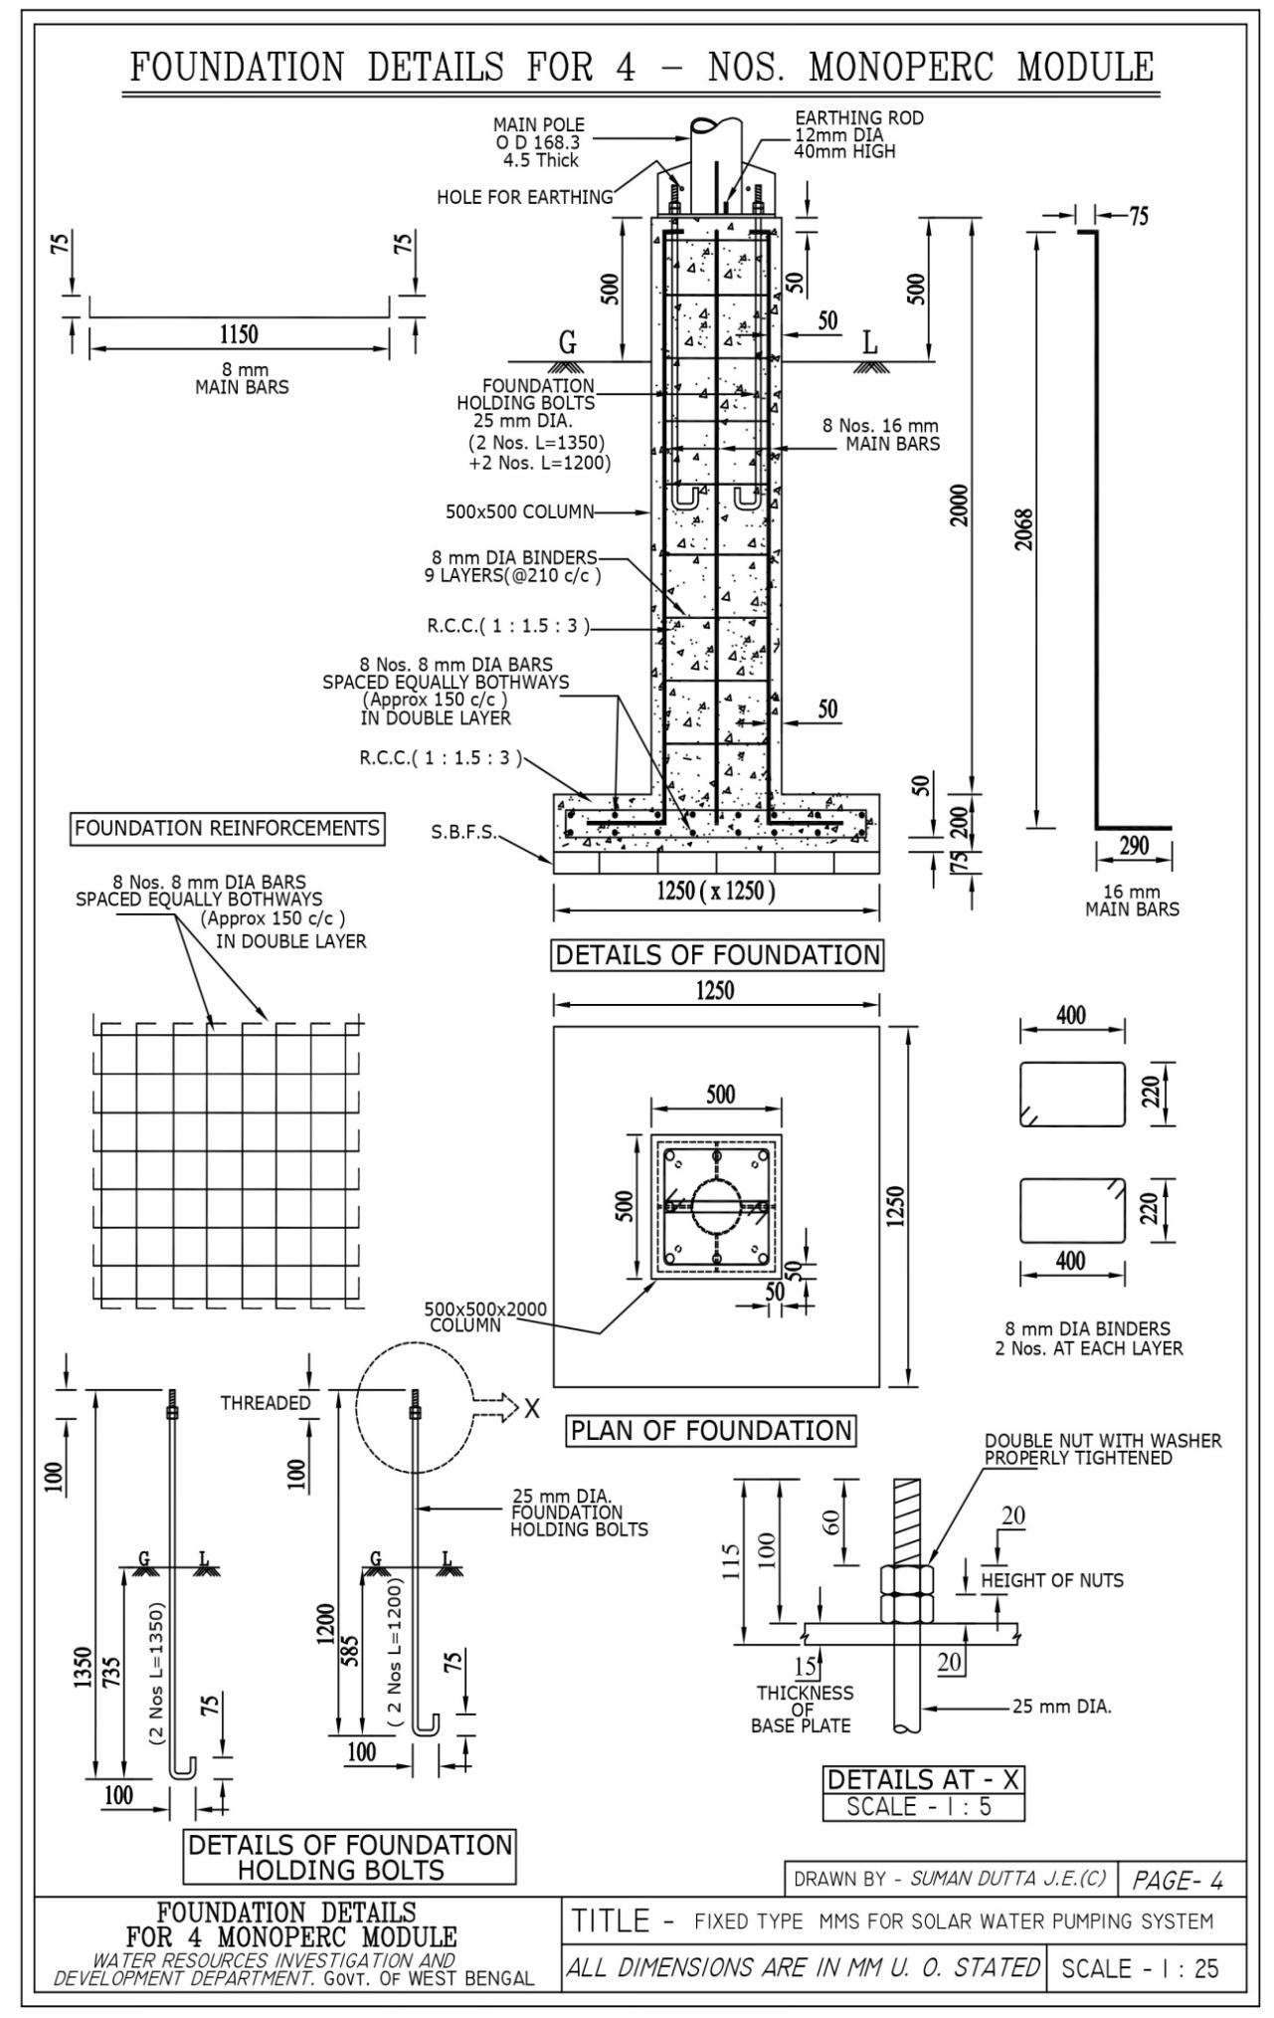

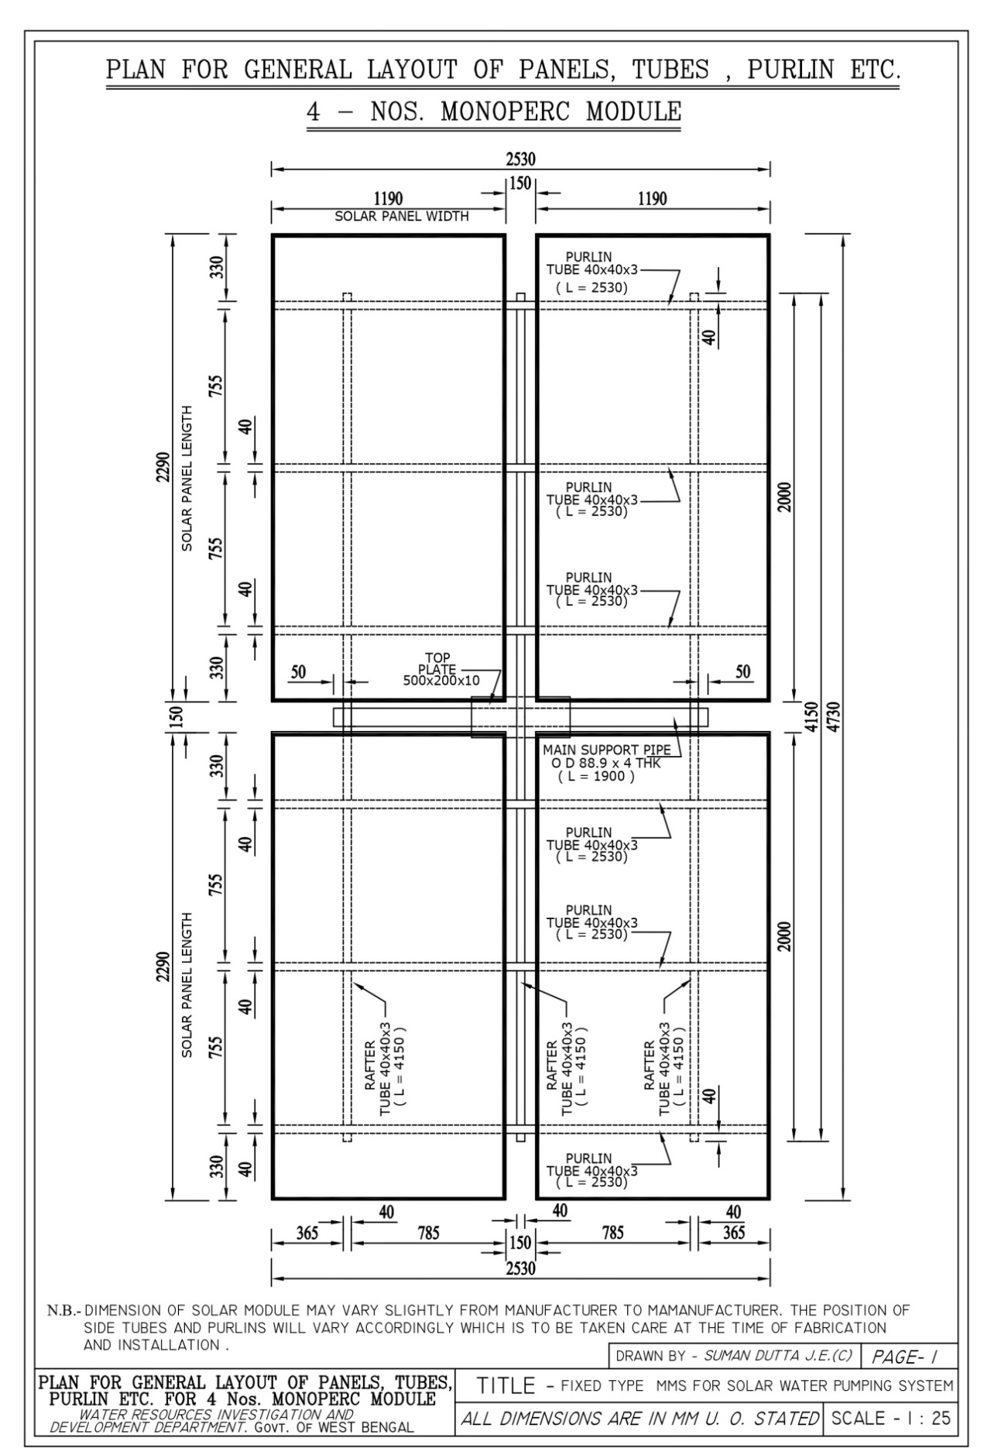

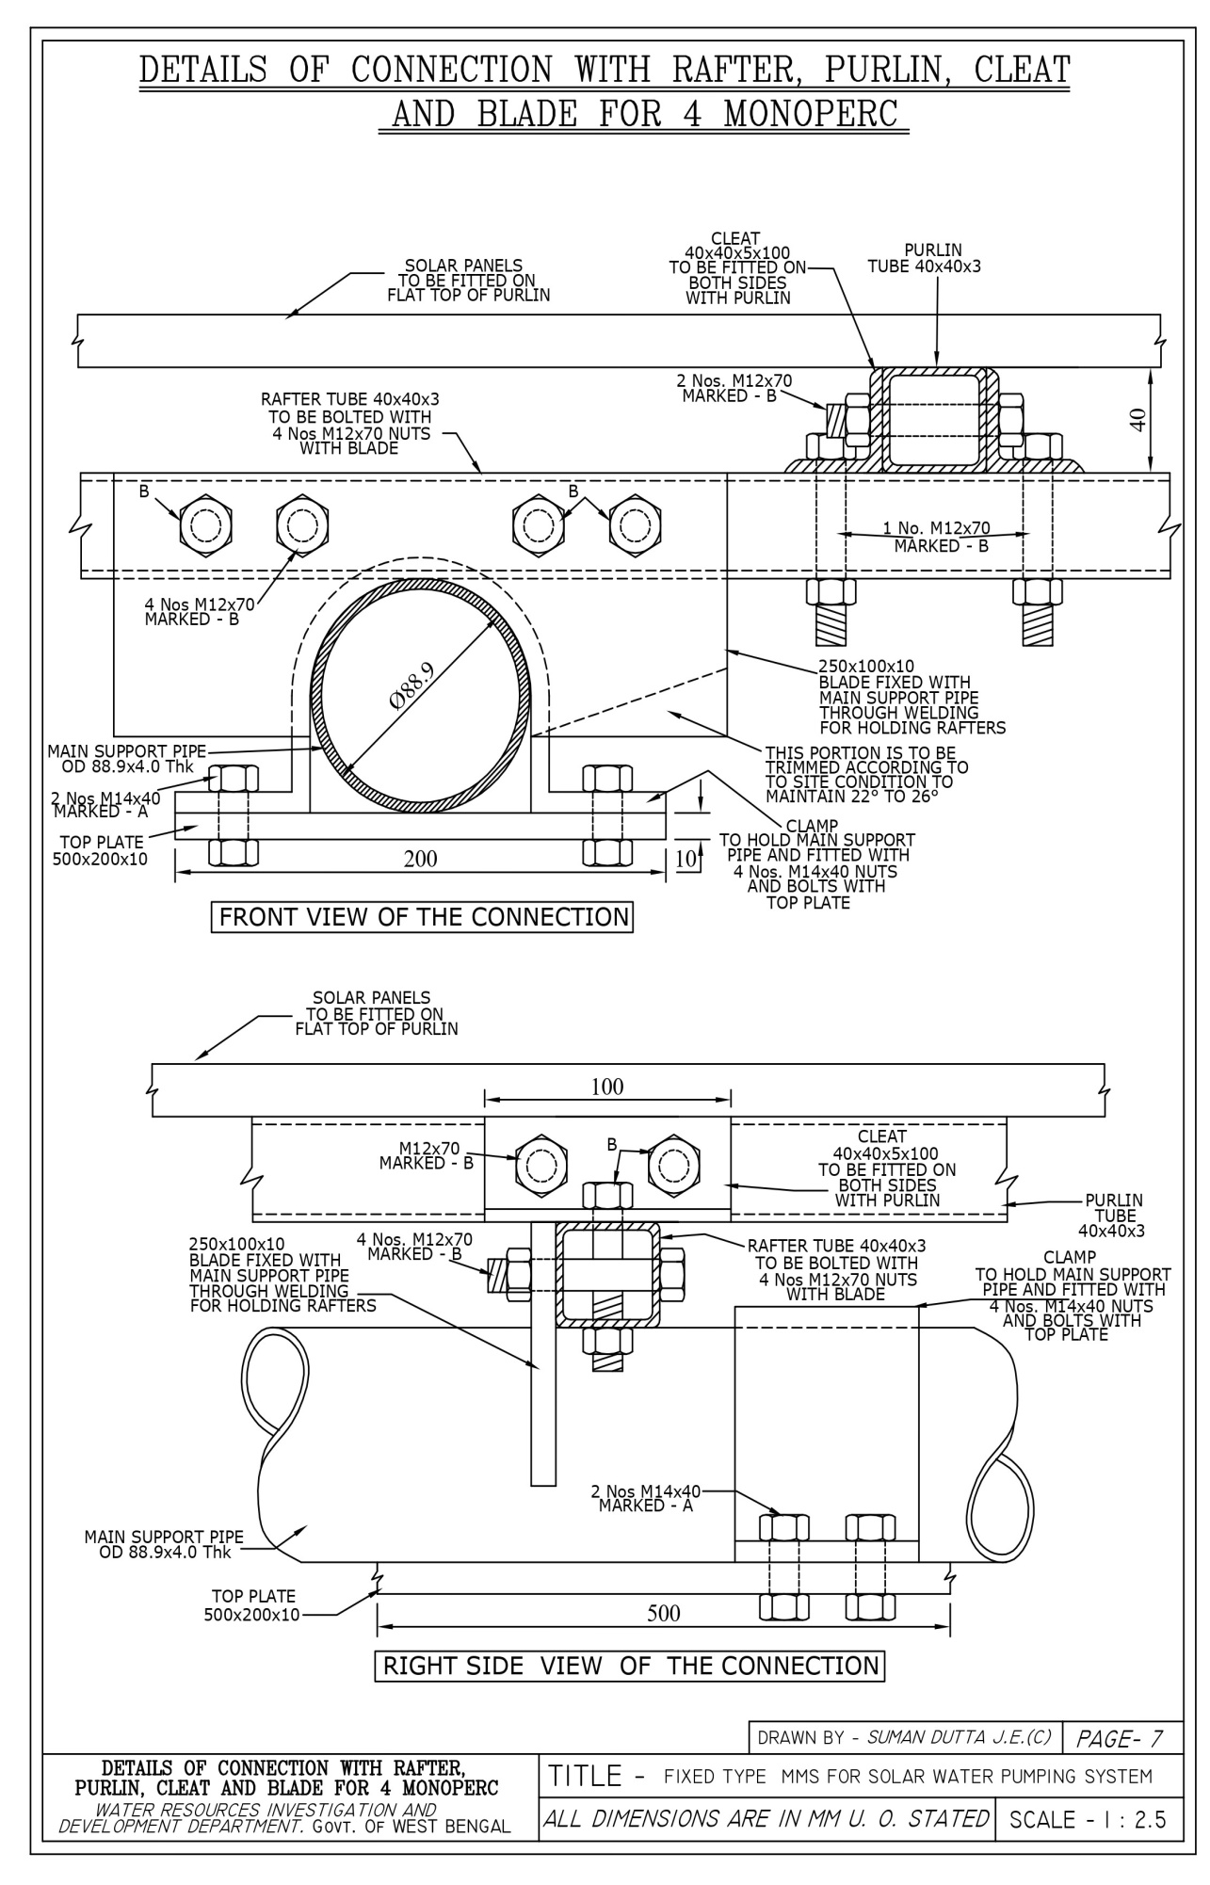

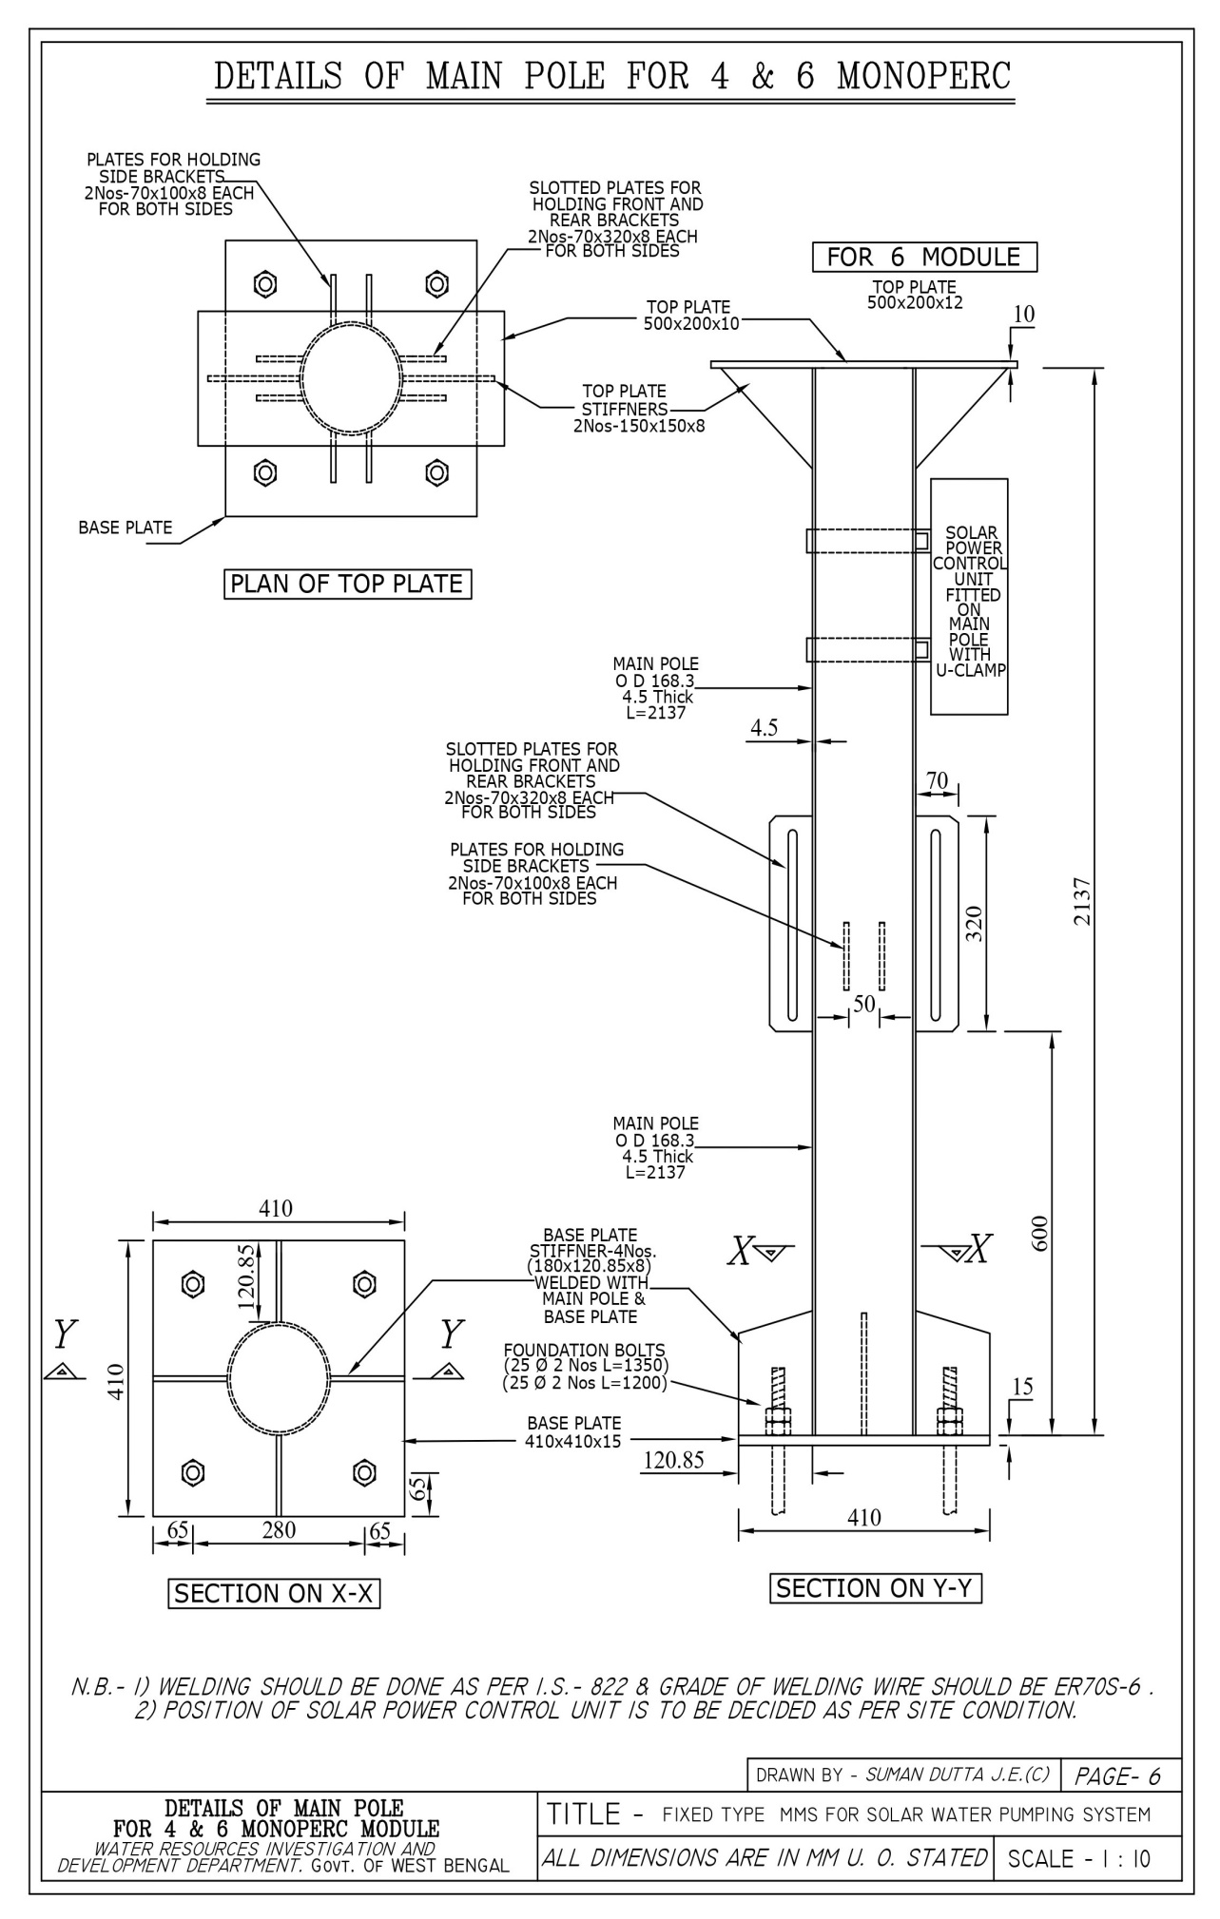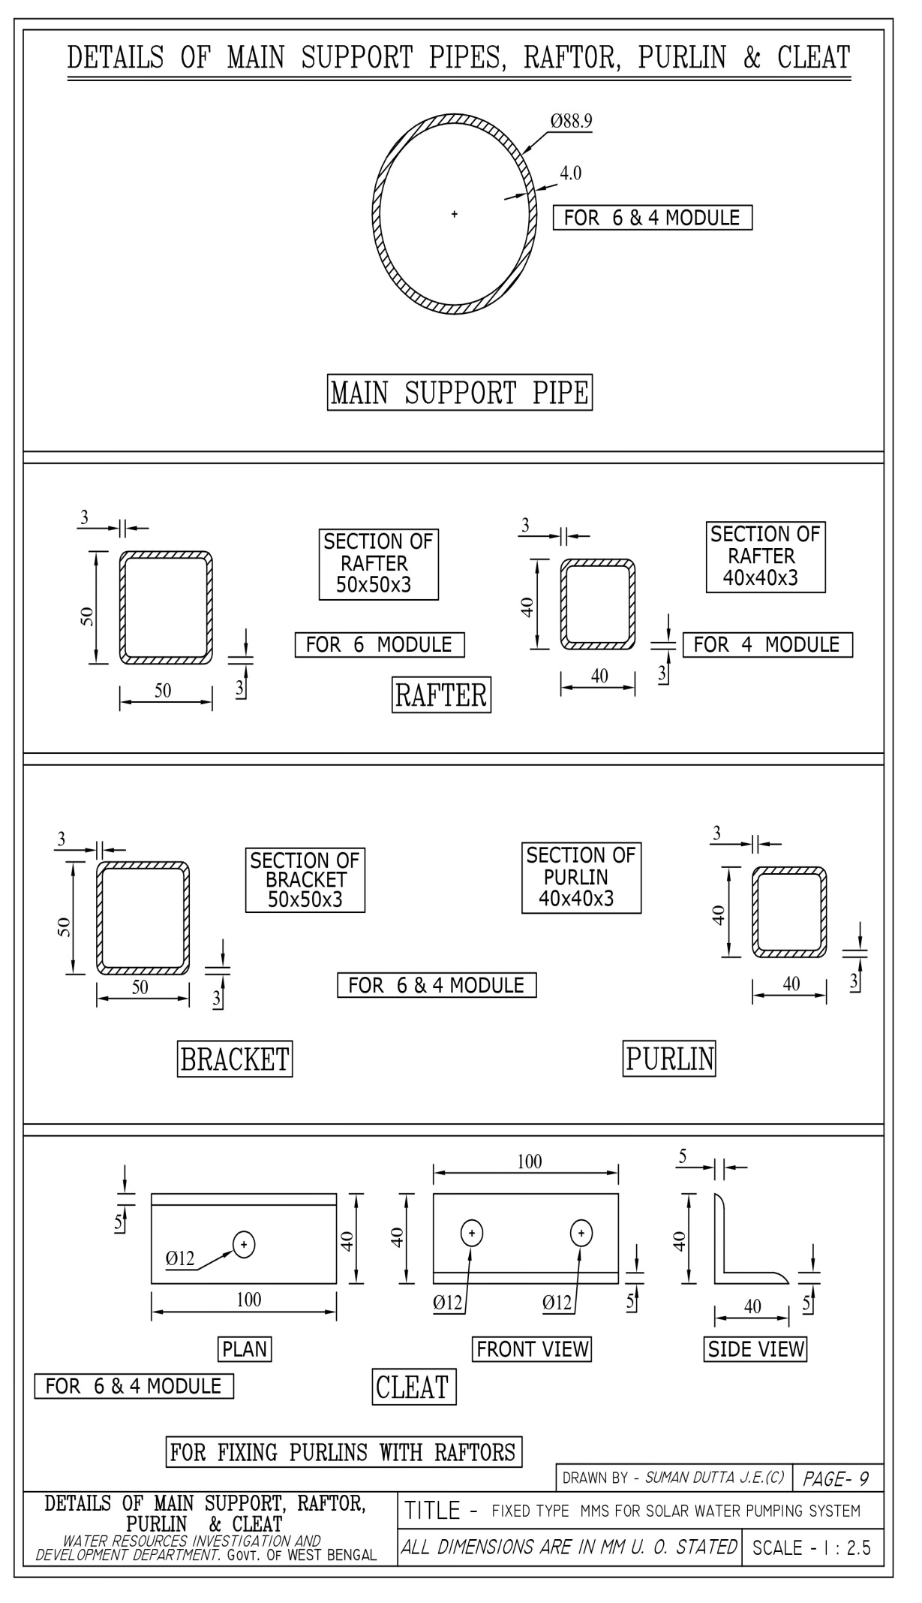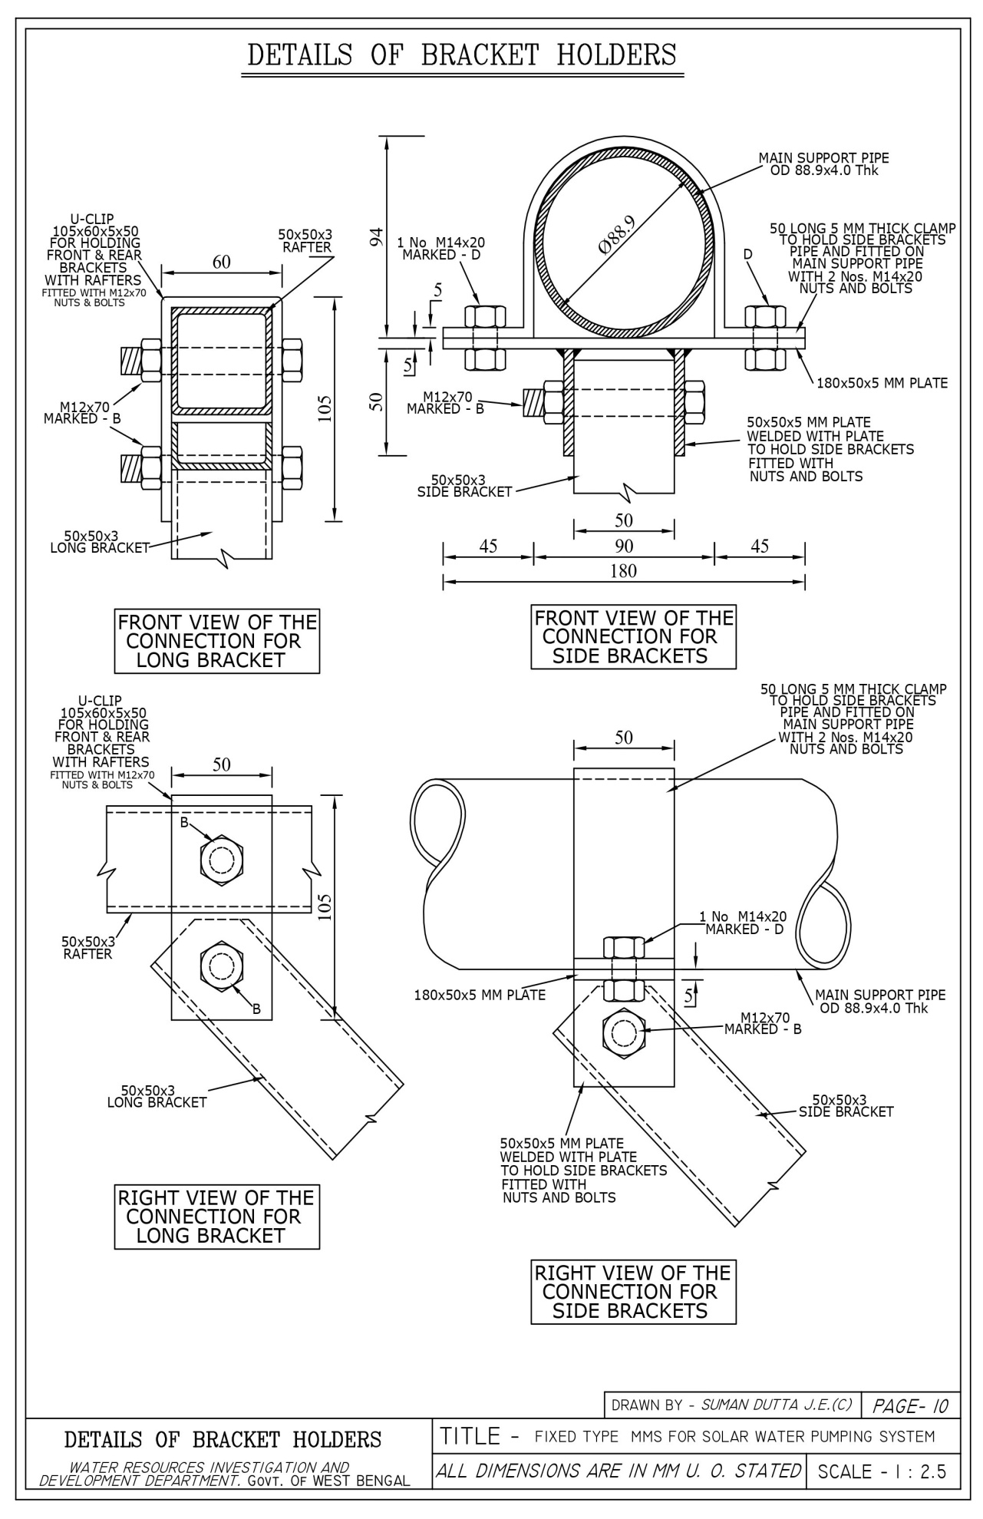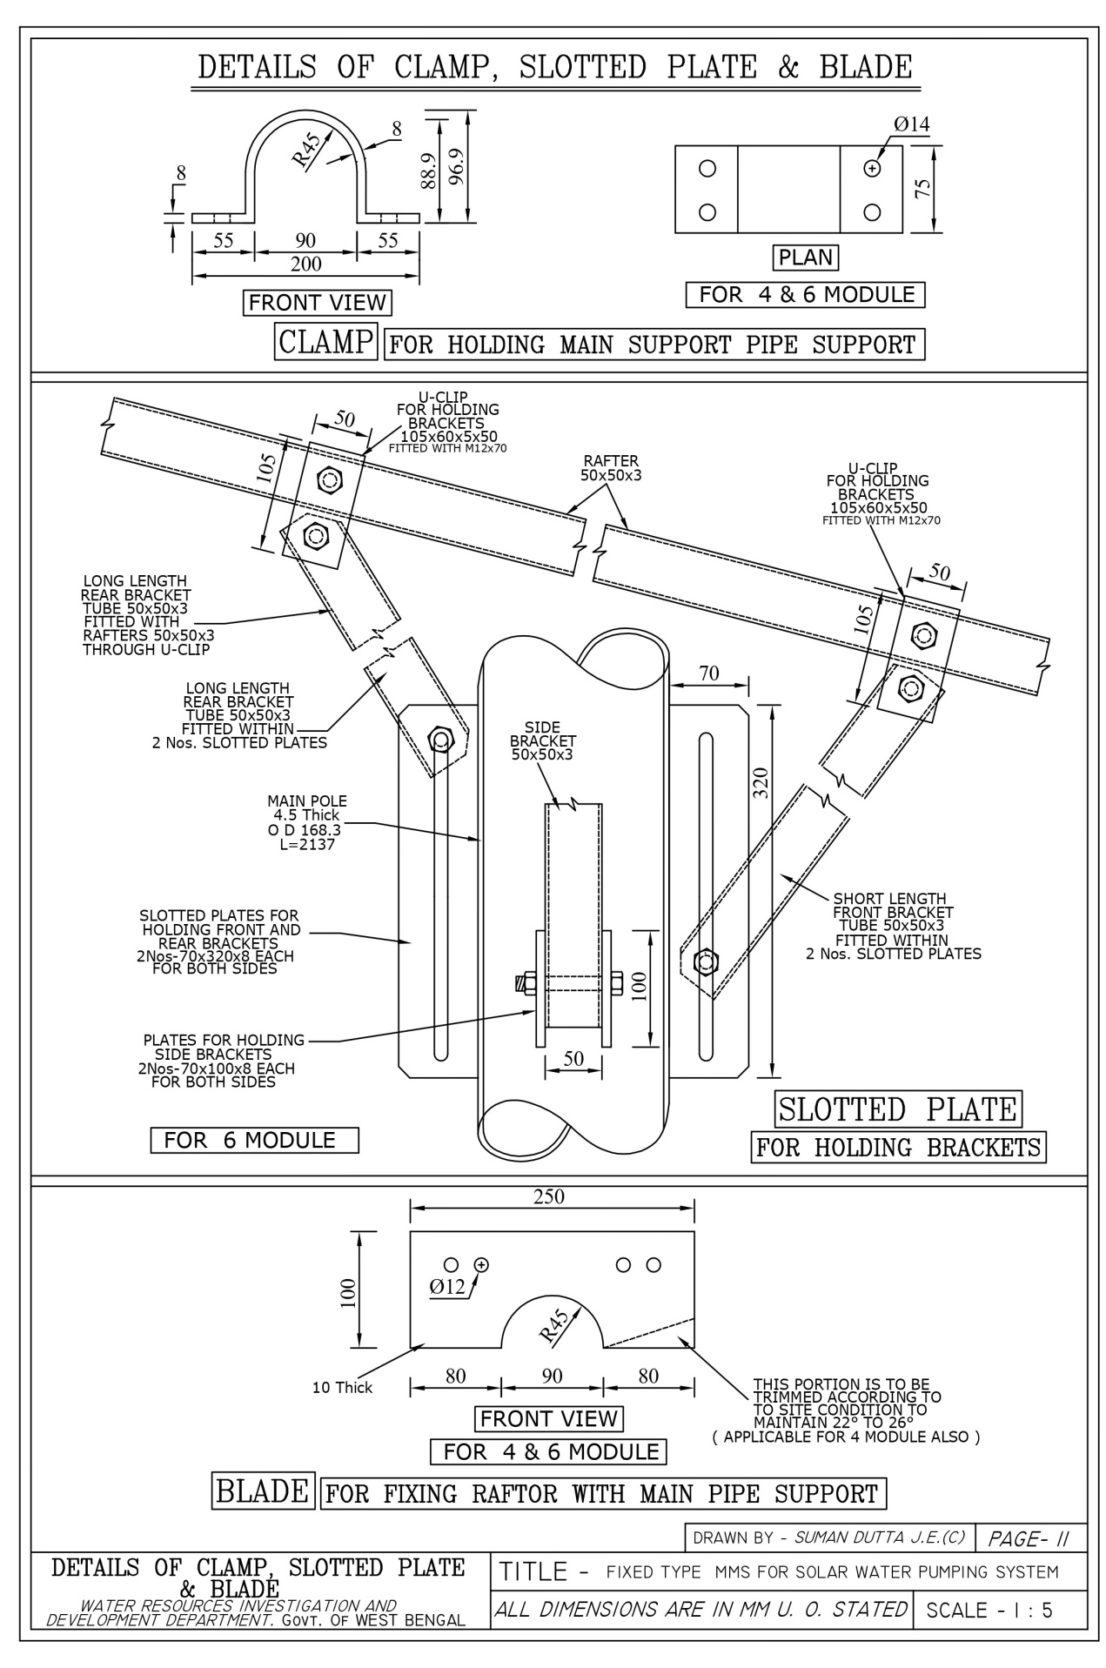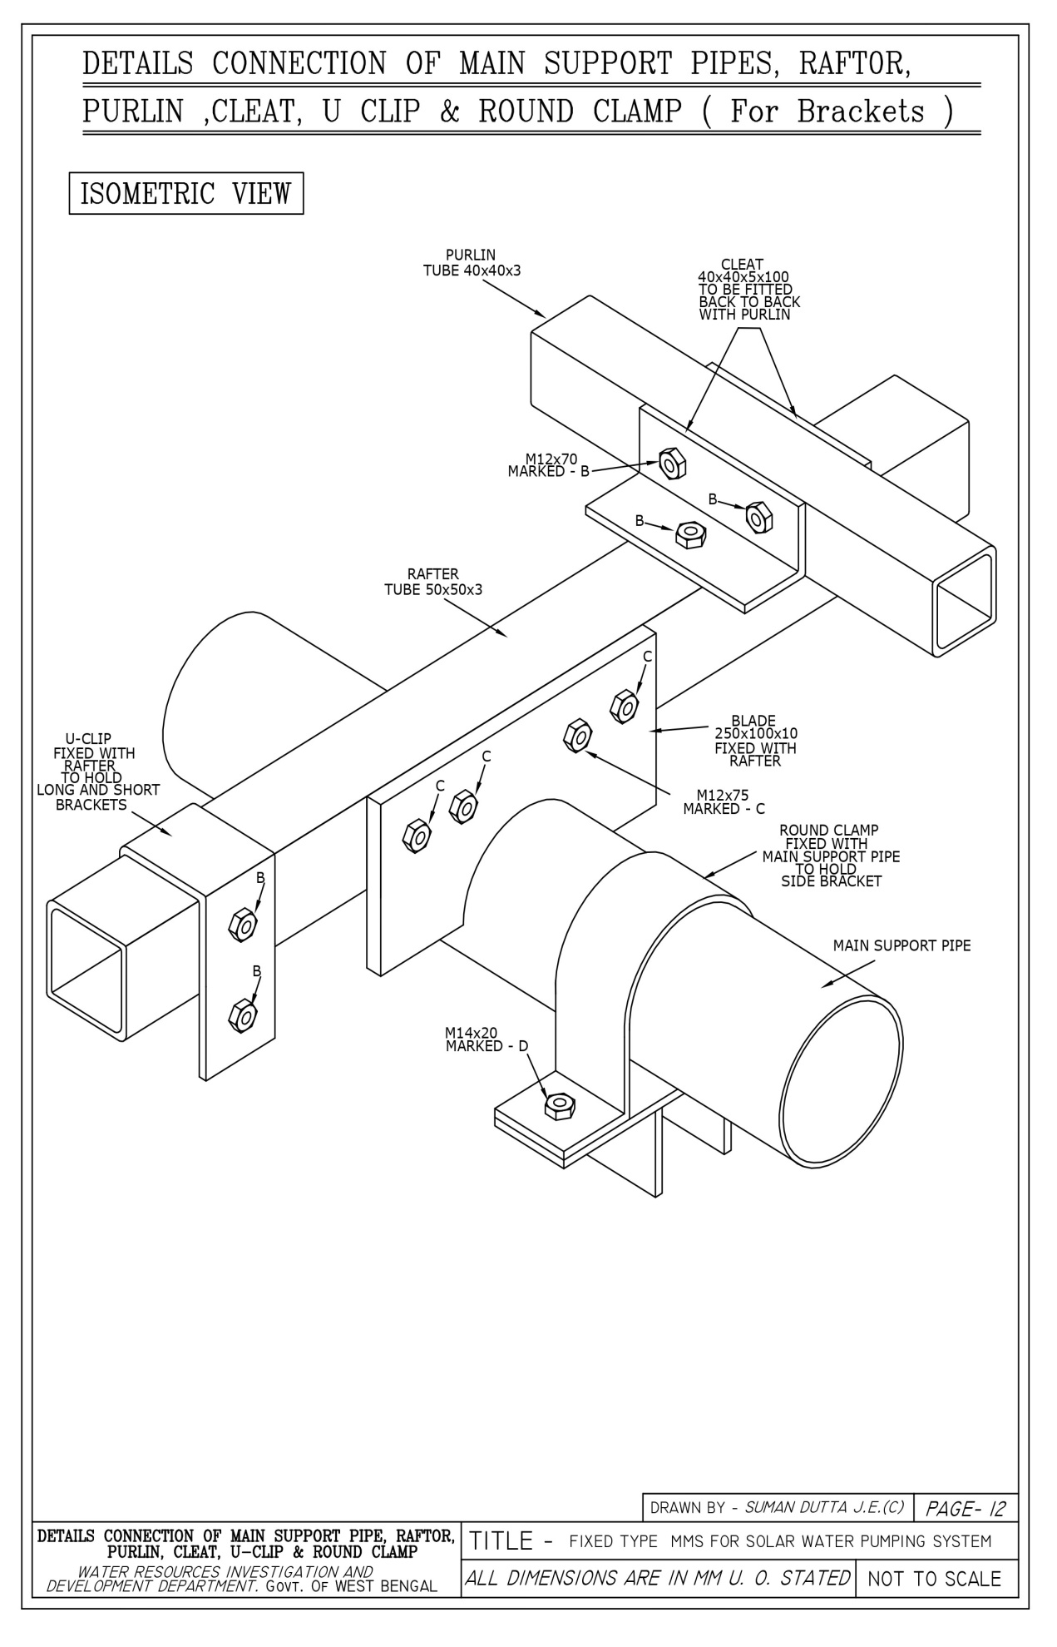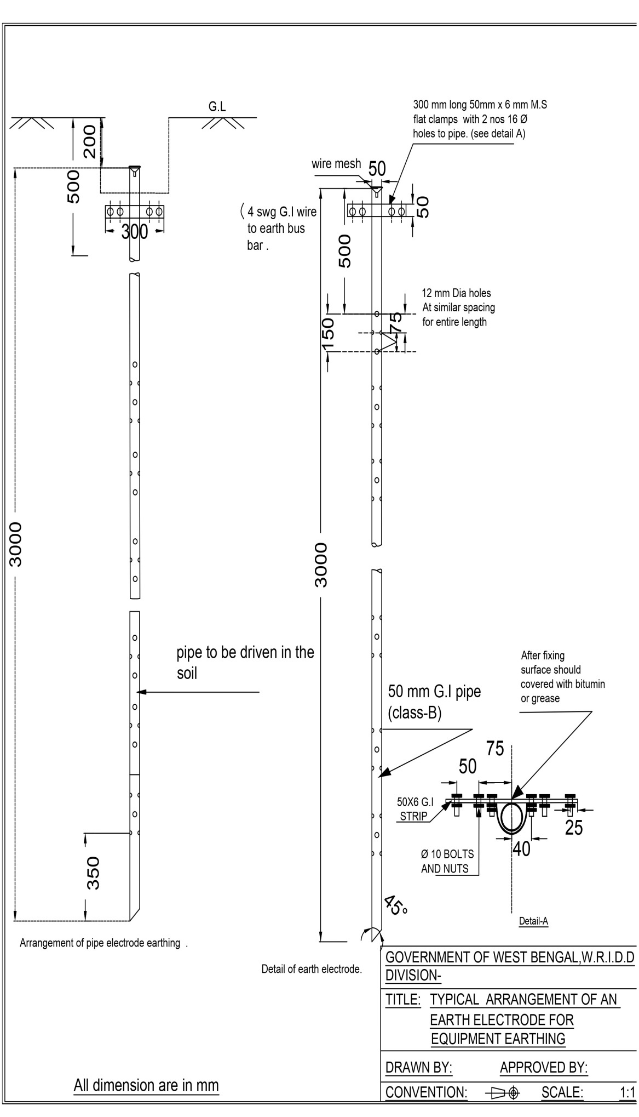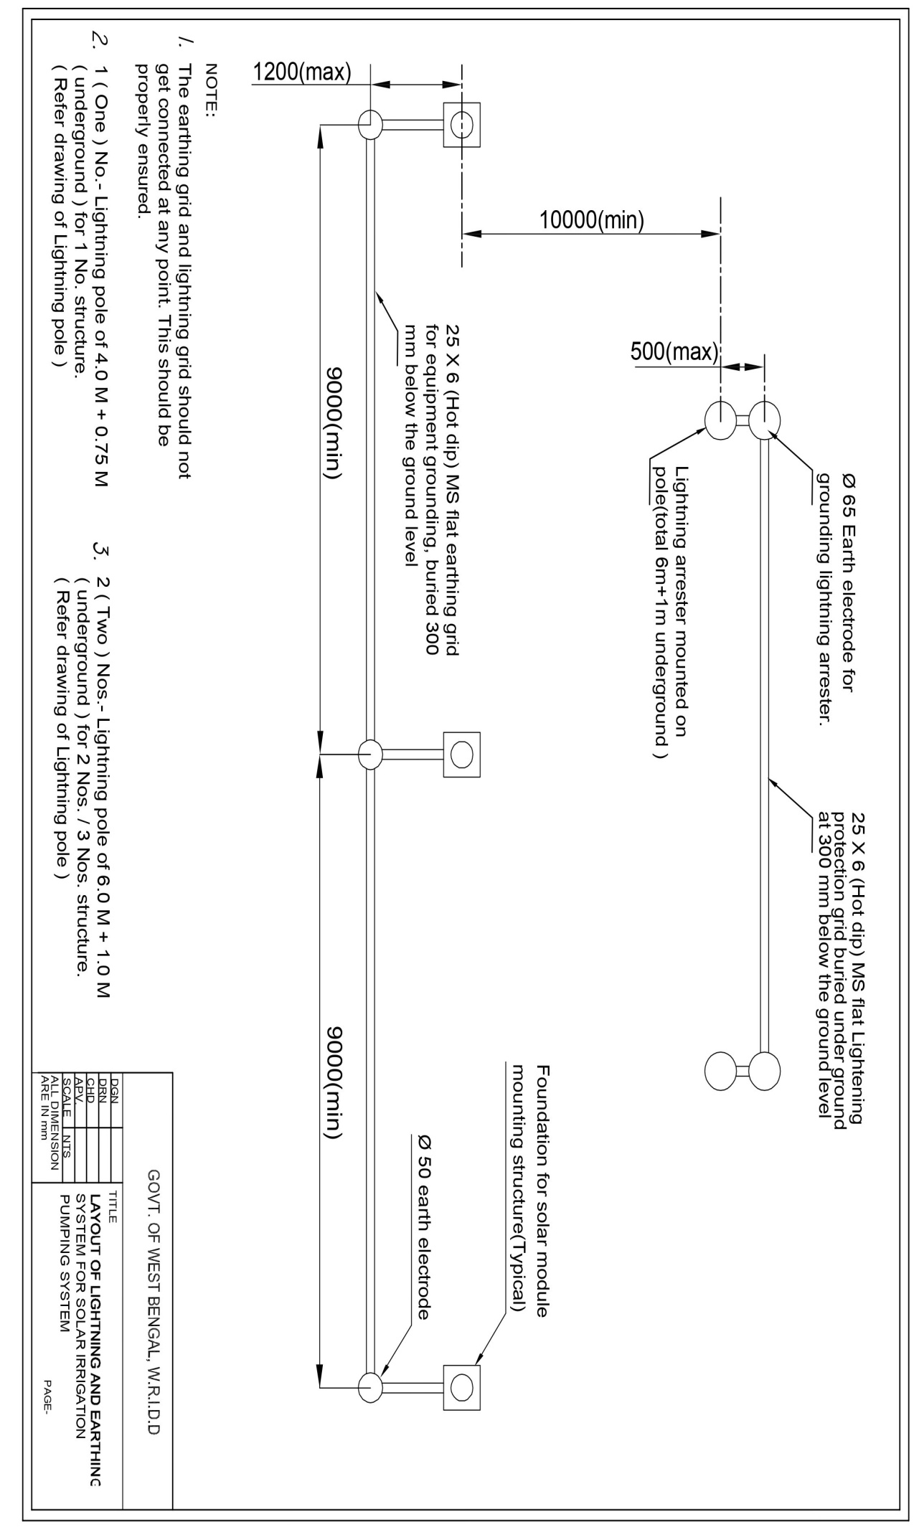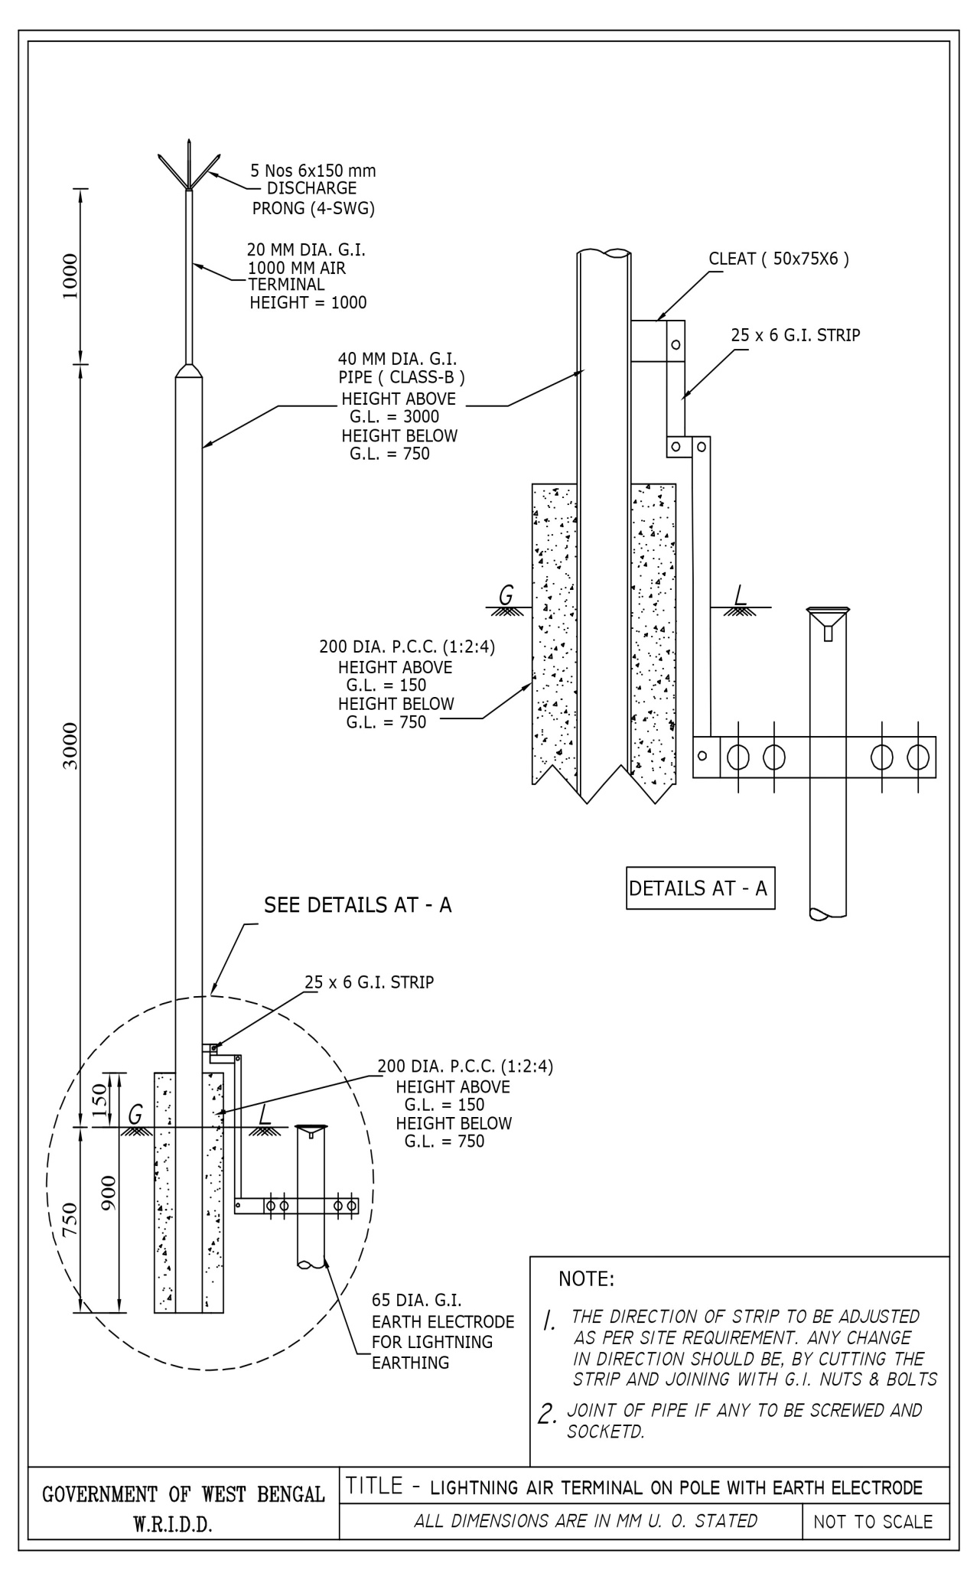

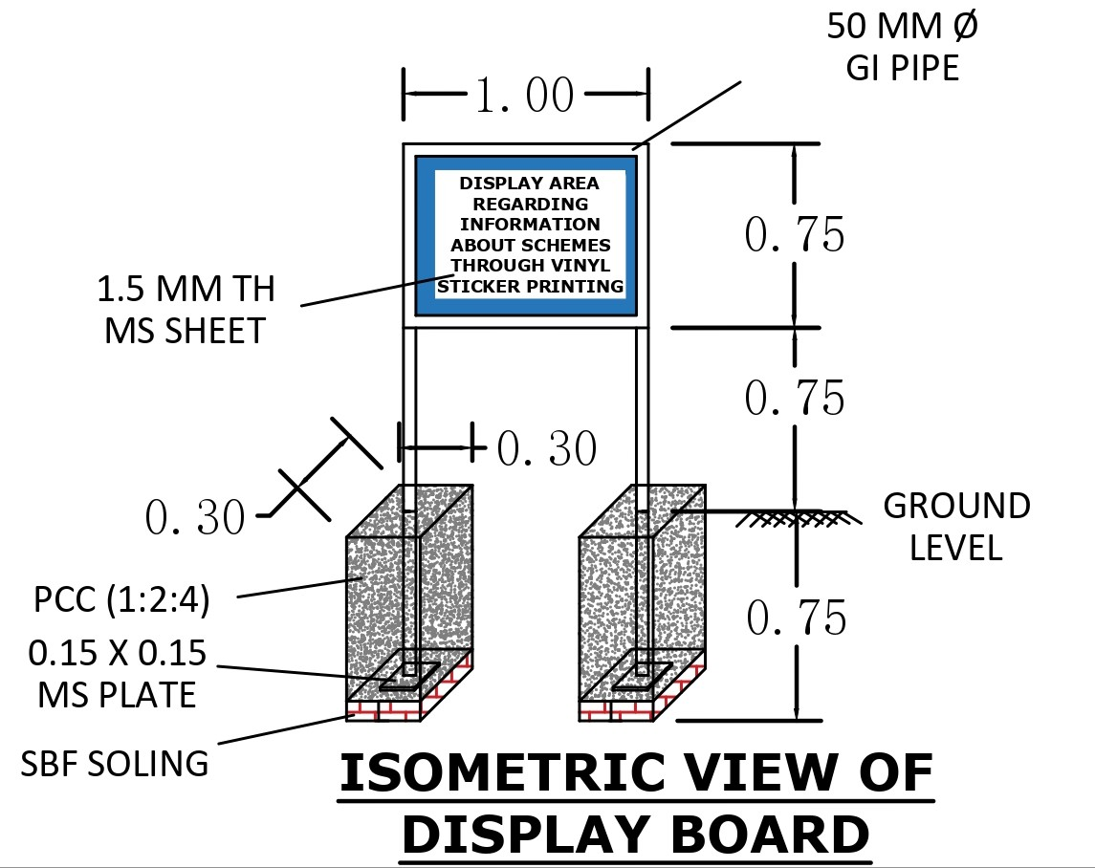

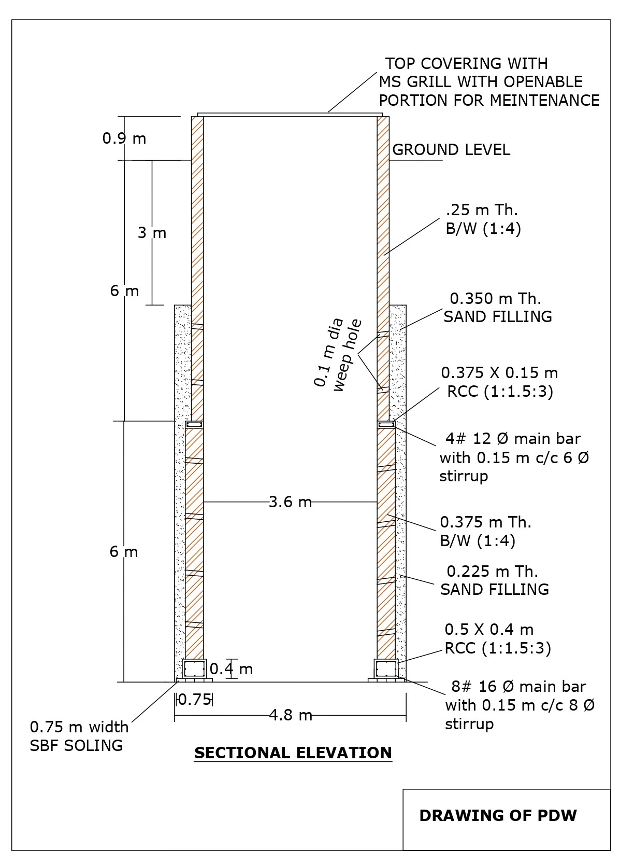

**Form of Bid Security - Bank Guarantee**

*[Guarantor letterhead or SWIFT identifier code]*

Bid Guarantee No…………………….*[insert guarantee reference number]*

Date………………………….*[insert date of issue of the guarantee]*

WHEREAS, _______________________ *[name of Bidder]5*(hereinafter called "the Bidder") has submitted his Bid dated _______________________ *[date]* or will submit his Bid for the construction of _____________________________________ *[name of Contract]* (hereinafter called "the Bid") under Request for Bids No……………………….*[insert number]* (hereinafter called “the RFB”)

5 *Insert name of the Bidder, which in the case of a joint venture shall be (a) the name of the joint venture that submits the bid if the JV has been constituted into a legally enforceable JV, or (b) the names of all future members of the JV as named in the letter of intent to execute the JV Agreement submitted by the bidder alongwith its bid.*

6 *The Guarantor should insert the amount of the guarantee in words and figures denominated in Indian Rupees. This figure should be the same as shown in Clause 5.5 of the Instructions to Bidders.*

KNOW ALL PEOPLE by these presents that We ______________________________ *[name of bank]* of ____________________________ *[name of country]* having our registered office at ___________________________________ (hereinafter called "the Bank") are bound unto ______________________________*[name of Employer]* (hereinafter called "the Employer") in the sum of ___________________6 for which payment well and truly to be made to the said Employer the Bank binds itself, his successors and assigns by these presents.

SEALED with the Common Seal of the said Bank this _________ day of __________ 20____.

THE CONDITIONS of this obligation are:

(1) If after Bid opening the Bidder (a) withdraws his bid during the period of Bid validity specified in the Letters of Bid, or any extension thereto provided by the Bidder; or (b) does not accept the correction of the Bid Price pursuant to ITB 11.1;

or

(2) If the Bidder having been notified of the acceptance of his Bid by the Employer during the period of Bid validity:

(a) fails or refuses to execute the Form of Agreement in accordance with the Instructions to Bidders, if required; or

(b) fails or refuses to furnish the Performance Security, in accordance with the Instruction to Bidders.

we undertake to pay to the Employer up to the above amount upon receipt of his first written demand, without the Employer having to substantiate his demand, provided that in his demand the Employer will note that the amount claimed by him is due to him owing to the occurrence of one or any of the four conditions, specifying the occurred condition or conditions.

This Guarantee will remain in force up to and including the date ____________________7 days after the deadline for submission of Bids as such deadline is stated in the Instructions to Bidders or as it may be extended by the Employer, notice of which extension(s) to the Bank is hereby waived. Any demand in respect of this guarantee should reach the Bank not later than the above date.

DATE _______________ SIGNATURE OF THE BANK _________________________

WITNESS ____________ SEAL _______________________________________

_________________________________________________________________

[signature, name, and address]

***Note: All italicized text (including footnotes) is for use in preparing this form and shall be deleted from the final product.***

**Performance Security - Bank Guarantee**

*[Guarantor letterhead or SWIFT identifier code]*

Performance Guarantee No…………………….*[insert guarantee reference number]*

Date………………………….*[insert date of issue of the guarantee]*

To: ______________________________________________ *[name of Employer]*

_________________________________________ *[address of Employer]*

WHEREAS _________________________ *[name and address of Contractor]* (hereinafter called "the Contractor") has undertaken, in pursuance of Contract No. _____ dated ________________ to execute __________________________ *[name of Contract and brief description of Works]* (hereinafter called "the Contract");

AND WHEREAS it has been stipulated by you in the said Contract that the Contractor shall furnish you with a Bank Guarantee by a recognized bank for the sum specified therein as security for compliance with his obligations in accordance with the Contract;

AND WHEREAS we have agreed to give the Contractor such a Bank Guarantee;

NOW THEREFORE we hereby affirm that we are the Guarantor and responsible to you, on behalf of the Contractor, up to a total of ____________________ *[amount of guarantee**[6]]* ___________________________ *[in words]*, such sum being payable in the types and proportions of currencies in which the Contract Price is payable, and we undertake to pay you, upon your first written demand and without cavil or argument, any sum or sums within the limits of ____________________ *[amount of guarantee]* as aforesaid without your needing to prove or to show grounds or reasons for your demand for the sum specified therein.

We hereby waive the necessity of your demanding the said debt from the Contractor before presenting us with the demand.

We further agree that no change or addition to or other modification of the terms of the Contract or of the Works to be performed thereunder or of any of the Contract documents which may be made between you and the Contractor shall in any way release us from any liability under this guarantee, and we hereby waive notice of any such change, addition or modification.

This guarantee shall be valid until …… (i.e.) 90 days after the date of issue of the Certificate of Completion, and any demand for payment under it must be received by us at this office on or before that date.

Signature and seal of the guarantor _____________________________

Name of Bank ____________________________________________

Address ____________________________________________

Date ____________________________________________

**Advance Payment Security**

**Demand Guarantee**

*[Guarantor letterhead or SWIFT identifier code]*

**DELETED**

**Retention Money Security**

**Demand Guarantee**

*[Guarantor letterhead or SWIFT identifier code]*

_____________________________ *[Bank’s name and address of issuing branch or office]*

**Beneficiary: ______________________** *[Name and Address of Employer]*

***Date: ____________________________***

**RETENTION MONEY GUARANTEE NO.: _________________**

We have been informed that ______________*[name of contractor]*(hereinafter called “the Contractor”) has entered into Contract No. _________________ *[reference number of the contract]* dated ______________________ with you, for the execution of __________________ *[name of contract and brief description of Works]* (hereinafter called “the Contract”).

Furthermore, we understand that, according to the conditions of the Contract, when the Taking-Over Certificate has been issued for the Works and the first half of the Retention Money has been certified for payment, payment of ___________ *[insert* the second half of the Retention Money*]* is to be made against a Retention Money guarantee.

At the request of the contractor, we _________________ *[name of Bank]* hereby irrevocably undertake to pay you the sum or sums not exceeding in total an amount of _____________________ *[amount in Rupees]* (______________________) *[amount in words[7]]* upon receipt by us of your first demand in writing accompanied by a written statement stating that the Contractor is in breach of its obligation under the Contract without cavil or argument.

It is a condition for any claim and payment under this guarantee to be made that the payment of the second half of the Retention Money referred to above must have been received by the Contractor on its account number _________ at ___________ *[name and address of Bank].*

This guarantee shall expire, at the latest, 21 days after the date when the Employer has received a copy of the Defects Liability Certificate issued by the Engineer. Consequently, any demand for payment under this guarantee must be received by us at this office on or before that date.

*_____________________*

*[Signature(s) and seal of the guarantor]*

***Note: All italicized text (including footnotes) is for use in preparing this form and shall be deleted from the final product.***

SAMPLE FORMAT FOR EVIDENCE OF ACCESS TO OR AVAILABILITY OF CREDIT

BANK SOLVENCY CERTIFICATE

*This is to certify that M/s. …………………………… is a reputed company with a good financial standing.*

*If the contract for the work, namely …………………………………………………………. [funded by the World Bank] is awarded to the above firm, we shall be able to provide overdraft/credit facilities to the extent of Rs. …………… to meet their working capital requirements for executing the above contract.*

**__ Sd. __**

**Name of Bank**

**Senior Bank Manager**

**Address of the Bank**

Section C. Fraud and Corruption

*(Text in this Section shall not be modified)*

1. **Purpose**
   1. The Bank’s Anti-Corruption Guidelines and this annex apply with respect to procurement under Bank Investment Project Financing operations.
2. **Requirements**
3. The Bank requires that Borrowers (including beneficiaries of Bank financing); bidders(applicants/proposers), consultants, contractors and suppliers; any sub-contractors, sub-consultants, service providers or suppliers; any agents (whether declared or not); and any of their personnel, observe the highest standard of ethics during the procurement process, selection and contract execution of Bank-financed contracts, and refrain from Fraud and Corruption.
4. To this end, the Bank:
5. Defines, for the purposes of this provision, the terms set forth below as follows:
6. “corrupt practice” is the offering, giving, receiving, or soliciting, directly or indirectly, of anything of value to influence improperly the actions of another party;
7. “fraudulent practice” is any act or omission, including misrepresentation, that knowingly or recklessly misleads, or attempts to mislead, a party to obtain financial or other benefit or to avoid an obligation;
8. “collusive practice” is an arrangement between two or more parties designed to achieve an improper purpose, including to influence improperly the actions of another party;
9. “coercive practice” is impairing or harming, or threatening to impair or harm, directly or indirectly, any party or the property of the party to influence improperly the actions of a party;
10. “obstructive practice” is:
11. deliberately destroying, falsifying, altering, or concealing of evidence material to the investigation or making false statements to investigators in order to materially impede a Bank investigation into allegations of a corrupt, fraudulent, coercive, or collusive practice; and/or threatening, harassing, or intimidating any party to prevent it from disclosing its knowledge of matters relevant to the investigation or from pursuing the investigation; or
12. acts intended to materially impede the exercise of the Bank’s inspection and audit rights provided for under paragraph 2.2 e. below.
13. Rejects a proposal for award if the Bank determines that the firm or individual recommended for award, any of its personnel, or its agents, or its sub-consultants, sub-contractors, service providers, suppliers and/ or their employees, has, directly or indirectly, engaged in corrupt, fraudulent, collusive, coercive, or obstructive practices in competing for the contract in question;
14. In addition to the legal remedies set out in the relevant Legal Agreement, may take other appropriate actions, including declaring misprocurement, if the Bank determines at any time that representatives of the Borrower or of a recipient of any part of the proceeds of the loan engaged in corrupt, fraudulent, collusive, coercive, or obstructive practices during the procurement process, selection and/or execution of the contract in question, without the Borrower having taken timely and appropriate action satisfactory to the Bank to address such practices when they occur, including by failing to inform the Bank in a timely manner at the time they knew of the practices;
15. Pursuant to the Bank’s Anti- Corruption Guidelines and in accordance with the Bank’s prevailing sanctions policies and procedures, may sanction a firm or individual, either indefinitely or for a stated period of time, including by publicly declaring such firm or individual ineligible (i) to be awarded or otherwise benefit from a Bank-financed contract, financially or in any other manner;[8] (ii) to be a nominated[9] sub-contractor, consultant, manufacturer or supplier, or service provider of an otherwise eligible firm being awarded a Bank-financed contract; and (iii) to receive the proceeds of any loan made by the Bank or otherwise to participate further in the preparation or implementation of any Bank-financed project;
16. Requires that a clause be included in bidding/request for proposals documents and in contracts financed by a Bank loan, requiring (i) bidders(applicants/proposers), consultants, contractors, and suppliers, and their sub-contractors, sub-consultants, service providers, suppliers, agents personnel, permit the Bank to inspect[10] all accounts, records and other documents relating to the procurement process, selection and/ or contract execution, and to have them audited by auditors appointed by the Bank.

**EMP CLAUSE**

1. The Contractor setting up camp for the accommodation of workers shall follow the IFC/EBRD guidance on Worker Accommodation([Workers’ accommodation: processes and standards (ifc.org)](https://www.ifc.org/wps/wcm/connect/60593977-91c6-4140-84d3-737d0e203475/workers_accomodation.pdf?MOD=AJPERES&CACHEID=ROOTWORKSPACE-60593977-91c6-4140-84d3-737d0e203475-jqetNIh)). For guidance on site selection of camps, planning of living conditions etc. please refer to the Guidance in Section 6.1.13Labor Influx and Construction Workers’ Camp Management Plan of the ESMF. (ESMF is available in [www.wbadmip.org](http://www.wbadmip.org) )
2. The Contractor shall ensure that :
   1. The contractor shall make adequate provisions for drinking water supply (conforming to IS 10500:2012 ).
   2. The contractor shall ensure that the campsite/s is/are equipped with sanitary facilities approved by the Government of India ( Swacchh Bharat Mission Phase (Grameen) II, Operational Guidelines, 2020; [SBM(G) ODF Plus Phase-II MIS App (swachhbharatmission.gov.in)](https://swachhbharatmission.gov.in/SBMCMS/writereaddata/portal/images/pdf/sbm-ph-II-Guidelines.pdf). The toilets, soak pit sanitary facilities should not be located nearwithin 15 m of drinking water sources either within or outside the camp.
   3. Firewood shall not be used for cooking purposes.
   4. First Aid Facilities must be always provided in Contractor Camp and worksites.
   5. Adequate Fire safety electrical safety measures shall be provided at both locations .
   6. All Fuel and Chemical shall be stored on the impervious ground, and measures are taken to prevent contamination of soil and groundwater
   7. For guidance on Living Conditions, Drinking-Water, Cooking Arrangement, Washing and bathing facilities, Toilets Facilities, Wastewater Handling, First Aid, `Fire Fighting, Fuel and Chemical Storage, Vehicle Maintenance and Repairs, and Transportation of Project workers etc, please consider the guidance provided in Section 6.1.13: Labor Influx and Construction Workers’ Camp Management Plan of the ESMF.
3. The Contractor is responsible for making safe working conditions and a safe work environment for all labors. All labour must be provided with the required PPE, and its compliance is ensured. He shall also ensure the safety of the local public during the working
4. All material required for construction activities, e.g. sand and aggregate, should be procured from quarries with valid environmental clearance and comply with other statutory requirements, e.g. payment of royalty. The Contractor shall submit to the DPMU the necessary documentation as directed by the DPMU.
5. The contractor shall adhere to good construction practices with respect to general safety, worksite safety, traffic safety, and electrical safety. Detailed guidance on these is provided in 6.1.10Environment Management Plan: Good Construction Practices and 6.1.11 Topsoil and Spoils Management Plan of the ESMF.
6. The Contractor should restore any site used for temporary purposes, e.g. vehicle parking and maintenance, material storage, labour accommodation etc. and repair all damages before decommissioning.
7. The contractor shall prepare a Labour Management Plan and Contractor Environment Management Plan for the sub-project along with the Method Statement in consultation with and also approved by concerned Executive Engineer.
8. The Executive Engineer shall, after appropriate notice, ensure that in case of failure by the Contractor to comply with the requirement of the EMP, execute the work at the Contractor’s own cost.

Special Terms and Condition

Bidders are requested to engage unskilled labourers under “Karmashree” Scheme of Govt. of WB, having Job Card under Mahatma Gandhi NREGS/as per guideline given in the following Kolkata Gazette Notification during execution of the subject mentioned work. The detailed report of the engagement of labourer has to be submitted to the undersigned as per the given format in the Gazette Notification & to be duly signed by the bidder following necessary guidelines vide The Kolkata Gazette Notification 07/03/24, Registered No. WB/SC-247, Notification No. 1140 PRD-33011/1/2024-MGNREGA SEC Dtd. 07-03-2024of Secretary to the Govt. of WB, Panchayats & Rural Development Department by the order of the Governor of Govt. of WB. Annexure Form No-VI Sample Copy enclosed.

|  |  |  |  |
| --- | --- | --- | --- |
| Financial Year |  | District |  |
| Work Code (system-generated) |  | Work Sector |  |
| Work Name |  | | |
| Work site Location |  | | |
| Block/Municipality |  | GP(for Block) |  |
| Funding Dept. (to be filled by  the Office) |  | Implementing Dept. |  |
| Implementing Agency (Office)  Of the Dept. |  | | |
| Work Order No. |  | | |
| Contractor/ Agency Name |  | Contact No. of  Contractor/Agency |  |

# KARMASHREE:EMPLOYMENTSHEET

(to be used by the implementing agency for recording the employment provided)

**WORK DETAILS. Form –VI (Pg 1)**

|  |  |  |  |  |  |  |  |  |  |
| --- | --- | --- | --- | --- | --- | --- | --- | --- | --- |
| **Sl.**  **No.** | **Name of**  **Worker** | **Job Card**  **No.**  **(full)** | **Gender ( (M/F)** | **Age** | **Caste(SC**  **/ST/OBC**  **/Gen)** | **Whether**  **Minority**  **(Y/N)** | **Whether Migrant**  **Worker**  **(Y/N)** | **Mobile No.** | **Aadhaar No.**  **(not**  **mandatory)** |
| **[1]** | **[2]** | **[3]** | **[4]** | **[5]** | **[6]** | **[7]** | **[8]** | **[9]** | **[10]** |
| 1 |  |  |  |  |  |  |  |  |  |
| 2 |  |  |  |  |  |  |  |  |  |
| 3 |  |  |  |  |  |  |  |  |  |
| … |  |  |  |  |  |  |  |  |  |
| … |  |  |  |  |  |  |  |  |  |
| 10  etc. |  |  |  |  |  |  |  |  |  |

## WORKER DETAILS

**Counter signature of Engineer**

**with Office Seal Name & Signature of**

**Contractor/ Agency**

# KARMASHREE:EMPLOYMENTSHEET

(to be used by the implementing agency for recording the employment provided)

# FORM-VI

**(Page 2)**

**EMPLOYMENT DETAILS;**

|  |  |  |  |  |  |  |  |  |  |  |
| --- | --- | --- | --- | --- | --- | --- | --- | --- | --- | --- |
| **Sl.**  **No.** | **Name**  **of Worker** | **Date of**  **application**  **For work\*** | **No of**  **Days**  **work**  **demanded\*\*** | **Work**  **allocated**  **from**  **(date)** | **Work**  **allocated**  **upto**  **(date)** | **Work**  **provided**  **from**  **(date)** | **Work provided**  **Upto**  **(date)** | **No. of**  **Days**  **work**  **provided** | **Total**  **Wage**  **Paid**  **(Rs.)** | **Date**  **of**  **payment** |
| **[1]** | **[2]** | **[11]** | **[12]** | **[13]** | **[14]** | **[15]** | **[16]** | **[17]** | **[18]** | **[19]** |
| 1 |  |  |  |  |  |  |  |  |  |  |
| 2 |  |  |  |  |  |  |  |  |  |  |
| 3 |  |  |  |  |  |  |  |  |  |  |
| … |  |  |  |  |  |  |  |  |  |  |
| … |  |  |  |  |  |  |  |  |  |  |
| 10  etc. |  |  |  |  |  |  |  |  |  |  |

**Counter signature of Engineer with Office Sea Name & Signature of Contractor/ Agency**

*Date of application for work:-As per application of workers/First day of reporting for work, if not

Previously applied for work

**No .ofdays work demanded=No. of days work allotted (if not previously applied for )

1. This document is drafted for construction of small works paid on lump sum basis; modify it suitably if works are to be paid on item rate basis.
2. If considered necessary, the Employer may attach minimum requirements for ESHS Management Strategies and Implementation Plans and ESHS Code of Conduct.A sample guidance note is attached at the end of the document.
3. If debarred/removed, please provide further details.
4. If debarred/removed, please provide further details.
5. In case of a firm insert ‘complete address of the firm’. In case of an individual contractor insert identification like ‘son of and resident of’ etc.
6. *An amount shall be inserted by the Guarantor, representing the percentage of the Contract Price specified in the Contract and denominated in Indian Rupees.*
7. *The Guarantor shall insert an amount representing the amount of the second half of the Retention Money.*
8. For the avoidance of doubt, a sanctioned party’s ineligibility to be awarded a contract shall include, without limitation, (i) applying for pre-qualification, expressing interest in a consultancy, and bidding, either directly or as a nominated sub-contractor, nominated consultant, nominated manufacturer or supplier, or nominated service provider, in respect of such contract, and (ii) entering into an addendum or amendment introducing a material modification to any existing contract.
9. A nominated sub-contractor, nominated consultant, nominated manufacturer or supplier, or nominated service provider (different names are used depending on the particular bidding document) is one which has been: (i) included by the bidder in its pre-qualification application or bid because it brings specific and critical experience and know-how that allow the bidder to meet the qualification requirements for the particular bid; or (ii) appointed by the Borrower.
10. Inspections in this context usually are investigative (i.e., forensic) in nature. They involve fact-finding activities undertaken by the Bank or persons appointed by the Bank to address specific matters related to investigations/audits, such as evaluating the veracity of an allegation of possible Fraud and Corruption, through the appropriate mechanisms. Such activity includes but is not limited to: accessing and examining a firm's or individual's financial records and information, and making copies thereof as relevant; accessing and examining any other documents, data and information (whether in hard copy or electronic format) deemed relevant for the investigation/audit, and making copies thereof as relevant; interviewing staff and other relevant individuals; performing physical inspections and site visits; and obtaining third party verification of information.