Mission Report of K.A.S.Mani
Visit to WBADMI Project from 1 to 5 March 2015

PURPOSE OF VISIT:
- Discuss with Project Director, Director SWID, Engineers, SPMU on the inputs required
- Carry out visit to representative tube well construction sites implemented under Batch II and Batch I
- Discuss and assess the QC QA protocols that need to be established
- Discuss potential areas for establishment of Automatic Weather Stations (AWS) and multiple monitoring wells.
- Assess opportunities of initiating Participatory Water resources monitoring by WUA in Jalpaiguri as pilot
- Assess the status of various procurements
- Finalise methodology for implementation of Century logger imported from USA and water quality field kits under procurement
2-3 March: K.A.S.Mani, Sri. Akilesh Pareh and Debalina Ray Chowdhury carried out field visit to East and West Midnapore on 2 and 3 March 2015. Sri. Niladri Naha Director SWID conducted and guided the field visit. Sri. Joydeep Das EE joined the team at East Midnapore and facilitated the technical discussions. Sri. Biswajit Behera, Dr. Moloy Kanti Ghosh Nodal Officers took us to representative sites in East & West Midnapore, arranged for extensive discussions, provided various data sheets and master Files. The DPMU, SO team members facilitated interaction with WUA, local community as well discussed the socio economic situation.
4th March: Briefed the Project Director on the field visits to East and West Midnapore and the critical points for appropriate action. Held discussions with SWID director and his team to review the various procurements. Held discussions with Sri. Pratik Chatterjee on the status of the procurement of logger, hire of consultants, SWID procurements and exposure visits. Held discussions with Akilesh, Debalina on the initiation of pilot Participatory Hydrologic Monitoring by WUA’s in Jalpaiguri. Discussed the development of QCQA document
5th March; Held discussions on the development of OK card. Developed a model OK card for testing.

VISIT TO EAST WEST MIDNAPORE 2-3 MARCH 2015

2.1 Pani Parul cluster in East Midnapore
Six tube well in Pani Parul in Egra Sub-Division are completed and awaiting commissioning.
- 6 tube well drilled as a cluster
- Geophysical resistivity surveys used in selection of drilling locations, depth of drilling.
- Rotory drilling rig engaged with bentonite mud as drilling fluid
- Drilling Samples gathered, analyzed and log chart prepared
- Initial Pilot hole drilled with dia of 10” followed by reaming to 14”.
- Electrical logging carried out to select the position of filter.
- In well JL 203, 150mm dia PVC casing pipe lowered down to final depth of 152.40 m.
- Sandy aquifer zone extends beyond 112.8 m, aquifer zone for placement of filter from 134-149m.
- PVC ribbed screen with slot size 0.5 to 1.0 mm is installed
- 3 m blank casing placed at the bottom
- Cutter Plug attached is attached to the bottom casing
- Gravel pack (1-3mm dia) installed for the entire depth of 150m.
- Well developed using compressor
- Panel Box fixed
- Power connection still awaited
  - Cleaning of tube well by circulation of fresh water and use of jetting tool not implemented.
  - Step drawn down test and long duration pump test not done
  - Detailed water quality testing not completed
  - Water distribution arrangements to the irrigation command still to be designed
2.2 Gogram tube well cluster, in Pingla West Midnapore
Three tube wells in Gogram cluster completed
- 6 tube well are proposed as part of this cluster
- Three have been completed
- Geophysical resistivity survey carried out.
- Geophysical survey data used in finalizing the drilling location, depth of tube well, position of filters.
- Tubewell in survey no 845 visited and discussions held with WUA
- Drilling completed adopting rotory method with bentonite mud as drilling fluid
- Drilling Samples gathered, analyzed and log chart prepared
- Pilot hole drilled using 10” bit and reamed to 14”
- Geophysical electrical logging conducted to help design the well assembly.
- Well assembly consists of 150mm inner dia PVC pipe lowered to 124 m .
- PVC ribbed screen placed from 109 to 121m
- 3 m blank casing placed at the bottom
- Cutter Plug attached to the well bottom.
- Gravel pack done from 30 m to bottom using 1-3mm gravel.
- Clay packing completed from surface to 30m
- Well developed using compressor
- Water level measured was 23 m with 5 m drawdown.
- Estimated discharge 6.5 cubic mtrs is reported(method of measurement not clear)
  - Cleaning of well using jetting tool (to totally clear bentonite mud ) not implemented
  - Step drawn down test and long duration pump test for designing pump HP, Stage and Discharge still to be implemented
  - Detailed water quality analysis not done
  - Panel Box is yet to be erected
  - Water storage tank is yet to be constructed
  - Water distribution arrangements to plots still not designed.
- Tubewell construction adopting new design is progressing well
- Contractors have largely implemented the construction as per specifications
- Particular areas need larger attention and adherence to conditions provided in the contract
2.3 Safety arrangements of tube well assembly
The tube wells need adequate protection from water logging, inadvertent mishaps and safeguard against theft of certain components. The safety proposed is to protect the PVC casing using a larger dia GI pipe firmly anchored to the ground. In Additionally it will be essential to construct a Brick/stone foundation around the GI casing (1 X 1 X 1 meter) above ground to protect against any impact from tractor, trailer or any other vehicles that are likely to be active around tube well location. An additional protection box (GI) will help provide room to locate advanced measurement equipment’s such as Water Level Recorder, portable ultrasonic flow meter, on line water quality testers, that might be incorporated at the future stage. Provision has to be provided for the routing of delivery pipe carrying water from the tube well to the storage tank.
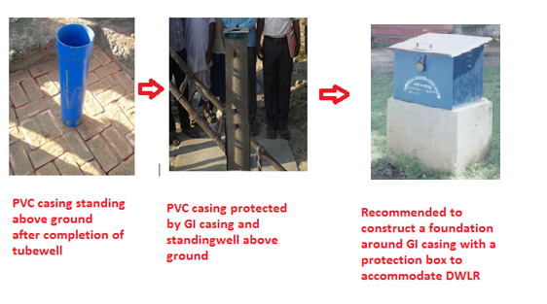
2.4 Design and layout of the storage tank, electric panel box, tube well
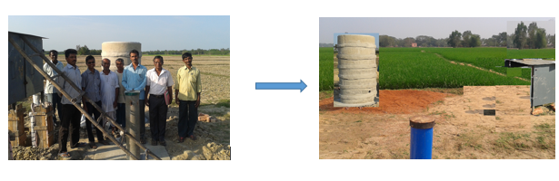 The tube well, storage tank and electrical switch box should not be crowded together. There should be working space around tube well to ensure obstruction free environment for major maintenance repairs. Open area around the tube well is required for removal of pumps for repairs, carrying out multi probe digital logging, aquifer parameter tests, packer tests etc. It has to be ensured that a separation of at the least 5m is maintained between the tube well, storage tanks, electrical switch board.

2.5 Design and construction of storage tank
The storage tank needs to be on a stronger foundation standing 1meter above the ground level. The diameter of rings can be increased from 1 to 1.5 m. Since the rings are being transported over long distances it is becoming very difficult to increase the dia and the weight is also difficult to handle when the rings have to be raised to greater heights. Instead the rings should be constructed at the tube-well site itself. This could be achieved by training local WUA members/ skilled local masons to carry out this work across several clusters . This will vastly improve the construction quality as well as provide for easy construction of larger diameter tanks. A tripod or alternate lifting arrangements need to be available at the site during the construction. This will help ease of construction, safeguard against accidents and make the system appear a lot more professional. Provision has to be provided for getting down inside the tank, for repairs, maintenance works and applying leak proof paints.
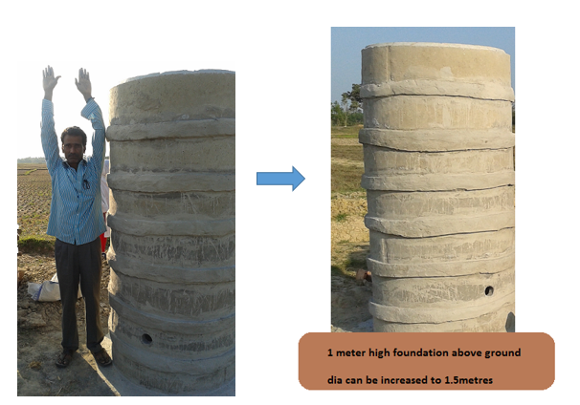
2.6 Development of Tube well
During the construction of tube well Bentonite mud is used. They penetrate deep into the water bearing formation. The well has to be adequately developed so as to remove the bentonite mud out of the aquifer, rearrange the gravel, open the aquifer flow into the tube well. The drilling contractor should be asked to use the drilling rig and do development using jetting tools and pumping in fresh water for cleaning. This should be followed by over pumping using compressor. In tube wells where the well development is good, the drawdown of the well will be low as compared to poorly developed wells.

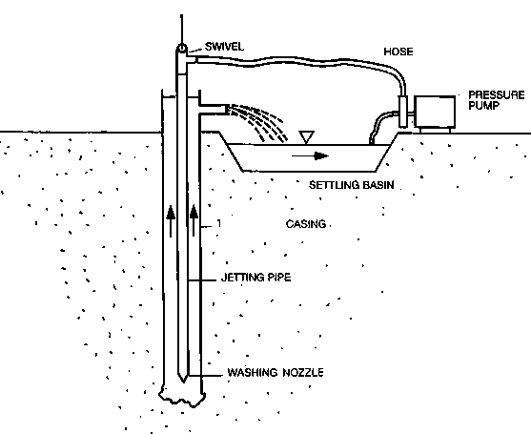
2.7 Approach to selection of appropriate Pump capacity
It is seen that decision on the choice of pump capacity is made at the design stage itself. This needs immediate rectification. An administrative convenience should be no reason for taking fundamental technical decisions that in many situation is highly arbitrary. In the long run this can create a serious setback to the process of sustainable groundwater pumping.
The contractor is expected to conduct a step drawdown test (3 steps) based on the discharge obtained from the tube well development. Step test data should also be analyzed for calculating well efficiency. Low efficiency wells need to be redeveloped after which only constant discharge test to be conducted. The 24 hour, long duration pump test should be conducted in all the drilled tube wells powered by generator. Based on the results of pumping test only the most ideal capacity of the pump calculated, discharge, and placement of pump need to be finalized.
The nodal officers should take special interest in ensuring this procedure is implemented on all the newly constructed Batch II tube wells. All test data need to be systematically preserved as this will be a major input to groundwater modelling studies.
2.8 Need for establishment of Automatic Weather Station (AWS) along with multiple monitoring wells
AWS along with three monitoring wells (part of multi-aquifer monitoring) need to be established in all the taluks where the project is operational. AWS station with monitoring wells need to be established within a fenced enclosure of 50x50 m preferably in the offices of GP, Block, Irrigation, and Agri Division. The parameters to be collected are very critical to help implement surface water, groundwater flow models as well solute transport model. This data will also help monitor the performance of the various schemes in the sub-divisions.

AWS will enable continuous automatic collection of weather dataat cheap cost and the data obtained can be made instantly available for analysis, modelling. The weather parameters to be measured should include:

Essential
- Anemometer for wind speed and direction
- Air Temperature
- Rainfall
- Humidity
- Soil Temperature
Optional
- Sunshine and UV intensity
- Soil Moisture
- Leaf Wetness.
Additional Parameters
- Pan Evaporation
Ground water monitoring
- Multiple Monitoring wells (3 nos)
- Digital Water level Recorder (3 nos)
Pan Evaporation can be computed using the other parameters. Additionally this data can be collected from any nearby Agricultural University, Research Station also.

An AWS consists of an integrated data-acquisition system connected to a data logger. The layout of an AWS typically consists of the following: The procurement should include a data logger for storage of data on a memory device. The logger's main function is to act as intermediate data storage device between AWS and the server at the office. The data mobility from the AWS station to the server should be through the appropriate GSM based mobile telephone linked communication system. The required computer hardware, software for the DPMU should be part of the procurement. The software should have capability for storage, validation checks, Analysis, Interpretation and Presentation. The data gathered should be uploaded on to dedicated web site on a daily basis as live reporting. The possibility of contracting out the whole process of setting up AWS station, data collection, O&M as a package for the entire state should be explored. The payment will be then linked to the data delivered.

The AWS enclosure should be an open area without any construction or trees in the neighbourhood so as to avoid shadow effect on the data. The fenced area of 15x15 meters need to be away from crowded area while at the same not so much isolated that it is vulnerable to poaching. Scope should be available for drilling of monitoring wells that will be fitted with DWLR so as to record the water level response to different rainfall events.

The software is a crucial component of AWS. It will maintain the database of all archived parameters organize it in daily / weekly/ monthly/ season/ annual files with fool proof backup. This archival database should make available data for individual stations as well as correlate data between stations.

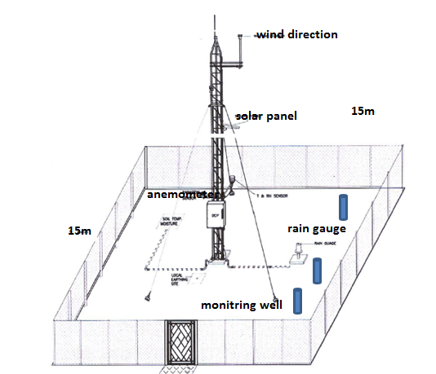
2.9 Multi Aquifer Monitoring wells

Idealised diagram of the multi-aquifer monitoring wells is as shown. Each piezometer shall tap a single aquifer and distance of separation shall be 3-5 m. Geophysical survey should have helped drill the deepest piezometer first. All wells should have platform and a box to install DWLR. The monitoring well should be installed in the same enclosure of AWS.
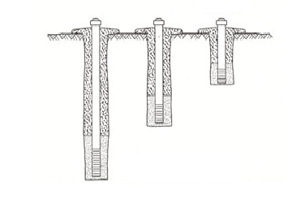
It has to be examined whether single data logger can store AWS and 3 DWR data. This will call for some customisation. However this will help save data loggers, data from all instruments will be compatible and will be easy to analyse.

2.10 Runoff gauging stations – manual

Stream flow measurement is another critical parameter to be monitored for all surface schemes preferably in the upstream as well as in the downstream. In small catchments with flows available for less than 50 days a year it will be difficult to establish and maintain permanent gauging sites. In such situations the best option is to use overflow weir of the check dam or any surface water storage tank/ culverts/ bridges to measure the stage and discharge manually. Ideally for all schemes there should be manual gauging site. That structure itself could be used as a gauging site or can be established in neighbourhood bridge or culvert.

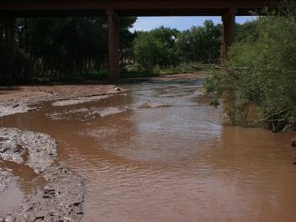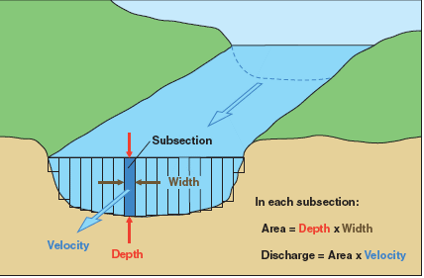

While selecting the site ensure the selected location is the mouth of a reasonably large catchment, with reasonably flat-bed profile, good strong embankments and the section is reasonably geometric in shape.

Carry out meticulous survey of the section to get the levels, develop the bed profile, and calculate the area of the section for different heights. Screw/Nail the measuring gauge rod, else paint on either side of the bridge/culvert/weir. Identify the point of measurement of the height of water flow. The view point should have no obstruction, provide clear view, should be above the highest flood level and measurements can be read clearly with naked eyes while ensuring the height of flow can be easily read even for very low flows as well as peak flows.

Identify a point of measurement of velocity of flow. This should preferably from the top of bridge, culvert. In the case of canals, streams without bridges the section chosen should be representative of the stream flow velocity. In special cases simple arrangements have to be made in the form raises wooden platforms for measuring the velocity of flow.
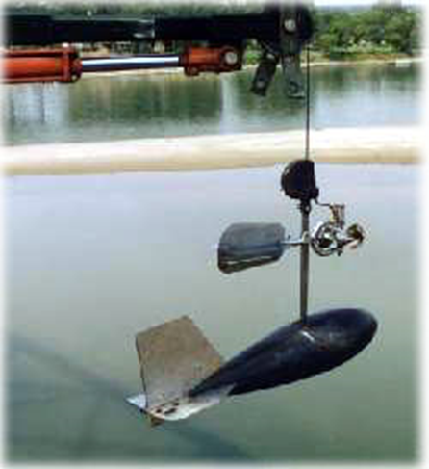
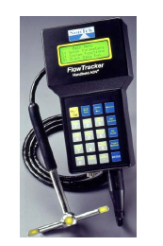

Procure either a pygmy type mechanical current meter or high accuracy digital current meter.
These measurements should be taken at the appropriate time. Peak flood flows last for few hours in small catchments and the measurements have to be taken at those periods (night, noon or during heavy rains). Adequate lighting, access to site are critical factors to be considered while selecting the gauge sites. Only local WUA members should be assigned the task and not a paid government assistant located far away from the site.

2.11 Coastal hydrogeology of East, West Midnapore
Given the significance of the location of Pani Parul (15 kms from coast) and and Gogram village (80 to 100 kms north of coast line and 50 kms west of tidal creek) the coastal hydrogeology has to be understood. The project is going ahead with the drilling of several hundred tube wells (close to 200 or more) in this block and neighbouring blocks. In the construction number of points have to be carefully considered in the tube well design.
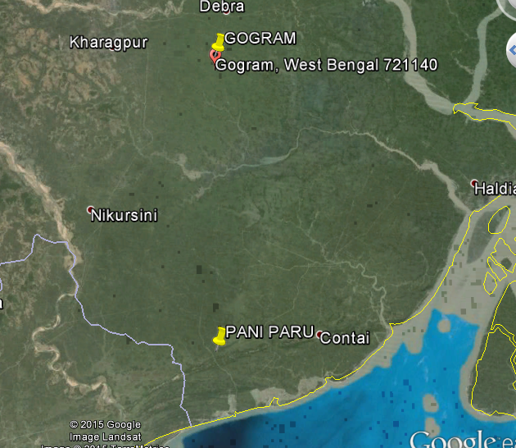

In both the locations examination of drilled sub surface formation shows medium to fine sand with clay separations. The sand shows the presence of deeper aquifer systems. Only after fully establishing the subsurface aquifer system geometry one can make an assessment of the nature of the formation of the lithological system and the influence of ancient sea coast movements on the area. Data on groundwater level fluctuations, aquifer characteristics (based on pumping test data) groundwater balance will help quantify the groundwater flow gradient, amount of fresh water entering into the sea, threat of salt water ingress if any.
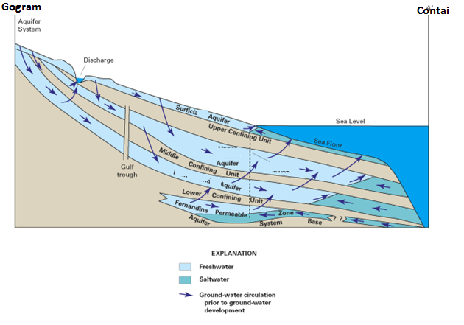
Construction of an idealized section from Gogram to Contai provides the following possibilities:
- Given the understanding that eastern India coast line Mahanadi and Hooghly delta was subjected to marine transgression and regression (sea coming inside the land and retreading back) during the Holocene period (12000 years back) the present day sea in Contai could have been far inland into the land reaching close to Gogram. In Puri (Orissa) coast the sea was 40 kms inland from the present day sea shore.
- As sea moves inland and retreats historical seawater got entrapped in the clays which are at depths.
- In some areas the rainfall recharge has completely flushed old saline water while in some areas the fossil water is still entrapped. This has always to be kept in mind during tube well design. This can be evaluated using borehole logging data and systematic interpretation of water quality data.
- During the design of the tube wells it has to be precisely ensured that no clay is part of the screened portion. This will create problem not only for that particular tube well but could also impact other neighbouring wells thus contaminating the entire aquifer system.
- Borehole logging is extremely important tool to guide in well design and placement of the screens.
- Any fossil obtained as drill cuttings during tube well drilling need to be safely preserved and sent to paleontology lab in the university geology department to identify its origin (fresh water/sea water).
- Study of the fossils will help understand the history of sea water movement and its impact on the current hydrogeology
- Some of the representative tube wells need to be fitted with DWLR, discharge measurement device to monitor water levels, water quality, and discharge.
- Groundwater modelling studies shall help understand the system as well help device plans for sustainable groundwater development, management in these areas.
Computer Model study can answer questions related to:
- Number of tube wells that can be constructed
- Quantity of groundwater that can be safely pumped
- particular aquifers that need protection
- quantum of fresh water getting drained into the sea
- nature of connate salt water entrapped in the clays, and opportunities for flushing.
- any threat of future reversal in groundwater gradient

2.12 Detailed water quality testing
Water quality being a critical constraint in these areas it is very important to carry out detailed analysis of water obtained after full development. The essential parameters to be analyzed are ph, Ec, temp, Ca, Mg, Na, K, CO₃ , HCO_{3,} NO₃ SO_{4,} Cl, F, I,As, Fe. Based on the results of the test only next set of activities need to be taken up.
In the neighbouring district of Balasore (Orissa) Chloride is met within any tube wells already. It is would be wise to be cautious. Environmental expert in SPMU needs to examine in this component and advise accordingly. The new set of water quality kits will be outmost use in these areas.

2.13 Digital multi-parameter Logging of Tube wells
Tube well construction has been initiated in a big way across the project. The drilling methods adopted and well designs are different from the past. Adoption of new methodology needs to be validated using advanced technology to assess the quality of the new construction, the accuracy of the filter placement and level of well development and tube well efficiency. It is recommended that the Logging Company (Michelle Drilling ) hired to conduct the geophysical logging during the USGS training in IIT be contacted to conduct logging in representative wells in all districts numbering 50 tube wells. This will also help the project to get trained in using the imported Century logger once it arrives into the project. This logging will also help in aquifer mapping. The probes to be used in logging are Electrical, three arm Caliper, Gamma, Temperature, Conductivity. Detailed technical specification for the study need to be developed.
2.12 Electrical Water Level Indicator for WUA
Tube well construction, energisation and command area development is being implemented in several clusters. All the schemes need to be handed over to WUA. As part of the handing over it will be very appropriate to provide one electrical water level indicator. This can be used by the WUA to measure water levels in tube wells as well as open wells and understand the depth of lowering of water levels, placement of pump, rate of recuperation of water levels and impact of rainfall recharge.
WUA should be trained in data collection, data entry in log book and analysis of data.
SWID is currently procuring 50 instruments additional 150 will be procured shortly for making it available to WUA.
2.14 Building entrepreneurship in WUA to partner in construction
In the construction of various sub projects there are several components the contractors depend on local labour as well as local artisans. One area of such immediate requirement is in the construction of storage tanks for tube well schemes. In each districts some WUA’s/local artisans need to be identified and training provided to construct the entire system on the site. All tools, skills, training notes, supervisory guidance should be provided in the initial one year.

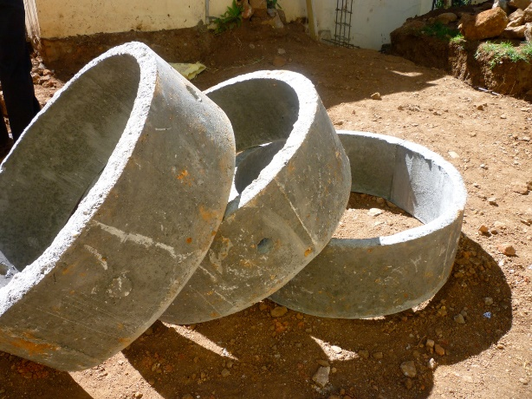

Another area is to identify local people experienced in hand drilling. These Mistry’s (technicians) need to be hired by the project to help the WUA supervise the work of tube well construction, ensure full development, pumping tests as well as guide WUA in upkeep of tube wells. Similarly plumbers, electricians, motor winding technicians, soil testing assistants all need to be identified, trained and made available on day rate/ job work basis.

DESIGN OF OK CARD
OK card concept is the means of providing greater voice to the WUA in the systematic planning, construction, monitoring of any scheme,. It is the starting point for WUA taking ownership of the overall investments done and ensure its future upkeep. The design of OK card should help offer data on short term needs such as the procedures in construction, quality and quantity of materials, overall community perception of the implementation. In the long term it should help build information to guide monitoring performance of various structures.
The OK card needs to be simple, graphical and self-explanatory for the WUA, however the information obtained should be transformed by the project into quantitative values for detailed analysis. This dual design is possible if the OK data can be captured on a iPad, note book computer at the site or data keyed into the computer in the office.
In any event the WUA should be provided with the data card that is simple pictorial card and can be filled by hand. Additionally the WUA can also have the option to use an iPad to make the entry. In the iPad there can be additional features to record interviews, capture photographs, videos as well as attach WUA meeting resolutions, press cuttings etc.
To run the OK card on an iPad a simple programme need to be designed. Every answer will have a numerical value with its own weightage. The data gathered will be organised as a database. The programme will have a graphics based front end, with touch screen facility, while in the back end the data will be stored as numeric value.
An unique scheme ID will identify the scheme, geographic location, WUA, design cost etc. The computerised nature of OK card will allow it to plug in with other database, can be developed as a GIS thematic layer as well as be used in future planning.
WUA should be provided with awareness on the information sought for the different questions asked in OK card, their relevance in the design, construction of structure and its maintenance. A ready reckoner type manual should be provided with the OK card. This ready reckoner should be in Bengali, simple, easy to read, understand information supported by enough pictures, charts, diagrams and posters.
The ready reckoner should also have loose linkages to the QC QA document so that there is a complete harmonization of thoughts between the Project Engineers, Contractors, WUA and QCQA monitoring agency.
- INTERNATIONAL EXPOSURE VISIT, TRAININGS

WBADMI project is at the threshold of moving out of traditional data management to state of art, data organization, analysis and interpretation. This is the appropriate time to expose the project management to new approaches in the area of advanced techniques in data gathering, modelling, real time decision making and forecasting. It would be most beneficial for the project to provide international exposure visit to the senior surface and groundwater managers implementing the project. The visit could be for three weeks to Europe (Netherlands, Denmark, United Kingdom) and USA. The focus of the visit should be to see and understand

- IWRM real time data collection, data handling, decision making and forecasting
- Automated Surface water, ground quality data gathering infrastructure
- Modelling
- Real time information sharing with users
- Water governance
- Using data for policy formulation
- Crisis management and data based decision making during Floods, Contamination of water sources, water logging, droughts etc

This is also the appropriate time to offer opportunities to mid-level managers to attend 3 months diploma or certificate courses in international universities for acquiring new skills in the area of modelling, designing water policy, improved water quality management, water governance etc.
- PROGRESS WITH SWID PROCUREMENTS

SWID Director Nliadri Naha along with his colleagues discussed the progress with various procurements and the way forward.

Details | Status | Remarks
Procurement of 250 no of DWLR | Specification to be developed, WB approval to be taken EOI to be published, proposed locations to be identified and depth of installation to be measured | For installation in the proposed multiple monitoring wells and one in each cluster drilled under Batch I, II where tube wells are 150mm dia to the entire depth
Procurement of 2 Deep resistivity survey equipment’s (Indian make) capable of probe to depth of 200m. | Supply order placed | To be placed in Vardhaman and Bankura.
Procurement of 50 nos electrical Water level indicator | Order placed | 30 instruments to be placed with SWID district office and HQ. 20 to be made available to WUA. Additional 150 more to procured
Construction of 5 no of multiple monitoring wells m ( 3 nos in each location) this will be linked with establishment of Automatic Weather Stations | WBADMI Nodal Officer West Midnapore to implement the drilling adopting the project specifications | Locations to be largely in government offices
Procurement of 15 field water test kits.  Digital Spectrophotometer | Order placed | Field kits and reagents part of procurement. To be placed with each DPMU.
Procurement of services of two Geophysict  and 2 modellers | Procurement through SPMU  CV, specs developed | Should be in position by April
Establishment of 19 District Ground Water Information System ( GWIS) | Computer and software procurement to be completed by before April
CMC for chemical laboratory equipment’s (5 years) | Agreement completed
Lab assistant for Chemical Laboratory | Procurement of services through HR agency

Upgradation of State Chemical Laboratory  Gas Chromatograph , Spectrophotometer | Specification prepared
Upgradation of State GIS laboratory | Procurement completed | ARC GIS, Mod flow,  rockworks
Upgradation of State Data centre | Being implemented | March end
Procurement of Digital Geophysical Borehole logger with accessories | Procurement completed | Shipment process to be initiated shortly
Reduced level survey, fixing of geographical co-ordinates and sounding of Hydrograph stations | TOR finalised tender to be floated by Director SWID | Work to be completed in three months
Conduct of training on Borehole logging | IIT to be contacted .Prepare officers for interpreting logging data to be collected from century logger | SWID/ SPMU will discuss with IIT Kharagpur

- QC QA DOCUMENT FOR WUA
A simple demystified technical QCQA document needs to be developed with illustrations for use by WUA. This document should guide the WUA to supervise all the civil, drilling, electrical, plumbing and other related work are implemented as per the prescribed technical specifications.
As an example for tube wells the QC QA shall describe the technical activities related to tube well in easy to understand fashion using local examples
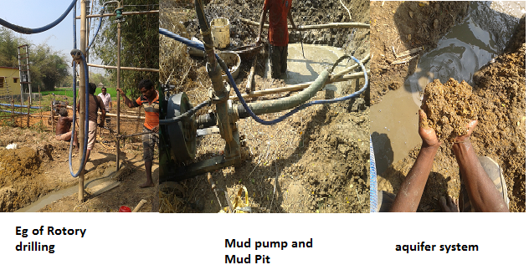
The document will also describe the tools to be used such as GPS, water level indicator, measurement of dia of drill bits, calculation of volume of mud pit, assessment of properties of drilling mud, analysis of drill samples etc.
The role and utility of logger, the importance of using the results of logging in well design, the specifications of well screens, texture of aquifer material will also described in the most simple fashion. Measurement of well assembly, duration of development, testing of water quality will all be described.
Tests to examine quality of Casing and screen, adherence to ISI norms, manufacturer details, testing of any exposure to sunlight, chemicals, deformity will all be explained and shown through pictures. Testing the layout of Well assembly, Supervision of lowering, recording measurements, calculation of volume of open space, gravel pack will also be included.
Supervision of verticality test, Well Development, discharge measurement water quality spot tests shall be included. The document will be designed to be easily handled in the field, explained as illustrations and colour codes provided to highlight critical tests. The document will also be available as soft copy on web site, USB device and potentially can be developed a s video for uploading in You Tube.

