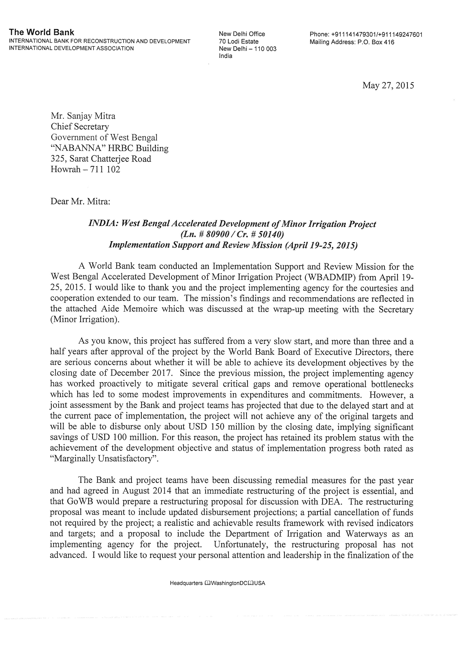
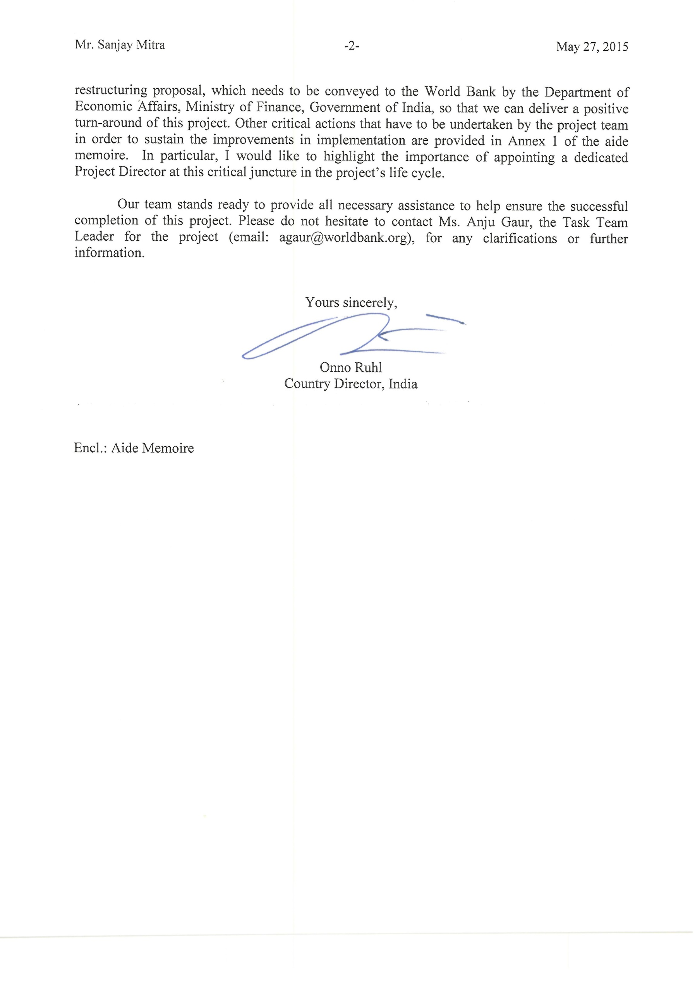
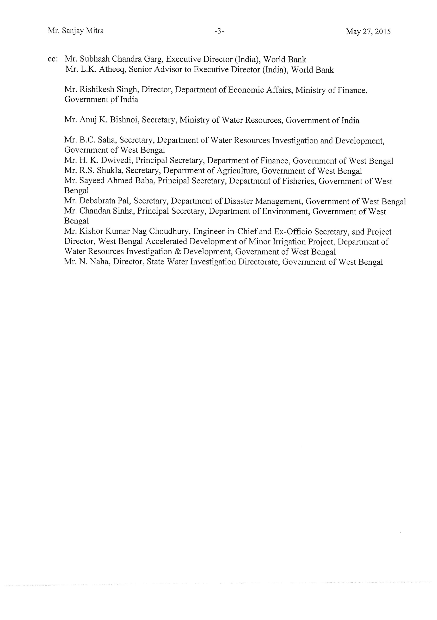

West Bengal Accelerated Development of Minor Irrigation Project

Implementation Support and Review Mission
APRIL 19-25, 2015

Aide Memoire

Introduction

- A World Bank mission visited West Bengal from April 19-25, 2015and conducted an Implementation Support and Review Mission for the West Bengal Accelerated Development of Minor Irrigation Project (WBADMIP). The objectives of the mission were to: (i)assess implementation progress including disbursement projections and the likelihood of achieving the project development objectives; (ii)review status of the key actions agreed during the last mission; and (iii) assess requirements to accelerate implementation including any changes in project design. This aide memoire summarizes the mission’s main finding.

- The team held multiple discussions with the State Project Management Unit (SPMU) and conducted workshops with the District Project Management Unit (DPMU) and Support Organization (SO) staff of the Department of Water Resources Investigation and Development (DWRID).The team visited more thantwenty schemesin five districts and interacted with members of the Water User Associations (WUA) (Figure 1). Mission findings and priority actions were discussed in a wrap-up meeting with Mr. B.C. Saha, Secretary (Irrigation) and the SPMU and DPMU staff. The team sincerely thanks project management especially DPMU staff for arranging these discussions and field visits.

Key Project Data

Table 1.Project Data and Performance Ratings
Project Data |  | Project Performance Ratings
Board Approval | October 4, 2011 |  | Last | Now
Effectiveness Date | March 19, 2012 | Development Objectives | Moderately Unsatisfactory | Moderately Unsatisfactory
Closing Date | December 31, 2017 | Implementation Progress | Moderately Unsatisfactory | Moderately Unsatisfactory
Loan Amount  Credit amount | USD 125 million  SDR 78.2 million  (equivalent to USD 116.4 million) | Problem Flag | 1
Total amount | USD 250 million
Disbursed Amount  (as of Mar 31, 2015) | USD 15.46 million*
Project Age | 3.5 years
% Disbursed | 6% (IDA)
(*Total Expenditures have reached to ~USD 25 M alongwith commitments of USD 13 M)

Overview of Project progress

- The project development objective (PDO) is to enhance agricultural production of small and marginal farmers in the project area. This will be achievedthrough accelerated development of irrigation services to small and marginal farmers, strengthening community-based irrigation management, operation and maintenance, and support to agricultural development, including provision of agricultural services for encouraging crop diversification, use of improved technologies as well as creating income generating opportunities.The project target was to provide 4,660schemes to provide irrigation to1,39,000 ha and benefit 166,000 farmers. As per the revised results framework, it was assessed that the projectwould beable to develop around 1,600 schemesto irrigate 40,000 ha and 100,000farmersthat will be operated and maintained by 1,200 WUAs.

- The mission is pleased to observe the clear transition of the project from a slow start and slow initial progress to a turnaround during this FY. The project team has mitigated critical gaps in implementation readiness and removed operational bottlenecks, leading to accelerated progress. The mitigation measures were introduced to overcome the slow pace of implementation during past few years and have been summarized in Mid-term report (Aug 2014) and are summarized in Annexure 3. The major measures included were redefining focus areas to target intended areas (Figure 2), selecting clusters (polygon) in each district and devising interventions based on the need of each district. DPMUs have identified 1,086 sites for new irrigation schemes. Against the revised project target of 1,600 schemes (under review), the project is currently implementing 575 schemes (375 scheme during current FY) and targets to award the contract for additional 238 schemes (USD 20 million) by June, 2015. The project has accomplished 65% of scheme implementation during this FY year. The improvements in implementation progress and effectiveness are reflected in recent expenditure and commitments. As of March 31 2015, total expenditure and commitments account for USD 38 million (USD 25 and 13 million, respectively) and are expected to increase to USD 68 million (USD 28 and 30 million, respectively) by June 2015. From a mere 42 schemes taken up for operation and maintenance by WUA in March 2014, the number has risen to 194 schemes. The number of WUA usersreceiving improved irrigation services has jumped from 5,712 to 17,399 farmers (net increase of 11,687 during the current fiscal year).Irrigation services have been supplemented with agricultural services via 1,760 agricultural demonstrations and associated training. The mission appreciates the improvements in average productivity achieved for the rice crop by the farmers accessing irrigation services (up to 3.5 T/ha) indicating that the end of project target of 4.1 T/ha is achievable. It is too early however, to assess the adoption of crop diversification in areas recently provided with irrigation services. Institutional development activities have increased to ensure sustainability of the services. The mission’s assessment is that recent progress is good and urges the project management team to maintain momentumto recover from the slow project start. In order to demonstrate the sustained momentum and quality of works, project needs to ensure dedicated Project director and QA/QC arrangements. The joint assessment by the mission and project team confirmed that the project would be able to disburse a total of USD 150 million by 2017, the current project closure date. The submission of restructuring proposal has been due since the mid term review in August and project has been requested to submit as soon as possible. In light of the improved progress but inability to match the implementation speed required to achieve the original targets, the PDO and Implementation Progress ratings have been maintained as Moderately Unsatisfactory.

- The project team needs to focus on the following critical actions over the next six months to sustain implementation: (i) complete 380 “in-progress” schemes and award contracts for 238 new schemes (USD 20 million) by June 2015; (ii) immediately establish a QA/QC cell in the department and mobilize third party consultancies for surface and groundwater schemes by June 2015; (iii) finalize the technical proposal from the Irrigation and Waterways Department (new implementing agency) by June 2015; (iv) put in place major consultancies for groundwater mapping and for survey & design by July 2015 respectively; (v) initiate the modelling study for feasibility of schemes; and most importantly (v) draft a restructuring paper with updated disbursement projections and a revised results framework with realistic and achievable indicators and targets.

Implementation Status, Issues and Recommendations by Component

Component A: Strengthening Community based Institutions

- The component aims at mobilizing and strengthening community institutions of farmers in the command area of irrigation investments under the project and assumes greater significant not only on the continued operation and maintenance of the scheme but also on the judicious management of water resources. The project has engaged four support organizations for overall institutional strengthening all over the state. In addition, two NGOs have been engaged to pilot scheme implementation through women based WUA (in two districts) and establishment ofsix bio villages. Although project has made substantial progress in formation of WUAs, this componentneeds improvement to strengthen the understanding of the Staff as well WUAs through clearly outlined procedures and manuals. Therefore, the overall implementation of this component is rated Moderately Unsatisfactory.

- Strengthened Institutions of the Farmer:Although513 WUAs have been mobilized and committees and sub-committees formed, the total number of WUAs registered is 513. A total of 138 WUA are performing well (as rated A/B). Registered WUAs have a total of 67,203 members of whom 4,680 (9%) are women. There are 5503 ST members (male and female) and49,940are small and marginal farmers. The mission recommends that the project deepen the participatory processfor the full involvement of small and marginal farmers in planning implementing, maintaining and managing irrigation services, as well as strengthening collective decision making and group action. There is also need for capacity building of office bearers on institution development activitiesincluding setting up of social accountability mechanisms.

- Continued Management of Commissioned Irrigation Services:A total of 194WUAs are operating and maintaining completed schemes. 13,643 executive committee members have been selected and trained, of whom 2,014 are women (15% compared to target of 20%). Some WUAs operating and managing completed irrigation services are managing their institutional activities with regular meetings and good record keeping.About half of the sub-projects have installed water meters and are ready to maintain water distribution registers. The fraction of WUAsusing water meters has fallen since the last review, as more WUAs have been established but many new WUAs are yet to install meters. The mission recommends implementation of the participatory hydrologic monitoring for ensuring sustainable use of available water resources and equipping WUA members with tools, knowledge and skills in sustainably managing the irrigation infrastructure.

- Streamlining Facilitation Support to WUAs: The project engaged four support organizations (SOs) to cover 18 districts. These SOs deployed 12 units of seven personnel each to support WUAs. The mission appreciates support provided to the WUAs in planning new irrigation schemes including collection of social, environmental, and economic data to complete the SDMPs with the full involvement of members. In order to strengthen implementation of sub-projects, the project is identifying and recognizing small and marginal farmers who have successfully implemented irrigation services in their own villages as Community Service Provides (CSPs). These CSPs will be the farmer resources pool assisting and supporting WUAs and will be responsible for (i) mobilization of community to form WUA and empower WUA; (ii) facilitatingproject implementation through WUAs; (iii) ensuring WUAs maintain documentation and records of progress; and (iv) coordinating with farmers and other stakeholders. DPMU supported by SOs will organize capacity building for CSPs on a regular basis.

- Continued Capacity Building: Institutional sustainability of WUAs is an important prerequisite for management and maintenance of irrigation services, including equitable water distribution and transparent and accountable financial management.Current farmer mobilization and institutional development activities fall short of the actual needs of the project, and it is recommended that institutional development aspects of the manual be strengthened and WUA capacity building be intensified. The project should revisit the terms of referencethe Institutional Development Specialistin the DPMU to address these issues. In additional to WUA office bearers, SO staff and project staff need thorough reorientation on mobilization, institution development and social accountability aspects of WUAs.It is recommended that the SPMU hire an institution experienced in mobilizing communities to assist in capacity building activities;this would also benefit schemes being implemented by DWRID outside of this project. The main responsibilities of an institution would be: (i) to update and incorporate all manuals guiding WUA functioning; (ii) develop a pool of trainers (from DPMU and SO staff) in each DPMU on participatory processes, institution development aspects and social accountability mechanisms and (iii) develop a pool of Community Service Providers who are well trained on all aspects of WUA functioning.Providing capacity building to farmers should not be a ‘one shot’ affair but an ongoing program of events designed to meet specific needs at different stages in the project cycle.Technical assistance could be provided to the project team to develop a capacity building strategy, to conduct an initial state-level workshop and to develop a training manual.

- Farmer level Self-monitoring and Learning: The source of data for the current MIS is the Support Organization – hired on a limited-term contract. It is recommendedthat data should be sourced at the WUAlevel. This may require simplification including via farmer-friendly monitoring formats and tools.WUAs should be tasked as soon as possible to implement simple, farmer-friendly, monitoring and learning systems to populate the MIS.Well-facilitated monthly learning fora should be conducted at the WUA level with three-monthly fora at DPMU level (ideally before and after each cropping season). The WUA manual should have a separate booklet on farmer-level self-monitoring and learning.

- Self-sustaining WUAs need strong governance and accountability arrangement:Sustained performance of WUA dependson the equity, participation, transparency and accountability. WUAs need to be strengthened with processes and tools for social accountability and governance. Prior to adopting irrigation infrastructure, WUAs should conduct an assessment of completed schemes. This will help WUAs fully understand the schemes ‘as completed’, deficiencies if any, required corrective measures and opportunities for better management including flow, water availability and resource planning. Social auditing is a mechanism for self-regulation. There is a need to strengthen grievance and complaint redress mechanisms for WUAs as well.

Component B: Irrigation System Development

- The component is for developing new minor surface water and ground water irrigation schemes mainly in areas that are currently cultivated under rain fed conditions with the objective of improving availability of water for agriculture and fisheries. The minor irrigation schemes include surface flow irrigation systems (comprising river lift schemes, check dams and water detention structures), and minor ground water irrigation schemes (light duty tube wells, and pump dug wells). These schemes have a potential of irrigating 5 ha to 40 ha each. It means the size of a water users association (WUA) might range from approximately 40-200 farmers.

- The mission appreciates the overall improvement in designing and implementing path-breaking reforms in an otherwise conventional system of planning, design and implementation in the minor irrigation sector in the state. The major reform and innovations include: redefining the scope of project target area based on the spatial pattern of land use (Figure 4), cluster based approach instead of scatter implementation and introduction of solar based energization.Now the project focus has shifted from south to Western part of the state for scheme construction while water management interventions will be provided in already developed southern districts. Cluster based approach is already showing the effective participation of communities during planning and implementation of schemes when compared with Batch 1 schemes which are implemented in scattered locations.Impressive progress has been made through enhanced institutional capacity to absorb innovations,and to translate the enhanced capacity into delivery of participatory irrigation services to small and marginal farmers. The rating of this component, therefore,is upgraded to Satisfactory.

- Renewed Momentum for Participatory Planning of Irrigation Services: Finally the project has been able to adapt to GIS/RS based selection criteria of the village and Batch 2 sites are already demonstrated the benefitswhen compared with Batch 1 on social as well technical aspects. Following the guidelines issued, several DPMUs have identified and recommended, during the fiscal year, 848 potential sites for irrigation infrastructure, bringing the total number of sites to 1,772 (compared to a target of 2400). Technical sanction from DLIC has been obtained for 877 schemes (404 during the current fiscal year) and SWID clearance has been obtained for 849 schemes. The participatory designing and planning of the schemes resulted in 314 SDMPs, of which 275 have been administratively approved by the SPMU. Work contracts have been awarded for 411 schemes, of which 192 have been commissioned and handed to WUA for operation and maintenance.

- The Bank has insisted, especially during Batch 2 schemes, that the technical feasibility of identified schemes must be validated by field measurements to ensure water availability and to ensure a watershed approach is adopted. It is stressed that if schemes under-perform because of water availability issues, they will not be covered by the project. Some schemes proposed under Batch 1 and Batch 2 may require additional infrastructure (storage structure for lift irrigation schemes) or additional water sources to make them effective. It is recommended that the required infrastructure be included in these schemes to make them effective. Minor defects found in other completed schemes should be rectified preferably by WUAs. Under-performing groundwater schemes should be rechecked so that required measures are introduced and similar mistakes are not made in future.

Figure 1: Layout of Batch 1 and Batch 2 schemes and sites visited by the mission
(Blue color refers to sites visited during this mission;
Yellow and green color refers to sites visited prior to this mission)
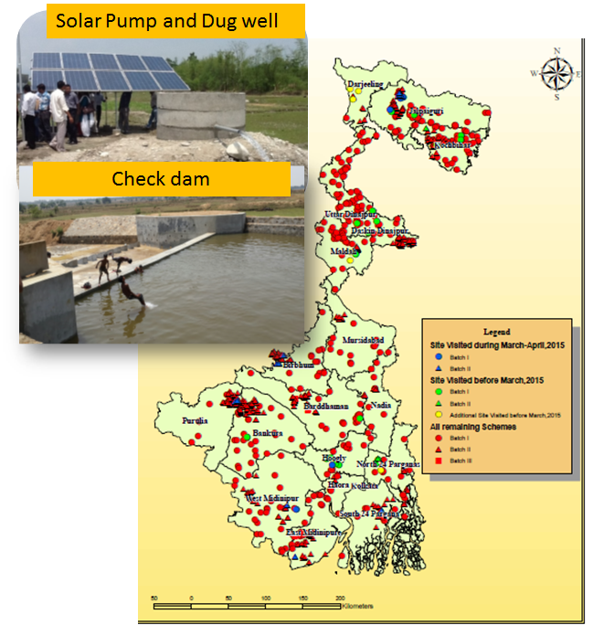

- Modernizing the clearance procedure for SWID:The mission appreciates the mandatory clearance by SWID of all proposed schemes. SWID is advised to maintain GIS maps of existing and proposed schemes, and of historical water (surface and groundwater) status. SWID shouldestablish a hydrologic model and analyze all existing schemes in a watershed, and analyze the implications of proposed schemes in terms of downstream impacts prior to clearance.

- Some groundwater schemes are not performing well. The earlier recommendation of strengthening SWID to improvegroundwater understanding is reiterated. A proliferation of private tube wells following the exemptionof small (up to 5 HP) pumped wells from groundwater policy raises concerns regarding groundwater sustainability including water quality issues. SWID is advised to establish a groundwater assessment and modelling system.In order to provide sustainable solutions through the project, the implications of further development needs to be adequately assessed. This requirement has beenstressed since project preparation. The mission recommends that SWID share water level data with the project, the project should share all scheme information including geophysical surveys, borehole logging and lithology.The project may seek technical assistance for any of the above.

- The real time water monitoring setup for groundwater and surface water has been long delayed. SWID is advised to expedite in the polygon streams as it would be critical for future design of structures. SWID should digitize all information in order to strengthen thebasis for planning.

- Rainfed Areas Received New Irrigation Services: 4,651 additional farmers are receiving improved irrigation services (towards a target of 29,412). The coverage of small and marginal farmers is 90% (target of 80%) and coverage for tribal farmers is 9% (target of 13%). The total area cultivated by farmers using water from commissioned schemes is 3,556 ha (target of 8000 ha).

- Cropping Intensities Picked up: Cropping intensity has improved across 3,556 ha of rainfed or/under-irrigated areas. A total of3,224 ha was double-cropped and 989 ha were triple-cropped. The gross irrigated area is now 7759 ha (target of 12,000 ha). It is recommended that design area of schemes is corrected based on actual area irrigated in the Rabi season.Schemes in Batch-I were over-designed in terms of command area meaning some farmers are not getting the reliable irrigation, which may lead to social conflict. In these cases schemes should be revisited and additional schemes (preferably surface schemes) should be considered. Progressive WUAsshould plan to provide water management based interventions and diversify cropsto irrigate more area with less water.

- Introduce Water management practice:Southern districts with developed irrigation and agricultural practices compared to rest of state have been identified to introduce water management practices. As explained in the area selection guideline, these districts need to focus on water management practices and it may include the area irrigated by non-project schemes include private ones. The potential water management practices may include drip/sprinkler irrigation, mulching, irrigation scheduling, crop management practices to reduce water requirement, crop diversification to horticulture, soil health management with vermicomposting and shed house etc.

- Introduce Quality Assurance and Quality Control in practice: The project is finalizingselection of a consultancy for independent quality control. The mission stressed the need to establish an internal QA/QC cell, headed by a chief engineer. The adjacent DPMUs could ensure quality and share lessons learned. DPMUsshould be equipped with mobile material testing laboratory for testing the quality of construction and testing of raw materials used for construction (Annexure B.2). During scheme performance tests, discharge should be measured using digital flow meters. Now that the format for OK Cardsfor farmers is finalized, the OK Card system should be implemented immediately for engineers as well.A consultancy should also be established for QA/QC of groundwater schemes and for aquifer characterization – this has been long delayed and is critical for high quality tube well installations.
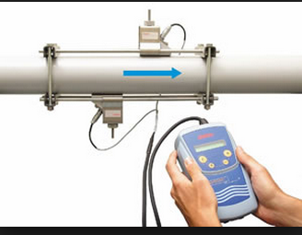
- Water meter based monitoring needs to be introduced:Acceptance of mechanical meters has been poor among WUAsbecause of fear of head lossfrom propeller-based meters.Use of analogue flow meters should be phased out. Digital flow meters with GPRS-based telemetryshould be trialed for one year and then used for the next batch of schemes. The relationship between electricity and water metersshould be established. Some schemes will require water level indicators (surface and groundwater schemes). DPMU may procure portable ultrasonic meter calibrate the energy use with the water (flow) use.

- Solving the Energisation Enigma through Solar power: The original project design was based on electric and diesel pumps. A major constraint in commissioning completed schemes has beenelectricity grid access.Electric pumps have been encouraged and the effortsinstall solar powerpumps are applauded – five schemes have been equipped with solar power and 54 schemes are under construction.Financial benefits have been observed from the solar pumping systems:in one hybrid tube well (grid and solar electricity) scheme the WUA reported savings of 50% in energy cost when compared with adjacent tubewell (around Rs.1300 per month)..To-date, solar pumps have only been installed by individuals, however, a group system with a cluster of solar panels serving one or more villages has been demonstrated. Such an approach has been attempted for the first time in the country and offers opportunity to minimize conflict, theft and damage. The mission recommends hands-on training for service providers as well as WUAs for smoother implementation. Proposals for solar pumping systems are encouraged, with consideration of the following:

  - Water storage to enhance the flexibility and reliability of supply. Concrete ring tanks for each farmer (filled via long flexible PVC pipe) are commonly used, constructed on-site from local materials.
  - Inlet pipesshould be HDPE in place of low quality pipe being used.
  - VFD invertersshould be used to cope with the variability of solar power and resultant variations output electricity frequency. Data loggersshould be installed as per the tender document.
  - A commissioning checklist (Annexure B) should be introduced for the engineer in-charge of certifying the installation of the solar irrigation pump (Annexure B.3). Training of the engineers facilitating the implementation (client-side and providers) will also improve installation quality. Training for engineers will be conducted in Jalpaiguri by Bank consultants. All the districts are encouraged to participate.

- The mission explored the feasibility of establishing solar-powered mini-grids in remote villages (Annexure B.4) that do not currently have grid access. Industry providers indicated support would be required to make such systemscommercially viable because of high capital costs andpotential future grid competition.Examples shared showed how foundations have supported establishment of such systems. The project is advised to continue consultation West Bengal Renewable Energy regarding system feasibility.

Component C. Agricultural Support Services

- This component provides follow-on support to small and marginal farmers who have been provided with irrigation services.Initial delays in scheme completion held back progress, but renewed momentum in Component B has unblocked agricultural support services. Component implementation is rated Moderately Satisfactory.

- Converged support to focus crops improving Productivity: The mission appreciates selection of focus crops to converge agriculture support services. While recognizing traditional crop varieties the project has balanced the selection with preferred oilseed crops and high-value vegetable crops to promote crop diversification and enhance cropping intensity. The suite of improved technologies is well designed to support the focus crops.A couple of production cycles may be required to achieve good technology adoption and see productivity improvements. However, initial productivity improvements(3.5 T/ha compared with baseline of 2.9 T/ha) for initial rice crops indicate that the end of project target(4.1 /ha) should be achieved. Impressive yields have been recorded for vegetables (12.7 T/ha comparedto baseline of 10.3 T/ha) and for mustard (1.1 T/ha compared to baseline of 0.4 T/ha).

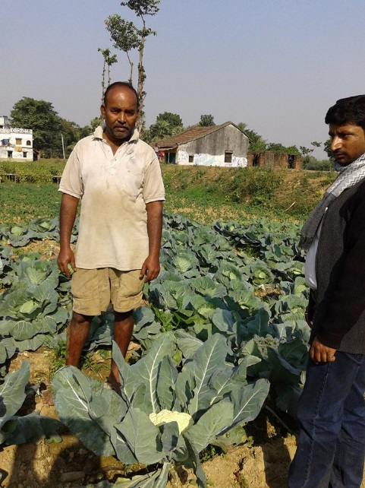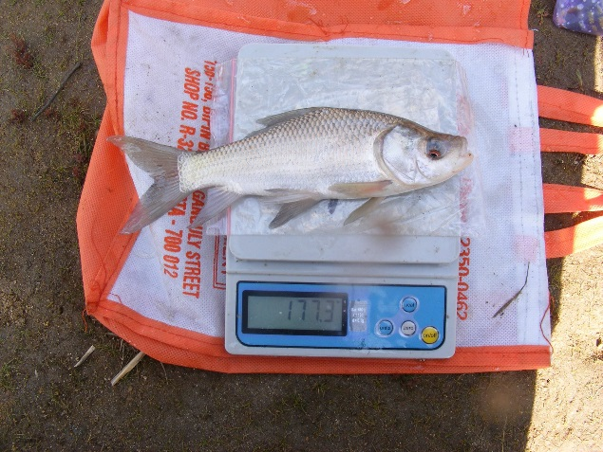
Figure 2. Vegetable and Fishery Demos

- Intensive demonstrations for enhancing adoption: The project conducted 1,515 agriculture demonstrations (against target of 1,238), 630 horticulture demonstrations (against target of 599) and 29 fisheries demonstrations (against target of 5). The total number of farmers trained through these demonstrations was 6,432 – good progress towards final target of 21,138.‘Bio-village pilots’ were initiated in six villages (one for each agro-climatic zone)for village -level dissemination of good agricultural practices. Adopters are defined as farmers adopting critical elements of a technology package over at least two crop cycles. As irrigation services have only been expanded during the last year, adoption will be assessed in missions.

- The mission recommends that WUA members discuss and jointly decide on the details of demonstrations including their understanding of good agriculture practices, selection of farmers, demonstration plots, demonstration crops and responsibilities of other farmers on adoption. The mission recommends gradually transferring responsibility for sourcing inputs and conducting the demonstrations to WUAs. There should be incentives for farmers to demonstrateand adopt technologies through social recognition by WUAs.

- Integrating Farmer Field Schools with Famer Water Schools: The project has adopted Farmer Field Schools to enhance outreach and ultimately improve farm practices. The mission notes the FFS orientation programs, materials development workshop and ToT workshops undertaken. This led to initiation of FFS in pre-Kharif in 14 districts, one in each of the 14 districts (12 FFS covering field crops and two in horticulture crops).

- The mission recommends FFS activities be integrated into Farmer Water Schools (FWS) to comprehensively cover post-scheme water management priorities including participatory water resources monitoring, operation and maintenance of facilities, and accountable and transparent water resources management.The scope of activities of the PPP will be broadened to cover end-to-end services following the handover of schemes.WUAs would nominate members to attend FFS who in turn remain accountable to the WUA to share learnings among members.

- Equipments to supplement knowledge support: The project has recognized the importance of providing farm equipment and small machinery to enhance adoption of improved technologies, especially among small and marginal farmers. The project has initiated activities to provide improved agricultural equipment including small machinery, facilities for controlled atmosphere growing of high value horticulture crops, water saving irrigation equipment, which will help improve adoption and productivityand enhance water use efficiency.The SPMU is advised to develop a framework agreement for such items to facilitate procurements.

Component D. Project Management

- In the last fiscal year, the project witnessed a hopeful turn around with good implementation progress. However, a new imminent risk arises out of the absence of a full time Project Director. This assumes significance as it is important to coordinate the engineering, agricultural and institutional services as they accelerate implementation. Similarly at DPMUs, coordination is required among multi-disciplinary team. The SPMU and DPMUs are advised to have progress review with multi-disciplinary team and SOs on weekly/fortnightly basis as applicable.The component is rated Moderately Satisfactory.

- Ever since the project became effective, missions have been repeatedly requesting that vacancies in the implementation team be filled. Majority of vacancies at SPMU and DPMU levelsfor full-time core staff and consulting staff have now been filled or are in the process of filling it up. Similarly, most of the SO staff are also on board. The mission recommends filling all vacant DPMU contractual positions. The mission requeststhe priority attention of the GoWB in appointing a full time Project Director and an Additional Project Director, to ensure current momentum is maintained.Arevised staffing structure at EGIS (SPMU consultancy) has been agreed, and should be expedited. The staffing requirement for SWID and for HR management may be included in the same. Also, the arrangements for continuity of PPP are yet to be worked out.

- As now project is picking up and water management and M&E are becoming critical. Two additional EEs for water management and EEs are required at SPMU. Also, project should not delay the action to be taken to the contract of SOs which are due to expire by September. Following HR issues also need management attention: i) Introduction of annual Increment system to contractual staff; ii) Group insurance and accidental insurance to all staff; iii) Comparable salaries for the contract staff based on their qualification and job responsibilities, for instance surveyor and SAE may fall in similar category.

- Office and transport facilities at DPMU: It was noticed that some DPMU offices(for example, Purulia) have not been fully furnished and there is insufficient space for teams to work. The mission requests that DPMU offices be furnished with all required facilities. A lack of transportation has also hamperedDPMU progress and effectiveness. Each DPMU may hire two or three vehicles to ensure proper quality supervision as well community mobilization and agricultural support services. Introducing appropriate travel allowancesfor staff willing to use their own motorbikes could be considered. The project needs to ensure that SO facilitate staff transport as their movement has also been limited.

- Continuing orientation and capacity building to staff:It is important that the project staff are clear on project implementation processes, principles and implementation guidelines. A capacity building agency should be engaged for continued training and capacity building of staff. The Project Implementation Planshould be updated with copies distributed to all field offices.

- Streamlining the implementation arrangement:The mission noted the limitations implementation capacity for delivering irrigation infrastructure.The capacity constraint could be overcome using additional implementation partners. The Irrigation and Waterways Department (IWD) have expressed their willingness to join as an implementation partner. This collaboration would have many advantages: (i) revamping lost irrigation potential via rehabilitation of infrastructure (Major and minor irrigation) and mobilization and strengthening of WUAs; (ii) enhancing implementation effectiveness through faster disbursement and (iii) synergies with Hydrology Project IIIimplementation via state-of-the-art technologiesfor irrigation services. The mission recommends a restructuring proposal to add IWD be submitted to the Bank as soon as possible.

- Fine tuning the monitoring framework: The project has now put in place improved systems and procedures to progress project implementation. As a consequence however, the monitoring arrangements have not evolved to match. Even at mid-term review the need for a revised results framework was identified. The project has revised the results framework (with Bank assistance): dropping redundant indicators and redefining indicators in line with core sector indicators. The original targets were arbitrary and unrealistic and hence were redefined. During the latest mission, guidance was provided on preparationof a results chain to link indicators clearly to component activities and establishment of a monitoring framework. A milestone monitoring matrix was developed by including progress milestones that clearly track progress and performance of different field units. A detailed note on the revised monitoring framework including agreed indicators and formats was shared with the project team. The mission recommends full integration of GIS and MIS functions to help implement the new monitoring system. The mission recommends project management submit the project re- proposal structuring including the revised results framework.

Financial Management

- Disbursement Profile: Againstthe original allocation of USD 125 million (IBRD 8090-IN) disbursements as of 28Apr2015 is USD 1.225 million (1%)including (i) up-front fee of USD 0.313 million; and (ii) reported project expenditures to 31-Dec-2014 of USD 0.912 million. The disbursement against the signed amount of SDR 78.2 million (IDA-5014-IN)is unchanged at SDR 9.310 million (equivalent of USD 14.236 million at 11.9%)reflecting (i) expenditure related to reinstatement of PPF and reported project expenditures up to 31Dec2014 of SDR 7.052 million and (ii) unadjusted advance of USD 3.136 million. Expenditure of `245.505 million reported during quarters to 30Sep2014 and 31Dec2014 have been documented against the designated account advance. No further disbursements have been processed, as DEA guidelines on the use of advances requires that at least 80% of the unadjusted advances be documented.
Table 2. Financial summary
Type | IDA 5014 |  | IBRD 8090
 | SDR | USD | USD
Signed Amount | 78,200,000 |  | 125,000,000
Disbursed | 9,309,708 | 14,235,862 | 1,224,957
Undisbursed | 68,890,292 | 94,423,789 | 123,775,043
DA balance |  | 3,163,182 | 0
Available |  | 97,586,971 | 123,775,043

- Budget and Fund Flows: Against the project budget allocation of `330 crores for FY15, `136.72 crores has been placed at the disposal of DDOs through an allotment process using the e-bantan system. This follows the decision of GoWB to switch over (from 01-April-2015) from the Letter of Credit system previously used, to the allotment system under the new Integrated Financial Management System (IFMS).

- Project Expenditures: The project has reported a total expenditure of `104.484 crores during FY15(and cumulative project expenditure of `154.138 crores).The project presently has committed contracts of USD 43 million, of which USD 25 million was expended by 31-Mar-2015 and commitments were USD 18 million.The project expects to award contracts for 330 schemes (valued at USD 30 million) by end-April 2015. In the best case scenario total project commitments are USD 75 million (against the total loan/credit of USD 250 million). The project estimates expenditure of Rs. 50 crores (USD 7.5 million) in the quarter ended 30Jun2015. Disbursements are likely to increase to USD 18.5 million (15% of IDA) by 30Jun2015. A summary of expenditure is in Table 3.

Table 3. Project expenditure by components. All figures in Indian Rs. Expenditure for Q4 FY15 is provisional
Project Components/Sub Components | Expenditure Reported
 | FY12 | FY13 | FY14 | FY 15 |  |  |  |  | Grand Total
 |  |  |  | Apr - Jun | Jul - Sep | Oct- Dec | Jan - Mar | Total
A |  | 10,618,588 | 35,089,813 | 86,577 | 11,450,448 | 5,383,585 | 20,602,297 | 37,522,907 | 83,231,308
B |  | 1,637,505 | 299,797,056 |  | 154,104,080 | 37,102,547 | 553,132,404 | 744,339,031 | 1,045,773,592
C I |  |  | 1,447,362 | 245,155 | 1,145,895 | 1,599,426 | 13,443,076 | 16,433,552 | 17,880,914
C II |  |  | 1,192,379 | 386,361 | 481,534 | 453,026 | 1,762,735 | 3,083,656 | 4,276,035
C III |  |  | 119,778 | 140,484 | 250,222 | 1,127,720 | 908,821 | 2,427,247 | 2,547,025
D I (SPMU) | 10,273,163 | 22,419,006 | 59,048,398 | 7,770,092 | 21,703,751 | 20,155,562 | 81,599,700 | 131,229,105 | 222,969,672
D II (DMPU) | 8,947,386 | 17,696,033 | 28,253,783 | 7,488,320 | 16,957,251 | 13,743,750 | 71,615,636 | 109,804,957 | 164,702,159
GRAND TOTAL | 19,220,549 | 52,371,132 | 424,948,569 | 16,116,989 | 206,093,181 | 79,565,616 | 743,064,669 | 1,044,840,455 | 1,541,380,705

- With the introduction of IFMS the State has, with effect from 1April2015, discontinued the Letter of Credit system for the Works Department. Departments have been brought under the ambit of Treasury with respect to payments against funds allotment provided to DDOs through e-bantan by Controlling Officers. With the accounting and financial reporting function now mainstreamed into the Treasury, the existing system of preparation and submission of monthly works accounts to AGWB has been discontinued. The frequency, access, form and content for periodic financial reporting however, is not yet clear.

- As part of the proposed restructuring of the project, it is envisaged that WBIWD and SWID will implement additional activities under the project. The financial management arrangements for these additional activities as discussed and agreed during the mission are summarized as follows:

- WBIWD: Project activities will be undertaken by WBIWD as deposit works. For this purpose DWIRD will place funds in advance with the concerned divisional officers of the department, who will in turn deposit the same in Treasury under Public Works Deposits (8443-00-108-PW Deposits). The Treasury will maintain separate deposit works Account Ledgers. The Divisional Officers of WBIWD will draw funds and process payments by presenting bills to the Treasury under the same deposit works account.All checks and balances now existing in the Divisions would be followed mutatis mutandis in preparing the bills and checked and signed by the Divisional Accountant and Divisional Officer. The funds placed with the department will not be considered as eligible expend for purposes of the project, until these are supported by DWIRD financial statements reflecting the actual utilization/closing balances. The project will need to determine ways to access monthly/quarterly financial reports of the deposit works from the Divisional Treasury Offices, consolidated for the State – from the Treasury Directorate. Unless the project is able to access correct and reliable consolidated financial reports on a timely basis, submission of IUFRs on a quarterly basis and thereon, the disbursements from the Credit/Loan may be impacted.

- SWID:SWID, as a part of DWRID will operate through departmental allotments in the same manner as other field divisions. Payments for expend will be made through the Treasury/PAO system and will reflect in the monthly financial statements prepared by Treasury.

- The project confirmed that expenditure reported during the quarter ended 31Mar2015 included Rs.1.5 crores placed with DST as deposit works for project related expenditure. The team clarified that the funds placed with DST are advances not considered eligible for disbursements from IDA/IBRD Credit. As for the arrangements with WBIWD, the project will have to arrange for access to monthly/quarterly financial reports of the deposit works from the Divisional Treasury Offices, consolidated for the State – from the Treasury Directorate.

- Contract Management: Development of a computerized MIS to track physical and financial progress on schemes is still not complete. The information on contracts awarded, physical and financial progress included in the IUFRs is presently being prepared on the basis of separate monthly reports provided by the district units. Contract management processes need to be strengthened significantly to validate the information on financial progress with reported physical progress. Data needs to be used more effectively to track exceptions (delaysin payments and/or contractor billing, need for contract extensions or revisions, slow physical progress). There is also need to streamline and document the business processes with respect to the sanction of works, award of contracts, contract revisions on account of price variations and/or time extensions so that there is uniformity in the processes.

- Overall, financial management performance remains unchanged at Moderately Satisfactory (MS). FM arrangements at the district/divisions and other departments, business processes with respect to contract management need to be significantly strengthened to facilitate the planned scaling-up of operations.

Procurement

- Mission reviewed the overall procurement in the light of the procurement plan dated 31 March, 2015(Revision 6). The estimated total cost of planned civil works is Rs.362 crores and the estimated total cost for planned goods and services are Rs.27 crores and Rs.31 croresrespectively. Total planned procurement planned is Rs.420 croreswhich is approximately one fourth of the project cost. No future activities are included in the procurement plan. The project advised that they are in the process of finalizing the DPRs for new activities and will send the revised version after including all schemes which will be executed in the next year within two months of the mission.

- Almost all contracts for Batch-I civil works are awarded, totaling around Rs.110 crores. In Batch-II, contract have been awarded for 133 packages totaling around Rs.88 crore, from 269 packages totaling around Rs.249 crore.The project advised that some urgent small works do not appear in the procurement plan. Mission advised that new items not in the procurement plan (unless of substantial nature) can be procured with clearance from the Bank on an individual basis. Such items must however, be included in the next revision of the plan.

- Construction has now accelerated but the SPMU has not been able to engage the QA/QC consultancy for tube wells. Valuable information about aquifer will be missed if the project does not act immediately, therefore following are recommended:

  - DPMUs may organize with scheme contractors for digital logging (including gamma logging). To ensure the availability of loggers, SPMU should facilitate and link them to scheme contractors. If contractors have already undertaken traditional logging, the DPMU should redo using the digital approach.
  - Contractors should be requested to employ telemetry based digital flow meters, which send all pumping test data directly to DPMU and SPMU.
  - Important information is not being shared with SPMU. Release of funds from SPMU needs to be linked to provision of: (i) geo-resistivity report, (ii) logging report and (iii) pump test (or discharge test for surface schemes.

- Dug wells and solar panel systems are being combined as one package. However, solar panel systems should be procured separately and preferably through the framework agreement. The quality of inlet pipe for solar pump schemes needs to be ensured: HDPE is recommended. DPMUs should work with contractors to ensure this.Dataloggers with flow metersare required. The project needs to work with WUAs to plan AMC arrangements for the selective items including electrical, motor and similar parts in order to sustain the operation of schemes.

- Of 26 consultancy activities proposed in the procurement plan, consultancy contracts are already awarded for 14 activities with total award amount of Rs.20 crore. The project has cancelled six packages and for the remaining six packagescontractare being processed.In the procurement plan (Revision 6), 237 packages for goods are proposed for procurement. Of these, contractshave been awarded for 196 packages totaling Rs.12.33 crore. Procurement is underway for the remaining packages.

- In the last mission, in the revised procurement manual, some discrepancies are pointed out, which the project has since complied with. Two procurement methods should be included in the project restructuring paper: framework agreements and community procurement. Once framework agreements are approved, the project should initiate procurement of solar panel systems, seed, sprinklers, drip systems and farm machinery. The project has adopted e-procurement for amounts above Rs.5 lakh from July 2014.The system is stabilized, but use of the system continues to be low. Project officials are acquainted with the e-procurement system, but prospective bidders need to be briefedon e-procurement methods so they adopt this approach for bidding. It has been proposed that the project adopt an online procurement plan monitoring system (SEPA). The project director has been asked to nominate (by the first week of May 2015 at the latest) two project officers to work as initiating and approving officers for online procurement plan clearance. The officers will be provided with two days of SEPA training.

- Contract management needs to be better organized. The mission stresses that the project team at the SPMU should review some contracts from each districts on monthly basis, and record exceptions in the monthly reports to the Bank. The Bank will conduct ex-post reviews of all contracts finalized between 1st July 2013 and 30th June 2014 using a Bank consultant. This review was postponed at the request of the project and is now expected to occurin May 2015. The consultant will undertake field visits for asset verifications and review field records. The mission advised the project to extend all possible cooperation and provide required documents to the Consultant.

- Though some procurement progress has been made many schemes still need to be planned and included in the procurement plan with follow-up action for early award of contracts. The procurement rating is retained as Moderately Satisfactory.

Social and Environmental Management

Social Safeguards

- Farmer Participation: Substantial delays in proving electricity to completed groundwater schemes are dampening farmer enthusiasm and participation. The mission appreciates the efforts to improve QA, but involvement of beneficiary farmers in the quality check will boost their confidence and morale for the continued irrigation management. There is a need to substantially improve the role of WUAs in planning and implementing agricultural support services.

- Land Donation: The project has stabilized procedures for voluntary donations / purchase of land for project implementation. The land donorprovides advice in writing on a Rs10 non-judicial stamp paper and the willingness to donate is recorded in WUA minutes books as a resolution. All details (such as total land owned by the donor, extend of land donated, detailed address and a map of the donated land) are included.

- Citizen Engagement:To increase community participation the project is developing a Scheme Development and Management Plan (SDMP).Under the SDMP the project is obtaining community feedback on scheme design. The project is also empowering WUAs to implement schemes independently in some schemes. Well performing WUA will be provided additional resources and activities to implement. To maximize project benefits several WUAs are providing irrigation water to non-members (including some outside the command area) and collecting user fees.

- Gender Actions:Gender based actions include: introduction of all women WUAs to construct, operate and maintain the irrigation schemes; inclusion as member in WUA by making spouse as eligible member, women (26% as governing council) as committee member in WUA, lead farmers for 107 ASS demonstrations.

- Women based WUA: In order to promote women based WUAs, project has hired an NGO PRADAAN in the Purulia and West Midnapur districts.In Bankura District, one all women managed WUA has been formed. The WUA office bearers are also members of Self Help Group and are from tribal community. Approximately 25% of the WUA members are landless households. The WUA members have taken 2 acres of land on lease from gram panchayat for mango and guava orchard. Project is planning to provide pump dug well and drip system. As was agreed earlier, project has initiated training of interested women members in pump repairing training and will also provide a bicycle and toolkit for delivery of services after successful implementation of the training part, DPMU has to recommend for cycle and tool kits. In
- Batch-1 sub projects, since most of the women do not have land rights, they have not been considered as primary stakeholders.In Batch-II-sub projects however, both the spouses are being encouraged for the WUA membership. This will help bring more women into WUAsand their governing councils. The project is supporting 3,439 woman-led households. However, for schemes adopted by WUAs the percentage of women in overall membership and on governing councils is 15%. SHG members have been specifically targeted for expertise in collaborative approaches, book-keeping,linkages with other departments,fee collection and conflict management. The project has selected some women as lead farmers and 107 ASS demonstration plots are managed by women. The percentage of women on WUA governing councils is 26%. Women members are largely engaged in organic vegetable farming (both kitchen gardens and larger plots, and in vermi compost preparation) – see Table 4..

Table 4: Number of women participants in different demonstrations
S. no. | District | Organic VegetableFarming | VermiCompost Preparation
1. | DakshinDinajpur | 20 | 13
2. | South 24 Parganas | 40 | 40
3. | Howrah | 20 | 20
4. | Bankura | 5 | 5 – Farm compost
5. | Birbhum | 20 | 20
6. | Malda | 40 | 20
7 | Jalpaiguri |  | 5
8 | Uttar Dinajpur |  | 5
9 | North 24 Pargana |  | 25
10 | Hoogly |  | 0
Total |  | 145 | 153

Environment Safeguards

- Overall, the environmental management systems and arrangements in the project showed improvement with joining of 6 (six) environmental specialists in the DPMUs; adoption of detailed screening formats for groundwater and surface-water subprojects; and the influence of environmental screening on selection of subprojects. There has been further progress in awareness training and detailed training on environmental management, with 3 specific training program organized since the last mission.
- In place of an emphasis on groundwater subprojects in Batch I, the Batch II subprojects emphasize surface water subprojects (45% of total subprojects, using check dams, water detention structures, surface flow, and river lift irrigation schemes). In 4 groundwater subprojects created under Batch I, solar power supply is being added. With the new environmental specialists in place in DPMUs, environmental screening of 437 “Batch II” subprojects has been completed, and on-field checks by SPMU reported full compliance with EMP. Water quality tests were completed for 472 subprojects (217 “Batch I” subprojects, and 255 “Batch II” subprojects), and is on track for covering all Batch II subprojects.

- Although environment assessment is now progressing well, it needs strengthening including through proper field verification. Some lift irrigation schemes and some groundwater schemes have been proposed where water availability is inadequate either because of seasonal flow variations or over-exploitation of groundwater. Irrespective of scheme size, permission should be sought from SWID to ensure tube wells are not introduced in areas where groundwater development has reached critical or semi-critical status.

- The “Bio-village” program, in spite of the initial delay in procurement is now progressing well, and the First Year Report submitted by consultants showed that all “first year targets” have been exceeded. There has now been a delay, again, in contracting for the agreed expansion of the “bio-village” program; and the mission discussed with SPMU the need for avoiding any delay in expansion of the program in the agreed manner. On the issue of delisting of the WHO Class 1B and Class 2 pesticides, the Department of Agriculture has informed the SPMU that the state is no longer continuing with any “approved list of pesticides” (the list has been withdrawn from the website of the department), and that only the national regulations is being followed in the state. The SPMU will, through the DPMUs, publicize the list of “pesticides banned, refused registration, and allowed only for restricted use in India”, as advised and revised from time to time by the Government of India. In light of the above, and in conformity to earlier agreements, the rating for the implementation of the environmental management plan is now upgraded and rated to be moderately satisfactory.

- A further upgrade of the rating will be considered based on (i) progress of water quality monitoring plan, (ii) avoiding further delay in the expansion of the “bio village” program, (iii) water quality testing for all subprojects prior to handing over to WUAs, and undertaking by WUAs for regular six monthly water quality testing where drinking is an intended or associated use; (iv) SPMU to undertake compliance monitoring of the completed subprojects including subprojects already handed over to WUAs.

Governance and Accountability

- The project has a website (http://www.wbadmip.org/) and a toll-free number (with a dedicated officer) for grievance redress. Each DPMU also has one dedicated person for registering grievances, and the name and telephone number for grievanceshave been widely disseminated. DPMUsare maintaining records of all grievances including written complaints. Grievances at DPMU level are resolved within a month or escalated to APD level at SPMU. The aggrieved person has the option of approaching the judiciary if grievance remains un-resolved at SPMU level. To-date the project has received 18 grievances of which 6 have been resolved. Of the 18 grievances, 8 have been escalated to SPMU, of which 4 have been resolved and 4 are being progressed.The SPMU has not received any complaints directly to-date.

- The mission recommends preparation of a Governance and Accountability Action Plan at DPMU and SPMU levels, to be updated annually. These plans should be prepared in participation with project staff and shared once finalized. A grievance redress framework starting from WUA extending up to SPMU should be established. The mission recommends project adopt a zero tolerance to financial misappropriation at all levels.

- To facilitate anonymous feedback on schemes, the project has posted a list of schemes inviting specific comments. The project is encouraged to publicize the contact information for feedback at various levels.

List of Annexures and Figures

Annex Number | Description
1 | Agreed Actions
2 | Result monitoring matrix and progress update
3 | Summary of reforms adopted in the projects
Figure 3.1 | Project target area before and after restructuring the project
B.1 | Plan and progress for SWID
B.2 | Quality control in Groundwater schemes and site visit observations
B.3 | Quality control in Surface schemes
B.4 | Solar installation checklist
B.5 | Opportunities to install micro-grid in West Bengal
C.1 | Agricultural Support services

Annexure 1.Agreed Key Actions by March’2015

S.No | Action | By Whom | By When/ revised | Status(Mar 31, 2015 | Revised/follow on Action and revised date
 | Scheme implementation: Finalize Implementation of 351schemes Batch 1 schemes. | SPMU | Jul 31, 2013/  June2015 | 194 schemes completed; work in progress forremaining. | Energization is taking 3-6 months. Improved significantly. Updated orders issued by WBSEDCL for fast and effective services.
 | Batch II: contract awarded for 459 Scheme prepared through SDMP approach | DPMU/  SPMU | March 2015/  June2015 | SDMP prepared for 155 schemes. Contract awarded for 211 schemes and expect to finalize by June for remaining. | Progressing well, however quality control system and SDMP preparation yet to be put in practice fully.
 | Project Management Unit: Ensure Full time PD, dedicated project team and key staff proposed | SPMU | Jun 2013/  Jun2015 | Dedicated positions approved by the State Government. Expected to be in place by May 2015.  90 SAE about to be mobilized. Majority of other staff is in place. | Full time Project director to be appointed. APD need to be dedicated to the project.  Formation of QA/QC cell pending.  Some key positions and arrangements for PPP are still pending.
 | Third Party QA/QC | SPMU | Dec 15, 2014/June 2015 | For surface schemes, it is advance stage. For GW it is delayed. | Alternate arrangement for GW schemes have been suggested. Expedite logging companies at the district level.
 | Proposal for Irrigation and waterways cleared and included as implementing agency | SPMU | Oct30, 2014 | Prelim proposal is received. Their inclusion is yet to be formalized. | Restructuring proposal is pending.
 | Survey and Design Consultancy | SPMU | 2013/Aug 2015 | Delayed substantially | EOI issued
 | Restructuring proposal | SPMU | May 15, 2015 | It was agreed during Aug 2015 MTR. | Substantially delayed.

Annexure1: Component wise detailed actions (Green indicates good progress, yellow indicates some progress)

S.No. | Action | By Whom | When/ revised | Status(July 31, 2015) | Revised/follow on Action
Component 1: Strengthening Community based Institutions
 | Renew contracts of SOs | SPMU | June, 2015 | The contract is due to expire by Sep.
 | Strengthen Management Operation and Maintenance in WUAs | DPMU/SO | Ongoing | MOM manual is ready and tested for WUA. | Introduce in other WUAs.
 | Engage a lead Institution/NGO for strengthening Training program for project staff and WUAs. | SO/SPMU | June, 2015 | TOR draft in progress.
 | Prepare QA/QC manual for WUAs. | SPMU | May 30, 2013/immediately | Work in progress. Introduce OK immediately. | The supervision has been weak by DPMU and WUA should learn to take the ownership of schemes and support in supervision. Work in process.
 | Introduce water resources monitoring at schemes before and after handover through WUA. | WUA/SO  /DPMU | Immediately | Delayed substantially. Water meters are already provided. Will be started from May’15. | Provide water level tape, and install gauges in streams.
Component 2: Irrigation system development
 | Selection of Batch 2 schemes : 300 SDMP | SPMU  /DPMU/ DLIC | Sep 30,2013/June 2015 | Selection completed but preparation ofSDMPs has been slow. | Need DWRID’s active support and dedicated staff.  Expected to be in place by May’15
 | Quality control cell in SPMU and system at DPMU | DPMU  /WUA | Ongoing | Supervision needs to be improved. | Mobile based and quality control needs to be put in place; Mobile quality control lab needs to be introduced and ok cards need to put in practice.
 | Revise bid documents with updated specifications and simplified BOQ | DPMU | Sep 30, 2013/ March 2014 | Improved substantially.
 | Pilot testing of solar system in Batch 1 schemes | DPMU | Nov 2013/ Dec 2015 | Five schemes completed and 54 are in progress. | Installation needs to be improved. Separate solar system from civil works. Dataloggers and monitoring system needs to be commissioned.
Component 3: Agricultural Support Services
 | Design Demos for innovative practices. | DOA/SOs | Ongoing | Completed for last year. Planning for Kharif 2015 | The team needs to work on improving the demos and record their impact. System in place and under pilot testing in current Pre Kharif.
 | Procure consultancies to engage agricultural institute for training of agricultural staff. | SPMU/DPMU | April 2014/October 30 2014 | Not completed | Arrangement with KVKs for conducting demos did not materialize. Instead the plan is to train the staff through institute and engage agi-business based services.
- De | Devise implementation plan and organize resources for implementing farm field school | SPMU | April 2014/ | Plan developed and under pilot testing. | Now upgrade same to farm water school.
- E | Engage PPP and community resource providers (CRP) | SPMU/DPMU | April 2014/  October 2014 | PPP in place since Nov’14. Plan has been cleared to engage through SPMU consultancy for PPP but yet to be materialized. CSP plan approved by World Bank and will be in place by May’15 after amendment of SO contract.
 | Initiate procurement of agri-business services | SPMU/DPMU | Dec, 2014 | Not yet initiated. | Few round of meetings done. Concept prepared and agreed.
 | Bio-Village program. | SPMU | Sep 30, 2013/  March 2014 | Introduced in 6 village and agreed to include the project activities. | Output seems promising and may consider expanding to additional villages. Monitoring needs to be improved.
Component 4:Project Management
 | Strengthen and manage SPMU consultancy with the required staff | SMPU/contract | Feb 15, 2013 | Needs reorganization to match with the current business needs. | Some actions have been taken but appointments are yet to be materialized.
 | Mobilize team for DPMUs and SAEs | SPMU | May 2013/  Nov 2014 | Partially completed.Dedicated Team and SAE expected to be in place by May’15. Orders issued for 76 SAEs | Their induction and training would be critical to project implementation.
 | Induction training to new staff in overall project and their field of work. | SPMU | Ongoing | Some trainings conducted. For field staff it needs to be done immediately. | Training need to be more effective and frequent. 4 Interstate exposure conducted.
 | Conduct a study to assess the status of old schemes and understand their needs. | SPMU | June 2013/  June 2015 | Delayed. Now the study is in progress. | Based on the recommendations and inventory assessment of old schemes, the renovation sub-component will be introduced.Study conducted and final report expected by May’15.
Upgradesto f water information system at SWID
 | Upgrade surface water monitoring system at lift and surface irrigation schemes | SPMU/SWID | June 30, 2014/  June 2015 | Delayed. Set up combination of real time and community based monitoring. | Needs attention of senior management.
 | Upgrade groundwater monitoring system | SPMU/SWID | June 30,2014/  July 2015 | Delayed substantially.
 | Upgrade database management system in SWID: Prepare monitoring plan | SPMU/SWID | Oct, 2013/  Dec 2014 | Delayed. Software for organizing GW database is recently procured. The information is yet to be computerized or updated through field investigation. | Engage the services to upgrade other information at SWID
 | Prepare a draft plan for comprehensive monitoring of water availability and water quality with estimates. | SWID/SPMU | Oct 31, 2013/  Dec2014 | Delayed | Some plan is there but needs to be organized well.
 | Update spatial database of old schemes with their status | SWID/SPMU | June 2014/ Dec 2014 | New activity. | Engage the services to finalize this survey.
MIS and M&E system
 | Develop web-based MIS for project immediately. | SPMU | March 2013/ Sep 2014 | Bet version is under testing. Update all the modules including physical, procurement and financial. | Link MIS with financial release to ensure that field staff provides the data. The approval of scheme should be linked with update of SDMP data.
 | Update Batch 1 data for both MIS and GIS platform with the details up to beneficiary/field level | DPMU/  SPMU | Oct 2013/  Dec 2014 | Delayed. Batch 1 has been pending long due. | Some attempts have been made but quality needs to be ensured.
 | Make GIS based mapping accessible to DPMU | SPMU | Feb 2013/ Immediately | Partially done. The experts have been engaged Not done. | Project has employer their own server but still need to be made DPMU friendly.
 | Finalize M&E framework | SPMU | June 2013/ October 2014 | Partially Completed. | Reporting is still very weak and time consuming.
 | Strengthen M&E at all levels upto WUA | SPMU/DPMU | July 2013 | MIS needs to be now put to practice M&E. Farmer/WUA cards are prepared. | Needs M&E specialist and need to put in practice at all levels.
 | Financial management
 | Forecast of expenditures for next two quarters in IUFR 1B to be sent to World Bank. | SPMU | Ongoing (prior to each semester) | Delayed. Yet to streamline for timely submission. | Forecast of expend for quarters ended 30-Jun-2015 and 30-Sep-2015 to be provided with IUFRs for quarter ended 31-Mar-2015
 | Office orders issued to clarify the business processes  - For sanction and payments of DPMU operational expenditures.  - with respect to sanction of works, award of contracts, contract revisions on account of price variations and/or time extensions. |  | March 31, 2014/ |  | Pending.
 | Update the expenditures with respect to physical progress in various contract and review on monthly basis. | SPMU/DPMU | March 31, 2014/June 2015 | Update for existing ones by April 15, 2014 | Development of computerized MIS to track physical and financial progress on various schemes [contracts awarded] is still not complete. The information on contracts awarded, physical and financial progress included in the IUFRs is presently being prepared on the basis of separate monthly reports provided by the district units.
 | Training to be provided to Divisional DWRID staff, including Divisional Accountants on the business processes and financial reporting requirements. | DPMU/SPMU | April, 30 2014/ May 15, 2015 | Conducted and in practice. | New system will be in place fromMay’15
 | Procurement
 | Update procurement plan. | SPMU | Every mission/July 31, 2015 | Revised procurement plan of 2014-2015 version 6 was shared prior to mission. | Updated and submitted to World Bank.
 | E tendering system for Batch-II. | SPMU/DPMU | Jan 2014/ July 201 | Started in July 2014. Now system is stabilized
 | Finalize procurement of 459 schemes for Batch-II. | SPMU/DPMU | March 15, 2015/July 2015 | Approval of 438 schemes given. 176 work orders awarded and remaining in bidding and expected to be awarded by June’15 | Need to introduce improvement in bids to ensure success of bids; invite bidders from out of state to address peak needs.
 | Training on procurement to perspective suppliers, | SPMU/DPMU | Sep 30, 2015 | New activity | In order to increase the response of bidders.
 | Social Development
 | Issue Guidelines to SOs on addressing the issues related to Lands, Impacts and Tribal Development. | SPMU/SO | Ongoing | Ongoing activity. Keep updating the SOs as there is large turn over | Continued.
 | Update information on actual land donationin Batch-I schemes. | DPMU/SPMU | Ongoing | In progress. Report on profile of donors, gratitude, impact on livelihoods.  Partially available for batch 1 schemes but process of data collation for batch 2 is yet to start. Information for batch 1 should be completed by June end 2015. | Yet to be done in organized manner. WUAs are yet to be clear about fee and cost of AMC.
 | Update Action Taken Report on implementing the TDP. | SPMU/DPMU | Sep 30, 2013/ May 2015 | In progress. | To be done;
 | Initiate the process of mutation of land parcels donated by the community members. | SPMU/DPMU | Nov 30, 2014/ongoing | Not done yet | To be done; Land owners will pledge their land to WUA. Process is yet to start.
 | Environment
 | Organize and complete training for DPMU staff andSO staff on environmental due diligence. | SPMU | Ongoing | Conducted and continued. | Field staff need to verify water availability.
 | Issue of Government Order to delist WHO Class I/ Class II pesticide from state approved list of pesticides | Deptof Agric - WRIDD to coordinate | July 15, 2012/  Dec 2014 | Not required now as the department has no list of such items. State Government follows GOI list.
 | Finalize ToR, adopt approved selection procedure, and award contract for study on bio-accumulation of synthetic and persistent pesticides in food crops. | SPMU | Oct 31, 2013/  Apr, 30 2014 | Delayed. | Not started
 | Governance
 | Establish a grievance cell | SPMU | Feb 25, 2014/ Immediately | Partially done. Toll free and MIS is place | Yet to put in full practice by sharing number with WUAs/community and dedicated person to it.Strengthened but still needs proactive disclosure. On web most of the Project information are shared.
 | Provision of display boards and projectinformation system | SPMU/DPMU | Immediately | In practice but need to be made mandatory. | During construction and post construction, display boards are needed and mechanism for sharing scheme details with villagers needs to be practiced.
Annexure 2: Result Monitoring report (March 31, 2015)

Sl.No | Activity/ Milestone | Cumulative upto 31st March 2014 | Annual FY 2014-15 |  | Overall achievement | Project Target
 |  |  | Cumulative Achv. For the year | Annual Target
A. | WUA STRENGHTENING MILESTONES
1 | No of sites identified for project initiation | 802 | 1335 | 862 | 2137 | 3000
2 | No of sites that applying to the project through Mass petition. | 700 | 1199 | 684 | 1899 | 3000
4 | No of sites approved by DLIC | 368 | 509 | 525 | 877 | 2700
5 | No of WUA management committees & sub-committees formed & members trained roles & responsibilities | 366 | 343 | 985 | 709 | 2400
6 | Number of WUA registered | 335 | 178 | 674 | 513 | 2400
7 | No of WUA having bank A/c. | 179 | 95 | 313 | 274 | 2400
8 | No of WUA collecting membership fees from the enrolled members | 182 | 249 | 267 | 431 | 2400
10 | No of Total Executive Committee Members (Management Committee & sub-Committee). | 6052 | 7591 | 6128 | 13643 | 50400
11 | No of Women in executive committee | 573 | 1441 | 914 | 2014 | 15120
12 | Number of WUA rated A/B | 0 | 0 | 0 | 0 | 1764
13 | No of operational FIGs strengthened | 0 | 26 | 30 | 26 | 600
13A | Total no of Women Farmers in FIG | 0 | 48 | 75 | 48 | 1080
13B | Total no of tribal farmers in FIG | 0 | 71 | 100 | 71 | 780
B. | SCHEME PLANNING MILESTONES
14 | No of schemes got SWID clearance. | 0 | 339 | 450 | 339 | 2700
15 | No of schemes technically feasible & environmentally suitable. | 366 | 452 | 495 | 818 | 2700
16 | No of SDMP approved by DPMU | 366 | 222 | 450 | 588 | 2700
17 | No of SDMP administratively approved | 366 | 183 | 450 | 549 | 2520
18 | Command area (HA). | 9462 | 16957 | 15000 | 26419 | 120000
19 | No of beneficiaries | 23939 | 31652 | 26740 | 55591 | 176475
19A | No of Women beneficiaries. | 3742 | 5399 | 12731 | 9141 | 31765
19B | No of Tribal beneficiaries. | 2256 | 3247 | 2374 | 5503 | 22942
19C | No of small & marginal beneficiaries | 20640 | 29300 | 40156 | 49940 | 141180
20 | Expenditure Incurred
C. | SCHEME IMPLEMENTATION MILESTONE
21 | No of schemes for which bids floated. | 366 | 398 | 495 | 764 | 3150
22 | No of schemes for which work order issued. | 278 | 252 | 495 | 530 | 2520
23 | No of schemes on schedule | 218 | 186 |  | 404 | 1700
24 | No of schemes in extension. | 60 | 86 |  | 146 | 820
25 | No of schemes dropped. | 0 | 6 | 0 | 6 | 120
27 | No of schemes completed, commissioned. | 73 | 121 | 354 | 194 | 2400
28 | No of schemes where water quality assessment done. | 13 | 459 | 302 | 472 | 2400
29 | No of schemes where WUA starts operation and maintenance | 42 | 106 | 251 | 148 | 2400
29A | Number of schemes with AMC arrangements | 0 | 0 | 0 | 0 | 2400
29B | Number of schemes or Volume of water generated by renewable energy sources (solar/Wind, Hydro-turbine) | 0 | 0 | 0 | 0 | 600
30 | No of farmers paying water charges. | 335 | 4316 | 4175 | 4651 | 2400
30A | Number of schemes with online water meters | 0 | 0 | 0 | 0 | 600
30B | Volume of water provided under the schemes (HA m) | 0 | 0 | 0 | 0 | 600
30C | Number of schemes performing within +-10% of design discharge |  | 0 |  | 0 | 1920
31 | Actualirrigated area cultivated by the farmers utilizing water from the scheme (net area in HA) | 2436 | 4793 | 8335 | 7229 | 48000
31A | Area under Annual/perennial crops (HA) | 1228 | 1541 | 4000 | 2769 | 2000
31B | Area under seasonal crop(HA) | 1206 | 2611 | 7500 | 3817 | 48000
31C | Area under seasonal crops cultivated twice(HA) | 1350 | 1874 | 5000 | 3224 | 48000
31D | Area under seasonal crops cultivated thrice(HA) | 375 | 615 | 500 | 990 | 22000
32 | Actual no of beneficiaries | 5712 | 11687 | 47334 | 17399 | 176475
33 | Actual no of Women beneficiaries. | 176 | 1444 | 12731 | 1620 | 31765
34 | Actual no of Tribal beneficiaries. | 2256 | 3247 | 2374 | 5503 | 22942
35 | Actual no of small & marginal beneficiaries | 4100 | 9450 | 40156 | 13550 | 141180
D. | OPERATION AND MAINTANENCE MILESTONES
36 | No of WUA mobilizing corpus fund | 39 | 229 | 196 | 268 | 2520
37 | Amount of Corpus fund (Rs. In lacs) | 0.73 | 10.18 |  | 10.91
38 | No of WUA collecting annual revenue in excess of annual O& M expenses | 35 | 29 | 133 | 64
E. | AGRICULTURE SUPPORT MILESTONES
39 | No of demonstration of Agriculture | 303 | 1457 | 1500 | 1760 | 12600
40 | No of adopters of agriculture technologies | 106 | 978 | 2579 | 1084 | 70588
40A | No of female adopters | 24 | 97 | 354 | 121 | 12706
40B | No of tribal adopters | 26 | 123 | 376 | 149 | 9176
40C | No of small & marginal farmer adopters. | 153 | 2530 | 2444 | 2683 | 56471
41 | Area for agriculture demonstration(HA) | 121 | 571 | 600 | 692 | 30000
42 | No of demonstration of Horticulture | 165 | 575 | 600 | 740 | 4800
43 | No of adopters of Horticulture technologies | 0 | 0 | 0 | 0 | 24000
44 | Area for Horticulture demonstration(HA) | 22 | 68 | 100 | 90 | 252
44A | No of female adopters | 0 | 0 | 0 | 0 | 4320
44B | No of tribal adopters | 0 | 0 | 0 | 0 | 3120
44C | No of small & marginal farmer adopters. | 0 | 0 | 0 | 0 | 19200
45 | No of Fisheries Demonstration | 0 | 47 | 50 | 47 | 600
45A | No of female adopters | 0 | 0 | 0 | 0 | 1080
45B | No of tribal adopters | 0 | 0 | 0 | 0 | 780
F. | PROJECT MANAGEMENT MILESTONES
46 | DPMUs established (nos.) | 18 |  |  | 18 | 18
47 | Staffing in SPMU (including gov staff) (nos.) | 32 | 1 |  | 33 | 28
48 | Staffing in DPMU (contracted staff) (nos.) | 107 | 75 |  | 182 | 188
49 | Staffing in DPMU (dedicated engineers) (nos.) | 20 | 119 |  | 139 | 139
50 | No. of workshops organized | 16 | 13 |  | 29 | 72
51 | No. of project staff trained in project activities | 121 | 119 |  | 240 | 500

Annexure 3: Summary of reforms adopted in the project (2012-2015)

Particulars | Initial practices | Current practices
Priority area | Central and North | Western and northern districts
Type of Schemes | Many types | LI/TW/PDW/WDS/ Check Dam
scheme per village | 1-2 | 4-5
Area Distribution | Scattered | Polygon
Approach | Open | Cluster & Watershed
Scheme Design & Specifications | Traditional | Improvised /modernized
Bill of quantity | Detailed | Simplified
Priority/expertise | Ground water | Surface flow schemes
Energization | Electrical/diesel | Introducing Solar and other renewable sources
Success rate | Normal | Improvised /more effective
Planning system | DPR | SDMP and VDMP
Safeguards | Experiential | Resistivity survey, GIS based planning
Results | Thin spread hard work | Concentrated smart work
Procurement process | Complicated, time consuming, limited response | Improved response, reduction in time and better quality.
Response and quality | Lack of awareness, limited capacity | Increased competition and standard of Contractors
QAQC arrangement | Internal | By Independent agency in process
Third party | NA | In the bidding process
Planning design agency | Internal | In bidding process
Monitoring | Difficult | Simplified
Planning | Physical by Department | GIS based and with community involvement
GIS/RS | No | Planning, Monitoring and evaluation
Monitoring and reporting | Excel based, randomly organized | Mobile app and excel based, MIS software
Real time monitoring | Did not exist | Mobile app , SMS service
Information access | Flow DPMU to SPMU | DPMU & SPMU
Staff capacity building | No exposure to interstate | Interstate exposure, national and international training program with World Bank
Exposure visit | Not done | Limited
Scaling up arrangement | Farmer Field School | Farmers water school
Support organization | Limited capacity and acceptance | Reorganized, strengthened and more effective

Annexure B.1: State Water Investigation Department

SWID’s role in the WBADMI project is becoming more and more critical as the project is getting into tough landscape. Critical advice on the status of groundwater balance, the level of sustainable development on a watershed scale, selection of sites for drilling, groundwater quality/environmental concerns need precise answers.

SWID has gone ahead with the procurement of hardware related to selection of sites for drilling of tube wells, mapping of aquifers, QCQA of tube wells and monitoring of groundwater levels. Deep Resistivity Survey Equipment, basic geophysical logger, Digital Geophysical Logger, electrical water level indicators are in different stages of procurement. Trained technical staff for operating and implementing the different equipment is critical. It has been proposed to hire dedicated geophysical staff in SPMU and attach them with SWID. This needs early implementation.

Water quality is an issue of critical concern and SWID need to address this issue with improved technology and state of art solution. Field level operational spectrophotometers procured for onsite field analysis need immediate execution. The need is to ensure that the results from the field analysis are systematically organized in a database and the water quality dynamics related to arsenic contamination, other pollution, sea water incursion, salinization are clearly understood well in advance for implementing appropriate remedial action.

Improvement in the existing groundwater monitoring network density is long overdue and this can be implemented only after assessment of current status of the network. The Consultancy on Reduced Level Survey and evaluation of status on individual monitoring wells has not shown satisfactory progress as a result the sites for drilling of new monitoring wells, locations for installation of DWLR and establishment of monitoring wells tapping multiple aquifers could not be finalized.

Establishment of Groundwater Data Centre in the different districts is making sufficient progress. The need is to implement the computerization of all historical data using the services of private operators will speed up the process considerably. Organization of all available data in a systematic fashion will help SWID move to advanced level of forecasting using groundwater flow models as well as solute transport models. Additional manpower need to be hired for modeling work.

Groundwater Flow Modeling calls for high density network data on meteorological parameters, groundwater levels, lithology, lateral/ vertical extension of aquifer, groundwater quality changes, aquifer characteristics, and other critical parameters. These can be gathered only after completion of the monitoring wells, followed by logging and pumping tests. Establishment of Automatic Weather Stations (AWS), Non Automatic Rain gauge Stations, Participatory Hydrologic Monitoring (PHM) will help generate high frequency, dense network data that will help implement computer models.

In the coming six months various procurements related to purchase of DWLR, other monitoring instruments, drilling, hiring of specialize manpower need to be completed.
SWID Procurements (needs updating)

Details | Status | Remarks
Procurement of 250 no of DWLR | Specification to be developed, WB approval to be taken EOI to be published, proposed locations to be identified and depth of installation to be measured | For installation in the proposed multiple monitoring wells and one in each cluster drilled under Batch I, II where tube wells are 150mm dia to the entire depth
Procurement of 2 Deep resistivity survey equipment’s (Indian make) capable of probe to depth of 200m. | Supply order placed | To be placed in Vardhaman and Bankura.
Procurement of 50 nos electrical Water level indicator | Order placed | 30 instruments to be placed with SWID district office and HQ. 20 to be made available to WUA. Additional 150 more to procured
Construction of 5 no of multiple monitoring wells m ( 3 nos in each location) this will be linked with establishment of Automatic Weather Stations | WBADMI Nodal Officer West Midnapore to implement the drilling adopting the project specifications | Locations to be largely in government offices
Procurement of 15 field water test kits.  Digital Spectrophotometer | Order placed | Field kits and reagents part of procurement. To be placed with each DPMU.
Procurement of services of two Geophysict  and 2 modellers | Procurement through SPMU  CV, specs developed | Should be in position by April
Establishment of 19 District Ground Water Information System ( GWIS) | Computer and software procurement to be completed by before April
CMC for chemical laboratory equipment’s (5 years) | Agreement completed
Lab assistant for Chemical Laboratory | Procurement of services through HR agency
Upgradation of State Chemical Laboratory  Gas Chromatograph , Spectrophotometer | Specification prepared
Upgradation of State GIS laboratory | Procurement completed | ARC GIS, Mod flow,  rockworks
Upgradation of State Data centre | Being implemented | March end
Procurement of Digital Geophysical Borehole logger with accessories | Procurement completed | Shipment process to be initiated shortly
Reduced level survey, fixing of geographical co-ordinates and sounding of Hydrograph stations | TOR finalised tender to be floated by Director SWID | Work to be completed in three months
Conduct of training on Borehole logging | IIT to be contacted .Prepare officers for interpreting logging data to be collected from century logger | SWID/ SPMU will discuss with IIT Kharagpur

Annexure B.2: Quality Control and Quality Assurance

Groundwater Schemes

Tube well construction adopting new designs are initiated in few districts with great promise and efforts are being made to implement it across the project keenly. This is a very encouraging feature, however caution need to be exercised before large scale replication is carried out. The following technical procedures require to be either refined/incorporated.

- Pre-construction Geophysical electrical resistivity surveys need to be carried more intensely, so that the data gathered is interpreted to get clear understanding on the subsurface formations, the water quality, nature of well design. Geophysical surveys need to focus on the identification of salinity, arsenic contamination and other quality issues.
- Drill cuttings gathered during tube well construction need to systematically interpret by field geologists. Fossils in the samples if any need to be identified and packed systematically for studying its origin as fresh water/saline water.
- Ideally Gravel pack should be installed for the entire depth. Sanitary sealing need to be installed from the surface to 5 meters below ground level
- Well development currently limited to cleaning using compressor should alsoinclude jetting by forcing fresh water into the screened portion.
- Arbitrary selection of Pump need to be replaced by systematic procedures involving Step drawn down and long duration pump test.
- The Tube well neighborhood comprising of the drilled well, the water storage tank and electrical switch box should not be crowded together. There should be working space around tube well for major maintenance repairs. Multi probe digital logging, aquifer parameter tests, packer tests etc.
- The tube well needs to be protected by security box for installation of Digital Water Level Recorder (DWLR), flow meter.
- Shallow tube-wells constructed in Jalpaiguri district need additional protection. In the present design they have neither a platform nor protective GI casing pipe. These lie submerged within the irrigated plots and are highly prone to submergence and siltation. Many of the tube wells are likely to be lost in few years if left exposed.

Site Visit to Groundwater based schemes (Summary of scheme visited with observations)

Pani Parul cluster in East Midnapore

Six tubes well in Pani Parul in Egra Sub-Division are completed and arewaiting commissioning. All the six tubewell form part of a cluster. Geophysical resistivity surveys were used in selection of drilling locations, depth of drilling. Rotary drilling rig was engaged; bentonite mud used as drilling fluid. Drilling Samples are collected, analyzed and log chart prepared. Initial Pilot hole drilled with dia of 10” dia bit, followed by reaming to 14”. Electrical logging carried out to select the position of filter. Well No well JL 203 consists of 150mm dia PVC casing pipe down to 52.40 m, with screen filter placedat 134-149m. Gravel pack (1-3mm dia) is installed for the entire depth of 150m.

The Well development is limited to use of compressor without the use of neither jetting tools nor washing the screen with clean water. Pump selection proposed is arbitrary without conducting pumping tests.

The neighborhood around the well is crammed with electrical panel box, storagetank. Power connection is still awaited. The water conveyance from the tube well to the various plots is still not designed.

Gogram tube well cluster, in Pingla West Midnapore

Of the proposed six tube wells in the cluster three have been completed. Tube well constructed in survey no 845 was visited. The drilling samples were examined and samples forming part of the screened portion was compared with the gravel pack. The pilot hole is drilled using 10” bitand reamed to 14”. Well design is based on the recommendations of electrical geophysical electrical logging data. The well assembly consists of 150mm inner dia PVC casing pipe down to a depth of 124 m, with PVC ribbed screen tapping a single aquifer between depths 109 to 121m. The bottom of the well assembly has been fitted with a Cutter Plug. Gravel packing is done using 1-3mm dia size sand between 30 m depth and tube well bottom. Clay packing is carried out from the from ground surface to 30m.

The two critical shortcomings noticed in the tube well construction relate to less than ideal development limited to cleaning by compressed air while preferably the screen should cleaned by jetting fresh water using specialized tools. Another area of concern is the arbitrariness in the choice of the submersible pump which is not based on systematic analysis of pumping test data.

Protection of the tube well neighborhood against water logging, inadvertent mishaps and safeguard against theft need to be appropriately strengthened. Provision has to be made for online measurement of flow discharge, groundwater levels, water quality and delivery of water to field plots. The water storage reservoir needs to be placed on a stronger foundation.
Coastal hydrogeology of East, West Midnapore

Given the significance of the location of Pani Parul (15 kms from coast) and Gogram village (80 to 100 kms north of coast line and 50 kms west of tidal creek) the coastal hydrogeology has to be understood. The project is going ahead with the drilling of several hundred tube wells (close to 200 or more) in this block and neighbouring blocks. In the construction number of points has to be carefully considered in the tube well design.
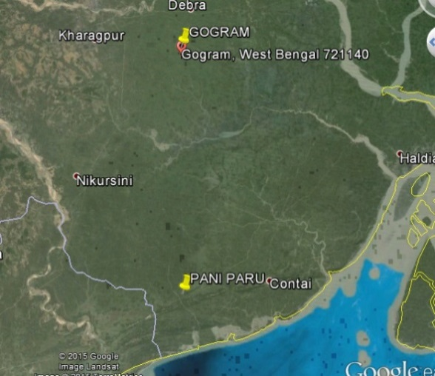

In both the locations examination of drilled sub surface formation shows medium to fine sand with clay separations. The sand shows the presence of deeper aquifer systems. Only after fully establishing the subsurface aquifer system geometry one can make an assessment of the nature of the formation of the lithological system and the influence of ancient sea coast movements on the area. Data on groundwater level fluctuations, aquifer characteristics (based on pumping test data) groundwater balance will help quantify the groundwater flow gradient, amount of fresh water entering into the sea, threat of salt water ingress if any.

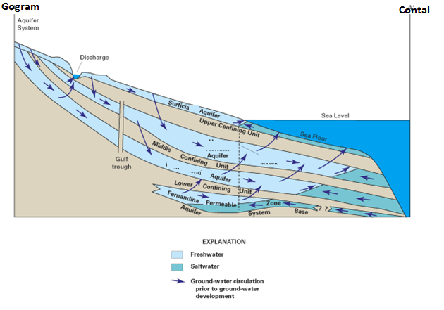

Construction of an idealized section from Gogram to Contai provides the following possibilities:

- Given the understanding that eastern India coast line Mahanadi and Hooghly delta was subjected to marine transgression and regression (sea coming inside the land and retreading back) during the Holocene period (12000 years back) the present day sea in Contai could have been far inland into the land reaching close to Gogram. In Puri (Orissa) coast the sea was 40 kms inland from the present day sea shore.
- As sea moves inland and retreats historical seawater got entrapped in the clays which are at depths.
- In some areas the rainfall recharge has completely flushed old saline water while in some areas the fossil water is still entrapped. This has always to be kept in mind during tube well design. This can be evaluated using borehole logging data and systematic interpretation of water quality data.
- During the design of the tube wells it has to be precisely ensured that no clay is part of the screened portion. This will create problem not only for that particular tube well but could also impact other neighbouring wells thus contaminating the entire aquifer system.
- Borehole logging is extremely important tool to guide in well design and placement of the screens.
- Any fossil obtained as drill cuttings during tube well drilling need to be safely preserved and sent to paleontology lab in the university geology department to identify its origin (fresh water/sea water).
- Study of the fossils will help understand the history of sea water movement and its impact on the current hydrogeology
- Some of the representative tube wells need to be fitted with DWLR, discharge measurement device to monitor water levels, water quality, and discharge.
- Groundwater modelling studies shall help understand the system as well help device plans for sustainable groundwater development, management in these areas.

Computer Model study can answer questions related to:

- Number of tube wells that can be constructed
- Quantity of groundwater that can be safely pumped
- particular aquifers that need protection
- quantum of fresh water getting drained into the sea
- nature of connate salt water entrapped in the clays, and opportunities for flushing.
- any threat of future reversal in groundwater gradient

Annexure B.3: Surface Schemes

Summary of observation:

Improved compaction methods: For compaction of earth, rollers (plain / sheep foot etc.) are not deployed. Huge earth work is reported to have been compacted by hand rammer. Compaction of earth work by rollers is essential for achieving designed density.

- Tanks: The deepening of tank bed is done for enhancement of capacity of the storage:

  - Earth is excavated in the basin from the toe line of dam itself which may affect the safety of dam section. Normally safe distance of 10H is kept from toe of dam where H is depth of water. This could be judiciously reduced if required.
  - Impervious soil cover (black cotton soil) existing in many of the basins is being removed and pervious soil below is exposed. This may result in water loss due to seepage loss from storage water. The issue needs examination.

- The huge quantity of earth obtained from excavation is being dumped all around the dam and adjoining villages. Dumping may be done in planned way at pre decided locations with proper spreading and dressing.

- The floor of Energy Dissipation Arrangement (EDA) has been casted but the baffle / friction blocks are to be constructed. The reinforcement has not been embedded for friction blocks. For stability of blocks reinforcement should have been embedded. Now it may be embedded in 30 cm rich wearing coat which is to be casted.

- The concrete of weir body wall is being plastered for final finish. Normally concrete is not plastered.

- Design of surplus structure (weir) is done as broad crested weir. If design is done as sharp crested weir then the structure could be more economical (by about 15%). As value of Coefficient of Discharge (Cd) for broad crested weir is 1.72 and Cd for sharp crested weir is 2.10. The advantages and disadvantages may be evaluated and proper design may be adopted.

Mobile Laboratories to be installed in the mobile van

Testing of raw material is rarely done and on basis of eye judgement work is Okayed. OMC and MDD are not worked out to ascertain proper compaction. There is no departmental lab or 3rd party supervision to assist the departmental officers. The department has reported to have developed OK card but is not implemented at site. The OK card system should be implemented at the earliest. For compaction of earth, rollers (plain / sheep foot etc.) should be deployed. Presently quite substantial quantity of earth work is compacted by hand rammer. Compaction of earth work by rollers is essential for achievement of designed density. For testing of quality of raw material and final products the department may establish 6 mobile laboratories (each mobile laboratory may cover three districts). Each of these laboratories shall be fitted in a van. One qualified trained quality engineer and one lab assistant will be attached with each mobile lab – van and the following (and other felt necessary) equipment shall be provided:

  - Rebound Hammers for non-destructive testing
  - Digital Moisture Meter
  - Digital Balance
  - Digital Temperature Meter ( 0-500⁰ C)
  - IS Sieves
  - Degree of Compaction testing equipment for earthwork.
  - Spread of Aggregate?
  - Slump testing equipment for concrete
  - Flow measuring table for morter

Safety and Environmental aspect:

The deepening of tank bed is done for enhancement of capacity of the dam. In this activity. a) Earth is excavated in the tank basin from the toe line of dam itself which may affect the safety of dam section. Normally safe distance of 10H is kept from toe of dam where H is depth of water. This could be judiciously reduced if required. b) Impervious soil cover (black cotton soil) existing in many of the basins is being removed and pervious soil below is exposed. This may result in water loss due to seepage from storage water. The issue may be got examined.

- The huge quantity of earth obtained from excavation is being dumped all around the dam and adjoining villages. Dumping may be done in planned way at pre decided locations with proper spreading and dressing. It may also be assured that these spoils are not causing any adverse environmental problem such as water quality and quantity of ground water in the affected area.
- Improvement in designs and construction procedure: Design of surplussing structure (weir) is done as broad crested weir. If design is done as sharp crested weir then the structure could be more economical (by about 15%). As value of Coefficient of Discharge (Cd) for broad crested weir is 1.72 and Cd for sharp crested weir is 2.10. The advantages and disadvantages may be evaluated and proper design may be adopted.
- The floor of Energy Dissipation Arrangement (EDA) has been casted but the baffle blocks are to be constructed. The reinforcement has not been embedded for friction blocks. For stability of these blocks the reinforcement should have been embedded. Now it may be embedded in 30 cm rich wearing coat which is to be casted.
- The concrete of weir body wall is being plastered for final finish. Normally concrete is not plastered.
- Construction planning: For work management the construction plan should be prepared scheme wise to monitor the construction activities. In most of the cases the progress of work is not proportional to the time elapsed. It would be good if a board is displayed at work site showing project data, project area and people benefitted, date of start, date of completion of important activities and cost of project.
- Regarding contract management it is noticed that in some contracts financial progress was shown much behind the time schedule (and also physical progress at site). When asked about it was informed that substantial work has been completed at site but has not been paid (for example Contract 7 0f 2014 - Purulia & Contract BR -6 of Birbhum). Such lag of payments affects the progress.

Some photographs of works in progress District Purulia and Birbhum.
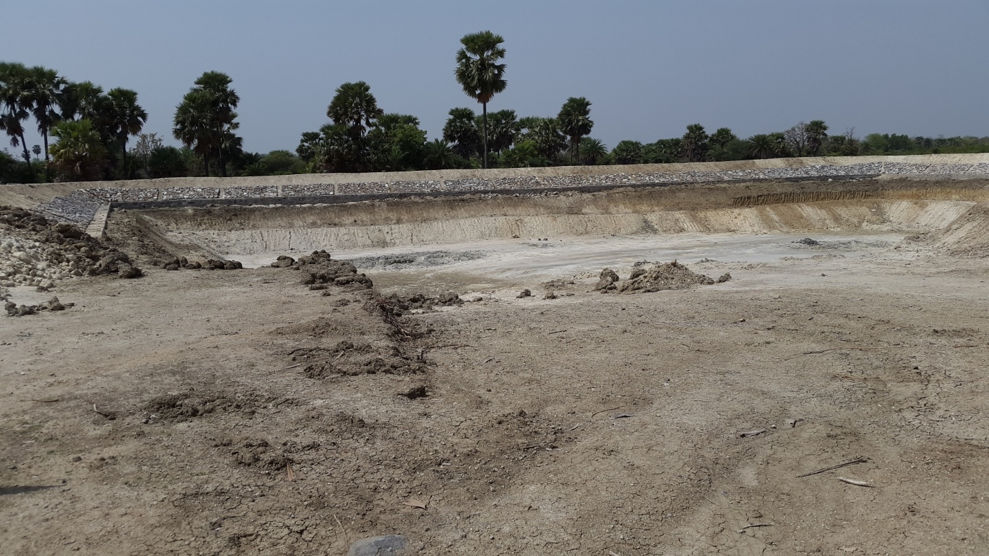
For enhancing storage, earth is removed from toe line of the dam. This has affected safety of the dam section. Further impervious natural clay cover is lost and pervious strata are exposed (at some places). This may result in water loss from reservoir.
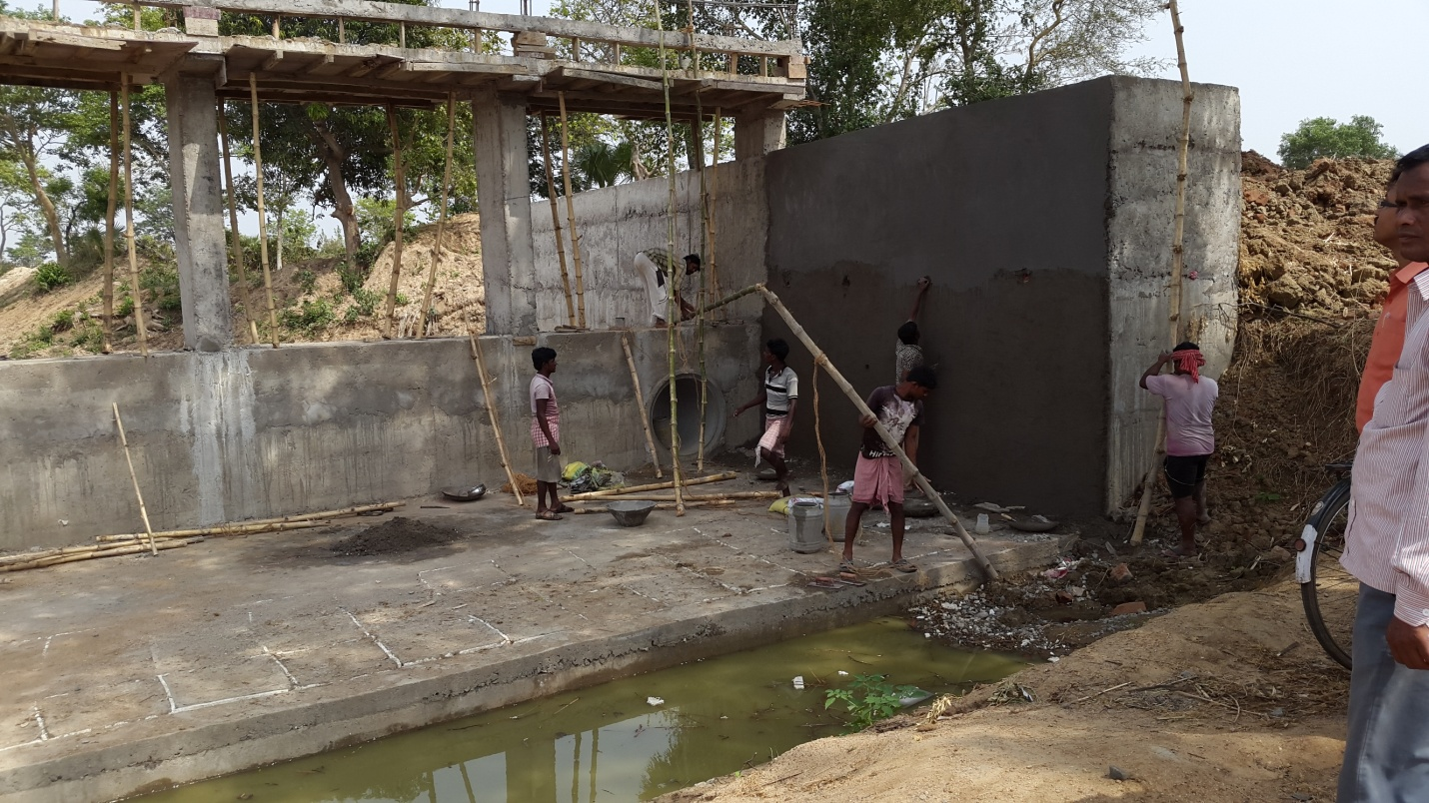
Plastering in progress. The concrete is not generally plastered as it is likely to be peeled out. Efforts should be made to improve the concrete finish.

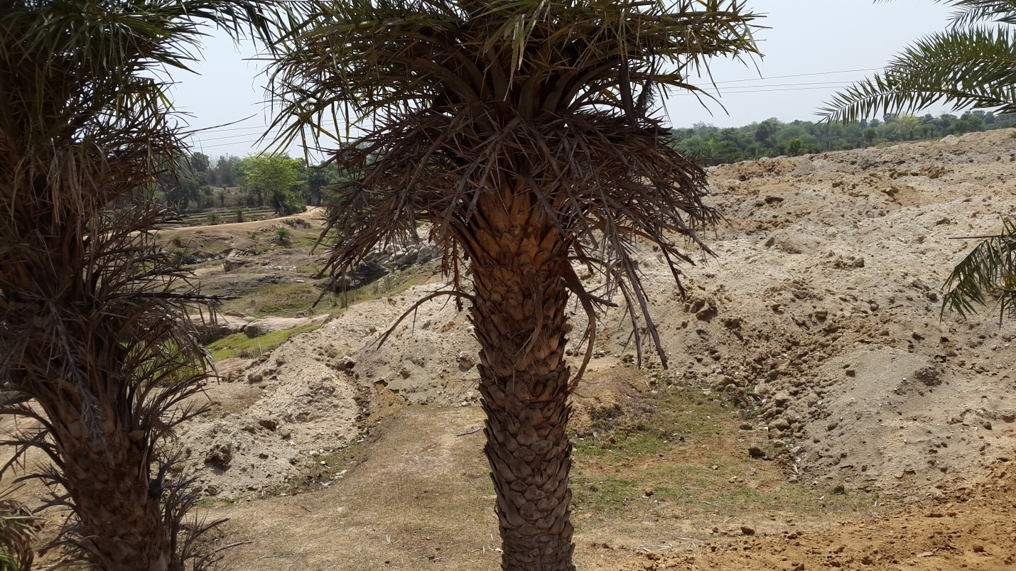
Excavated earth should be dumped in the approved earmarked area.

Annexure B.4: Solar-powered Irrigation Pumps Deployed under WBADMIP

Installation checklist solar water pumps

Sr.No. | Item for inspection | Inspection guideline | Remark
 | Site layout | - Ensure that the site is a shadow free area and not having nearby trees and buildings causing shadow on the array  - Ensure that site is not in a area where water flooding can take place  - Mark south direction on the foundation
 | Solar Panel Installation | - Check all the panels are tightened properly on the structure  - Check module clamps are not putting shadow on the PV panels.  - Check the DC wiring of the PV modules. The wiring should not have any sparking or loose connections.  - The DC wiring should be connected through MC4 connectors. There is no direct joining of cables with MC 4 connectors.  - The AC wires should not be used for DC interconnections.  - Check that all the PV modules are with RFID tag  - Check that the junction boxes are properly sealed.  - The DC wires should be taken through a proper conduit
 | Mounting structure | - Check that the structure is rigid and mounted properly on the foundation  - Ensure that earthling of mounting structure is done properly.  - The earthling of structure and inverter should be separate  - Check, that a lighting arrestor is installed on the mounting structure and have a separate earthing.
 | Inverter/VFD | - Ensure that the input of positive and negatives from array are in the right slots.  - The red wires should be in the red slot and black wires should be in the black slot in the inverter  - Ensure that the installation of inverter is in a covered area and there is no water/rain exposure of the inverter.  - Ensure that Inverter is mounted properly on the mounting structure. It should not be loose.  - Ensure sufficient extra wiring of DC and AC side so that it can be moved for maintenance  - Inverter should be easily accessible for maintenance  - Inverter should be placed in a ventilated area for proper cooling  - Ensure that inverter earthling is done properly  - Ensure that the inverter has a data logger with it and has display of all the parameters.
 | Pump-set | - Ensure that pump is mounted on a rigid structure (in case of a surface mounted pump)  - Ensure that there is no air leakage in the suction side of the pump  - Check the pump flow through a portable tank of sufficient capacity and measure the flow rate of water in lt/s  - Measure the current consumption of the pump through a tong tester and it should be within the range of its technical specifications
 | Lighting | - Ensure that two CLFs of 23 Watt each are installed  - Ensure that the light pole is mounted on the north side of the PV array structure only.
 | Monitoring system | - Ensure that a digital type of flow meter is installed on the outlet of the pump  - Ensure that a data logger is installed along with the inverter  - Ensure that the Inverter and the data logger are housed in a mounting box with a lock and key.  - Ensure that the supplier has provided a O&M manual for the solar pumping system

Signature of the commissioning engineer Signature of the WUA representative

Annexure B.5: Opportunities to install micro-grid in West Bengal

Solar PV micro grids can be set up in the villages for betterment of lives of rural India in solar resource regions. India has about 9 million diesel pump sets have been deployed by farmers for irrigation in India. Out of these 9 million pump sets, 4.5 million diesel pump sets are located in solar resource regions and have the land for installation Solar PV system. India has about 400,000 telecommunication towers, out of which 84,000 telecom towers powered by diesel generating sets are located in solar resource regions and having land for installation of solar PV.

The installation of micro grids in villages can be done through a public private partnership model. Residents of a village must come together and agree to either purchase power from an IPP which install, own, and operate the solar minigrid system. Installation of mini-grid system requires the land, which can be provided by the local panchayat or through the villagers. Under this IPP model the land should be treated equity by the business enterprise. The local technicians can be trained on the O&M activity. If the installation of minigrid is in association with a telecom company which has existing telecom tower running on diesel generating set, the business model becomes financially viable with a small upfront support from the government.

The typical cost of a mini grid system is about 2 lakh per kW, which implies that a system of 30kWp would need an investment of ~Rs. 60 lakhs upfront. To start with, some investments can be through soft loan programs of the solar off grid projects by GOI, and some subsidy can be available from GOI subsidy program.

The system configuration proposed is of 30 KWp, with a hybrid inverter, which can take up input from diesel generating sets, electricity grid, battery, and from the solar arrays. A combination of hub and spoke model can be adopted where the minigrid can feed the nearby residents through solar power mini grid system, and the distant residents can come and pick up the charged batteries and leave their discharged batteries at the charging station. The power can be also available for the telecom tower as well. The system can also feed electricity to the community based water pumping system.

Minutes of meeting with the industries on viability of mini grid systems under the Project

A meeting with various industry experts to assess the techno-economic feasibility installing the solar mini grid systems in the villages where the access to grid power is not available to meet their domestic power and water pumping requirements. The systems can be designed to meet the minimum service requirements, of the villagers, for the electricity lighting, water pumping, lighting, fans, etc. As there is a significant penetration of telecom towers in villages, which also run mostly on diesel generating sets, the mini-grid system can be clubbed with the existing DG sets available along with the telecom towers to improve the system reliability and the commercial feasibility. The stakeholders suggested an upfront capital support by World Bank and collecting recurring cost through the user communities to make the system self sustainable. It was proposed that the energy storage systems in the form of batteries can be used as a central storage facility powered by the proposed mini- grid system and the distant locations where the electricity wiring becomes difficult, a portable battery system supply chain can be established in the form of recharging the batteries on chargeable fees basis. This will also generate additional revenue to the minigrid power user association. There have been earlier pilots also on installations, and typical individual system used in the mini grid is of 30-100 KW system, with battery storage. A typical mini grid system cost is in the range of about Rs. 150-200/Wp, which is almost double than the conventional grid connected systems. The high cost is due to the battery backup required in the system. However if the mini grid system is integrated with the water pumping requirement of the WUAs, a configuration of mini-grid system of 30 kWp which meets the water pumping needs of the community for irrigation purpose as well the same solar array can also be used for the lighting purpose for the community.

The major issues identified were on identifying the land for installation of the mini-grid system. Whether the land needs to be procured or can be taken on lease from the local panchayat. The primary driver to the mini-grid system shall be the savings on the diesel consumption in the water pumping as well as in the telecom tower operations. It was recognised that displacing diesel consumption with solar would improve the techno-commercial viability of the mini-grid introduction in the communities. The system can be designed in such a way that the basic energy/power requirements of the communities for water pumping, lighting, grain grinding, water purification, etc can be met through the introduction of mini-grid system.

Installation of the proposed system can be coupled with the various monitoring systems, to collect the different parameters on day to day basis. These parameters can be of solar radiation, water pumped, energy (electricity) consumption in different applications, as well as by different users, battery charging requirements, etc. This will help in designing a large scale mini grid program to replicate in other locations.

Annexure C1: Agriculture Support Services

The Agricultural Support Services (ASS) component aims at enhancing productivity and diversification of agriculture in the project areas by dissemination and adoption of improved production and water management technologies for agriculture, horticulture and fisheries; and more efficient and effective farm advisory services. The delay in commissioning of new schemes also affected the progress of implementation of the component.

Demonstrating Improved Technologies: The project has been able to successfully implement 2,198 agricultural demonstrations (11,987 expected at the end of the project), 675 horticulture demonstrations (8750 expected at the end of the project), and 26 fisheries demonstrations (117 expected at the end of the project) so far. The total numbers of farmers trained through these demonstrations are 6,432 against the targeted 21,138 by the end of the project.

Increasing Yield: As the schemes have been recently commissioned and water has been made available since mid of 2014, it is too early to report on the benefits accrued from post scheme implementation on productivity and adoption. However, the crop cuttings done through these demonstrations have revealed that productivity of paddy improved to 3.5 tons per ha from the baseline of 2.9 tons per ha. The productivity of vegetables improved to 12.73tonsper ha from the baseline of 10.3 tonsper ha.Similarly, mustard recorded a productivity improvement of1.1tons per ha from the baseline of 0.4 tons per ha.

The SPMU agriculture unit has been strengthened with one agriculture specialist and one horticulture specialist. Aside from this, one Agriculture Coordinatorand one Fishery Coordinator are in place with respective line departments. The position of Horticulture Coordinator has fallen vacant and should be filled on a priority basis. The agricultural specialists and Project Program Promoters (PPPs) in the DPMUs are in place in all 18 project districts and they are providingAgriculture Support Services in their respective districts. 7 Fishery Specialists and 6 Project Program Promoters (PPPs) are in place to implement fishery activities in 7 districts, i.e. Jalpaiguri, Darjeeling, Birbhum, Burdwan, Purulia, Bankura, and Paschim Midnapore—identified for implementation of fishery activities. The PPPs are placed at the Block-level in respective districts and are responsible for implementing Farmer Field Schools (FFS) in agriculture, horticulture and fisheries.

One Community Service Provider (CSP) is planned for each project village to assist in Agriculture Support Services (ASS) implementation. The recruitment of CSPs is critical for effective implementation of ASS activities and should be completed on a priority basis. The CSPs will also assist in FFS implementation, collect data of individual farmers and consolidate farmers’ data at the village-level.

Farmer Field Schools (FFS): ASS is using Farmer Field Schools as a vehicle to increase farmer outreach and improve farmer practices. To initiate the FFS activities, a host of trainings were organized for the SPMU and DPMU staff. These include: FFS Orientation Workshop for PPPs (28th Oct to 1st Nov 2014), FFS Orientation for Fishery Specialists and PPPs (20th to 21st Nov 2014), FFS Materials Development Workshop for Agriculture Specialists of DPMUs and SOs (12th to 14th January 2015), FFS Training of Trainers (ToT) workshop for Agriculture Specialists of DPMUs and SOs (16th to 21st Feb 2015). The project has initiated FFS in pre-kharif in14 districts, one FFS in each of the 14 districts (i.e. 12 in field crops and 2 in horticulture crops) covering 211 farmers. FFS in fishery will be initiated in June 2015.

A ‘bio-village pilot’ has been initiated in 6 villages in 6 different agro-climatic zones for establishing and disseminating village-wide good agricultural practices. The results are still emerging and will be scaled up to 15 villages if found successful. Although, the project has developed good rapport with the Agricultural Department and their officers are providing the necessary advisory services, on the job training to field staff is yet to be streamlined.

Physical Progress Indicators

Indicator | Unit | Progress till March 2014 | Progress till date (March 2015) | Total Achievement | End of Project target
Agriculture demonstrations | Nos. | 691 | 1507 | 2198 | 11987
 | Ha | 276 | 602 | 879 | 4795
Horticulture demonstrations | Nos. | 165 | 510 | 675 | 8750
 | Ha | 22 | 68 | 90 | 1166
No. of fisheries demonstrations | Nos. | Nil | 47 | 47 | 117
 | Ha | Nil | 11.84 | 11.84 | 989
Farmers trained | Nos. | 1866 | 3745 (ag), 510 (horti), 311 (Fisheries) | 6432 | 21138
Farmers taken on exposure visits | batches | 2 | 23 | 25 | 300
Schemes covered under fisheries | Nos. | Nil | 30 |  | 117
No. of FIGs trained | Nos. | Nil | 26 | 26 | 120
Farmers adopting Improved agricultural practices | Ha | 106 (1%) | 1224 | 1330 | 40%
Farmers adopting SRI practices |  |  | 214 | 214
Departmental staff trained – (Agriculture, Horticulture & Fisheries) | Nos. | Nil | Nil |  | 2000
No. of Bio villages established | nos. | 6 in progress | 6 in progress | 6 in progress | 50
No. of FFS initiated in Agriculture& Horticulture |  |  | 14 | 14
Farmer Participants |  |  | 211 | 211
Recommendations

Recommendations for improvement are broadly categorized under crop demonstration and Farmer Field Schools:

Crop Demonstrations:
- In command areas where MI schemes have been handed over, the following process should guide the selection of the crop, resource farmer, and demonstration plot:
- Use GIS map as a guiding tool to identify farm plots that have good crop growth—an indicator of high productivity;
- Enquire with the particular farmer about the agriculture practices observed in the farm plot with good crop growth;
- Reach common understanding with the farmer on Good Agriculture Practices for the particular crop and encourage him to be the Community Resource Person for the particular crop. Use creative social incentives (like putting the farmers’ picture on the sign board of FFS /demonstration plot) to motivate the farmer to undertake farmer-to-farmer outreach;
- To choose a crop for demonstration, conduct a survey of the MI scheme command area to identify a crop that has potential to boost farmers’ income across the scheme and has appropriate crop-water requirement;
- Develop a set of Good Agriculture Practices for the chosen crop and introduce it as a crop demonstration for the particular scheme.

Farmer Field School (FFS):

- FFS should be redesigned as Farmer Water Schools (FWS) to ensure effective integration of hydrological monitoring components into ASS activities;
- Farmers’ crop choices in a MI scheme should be based on crop-water requirement and water availability in the scheme;
- Irrigation scheduling, number of irrigations, irrigation at critical crop stages, crop-water requirement should be integrated into FWS;
- FWS discussions or learning should be shared regularly by participants in the monthly WUA meetings.

The Mission comprised Mmes/Messrs. Anju Gaur (Sr. Water Resources Specialist & Task Team Leader), Jacqueline Julian (Operations Analyst), ManvinderMamak (Sr. Financial Management Specialist), Satyanarayan Panda (Procurement Specialist), Parthapriya Ghosh (Sr. Social Development Specialist), C.S.Renjit (Institution Specialist Consultant), K.A.S. Mani (Groundwater Specialist – Consultant), Anil Borwanker (Design and Construction Consultant) Sanjay Vashisht (Solar energy expert) and KondaChawa (Farmer Field Schools Specialist)

