**ICM in Paddy: FFS Session Guides**

**Farmer Field Schools in Paddy (kharif)**

**Hypothesis:** ICM practices in paddy will improve all the yield attributing components of the crop (number of tillers, panicle size, number of filled grains per panicle, and test weight) resulting in higher productivity.

**Package of practices**

* Integrated Crop Management (ICM)/ Good Agricultural practices
* Soil testing
* Seed selection and management
* Spacing of seedlings (line-to-line and plant-to-plant)
* Nutrient management
* Pest management
* Weed management
* Water management
* Crop-harvesting

**Pre-FFS Session: Introduction to FFS**

Session schedule

|  |  |  |  |  |
| --- | --- | --- | --- | --- |
|  | **Topic** | **Facilitation methods** | **Materials** | **Time** |
| 1 | Participant Introductions & Roll Call | Dyad technique |  | 30 min |
| 2 | FFS Objectives | Large group discussion | Charts, markers and pictures | 30 min |
| 3 | Pre-Ballot Box Exercise (BBE) | Exercise | Charts, markers whistle, card boards, nails, long sticks, knife, thread, ballot boxes | 60 min |
| 4 | Norms setting | Large group discussion | Pictures, charts, markers, story script: Father and two sons | 20 min |
| 5 | Formation of Small Learning Groups | Large group discussion | 10 stones of medium size, different varieties of stones Charts, markers and board | 25 min |
| 6 | FFS Pledge | Large group |  | 10 min |
| 7 | Gender-work Matrix | Large group discussion | Charts and markers | 30 min |
| 8 | Session Evaluation & Roll Call | Large group discussion | Charts and markers | 10 min |

**Learning objectives:** By the end of the session, participants would have:

* Introduced each other,
* Discussed objectives of Farmer Field School (FFS),
* Participated in pre-ballot box exercise,
* Formed small learning groups and set norms for smooth and effective conduct of FFS sessions; and
* Discussed the role of women in agriculture and water management.

**Process:**

1. **Participant Introductions** Time: 30 min.

* Ask participants to pair up with the person on their right
* After all participants have formed into pairs, ask them to introduce themselves to their partner. Participants should use the following to guide the introductions:
  + Name,
  + Village, and
  + Position in WUA or any other institution.
* Later, ask each participant in the pairs to introduce his/her partner to the large group.
* Continue the introductions till all the participants introduce one another.
* Call out participants names and mark their attendance.

1. **FFS objectives** Time: 30 min

* Ask farmer participants to reflect for a minute on crop management /production issues (crop inputs, crop growth, water availability, marketing, etc.) affecting them.
* Ask two or three participants to share problems faced in crop production.
* Later, encourage participants to share issues that need to be discussed in the season-long FFS that would provide a good understanding of crop growth and crop-water management techniques.
* Ensure that each participant gets a chance to share their thoughts. Note the participants’ ideas on a chart.
* After all ideas have been shared, review the list of ideas. Thank the participants for the inputs and share the FFS objectives.
* Request participants to compare their expectations with the FFS objectives and make additions to the FFS objectives if needed.
* Following these discussions, finalize the objectives for the season-long FFS.

|  |
| --- |
| The FFS objectives are as follows:   * Empower farmers with knowledge and skills in making on-farm decisions, * Sensitize farmers on the need for collective action, * Sharpen the farmers’ ability to make critical and informed decisions on crop plans, * Sensitize farmers on new ways of thinking and resolving issues. |

1. **Pre-Ballot Box Exercise** Time: 60 min.

* State the purpose of Ballot Box Exercise (BBE).The purpose of BBE is to assess participants’ awareness on crop growth, pest and disease management, nutrient management and other water use efficiency methods. The pre-BBE results will help determine topics that need to be focused in FFS sessions.
* After sharing the purpose of BBE, assign a registration number to each participant.
* 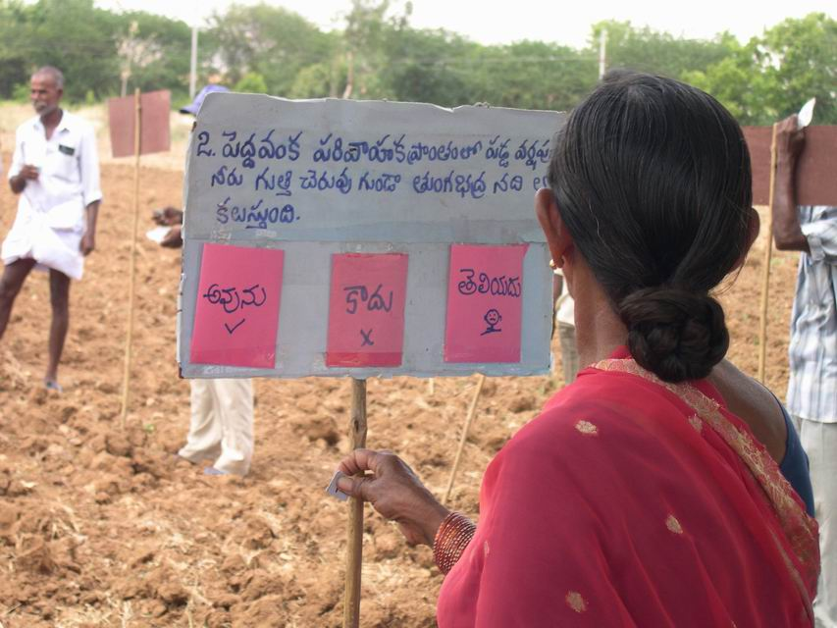Give each participant 30 ballot slips (number of slips should equal the number of questions) bearing his/her registration number.
* Ask each participant to stand facing a cardboard station (i.e. one participant in front of one cardboard station).
* Each cardboard station has a question and three options (**YES, NO,** and **NO IDEA**). Each option has a cover (envelope) beneath for participants to drop their ballot.
* Ask participants to read the question, choose the appropriate option and drop the ballot in the cover beneath that option.
* On blowing the whistle, participants move to the next cardboard station to read the question and cast their votes for the question.
* Participants exercise their ballot at each station.

|  |
| --- |
| Tips to facilitator   * Before the conduct of the exercise, explain all the instructions to the participants. * Organize a mock demonstration before the actual conduct of the exercise. * Assist illiterate or semi-literate farmers by reading the question and options. * Only one participant should stand near one cardboard station. * Do not allow two or more persons to crowd near one cardboard station. |

|  |
| --- |
| Analysis of BBE Results   * First take out chits from ‘No Idea’ pocket, count them and record on a chart. * After this, go to the pocket with least number of chits, count them and record on a chart. * Finally record the third one by deducting the sum of the two from the total participants (There is no need to count the chits in the third pocket). * Categorize the questions based on similarity. * Calculate cumulative right/ wrong/ no idea question-wise and individual farmer-wise. * Calculate percentages. * Based on the results, determine topics that need focused attention in FFS. |

1. **Norm setting** Time: 20 min.

* Inform the participants that it is important to lay down norms for the effective conduct of Farmer Field School sessions.
* 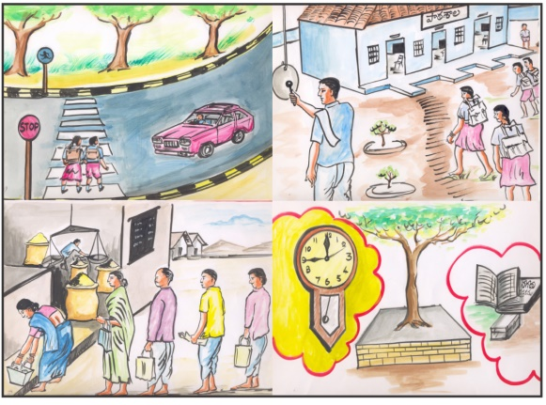Show the following pictures and generate a discussion on the norms observed in the pictures. Likewise, ask participants to list the norms for effective conduct of Farmer Field Schools. Jot them down on a chart paper.
* Read aloud the list and finalize the norms for the effective conduct of Farmer Field Schools.
* Write the norms, on a chart and read them aloud. Ensure that the norms chart is displayed in every session.

|  |
| --- |
| Tips to facilitator:  Encourage participants to setup norms on the following:   * Time maintenance * Transportation * Venue, responsibilities of host teams in the conduct of session * Regular attendance (no substitution) * Mutual respect * Cell phone usage |

1. **Formation of Small Learning Groups** Time: 25 min**.**

* Ask participants to list the advantages of working and learning in small groups.
* Write participants responses on a chart paper and summarize using the points below:
  + It is easier for all members to participate and share their experiences /ideas / knowledge in a small group.
  + The opportunities to learn new skills and knowledge are more in small groups.
  + Enables mutual learning and promotes teamwork.
* Ask participants for ideas on how to group them into smaller learning groups.
* Use the criteria laid out by the participants to form small learning groups.
* Ask participants in each learning groups to choose a name and a leader for their group.
* Inform members that the group leaders have the following responsibilities:
  + Ensure regular attendance of all members in their small learning group to all FFS sessions.
  + Lead the discussion and ensure that all group members have equal opportunities to participate and share their experiences/knowledge/ideas.
  + Encourage every group member to present the groups work in large group.
* Later, ask the leader of each small learning group to come forward and state their group’s name and members.
* Conclude the discussion by stating that participants in these small groups will remain as a cohesive learning unit for the entire duration of the Farmer Field School.

1. **FFS Pledge** Time: 10 min.

* Ask participants: why do school children begin their day with a pledge?
* Elicit responses from the large group and state that a pledge is to inculcate a discipline in our mind and enables us to take work more seriously.
* Ask participants what should be the content /theme of the FFS pledge. Check if any of the participants is willing to volunteer to draft a pledge.
* State that it will be like promising ourselves that we will save our groundwater resources together.
* At the end, ask participants, if they wish start to future FFS sessions with a FFS pledge.

1. **Gender work matrix** Time: 30 min.

* Tell participants that often the important role of women in agriculture and water management goes unnoticed. Emphasize the critical role that women play in effective crop-production, crop-water management, pest and disease management, and post-harvest management. This exercise is done to help participants recognize the important role women play in agriculture.
* First, ask participants to list the agriculture activities in which women are involved. Write participants responses on a chart and sequence them in the order in which the agricultural operations are implemented.
* Later, present the following gender-work matrix in agriculture and complete it with participants’ inputs.

| **S. No.** | **Agricultural Operations** | **No of days ( 8 hrs/day)** | | **Decision** | |
| --- | --- | --- | --- | --- | --- |
| **Women** | **Men** | **Women** | **Men** |
| 1 | Ploughing / Harrowing |  |  |  |  |
| 2 | Cleaning field |  |  |  |  |
| 3 | FYM - Transport - Application |  |  |  |  |
| 4 | Seed selection |  |  |  |  |
| 5 | Seed purchase |  |  |  |  |
| 6 | Ridge & furrow preparation |  |  |  |  |
| 7 | Sowing |  |  |  |  |
| 8 | Irrigation |  |  |  |  |
| 9 | Weeding |  |  |  |  |
| 10 | Fertilizer/ purchase |  |  |  |  |
| 11 | Fertilizer application |  |  |  |  |
| 12 | Pesticide selection |  |  |  |  |
| 13 | Pesticide purchase |  |  |  |  |
| 14 | Pesticide application |  |  |  |  |
| 15 | Harvest |  |  |  |  |
| 16 | Marketing transport |  |  |  |  |
| 17 | Marketing |  |  |  |  |
| 18 | Money transaction |  |  |  |  |

* Ask participants to share their observations from participating in the exercise and draw conclusions about the critical role of women in agriculture and water management.

1. **Session Evaluation** Time: 10min.

* Ask the following questions in large group to evaluate the day’s session.
  + What did you learn today?
  + How are these useful to you?
* Note participants’ feedback and thank everyone for their active participation.
* Before closing the session, call out participants names and mark their attendance.

**FFS Session 1: Soil & Seed Testing**

|  |  |  |  |  |
| --- | --- | --- | --- | --- |
|  | **Topic** | **Facilitation methods** | **Materials** | **Time** |
| 1 | Recap & Roll Call | Large group | Charts and markers | 15 min |
| 2 | Share Pre-BBE Results | Large group | Charts and markers | 15 min |
| 3 | Soil testing | Demonstration | Spade, crow bar, polythene bags, and tags | 45 min |
| 4 | Germination test | Experiment | Tea plate, newspaper, seeds, and water | 30 min |
| 5 | Institutional Support Action Plan | Exercise | Charts and markers | 45 min |
| 6 | Session Evaluation & Roll Call | Large group discussion | Charts and markers | 10 min |

**Process**:

1. **Recap & Participants Attendance** Time: 15 min

* Welcome participants to the session.
* Ask participants to recap the concepts and learning from previous session.
* List the participants responses on a chart and summarize the concepts and learning from the previous session.
* Call out participants names and mark their attendance.

1. **Share Pre-BBE Results** Time: 15 min

* Inform participants that performance of the whole group on different sections (topics) or individual questions will be shared.
* Individual results will be shared only with those who are interested in knowing their own performance.
* Share BBE results with the participants. Explain the process used to analyse BBE results.

1. **Soil Testing** Time: 45 min

* Soil samples should be collected from 5 different places in a plot—i.e. one sample each from 4 corners and middle of the plot.
* Soil sample should be collected from 6 inches below the surface, i.e. after removing the top soil. The quantity of soil in each sample should be 500 grams.
* The collected soil samples should be dried in sun to remove moisture.
* Later, the dried samples are grounded manually with a wooden mortar.
* Following this, the 5 samples are mixed to form a composite sample. 500 grams of the composite sample should be sent to the laboratory for soil analysis.

1. **Germination Test** Time: 30 min

* Germination test is done to assess the quality of seed
* Place a moist blotting paper (newspaper) in a tea plate.
* Put 100 randomly collected seeds on the blotting paper. Fill the tea plate with water. After 10 minutes, drain the excess water.
* Cover the wet seeds with another plate and remove it after two days.
* Periodically moisten the blotting paper up to seventh day.
* Count the germination on the seventh day and assess the vigour of the seed.
* In case of paddy the quality of the seed is considered poor, if the germination count is less than 80 per cent.

1. **Institutional support mapping and action plan** Time: 45 min

* Ask farmers to list the types of support they need for growing the particular crop and implementing FFS. Ask them identify the community institutions, government departments and agencies from which to access support. Use a venn diagram to map the support needed for growing particular crop and implementing FFS.
* 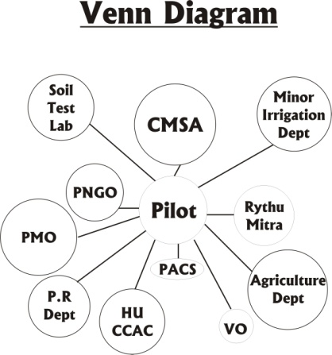Use circles to represent each institution, department, organization, or group. The size of the circle indicates the importance of the particular institution for growing the particular crop and implementing FFS. The distance of a circle indicates the difficulty in accessing the particular institution/department/ organization.
* Later, ask participants to prepare an action plan (clearly specifying the what, when, and who) for accessing support from various sources for growing the particular crop and implementing FFS.
* Use the table below to develop an action plan

| **S. No.** | **Assistance needed** | **Institution/ Department/ Organization** | **By when (Timeline)** | **Responsibility** |
| --- | --- | --- | --- | --- |
|  |  |  |  |  |
|  |  |  |  |  |

1. **Session Evaluation** Time: 10min.

* Ask the following questions in large group to evaluate the day’s session.
  + What did you learn today?
  + How are these useful to you?
* Note participants’ feedback and thank everyone for their active participation.
* Before closing the session, call out participants names and mark their attendance.

**FFS Session 2: Seed-bed Preparation**

|  |  |  |  |  |  |
| --- | --- | --- | --- | --- | --- |
|  | **Topic** | **Facilitation methods** | **Materials** | | **Time** |
| 1 | Recap & Roll Call | Large group | Charts and markers | 15 min | |
| 2 | Seed-bed preparation  - Water management  -Tillage operations  - Nutrient management | Demonstration | Spade and nylon rope Organic manure and NPK | | 60 min |
| 3 | Seed treatment & Sowing operations | Demonstration | Seeds, carbandazim (Bavistin), common salt, water, bucket cloth bag, and paddy straw. | | 30 min |
| 4 | Importance of Teamwork | Small group work | Thread roll, soft drink bottle, and pens | | 30 min |
| 5 | Session Evaluation & Roll Call | Large group discussion | Charts and markers | | 10 min |

**Process**:

1. **Recap & Participants Attendance** Time: 15 min

* Welcome participants to the session.
* Ask participants to recap the concepts and learning from previous session.
* List the participants responses on a chart and summarize the concepts and learning from the previous session.
* Call out participants names and mark their attendance.

1. **Seed-bed Preparation** Time: 60 min

* To grow one acre of paddy, a seed bed of 1/10 acre should be prepared and maintained.
* Irrigate the seed-bed and ensure 3 to 4 cm of submergence for ploughing.
* Tillage operations: plough the field at least twice with a country plough or power tiller. Remove the weeds.
* Nutrient management: spread 500 kilos of Farm Yard Manure evenly in the field. Later prepare a mixture of NPK, by mixing 2 kilos each of Nitrogen, Phosphate, and Potash. Spread the mixture with hand uniformly in the seed bed.

1. **Seed Treatment & Sowing** Time: 30 min

* Seeds are treated one-day prior to sowing with @ rate of 2 to 2.5 gram of Carbendazim (powder) for one kilogram of seed to control seed borne diseases. Treated seeds are soaked in saline water (150 gm salt/ 1 litre water). After 10 minutes, remove the seeds that are still floating. The soaked seed should be put in a cloth bag and put inside a straw heap for germination. The time duration for germination is 24 hours in Kharif and 72 hours in rabi.
* The sprouted seeds should be sown in the wet seed bed with a seeding density of 50 gms per square meter.

1. **Importance of Teamwork** Time: 30 min

* This exercise is to help farmers to recognize the need for cooperation amongst office bearers for effective functioning of the WUA.
* Divide participants into small groups of five. Ask each group to have its members stand in a circle facing inwards. Tie five strings of equal length (3 meters) to a pen.
* Give one pen with strings tied to it to each group. Ask each group member to hold the loose end of one string. Place the bottle of soft drink on the ground a little away from the centre of the group. Ask the group members to coordinate their actions to gently drop the ball pen into the soft drink bottle. The first group to complete the activity will be declared as the winner.
* After the game, ask the following questions:
  + What are the reasons for winning?
  + What are the reasons for not winning?
* Encourage participants to discuss the need for cooperation amongst executive body members of WUA for effective functioning of the group, establishing functional linkages and finding solutions to problems that their group is facing.

1. **Session Evaluation** Time: 10min.

* Ask the following questions in large group to evaluate the day’s session.
  + What did you learn today?
  + How are these useful to you?
* Note participants’ feedback and thank everyone for their active participation.
* Before closing the session, call out participants names and mark their attendance.

**Session 3: Transplantation**

|  |  |  |  |  |  |  |
| --- | --- | --- | --- | --- | --- | --- |
|  | | **Topic** | **Facilitation methods** | | **Materials** | **Time** |
| 1 | Recap & Roll Call | | Large group | Charts and markers | | 15 min | |
| 2 | Pre-Transplantation  - Seedling age  - Seedling uprooting  - Field preparation  - Weed & Nutrient management  - Water management | | Demonstration |  | | 30 min | |
| 3 | Transplantation  - Number of seedling per hill  - Spacing | | Demonstration |  | | 30 min | |
| 4 | Post-Transplantation  - Weed & Nutrient Management  - Water management | | Lecture |  | | 15 min | |
| 5 | | Group dynamic: WUA assets maintenance | Story, Large group discussion | | Script of the story: The guru and his disciples; Charts and markers | 30 min |
| 6 | | Session Evaluation & Roll Call | Large group discussion | | Charts and markers | 10 min |

**Process**:

1. **Recap & Roll Call** Time: 15 min

* Welcome participants to the session.
* Ask participants to recap the concepts and learning from previous session.
* List the participants responses on a chart and summarize the concepts and learning from the previous session.
* Call out participants names and mark their attendance.

1. **Pre-Transplantation** Time: 30 min

* Seedling Age: A seedling is ready for transplantation when it attains 4 to 5 leaves stage (approximately 3 to 4 weeks).
* Field Preparation: Irrigate the main field and ensure 3 to 4 cm of submergence for ploughing. Plough the field at least twice with a country plough or power tiller or tractor. Remove the weeds. Level the field with a ladder.
* Nutrient management: spread 2 tons of Farm Yard Manure evenly in the field. Dosage of nutrients will depend on soil test results. Of the total recommended dosage, ¼ of Nitrogen, total phosphate, and ¾ of Potash is to be given during land preparation. Each of the nutrients is spread separately. Now the field is ready for transplanting
* Seedling uprooting: Irrigate the seed-bed and ensure 3 to 4 cm of submergence for at least one hour to facilitate proper uprooting. The uprooted seedling should be thoroughly washed so that soil is removed from the roots. This ensures easy separation of seedlings.

1. **Transplantation** Time: 30 min

* Number of Seedling per Hill: Two to three seedlings should be transplanted per hill.
* Spacing: a spacing of 20 cms line-to-line and 15cm plant-to-plant is to be maintained.
* Skip a row of 30 cm after every 10 rows for ease of monitoring the crop.

1. **Post-Transplantation** Time: 15 min

* Weed & Nutrient Management: Weedicide should be applied 3 to 4 days after transplantation. ½ of the prescribed Nitrogen is applied as top dressing after 15 to 20 days of transplantation. Weeder (or manual weeding) should be applied immediately after the top-dressing for proper aeration, nutrient uptake, and weeding.
* Water Management: From transplantation till 15 days before maturity 2.5 to 5 cm of water level is to be maintained in the field.

1. **Group dynamic-WUA assets maintenance** Time: 30 min.

* Tell participants the following story:

Long ago, there lived a guru who had three disciples. Once day, the guru decided to go on a pilgrimage. The guru’s only property was three sacks of paddy which he decided to give one each to his three disciples. While giving a sack of paddy to each of his disciples, the guru suggested them to use it in the best way possible without wasting it and left on a pilgrimage. The first disciple assumed that his guru might take a long time to return from pilgrimage or not return at all. With this idea, he milled the paddy and ate up all the rice. The second disciple was worried that some animal might eat the paddy or a thief would steal it. So, he kept it beside him all the time and even slept on it. The paddy gradually deteriorated and was destroyed. The third disciple sowed the paddy. By the time the Guru returned from his pilgrimage, he was able to harvest two crops, producing 40 bags of paddy.

* Pose a question in large group: “Which disciple utilized the paddy in the best possible way?”
* List out the participants responses on a chart paper.
* Summarize the discussion by stating that ‘any asset is useless if it is spent or kept idle. It will give us maximum benefit only when utilized in a productive way’.
* Present the institutional support plan prepared by participants in the first session. Review activities listed in the action plan that was to be completed before the start of this session.
* Ask the concerned office bearers /participants to report the progress in accomplishing the tasks.
* Later, discuss challenges encountered and support needed in implementing the institutional support action plan.
* Inform participants that progress on institutional linkages will be reviewed in each session.

1. **Session Evaluation & Roll Call** Time: 10min.

* Ask the following questions in large group to evaluate the day’s session.
  + What did you learn today?
  + How are these useful to you?
* Note participants’ feedback and thank everyone for their active participation.
* Before closing the session, call out participants names and mark their attendance.

**Session 4: Vegetative Growth Stage (Tillering)**

|  |  |  |  |  |
| --- | --- | --- | --- | --- |
|  | **Topic** | **Facilitation methods** | **Materials** | **Time** |
| 1 | Recap & Roll Call | Large group | Charts and markers | 15 min |
| 2 | Agro Ecosystem Analysis (AESA)  - Tillering  - Nutrient management  - Weed management  - Pest management  - Water management | Observation – 20 mins; Discussion, Analysis & Decisions – 30 mins; Large Group Presentation – 45 mins | Scale, note books, charts and markers | 105 min |
| 3 | Review Institutional Support Action Plan | Large group discussion | Charts and markers | 15min |
| 4 | Group dynamic: Leadership qualities | Demonstration | Glass tumblers, pebbles, clay and sugar. | 30 |
| 5 | Session Evaluation & Roll Call | Large group discussion | Charts and markers | 10 min |

**Process**:

1. **Recap & Roll Call** Time: 15 min

* Welcome participants to the session.
* Ask participants to recap the concepts and learning from previous session.
* List the participants responses on a chart and summarize the concepts and learning from the previous session.
* Call out participants names and mark their attendance.

1. **Agro-Ecosystem Analysis (AESA)** Time: 105 min.

* Ask participants to recall and record the weather conditions prevailing in the preceding one week. Record the weather parameters on the chart/board.
* Later, ask the participants the crop-growth stage and record it on the chart/board.
* After that, ask participants to list the plant parameters to be observed for the particular crop-growth stage.
* Following this, ask participants to form into their respective small groups to observe (for about 20 minutes) the plant parameters, weeds, pests and predators and jot them down in their notes.
* Following the observations, ask them to continue to work in their small groups (for about 30 minutes) to tabulate their observations as beneficial and harmful/risks. For effective analysis, ask participants to mention the number of branches/ tillers, density and size of weeds in relation to the size of the plant, presence of insect pests (per leaf for sucking pests and per plant for others), average number of beneficial insects per plant, average number of fruiting bodies damaged by rats per plant, and weather parameters when tabulating observations.
* Ask participants to use the following chart to capture their observations and record their analysis and decisions.



Group name: Plot name: Date:

Crop stage / Days after sowing:

Beneficial factors

Risks / Harmful factors

Analysis

Decisions

* Presentation to the larger group: Ask one representative from each group to come forward and present their group’s observations, analysis, and decisions to the larger group.
* Following each group presentation ask participants from other groups to share their comments or clarifications on the presentation.
* Conclusion of Management Practices: Following the presentations of all groups, the facilitator should reach common understanding on the decisions and management practices.

|  |
| --- |
| **Facilitator Tips on Plant Sample selection:**  Selection of sample plants for regular observation should be done after the transplantation at tillering stage. The plants within one to two meters from the field bund should not be included to avoid border effect on sampling.  A total of 25 plants per field have to be sampled. In order to select these 25 plants walk across the field in two diagonals as shown in the diagram. Select 13 plants in the first diagonal and 12 plants in the second diagonal. The sample plants should be evenly spread and not clustered.  Of these 25 plants, select 5 plants (3 in the first diagonal and 2 in the second diagonal) as permanent plants with permanent labels. Assign each plant to one small group. The small group will record the plant growth parameters of these plants in each FFS session.  **Facilitator Tips for Observing Plant Parameters:**  Ask participants to follow the below guidelines for observing plant parameters:   * Count the flying insects in and around the plant canopy without disturbing the plant. * Record the plant parameters viz. Plant height, canopy width, number of leaves, branches, flowers and fruits in the marked plant every week.   + Select randomly three leaves at the top, middle and bottom and record the number of sucking pests and defenders on upper and lower sides of the leaves. Note down the stage of the organisms. Workout the average population per leaf.   + Observe the whole plant for type and numbers of defenders present. Note down the stage of the organisms.   + To assess the damage to leaves, count the total number of leaves and number of damaged leaves and calculate the percentage defoliation. Leaves with less than 25% leaf area damage may be ignored. Record the number of live larvae present.   + Record the percentage damage to the fruiting bodies such as buds, flowers and fruits by counting the total number and damaged fruiting bodies. Record number of live larvae present and their stages.   + Disease: observe the leaves, stems and fruiting bodies for any discoloration or disease symptoms. Estimate the percentage of leaf/fruiting bodies affected.   + Weeds: observe the weeds; compare their presence and size in relation to crop plant and population density. * Observe the soil surface and deep soil by scratching about 2-3” deep around the plant for the ground dwelling organisms and record their numbers.  **Facilitator Tips for Small Group Discussions:** When discussing observations in small groups, encourage participants to refer to previous sessions/week’s charts to note the population fluctuation of pests and defenders. Discussion points could include the following: Stage of the plant, its health and compensation ability;Changes in pest population over the previous weeks;  * Changes in defenders population; * Relative changes between pests and defender population; * Diseases – presence of diseases; * Weeds – types of weeds and density, * Climatic factors – temperature, rainfall, humidity, wind velocity and their influence on pests, defenders, crop growth etc.; * Agronomic practices – irrigation, fertilizer application and inter cultivation etc. * After discussion and analysis of observations, the group members arrive at conclusions and recommendations. |

1. **Review of institutional support action plan** Time: 15 min.

* Display the institutional support action plan prepared by participants in the first session. Review activities listed in the action plan that was to be completed before the start of this session.
* Ask the concerned office bearers /participants to report the progress in accomplishing the tasks.
* Later, discuss challenges encountered and support needed in implementing the institutional support action plan.
* Inform participants that progress on institutional linkages will be reviewed in each session.

1. **Group dynamic: Leadership qualities** Time: 30 min.

This game helps participants to identify leaders who:

* + trust and respect others,
  + have a vision, and
  + encourage every one’s participation in WUA.

Game: Three tumblers

* Take four transparent tumblers (glass or plastic) and fill them with water.
* Ask the participants to put the pebble in the first glass, some water in the second, some wet clay in the third, and sugar in the fourth glass.
* Ask them to explain what happened in each case.
* Explain that the pebble represents the autocratic leader, who is dominating and does not mingle with other members.
* Adding water to the second glass represents the dummy leader in a group; there is no difference between the leader and other members in the group.
* The wet clay in the third glass represents the anarchic leader who often promotes chaos and dissidence in the group, making clean water muddy. The group is spoilt just as the water gets muddy.
* The sugar in the fourth glass represents the democratic leader who mingles with the group, improves its quality (sweetens the water), and functions like a genuine people’s representative.

After the game ask participants the following question:

* Who is a good leader in this game and why?

Write the responses on a chart and summarize the discussion with the list of characteristics of a good leader.

1. **Session Evaluation & Roll Call** Time: 10min.

* Ask the following questions in large group to evaluate the day’s session.
  + What did you learn today?
  + How are these useful to you?
* Note participants’ feedback and thank everyone for their active participation.
* Before closing the session, call out participants names and mark their attendance.

**Session 5: Reproductive Stage (Flowering)**

|  |  |  |  |  |
| --- | --- | --- | --- | --- |
|  | **Topic** | **Facilitation methods** | **Materials** | **Time** |
| 1 | Recap & Roll Call | Large group | Charts and markers | 15 min | |
| 2 | AESA  - Flowering  - Nutrient management (top dressing)  - Weed management  - Pest management  - Water management | Observation – 20 mins; Discussion, Analysis & Decisions – 30 mins; Large Group Presentation – 45 mins | Scale, note books, charts and markers | 105 min | |
| 3 | Creative Problem Solving | Small group discussion | 24 pieces of toothpick or match sticks per group. | 30 min |
| 4 | Session Evaluation & Roll Call | Large group discussion | Charts and markers | 10 min |

**Process**:

1. **Recap & Participants Attendance** Time: 15 min

* Welcome participants to the session.
* Ask participants to recap the concepts and learning from previous session.
* List the participants responses on a chart and summarize the concepts and learning from the previous session.
* Call out participants names and mark their attendance.

1. **Agro-Ecosystem Analysis (AESA)** Time: 105 min.

* Ask participants to recall and record the weather conditions prevailing in the preceding one week. Record the weather parameters on the chart/board.
* Later, ask the participants the crop-growth stage and record it on the chart/board.
* After that, ask participants to list the plant parameters to be observed for the particular crop-growth stage.
* Following this, ask participants form into their respective small groups to observe (for about 20 minutes) the plant parameters, weeds, pests and predators and jot them down in their notes.
* Following the observations, as them to continue to work in their small groups (for about 30 minutes) to tabulate their observations as beneficial and harmful/risks. For effective analysis, ask participants to mention the number of branches/ tillers, density and size of weeds in relation to the size of the plant, average number of insect pests (per leaf for sucking pests and per plant for others), average number of beneficial insects per plant, average number of fruiting bodies damaged by rats per plant, and weather parameters when tabulating observations.
* Ask participants to use the following chart to capture their observations and record their analysis and decisions.



Group name: Plot name: Date:

Crop stage / Days after sowing:

Beneficial factors

Risks / Harmful factors

Analysis

Decisions

* Presentation to the larger group: Ask one representative from each group to come forward and present their group’s observations, analysis, and decisions to the larger group.
* Following each group presentation ask participants to share their comments or clarifications on the group presentation.
* Conclusion of Management Practices: Following the presentations of all groups, the facilitator should reach common understanding on the decisions and management practices.

1. **Creative Problem Solving** Time: 30 min.

* Ask each group to arrange the toothpicks or matchsticks so that they are able to form four contiguous squares in one place. Use two matchsticks in each side of the square as below.
* Narrate the inheritance story. Give 10 minutes to the groups to solve the puzzle.
* *Preconditions/ Norms*: The boundaries of the squares should not be altered as the nearby land owners will file a protest. Each group should operate within the given boundaries to form four equal figures).
* Debriefing Questions: After the game ends, ask each group the following questions.
  + How do you feel about the game?
  + What is the secret behind your winning?
  + What are the lessons that you can draw from this game?

*The Inheritance Story:*

In a farming village, there lives a couple with three sons. They own four hectares of rice land (as in the figure above. Each square represent one hectare of rice field) with uniform fertility. The family derives their main source of income from cultivating the land to live comfortably. One day however, the father becomes sick and the family has to sell a hectare of rice land for hospitalization. (At this point of the story each group has to take out one square from the original figure by removing four sticks so that the figure will look as below).

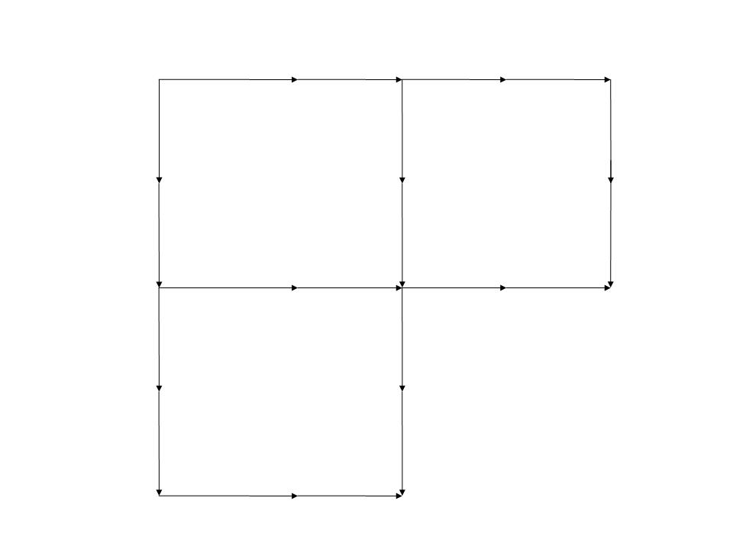Now the family owns only three hectares. The father fully recovered and was back working in the field again. As the years go by, the sons decided to get married and to raise their families. The father has now to divide the three hectares land into four equal parts one for him and rest to the sons.

As the father of the family how will you divide the three hectares land (three squares) into four equal parts so that each son and you receive equal land area? Use the four sticks taken out previously to solve the puzzle.

Solution:

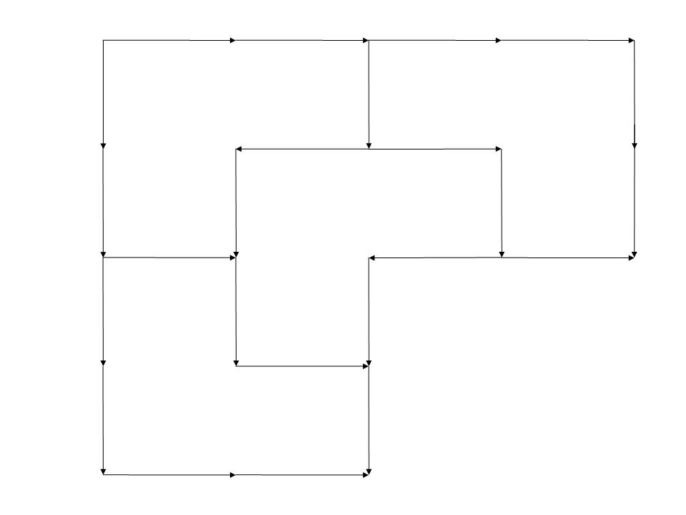

1. **Session Evaluation & Roll Call** Time: 10min.

* Ask the following questions in large group to evaluate the day’s session.
  + What did you learn today?
  + How are these useful to you?
* Note participants’ feedback and thank everyone for their active participation.
* Before closing the session, call out participants names and mark their attendance.

**Session 6: Pre-Maturity stage (Dough stage)**

|  |  |  |  |  |  |  |
| --- | --- | --- | --- | --- | --- | --- |
|  | **Topic** | | **Facilitation methods** | **Materials** | | **Time** |
| 1 | Recap & Roll Call | Large group | | Charts and markers | 15 min | |
| 2 | AESA  - Dough stage  - Nutrient management  - Weed management  - Pest management  - Water management | Observation – 20 mins; Discussion, Analysis & Decisions – 30 mins; Large Group Presentation – 45 mins | | Scale, note books, charts and markers | 105 min | |
| 3 | Post-BBE | | Exercise | Charts, markers whistle, card boards, nails, long sticks, knife, thread, ballot boxes | | 60 min |
| 4 | Session Evaluation & Roll Call | | Large group discussion | Charts and markers | | 10 min |

**Process**:

1. **Recap & Roll Call** Time: 15 min

* Welcome participants to the session.
* Ask participants to recap the concepts and learning from previous session.
* List the participants responses on a chart and summarize the concepts and learning from the previous session.
* Call out participants names and mark their attendance.

1. **Agro-Ecosystem Analysis (AESA)** Time: 105 min.

* Ask participants to recall and record the weather conditions prevailing in the preceding one week. Record the weather parameters on the chart/board.
* Later, ask the participants the crop-growth stage and record it on the chart/board.
* After that, ask participants to list the plant parameters to be observed for the particular crop-growth stage.
* Following this, ask participants form into their respective small groups to observe (for about 20 minutes) the plant parameters, weeds, pests and predators and jot them down in their notes.
* Following the observations, as them to continue to work in their small groups (for about 30 minutes) to tabulate their observations as beneficial and harmful/risks. For effective analysis, ask participants to mention the number of branches/ tillers, density and size of weeds in relation to the size of the plant, average number of insect pests (per leaf for sucking pests and per plant for others), average number of beneficial insects per plant, average number of fruiting bodies damaged by rats per plant, and weather parameters when tabulating observations.
* Ask participants to use the following chart to capture their observations and record their analysis and decisions.



Group name: Plot name: Date:

Crop stage / Days after sowing:

Beneficial factors

Risks / Harmful factors

Analysis

Decisions

* Presentation to the larger group: Ask one representative from each group to come forward and present their group’s observations, analysis, and decisions to the larger group.
* Following each group presentation ask participants to share their comments or clarifications on the group presentation.
* Conclusion of Management Practices: Following the presentations of all groups, the facilitator should reach common understanding on the decisions and management practices.

1. **Post-BBE** Time: 60 min.

* Tell participants that the purpose of Post Ballot Box Exercise (Post-BBE) is to evaluate the impact of FFS on participants’ knowledge, attitude, and skills.
* After sharing the purpose of BBE, assign a registration number to each participant.
* Give each participant 30 ballot slips (number of slips should equal the number of questions) bearing his/her registration number.
* Ask each participant to stand facing a cardboard station (i.e. one participant in front of one cardboard station).
* Each cardboard station has a question and three options (**YES, NO,** and **NO IDEA**). Each option has a cover (envelope) beneath for participants to drop their ballot.
* Ask participants to read the question, choose the appropriate option and drop the ballot in the cover beneath that option.
* On blowing the whistle, participants move to the next cardboard station to read the question and cast their votes for the question.
* Participants exercise their ballot at each station.

|  |
| --- |
| Tips to facilitator   * Before the conduct of the exercise, explain all the instructions to the participants. * Organize a mock demonstration before the actual conduct of the exercise. * Assist illiterate or semi-literate farmers by reading the question and options. * Only one participant should stand near one cardboard station. * Do not allow two or more persons to crowd near one cardboard station. |

|  |
| --- |
| Analysis of BBE Results   * First take out chits from ‘No Idea’ pocket, count them and record on a chart. * After this, go to the pocket with least number of chits, count them and record on a chart. * Finally record the third one by deducting the sum of the two from the total participants (There is no need to count the chits in the third pocket). * Categorize the questions based on similarity. * Calculate cumulative right/ wrong/ no idea question-wise and individual farmer-wise. * Calculate percentages. * Based on the results, determine topics that need focused attention in FFS. |

1. **Session Evaluation & Roll Call** Time: 10min.

* Ask the following questions in large group to evaluate the day’s session.
  + What did you learn today?
  + How are these useful to you?
* Note participants’ feedback and thank everyone for their active participation.
* Before closing the session, call out participants names and mark their attendance.

**Session 7: Field Day**

|  |  |  |  |  |
| --- | --- | --- | --- | --- |
|  | **Topic** | **Methods** | **Materials** | **Time** |
| 1 | Registration | Interactive Lecture method | Registration form |  |
| 2 | Purpose of Field Day | Interactive Lecture |  | 15 min |
| 3 | Field Tour (Control & Demo Plots) &  - Crop Cutting Exercise |  |  | 60 min |
| 4 | Grain & Seed storage | Demonstration /lecture | Charts and markers | 15 min |
| 5 | Sharing of Experiences: FFS Graduates | Interactive Lecture | Charts and markers | 45 min |
| 6 | Farmers Questions |  |  | 15 min |
| 7 | Experts speech | Lecture |  | 45 min |
| 8 | Distribution of FFS certificates | Distribute certificates | Graduation certificates | 30 min |
| 9 | Vote of thanks | Lecture |  | 5 min |

**Venue: Pilot Farmer’s Field**

**Objectives:**

By the end of the day, participants will be able to:

* Understand the purpose of Field day,
* Discuss the relevance of FFS to crop management,
* Share their FFS experiences, and
* Receive graduation certificates.

1. **Registration**

Field day should begin with registration of farmer participants. After a farmer completes his/her registration, request them to go for a gallery walk and interact with the FFS participants manning the stalls. Encourage farmers to ask probing questions during the gallery walk. At each stall, FFS farmer participants present at the stall should explain to the visitors the theme of the stall, their experiences, and learning from FFS sessions.

1. **Purpose of Field day**

After the gallery walk, WUA President or Secretary should request all the participants to be seated in the space provided at the venue. Then, invite the VIPs to occupy dais and garland them. Next, WUA president or Secretary has to request one of the VIPs to chair the program. Give the program sheet to all VIPs. The chief guest requests WUA members to begin the program with prayer.

1. **Field Tour (Control & Demo plots) & Crop Cutting Exercise**

* Ask all farmers to stand on the field bund and observe the differences in the demonstration and control plots for plant parameters.
* The lead farmer should select an area of 25 square meters (5X5 mts) in each plot (demonstration & control plots). The crop in the selected areas should be harvested and compared for yield and yield parameters (number of tillers, panicle size, average number of grains per panicle).

1. **Grain and Seed Storage**

* The grain should be sundried after harvest. A simple test to assess the dryness of the grain is to cut a sample grain with the front teeth.
* Seed should be stored in a gunny bag in a moisture-free room on a wooden platform. Seed should not be placed directly on floor.
* Seed should be sun dried at an interval of 2 months till the next sowing.

1. **Sharing of Experiences: FFS Graduates**

Next, the WUA President or Secretary should invite FFS farmer participants to come forward and share their experiences and learning. It would be useful if farmer participants share:

* Usefulness of FFS methodology for effective crop management;
* Importance of awareness on FFS concepts of soil testing, tillage operations, germination tests, seed-bed preparation, seed treatment, sowing operations, transplantation, weed management, water management, and pest management in helping farmers make informed choices on crops and effective crop-water management;
* Importance of linkages and institutional support for effective functioning of WUA.

Ideally each farmer should restrict their speech to five minutes.

1. **Farmers Questions**

After sharing of farmers experiences, ask farmers to raise questions on package of practices followed in the FFS plot and any other concerns they may have about the particular crop. Write the farmers questions on a chart paper.

1. **Experts Speech**

Next, ask the Experts to answer the questions and clarify farmers’ concerns. Also, experts should be encouraged to share about modern practices, government schemes and subsidies.

1. **Distribution of FFS graduation certificates**

WUA President/Secretary has to share the importance of FFS graduation certificate and request the Chief Guest to distribute the FFS graduation certificates to FFS farmer participants.

1. **Vote of thanks**

A member of the WUA committee should be invited to give a brief vote of thanks to all those who graced the event and those who have helped organize the Field Day. Inform the participants that lunch has been organized for all.