CHAPTER 6

STAKEHOLDER CONSULTATION

6.1 INTRODUCTION

There is a growing consensus that timely and broadbased stakeholder involvement is a vital ingredient for effective environmental assessment, as it is for project planning, appraisal and development in general. The World Bank has found that public participation in EIA tends to improve project design, environmental soundness and social acceptability. This has been the general experience that environmental assessments that successfully involved a broad range of stakeholders tended to lead to more influential environmental assessment processes and, consequently, to development that delivered more environmental and social benefits. Conversely, environmental assessments that failed to be inclusive tended to have less influence over planning and implementation, and consequently resulted in higher social and environmental costs.

Stakeholder involvement during environmental assessment can result in accrual of wide-ranging benefits like:

- Helping environmental assessments address relevant issues including those perceived by other sectoral agencies, public bodies, local communities including beneficiaries affected groups etc.
- Assisting in improving information flows between proponents and different stakeholder groups thus improving the understanding and ownership of a project
- Enabling project proponents to better respond to different stakeholder needs
- Helping to harnessing traditional knowledge often overlooked in conventional approaches
- Assisting in identifying proper identification of environmental impacts and their characterisation
- And above all improving the acceptability and quality of mitigation measures and monitoring process.

6.2 Preliminary State Level Stakeholder Consultation

The consultants had consulted policy–making and senior level officers of some Government Departments, autonomous bodies and Government Corporations to have their inputs on the programme conceived by the Client under Accelerated Development of Minor Irrigation. The consultation primarily spread over the period of August- October 2008. The list of officials consulted include:

- The Principal Secretary, Department of Panchayat and Rural Development
- Land Reforms Commissioner
- The Director , Land Records and Surveys
- Chief Environmental Officer and Senior Environmental Officer of the Department of Environment
- Principal Secretary and some Joint Directors of the Department of Agriculture
- The Project Director, ADMI and the Members of the Project Preparation Team
- Director and the Additional Director of the State Water Investigation Directorate
- Member Secretary West Bengal State Pollution Control Board and Scientists under his control
- The Managing Director, West Bengal Renewable Energy Development Agency
- The Director (Distribution), West Bengal State Electricity Distribution Company Ltd.
- Professors and Readers of the Kalyani Agriculture University
- Officials of CGWB, Eastern Region

During such consultation, the consultants tried to have their comments on the proposed project and their feasibility of implementation. The issues of environmental concern in implementation of the project were raised during consultation with the officers of the Department of Environment and the West Bengal Pollution Control Board. Availability of electrical power for energisation of minor irrigation systems was raised during the process of consultation with the WBSEDC Ltd. The possibility of harnessing non-conventional energy sources on trial basis to energise minor irrigation systems was the focus of consultation with the MD, WBREDA. Department of Agriculture officials and some faculties of Agriculture Universities were extensively consulted for inputs on IPM and INM as well as the issue of increased water use efficiency in agriculture irrigation. CGWB officials tried to focus on their studies on ground water and the results published for different districts.

Such consultation indicated that subprojects conceived are not likely to cause any irreversible or significant adverse impacts in case these are screened through a set of criteria built on a proper understanding of the environmental setting, ground /surface water availability, and a proper assessment of the need of the beneficiaries and their willingness to take over operation and maintenance of subprojects.

Salient issues that came out of this consultation process are the following;

- Selection of projects should be demand driven
- Subprojects need be selected carefully particularly in blocks of very high ground water development status and in the blocks where ground water has been severely affected by arsenic & fluoride contamination
- Water harvesting tanks, water-harvesting structures, dugwells having CCA less than 2 ha should better be taken up under the National Rural Employment Guarantee Scheme. This was impressed upon the Panchyat & Rural Development Department
- Wherever possible minor irrigation systems should be energised by electricity and for this a dialogue should be started with West Bengal State Electricity Distribution Company Ltd.
- Subprojects relying on extraction of ground water in the coastal saline zone have to take guard against ingress of saline water into the aquifers.
- In some of the districts prone to flooding and water logging and having a very low level of ground water development status , ground water abstraction through irrigation systems may ameliorate such conditions
- There should be close coordination between the Department of Agriculture and the Water Resources Investigation & Development Department to ensure sustainability of the Participatory Irrigation Management.

6.3 Stakeholder consultation in sample blocks

In terms of the TOR stakeholder consultations were organised in all sample blocks as selected in consultation with the Client. These have been representative of different agro-climatic zones. All consultation at sites were organised in consultation with the District convenors or their representatives. The participants in such consultations included officials of the WRIDD, the Department of Agriculture, block level officers of the administration and members of farming communities. In many of such consultations, there has been fair representation of women and economically disadvantaged groups. All such consultations have been organised on a proper advance notice amongst the communities.

Stakeholder categories and the strength of participation against each category are furnished in the table below;

Sl. No.  Row No. | Categories  Dist. | Total No. of Participants | Officials Total | Official Adminis-trators | Official PRI Rep. | Engineers & Others | Villagers Total | Villagers Women | Villagers SC/ST
1 | 2 | 3 | 4 | 5 | 6 | 7 | 8 | 9 | 10
1 | Bankura
 | i. Kotulpur 9th Jan.’09 | 67 | 6 | 2 | 2 | 2 | 61 | 5 | 19
 | ii. Ranibandh 7th Jan.’09 | 70 | 12 | 2 | 7 | 3 | 58 | 31 | 49
2 | Birbhum
 | i. Rampurhat-I 20th Nov.’08 | 60 | 18 | 4 | X | 14 | 42 | 8 | 27
3 | Burdwan
 | i. Ketugram-II 5th Dec.’08 | 51 | 31 | 3 | 20 | 8 | 20 | X | 10
4 | Cooch Behar
 | i. Sitai  4th Dec.’08 | 31 | 19 | 3 | 9 | 7 | 12 | 4 | X
 | ii. Tufangunj-II 3rd Dec.’08 | 53 | 18 | 2 | 7 | 9 | 35 | 1 | 1
5 | Darjeeling
 | i. Phansidewa 5th Dec.’08 | 21 | 6 | 3 | 1 | 2 | 15 | 3 | X
6 | Hooghly
 | i. Balagarh 17th Feb.’09 | 64 | 36 | 2 | 17 | 17 | 28 | 8 | 10
 | ii. Chinsura-Mogra 18th Feb.’09 | 43 | 28 | 2 | 15 | 11 | 15 | 4 | X
7 | Howrah
 | i. Uluberia – I 19th March’09 | 44 | 13 | 3 | 5 | 5 | 31 | 1 | 2

Sl. No.  Row No. | Categories  Dist. | Total No. of Participants | Officials Total | Official Adminis-trators | Official PRI Rep. | Engineers & Others | Villagers Total | Villagers Women | Villagers SC/ST
1 | 2 | 3 | 4 | 5 | 6 | 7 | 8 | 9 | 10
8 | Jalpaiguri
 | i. Mal  19th Nov.’08 | 41 | 29 | 1 | 17 | 11 | 12 | 5 | 5
 | ii. Dhupguri 20th Nov.’08 | 42 | 30 | 5 | 17 | 8 | 12 | X | 4
9 | Maldah
 | i. Gajal 17th Dec.’08 | 35 | 30 | 3 | 20 | 7 | 5 | 1 | X
 | ii. Ratua 18th Dec.’08 | 62 | 53 | 7 | 22 | 24 | 9 | 2 | X
10 | Murshidabad
 | i. Bharatpur – I 22nd Oct.’08 | 55 | 8 | X | 2 | 6 | 47 | 1 | X
 | ii. Sagardighi 23rd oct.’08 | 52 | 7 | 2 | 2 | 3 | 45 | 6 | 6
11 | Nadia
 | i. Nabadwip 6th Nov.’08 | 50 | 5 | 2 | X | 3 | 45 | 1 | X
12 | 24 Parganas (N)
 | i. Barrackpore-I 9th March’09 | 55 | 4 | 1 | 1 | 2 | 31 | 6 | 6
 | ii. Habra – I 9th Feb.’09 | 25 | 11 | 1 | 3 | 7 | 14 | 4 | X
 | iii. Haroa 13th March’09 | 41 | 7 | 2 | 1 | 4 | 34 | 4 | 10
13 | 24 Parganas (S)
 | i. Canning – I 6th Feb.’09 | 37 | 4 | 1 | 3 | X | 33 | X | X
 | ii. Kulpi 3rd Nov.’08 & 11th Feb.’09 | 68 | 25 | 5 | 12 | 8 | 43 | 4 | 1
14 | Purulia
 | i. Joypur 6th Nov.’08 | 41 | 17 | 4 | 6 | 7 | 24 | 6 | 6
 | ii. Neturia  7th.Nov,08 | 43 | 23 | 5 | 3 | 15 | 20 | 18 | 12
15 | Purba Medinipur
 | i. Panskura I  11th. Feb,09 | 29 | 4 | 2 | 1 | 1 | 25 | 5 | 2
 | ii. Khejuri- I  24th.Feb,09 | 31 | 20 | 4 | 14 | 2 | 11 | 4 | x
16 | Paschim Medinipur
 | - Garbeta I  - 3rd Feb,09 | 30 | 23 | 2 | 14 | 7 | 7 | X | 4
17 | Dakshin Dinajpur
 | Gangarampur  6th.Feb,09 | 61 | 27 | 6 | 6 | 15 | 34 | 11 | 10
18 | Uttar Dinajpur
 | Goalpokhr I  !9th Dec,08 | 64 | 19 | 2 | 5 | 12 | 45 | 2 | x

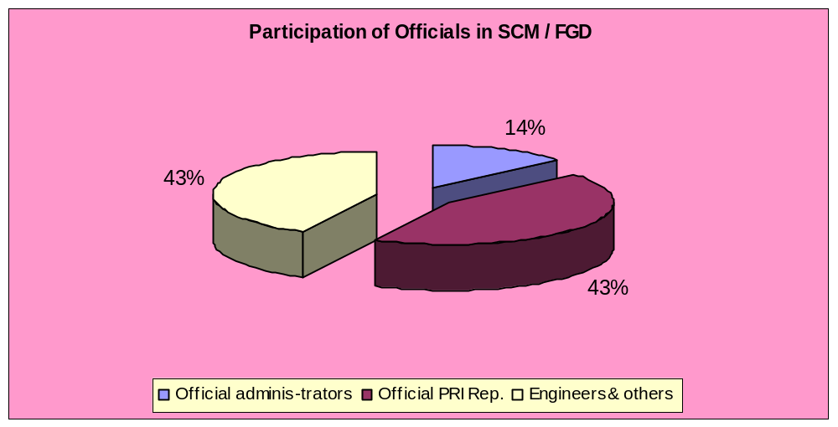

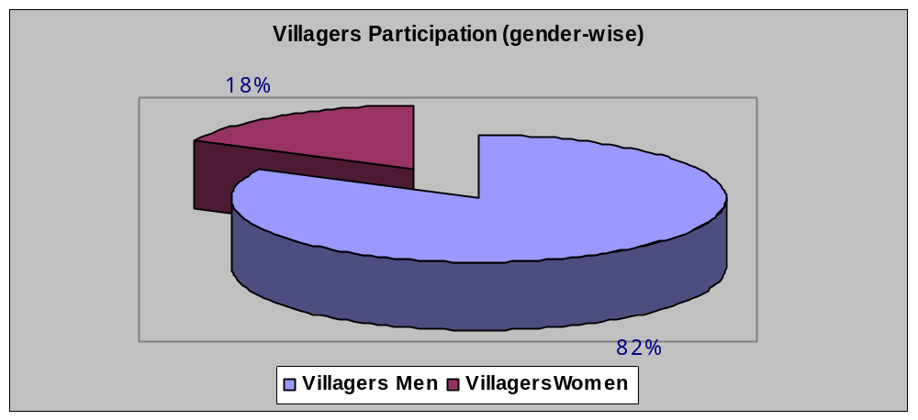

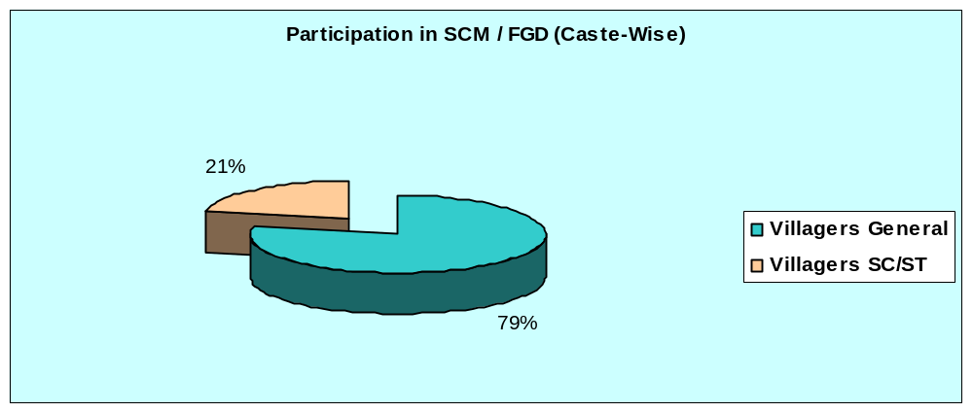

6.4 Issues raised by stakeholders during site consultations

The stakeholders, in general, felt that the project execution will benefit the farming communities provided there is adequate back up by the Department of Agriculture in providing the required advice on cropping particularly on crop rotation and diversification, provision on inputs on time and assistance in marketing through dissemination of market information. The stakeholders did not have any inhibition in expressing their opinion. Issues raised during such consultation are summarised below:

- General lack of awareness on organic farming and the need for crop rotation and crop diversification
- Deficient facilities for soil testing and appropriate advice on use of chemical fertilisers and insecticide/pesticides
- The need for intensive campaigning for awareness development on IPM/INM is a prime requirement to avoid adverse environmental impacts
- Need for avoidance of groundwater abstraction in areas severely affected by arsenic and fluoride contamination; in such areas more stress should be laid on surface water irrigation schemes
- A inventory of old and dysfunctional RLI/DTWs to decide on the possibility of rehabilitation at economic cost
- More stress on energisation of minor irrigation systems with electricity and rationalizing tariff rate as they feel such rates are high
- Undertaking of proper bank protection works in stretches of streams used for surface water abstraction
- Careful Installation of RLIs in stretches of a stream/river bed after proper assessment of discharge to avoid reduced streamflow resulting in problems of siltation
- Need for avoidance of ground water abstraction to prevent saline water intrusion in coastal areas
- Need for more co-ordination amongst allied departments to optimise benefits flowing from the scheme.
- Awareness development for water use efficiency in irrigation and more stress on cropping with less water consumptive crops

Issues raised during consultaion at different sites are tabulated below;

Sl. No. | Issues Raised | Blocks | Measures to address the issues by the project
1 | Excessive use of chemical fertilisers | Kotulpur, Ranibandh, Sitai, Canning-I, Tufangunj, Gangarampur, Cinsura-Mogra, Goalpokhor, Uluberia-I, Panskura-I, Dhubguri, Mal, Ratua-II, Bharatpur-I, Sagardighi, Barrckpore-I, Habra-I, Nabadwip , Kulpi, Garbeta-I | Judicious mix of organic and inorganic fertilizer and adoption of good agronomic practices. Promoting INM through the Agriculture and Horticulture components. Adoption of bio-village programme in blocks having high cropping intensity.
2 | Necessity for rehabilitation of old and dysfunctional RLII/DTW/Sluice Gate | Canning-I, Khejuri-I, Uluberia, Tufangunj, Garbeta-I, Gangarampur, Goalpokhor, Panskura-I, Dhubguri, Sagardighi, Barrackpore-I, Nabadwip, Garbeta-I | This issue has not been addressed in the project; WRIDD will deal with this from other on-going schemes in the State.
3 | Emphasis on organic and bio-farming | Kotulpur, Ranibandh, Sitai, Canning-I, Tufangunj, Gangarampur, Cinsura-Mogra, Goalpokhor, Uluberia-I, Ratua-II,Neturia | Adoption/expansion of bio-village programme with intensified extension and awareness development programmes under the agriculture component and pesticide management. Intensification of the production of biofertilisers through reputed institutions
4 | Wastage of irrigation water through seepage in kutcha channels | Tufangunj, Gangarampur, Barrackpore-I | Provision of lining for irrigation channels and adoption of furrow/ alternate furrow irrigation.
5 | Lack of awareness for organic farming | Tufangunj, Goalpokhar, Ratua-II, Barrackpore-I | Awareness development programme for WUAs and beneficiary committees through the proposed bio-village programme. Training them through the modules proposed under section 9.4.3 of chapter 9.
6 | More use of less water consumptive crops | Ranibandh, Phansideoa | Diversification of cropping pattern with less water consumptive crops in areas having water stress with the help of Programme Promoters and Support Organizations under the Agriculture component.
7 | Shifting of stream and river courses | Sitai, Tufangunj, Phansideoa, Dhubguri, Nituria | Avoidance of sites vulnerable to bank erosion; in case of compulsion undertake bank protection works in consultation with the Irrigation and Waterways Department.
8 | Inadequate departmental / Inter –departmental Coordination | Sitai, Gangarampur | DPMUs and SPMUs having representatives of different Departments will strengthen such coordination
9 | Pesticides agri-chemical induced diseases | Sitai, Tufangunj, Mal | Promoting organic farming through expansion of biovillage programme and intensification of production of biofertilisers. Awareness development programmes by local panchayat institutions supported by local health workers will reduce the incidence of agri-chemical induced diseases.
10 | Deficiency in extension services | Habra-I | Filling up existing vacancies of KPS and monitoring of extension services by the Programme Promoters and Support Organisations of the Agriculture component.
11 | Problem of diesel pumps maintenance and theft of equipment | Tufangunj, Chinsura-Mogra, Dhubguri, Ratua-II, Nabadwip, Garbeta-I, Joypur and Neturia | Irrigation water installations will be managed by WUAs and the beneficiary committees. Beneficiary committee members will be trained to maintained diesel pumps
12 | Arsenic/ Fluoride/Iron | Tufangunj (Iron), Uluberia, Habra-I, Bharatpur-I, Neturia, Purulia, Mal(iron), Gajol, Ratua-II, Habra-I, Nabadwip, Neturia | Exclusion criteria designed to avoid installation of ground water structure in arsenic /fluoride affected areas having contamination beyond permissible Indian Standards. Monitoring of As/Fl has been prescribed both during construction /operation phase to ensure marking of such installations in case the water is diagnosed to have these contaminants above permissible level to prevent use of such water for drinking purposes.
13 | Dry season acute water shortage in pond/rivers | Gangarampur, Tufangunj | Avoid abstraction of water from such rivers without taking recourse to adequate water recharging measures.
14 | Siltation of river bed & reduced stream flow | Tufangunj, Dhubguri | Adoption of silt control protocol measures as embodied under section 8.3.7 of Chapter & and section 2.11 of Chapter 2 of EC0P at annexure VIII.
15 | Depletion of water table | Khejuri-I, Dhubguri | Exclusion criteria takes care of no abstraction of ground water in critical blocks and cautious abstraction in semi critical blocks after categorisation of subprojects through screening criteria and prescribed scoring scales
16 | Irregular /uncertain power supply | Barrackpore-I, Habra-I, Garbeta-I | To be taken care of by the DPMU in consultation with WBSEDCL.
17 | Local flooding / drainage probleml | Tufangunj, Ketugram-II, Dhubguri, Mal, Gajol | Avoidace of areas subjected to flooding and inundation. Judicious use of water for irrigation through furrow and alternate furrow method.
18 | Leaching of soil nutrients | Khejuri-I | Judicious use of irrigation water; avoidance of flooding with water. Adoption of Integrated Nutrient Management practices.
19 | Increased salinity of water | Khejuri-I, Kulpi | Saline blocks will generally be avoided. Adoption of management strategies like altering irrigation schedules, adoption of improved tillage practices and incorporating soil ameliorates may be useful in reducing the rate of salinity.
20 | Inadequate staffing (OCM, KPS) | Uluberia, Habra-I, Nabadwip | Filling up of vacancies by WRIDD and the Department of Agriculture. DPMU and SPMU to keep track on progress.
21 | Necessity for introduction of crop rotation / crop diversification | Khejuri-I, Panskura-I, Dhubguri, Ratua-II, Bharatpur-I, Sagardighi,Neturia, Garbeta-I | Agriculture component will take care of this through Programme Promoters and their Support Organisations.
22 | Felt need for taking up measures of rain water harvesting | Khejuri-I, Dhubguri, Bharatpur-I, Joypur, Neturia, Garbeta-I | Rain water harvesting may be taken recourse to in semicritical blocks for recharging and as also in saline blocks to reduce salinity.
23 | Emphasis on use of electricity –run pumps | Mal, Gajol, Ratua-II, Bharatpur-I, Nabadwip | Whereever possible Electricity –run pumps will be used
24 | Laying more stress on use of surface water irrigation | Tufangunj(Iron), Uluberia, Habra-I, Bharatpur-I, Neturia, Purulia, Mal(iron), Gajol, Ratua-II, Sagardighi, Habra-I, Joypur | Proposed subprojects will have judicious mix of ground and surface water taking into consideration the availability of such resource
25 | Augmentation of facilities for soil testing | Habra-I, Bharatpur-I, Barrackpore-I, Habra-I | Existing SWID and Department of Agriculture laboratories will provide these facilities. Two additional laboratories of SWID have been proposed under the programme
26 | Stress on need for excavation/ re-excavation ponds/beels/ canals | Mal, Gajol, Ratua-II, Bharatpur-I, Sagardighi, Nabadwip, Joypur,Neturia | Some provision has been kept under surface water schemes.
27 | Suggestion for more awareness and training camps on IPM /INM | Gajol, Neturia | Awareness training and modules for different target groups have been suggested under section 9.4 of chapter 9. Pesticide Management (Chapter 13) under section 13.9 discusses this issue
28 | Upstream /Municipal Sewage –induced pollution affection irrigation | Mal, Barrackpore-I | Water quality to be deciphered during construction stage through approved laboratories before installation to judge suitability of the same for irrigation.
29 | Pollution of soil and ground water from polluted run-off | Mal | Avoidance of use of polluted run-off for irrigation
30 | Felt need for introduction of sprinkler/drip irrigation | Sagardighi | The project does not have scope for sprinkler /drip irrigation.

A few photographs of Stakeholder Consultations are furnished below :

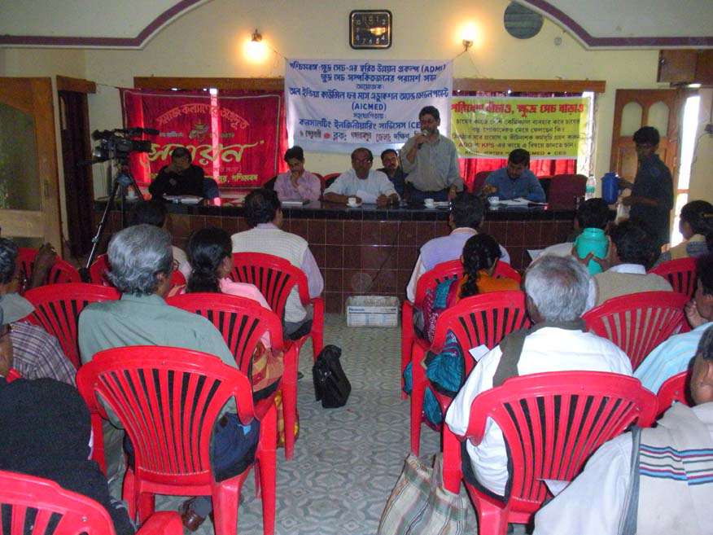

Stakeholder Consultation at Gangarampur, Dakshin Dinajpur

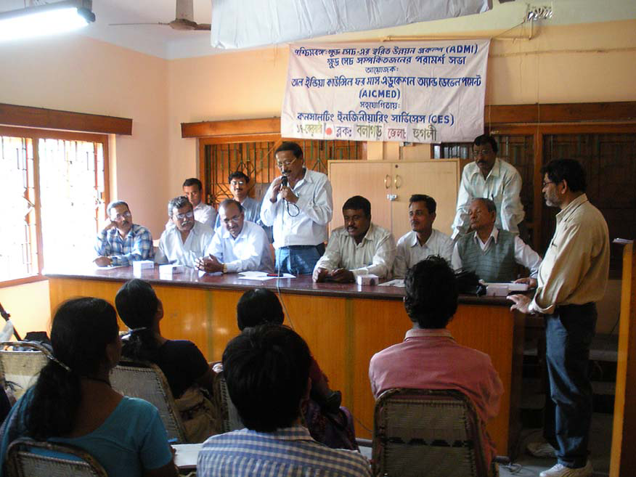

CHAPTER- 7

SCREENING CRITERIA FOR SUB-PROJECTS

7.1 NEED FOR DEFINING CRITERIA

Minor irrigation schemes included under the program will not require environmental clearance either from the Ministry of Environment and Forests, Government of India or the Department of Environment in the State Government. The Implementing Agency however will require some permission under the regulatory framework of the State and such regulations have been brought out earlier. These have also been reiterated in the Environmental Code of Practice developed for program execution.

The funding agency however is keen on ensuring that the execution of sub-projects do not under any circumstances cause any significant adverse impact on any of the environmental components keeping in view some environmental concerns in the environmental setting of the widely geographically dispersed areas of 18 districts of the State.

7.2. SELECTION OF CRITERIA

The environmental setting of the program execution area has been brought out in fair details. Environmental concerns in different agro-climatic zones are fairly predictable from the issues discussed. As the project has the specific objective of conjunctive use of ground and surface water, irrigation resources data have also been brought from secondary sources to have a clear picture. Based on these and drawing inputs from the stakeholder consultations and the officers of the WRIDD at different levels, the criteria for screening have been arrived. The criteria have been designed to be simple so as to avoid a process of detailed analysis at the screening stage. Each criterion has also been scaled to facilitate preparation of a scorecard for each subproject for categorisation as projects of low impact category or medium impact category. Exclusion criteria have been developed on the basis of precautionary principle

  - SELECTED CRITERIA

All subprojects identified under the programme can be selected on the following criteria:

Criterion I :Siting of the project with reference to environmentally sensitive areas which will include protected area network including wildlife sanctuaries, national parks, natural habitats including reserved forests/protected forests, wetlands of national and international importance, sacred groves of significant bio-diversity, wild elephant corridors etc.

Criterion II : Status of ground water availability
Criterion III: Degree of Arsenic contamination in the aquifers

Criterion IV: Degree of Fluoride contamination in the aquifers

Criterion V: Irrigation water quality determined by parameters of pH, EC (electrical conductivity), SAR (Sodium absorption ratio) and Boron as set by Central Pollution Control Board.,

Criterion VI: Degree of impact on downstream flow-regime affecting riparian habitat and livelihood of down- stream users

Criterion VII: Presence or absence of historic and archaeological remains preserved under the provisions of the Ancient Monuments and Archaeological Sites and Remains (Act), 1958

Criterion VIII: Possibility of energisation with electrical sources of power

Of these criteria I, II, III, IV, V, VII & VIII are relevant for subprojects proposing ground water abstraction whereas criteria I.V.VI.VII & VIII are relevant only for surface flow or river lift irrigation sub-projects.

7.4 SCALES AND SCORING

Each of these criteria may be rated on the scales suggested below:

Criterion I: Scale 0 -3: 0 (Present beyond 500m), 1 (present within 251m to 500m of CCA or Head works and the reservoir), 2 (present within 101m to 250m). 3 (present within 100m)

Criterion II: Scale 0 – 2 , 0 ( safe ) , 1 ( semi critical), 2 ( critical )

Criterion III : Scale 0-2, 0 ( present within permissible limits of 10µg/l as approved by WHO ), 1 ( present within permissible limits of 50 µg/L as approved by the country ), 2 ( present beyond permissible limits of 50µg/l as approved by the country).

Criterion IV: Scale 0 – 2, 0 (present within permissible limits of 1mg/L as approved by BIS), 1 (present within limits of > 1.mg/l < 2.0mg/l ), 2 ( present beyond > 2mg/l )

Criterion V: Scale 0 -2, 0 (All parameters well within CPCB standards; EC at 25º C < 2000 micromhos/cm and SAR < 20), 1 (SAR > 20 and < 26 and EC at 25º C >2000 and < 2250 micromhos/cm and other parameters within CPCB standards), 2 (one or more of parameters exceed CPCB standards)

Criterion VI: Scale 0 – 3, 0 (adverse impact imperceptible), 1 (adverse impact low), 2 (adverse impact moderate), 3 (adverse impact irreversible and significant)

Criterion VII : Scale 0-3 , 0 ( present beyond 500m ) , 1 ( present within 251m to 500m ), 2 ( present within101m to 250m ), 3 ( present within 100m)

Criterion VIII: Scale 0- 3, 0 (Available), 1 (Available on short term of 2 years), 2 (Available on mid term of 5 years), 3 (likely to be available beyond 5 years )

All ground water abstraction subprojects having score of 0 to 10 can be categorised as low impact category projects. Projects scoring 11 to 13 will be categorised as medium impact category projects Similarly all surface water projects having scores of 0 to 8 will be categorised as low impact category projects and projects having scores of 9 to 10 will get categorised as medium impact category projects.

7.5 EXCLUSION CRITERIA

- All ground water abstraction sub- projects having scores of 2 against one or more of criteria II , III, IV , V shall not be taken up for execution because of likely adverse impacts on ground water depletion, soil quality and on human and livestock health through arsenic and fluoride intake through food chain..

- All surface water sub-projects ( surface flow or river lift ) having scores of 2 against criterion V shall not be taken up for execution: Similarly all surface water sub-projects having scores of 3 against criterion VI will be avoided as execution of such sub-projects may have irreversible adverse impact on down stream flow regime, infiltration rate and crop productivity.

- All sub-projects requiring diversion of areas included in protected areas like sanctuaries and national parks should not be considered for execution as diversion of such areas is a very sensitive issue with the Ministry of Environment and Forests of the GOI and getting clearance for such projects is a time- consuming process involving even the Apex court of the country under the orders in force..

7.6 STANDARDS CONSIDERED IN DEVELOPING CRITERIA

In developing the screening both the Indian and international standards have been kept in view. Wherever necessary precautionary principles have been employed to avoid any adverse impact on human health and agriculture productivity

7.6.1 INDIAN STANDARDS

- Arsenic: 50µg/l Fluoride: 1.0mg/L

- CPCB standards for irrigation water: i. pH between 6.0 and 8.5
ii. Electrical Conductivity at 25º c Micromhos/cm 2250 max
iii. Sodium Absorption Ratio 26 max
iv. Boron Max. 2mg/l
7.6.2 INTERNATIONAL STANDARDS
WHO EPA, USA
1 Arsenic 10µg/l 10µg/l
2. Fluoride 1.5µg/l 2.0mg/l

7.7 Responsibilities for Implementation of Environmental Screening
7.7.1 Preparation of subproject proposal
The Assistant Engineer under the PIU ( the Executive Engineer) will prepare the proposal with the assistance of the Sub-assistant Engineer through the steps of rapid environmental survey, consultation with the local communities and site selection as discussed under items 2.2 to 2.4 of chapter 2 of ECOP at Annexure VIII. Thereafter the REA checklist provided at Appendix I of ECoP will be filled up and submitted to the PIU. Irrigation water quality parameters will be checked up with the help of SWID laboratories. SAR may be determined only for subprojects to be located in saline blocks
7.7.2 Verification of the proposal and categorisation
The PIU (Executive Engineer) will verify the REA checklist and carry out categorisation of subprojects using the screening criteria and the scale of categorisation. In undertaking this exercise he will obtain advice of the DPMU where Environmental Engineer/Environmental Specialist will be located.
7.7.3 Permission for implementation
The PIU will permit implementation of low impact category projects and the appointed contractor will have the responsibility of implementing the provisions of the GEMP provided at Appendix II of ECoP at Annexure VIII. For medium impact category projects the PIU will undertake a limited EA of the sub-project with the assistance of the Environmental Engineer/Environmental Specialist located in the DPMU. The PIU may also induct some Consultants for taking up preparation of such limited EA.

7.7.4 Responsibility for implementation of environmental monitoring plan
Environmental Monitoring Plan for low impact category projects is provided at chapter 3 of ECoP at Annexure VIII. Such plan for medium impact category projects appears Attachment 1 of Annexure IX (TOR for Limited EA). PIU and the appointed contractor will share the responsibility of carrying out such monitoring.

