WBADMI PROJECT
Tube well construction OK card for use by WUA

Name of the Scheme: |  | Survey No:
Name of WUA : |  | GPS coordinate of the scheme
WUA Office Bearers: |  | OK card filled on
WUA members: |  | No of Members Present
OK card for use by WUA using hand
ACTIVITY |  | DONE | NOT DONE | SAW WHEN IT WAS DONE | ONLY HEARD | RESULTSSHARED | RESULT NOT SHARED | Quality of material/ work good | Quality of material/ work could have been better | Quality of material/ work poor | TOTAL
 |  |  |  |  |  |  |  |  | 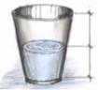
Site selection adopting electrical resistivity survey | 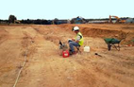
Water quality from existing wells tested | 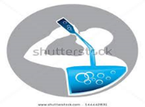
Display Board installed while work is going on
Drilling – is done at the identified location | 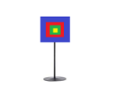
Drilling is completed to depth as told to WUA | 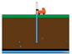
Drilling samples collected and laid out systematically for studying it | 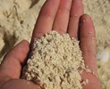
Electrical logging was carried out before lowering of casing pipes and screens | 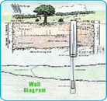
Do you know how many casing pipes were lowered into the well
Do you know how many screens were lowered into the well
Do you know how many water bearing zones were met with during drilling | 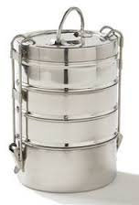
Was gravel pack done in the well and what quantity was used | 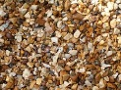
Was Cleaning of the well (Development) done | 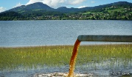
Did y see and taste the water that came after cleaning
Was the well tested using pump | 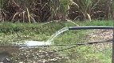
Did u see the water flowing from the well during pump test | 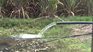
Do you know the discharge from bore well based on pump test | 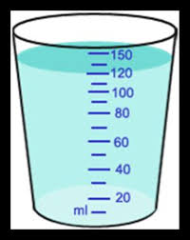
Has the submersible pump been installed in the well | 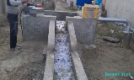
has the electrical connection obtained | 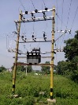
Has the storage reservoir been completed
Has the drainage pipe line been laid | 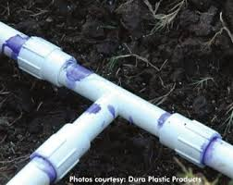
Has the command area been defined | 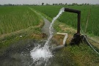
Total

Typical Appearance of OK card screen on iPad

Touch screen data entry

Facility to record the OD card data collection, photograph/Video structure, attach press cuttings, meeting resolutions etc.
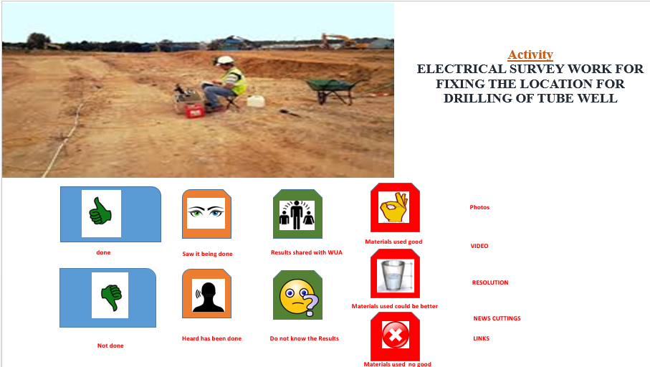
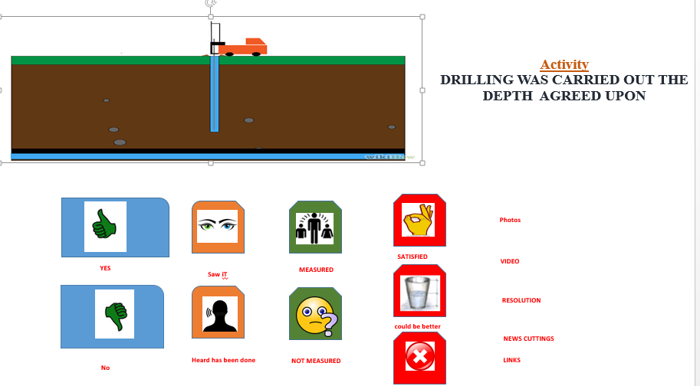

Storage of information in the data base (backend)
ACTIVITY | DONE | NOT DONE | SAW WHEN IT WAS DONE | ONLY HEARD | RESULT SHARED | RESULT NOT SHARED | Quality of material/ work good | Quality of material/ work could have been better | Quality of material/ work poor | TOTAL
Site selection adopting electrical resistivity survey | 1 | 0 | 1+2 | 1+1 | 1+2+2 | 1+2+0 | 1+2+2+5 | 1+2+2+3 | 1+2+2+2
Water quality from existing wells tested | 1 | 0 | 1+2 | 1+1 | !+2+2 | 1+2+0 | 1+2+2+5 | 1+2+2+3 | 1+2+2+2
Display Board installed while work is going on | 1 | 0 | 1+2 | 1+1 | !+2+2 | 1+2+0 | 1+2+2+5 | 1+2+2+3 | 1+2+2+2
Drilling – is done at the identified location | 1 | 0 | 1+2 | 1+1 | !+2+2 | 1+2+0 | 1+2+2+5 | 1+2+2+3 | 1+2+2+2
Drilling is completed to depth as told to WUA | 1 | 0 | 1+2 | 1+1 | !+2+2 | 1+2+0 | 1+2+2+5 | 1+2+2+3 | 1+2+2+2
Drilling samples collected and laid out systematically for studying it | 1 | 0 | 1+2 | 1+1 | !+2+2 | 1+2+0 | 1+2+2+5 | 1+2+2+3 | 1+2+2+2
Electro logging was carried out before lowering of casing pipes and screens | 1 | 0 | 1+2 | 1+1 | !+2+2 | 1+2+0 | 1+2+2+5 | 1+2+2+3 | 1+2+2+2
Do you know how many casing pipes were lowered into the well | 1 | 0 | 1+2 | 1+1 | !+2+2 | 1+2+0 | 1+2+2+5 | 1+2+2+3 | 1+2+2+2
Do you know how many screens were lowered into the well | 1 | 0 | 1+2 | 1+1 | !+2+2 | 1+2+0 | 1+2+2+5 | 1+2+2+3 | 1+2+2+2
Do you know how many water bearing zones were met with during drilling | 1 | 0 | 1+2 | 1+1 | !+2+2 | 1+2+0 | 1+2+2+5 | 1+2+2+3 | 1+2+2+2
Was gravel pack done in the well and what quantity was used | 1 | 0 | 1+2 | 1+1 | !+2+2 | 1+2+0 | 1+2+2+5 | 1+2+2+3 | 1+2+2+2
Was Cleaning of the well (Development) done | 1 | 0 | 1+2 | 1+1 | !+2+2 | 1+2+0 | 1+2+2+5 | 1+2+2+3 | 1+2+2+2
Did y see and taste the water that came after cleaning | 1 | 0 | 1+2 | 1+1 | !+2+2 | 1+2+0 | 1+2+2+5 | 1+2+2+3 | 1+2+2+2
Was the well tested using pump | 1 | 0 | 1+2 | 1+1 | !+2+2 | 1+2+0 | 1+2+2+5 | 1+2+2+3 | 1+2+2+2
Did u see the water flowing from the well during pump test | 1 | 0 | 1+2 | 1+1 | !+2+2 | 1+2+0 | 1+2+2+5 | 1+2+2+3 | 1+2+2+2
Do you know the discharge from bore well based on pump test | 1 | 0 | 1+2 | 1+1 | !+2+2 | 1+2+0 | 1+2+2+5 | 1+2+2+3 | 1+2+2+2
Has the submersible pump been installed in the well | 1 | 0 | 1+2 | 1+1 | !+2+2 | 1+2+0 | 1+2+2+5 | 1+2+2+3 | 1+2+2+2
has the electrical connection obtained | 1 | 0 | 1+2 | 1+1 | !+2+2 | 1+2+0 | 1+2+2+5 | 1+2+2+3 | 1+2+2+2
Has the storage reservoir been completed | 1 | 0 | 1+2 | 1+1 | !+2+2 | 1+2+0 | 1+2+2+5 | 1+2+2+3 | 1+2+2+2
Has the drainage pipe line been laid | 1 | 0 | 1+2 | 1+1 | !+2+2 | 1+2+0 | 1+2+2+5 | 1+2+2+3 | 1+2+2+2
Has the command area been defined | 1 | 0 | 1+2 | 1+1 | !+2+2 | 1+2+0 | 1+2+2+5 | 1+2+2+3 | 1+2+2+2
 | 1 | 0 | 1+2 | 1+1 | !+2+2 | 1+2+0 | 1+2+2+5 | 1+2+2+3 | 1+2+2+2
Total

Grading of scheme tube well construction as per Community Perception
GRADE | RATINGS
Excellent :85-100% | Materials / construction good
 | Activities carried out : 85-100%
 | Activities Seen : 85-100%
 | Activities results shared : 85-100%
good :70-84%% | Materials / construction good
 | Activities carried out :70-84%
 | Activities Seen : 70-84%
 | Activities results shared :70-84%
Fair:60-69% | Materials / construction could have been better
 | Activities carried out :60-69%
 | Activities Seen : 60-69%
 | Activities results shared :60-69%
Poor:<60 | Materials / construction poor
 | Activities carried out :<60%
 | Activities Seen : <60%
 | Activities results shared :<60%

