West Bengal Accelerated Development of Minor Irrigation Project

Implementation Support and Review Mission
September 5-9, 2016

Aide Memoire

Introduction

- A World Bank mission visited West Bengal from September 5-9 2016 and conducted an Implementation Support and Review Mission for the West Bengal Accelerated Development of Minor Irrigation Project (WBADMIP). The objectives of the mission were to: (i) review overall progress and assess the implementation capacity by current closing date December 2017; (ii) discuss and agree with project on details of project restructuring, and (iv) review overall project status, including fiduciary and safeguard arrangements. This aide memoire summarizes the mission’s main finding.

- The team held multiple discussions with the Project Management Unit of state (SPMU) and district (DPMU) and mission was concluded with a joint meeting with the District Project Management Units (DPMU) and Support Organization (SO) staff. The honorable minister of minor irrigation also joined the meeting to motivate the team and award the well performing ones. At the end of joint meeting, the findings were discussed in presence of Secretary and Project Director, Mr. Prabhat Mishra. The team visited proposed villages and more than 31 schemes and other works done by external agencies in nine districts and interacted with members of the Water User Associations (WUA) (Figure 1) and DPMU. The team sincerely thanks project management staff for arranging these discussions and field visits.

Key Project Data

Table 1. Project Data and Performance Ratings
Project Data |  | Project Performance Ratings
Board Approval | October 4, 2011 |  | Last | Now
Effectiveness Date | March 19, 2012 | Development Objectives | MU | MU
Closing Date | December 31, 2017 | Implementation Progress | MU | MS
Loan Amount  Credit amount | USD 30 million  SDR 78.2 million  (equivalent to USD 116.4 million) | Problem Flag | 1
Total amount | USD 155 million | Procurement | MS | MS
Disbursed Amount  (as of Sep 15, 2016) | USD 53.40 million | Finance management | MS | MS
Project Age | 5 years | Monitoring | MU | MS
% Disbursed | 34.5%
Moderately Unsatisfactory (MU), Moderately Satisfactory (MS)

Overview of Project progress

- The project development objective (PDO) is to enhance agricultural production of small and marginal farmers in the project area. This will be achieved through accelerated development of irrigation services to small and marginal farmers, strengthening community-based irrigation management, operation and maintenance, and support to agricultural development, including provision of agricultural services for encouraging crop diversification, use of improved technologies as well as creating income generating opportunities. Originally the project target was to provide 4,660 schemes to provide irrigation to 139, 000 ha and benefit 166,000 farmers. In Feb 2016, a total of USD 95 million was cancelled from the IBRD loan, mainly due to project savings and currency gains. It means now the revised budget of project would be ~USD 205 million. It was assessed that with the revised project budget, the project would be able to develop around 2,000 schemes to irrigate 75,000 ha and 100,000 farmers that will be operated and maintained by 1,800 WUAs. The type of schemes under the project has also been revised from more groundwater based to surface water based in drier zones of the state which would mean larger investment per unit of water to be harnessed however operation cost to the farmer would be less.

- The project has now maintained its momentum with current disbursement at USD 53.4 million (34.5%) while expenditures incurred and commitments are around USD 60 and 40 million respectively. The cumulative expenditure and commitments would account for 50% of total project cost. The project is now working on almost 1206 schemes (60% of revised target) with 566 schemes already handed over to water users associations and 508 schemes under implementation while remaining are in preplanning stage. It was estimated that project would be able to complete the construction of 1400 schemes and disburse USD 105 Million by Dec 2017 (current closing date). The post construction activity are critical to meet project objective of project and would require at least one crop cycle. Current status and pace of project indicates that it would require minimum of two additional years to complete the construction of targeted schemes, hand hold the institutions for operation and maintenance and adoption of irrigated agriculture which are critical elements of project for sustainably of schemes.

- A total of 566 completed schemes have been handed over to WUAs. These are expected to harness 85.15 MCM, serve 17,528 ha with gross command area of 33,000 Ha and benefit more than 46,650 users. Out of these schemes, 398 were handed over before December 2015 and have served at least two cropping seasons with 11,103 ha net area and 20,208 gross area. In these schemes, cropping intensity has improved from 90% to 178%. Half of WUAs have been rated satisfactory or higher while many are yet to pickup on water management practices fully. With the introduction of agricultural support services (in particular horticulture and pulses), the area under non-paddy has increased from 10% to 28%. As a result of increased cropped area, productivity, and diversion to more cash crops, the value of produce in net project area of 11,103 ha has almost doubled (from INR 41,558 per ha to INR 76,323 per ha). Fish production based demonstrations have also shown the potential to increase the gross income by five times (from INR 72,000 per ha to INR 3,60,000 per ha).

- Mission was pleased to note that many innovations introduced under the project are being scaled up not only under the project but also in the state run schemes including solar based hybrid schemes; integrated approach with agriculture based services.

- Based on the above assessment and project status, the Implementation Progress rating has been upgraded to “Moderately Satisfactory”. The target indicators for project are yet to be matched with the revised project budget while it seems unlikely that the project would be able to meaningfully complete the revised targets by current closing date. Therefore project development objective is being maintained at “Moderately Unsatisfactory”.

- The project team needs to focus on the following critical actions over the next six months to sustain implementation: (i) immediately establish a design and Quality Assurance/Quality Control (QA/QC) cell in the department; (ii) Strengthen the DPMU team with dedicated and appropriate team members including additional support organizations; (iii) Update the MIS including performance of schemes; (iv) finalize restructuring of the project including realistic indicators; (v) strengthen supervision including for environmental screening.

Innovations and leveraging

- The project has introduced many innovations or improvements in current practices which has contributed to success and effectiveness of irrigation based investment and is slowly being recognized by the state and other projects in the country. The following are being scaled up not only in schemes financed by the project but also in other schemes in West Bengal. The specific activities included:

  - Technical Support to state flagship program, Jaltirtha in western districts: The revised focus of project and the state’s program of Jalthirtha were introduced around same time. The project has supported in concept for water harvesting, and locating the sites for implementation under Jal Tirtha. Project is also focusing more on surface water based schemes.
  - Community based planning and implementation: Project has demonstrated the process of scheme development and management plan (SDMP) in rainfed area in consultation with community and with holistic planning for irrigation and agriculture.
  - Watershed based planning with GIS and remote sensing tools: GIS and remote sensing based technique for planning, design and impact monitoring of schemes has contributed to target project intended areas in transparent manner.
  - Improved planning and Design of Tubewells: The success rate of tubewell commissioning has improved drastically with the use of modern techniques for site selection, geological characteristics and design. The use of geo-resistivity for locating the site, cost effective and environmentally sustainable material and digital borehole logging to locate right aquifer zone have been introduced under the project.
  - Introduction of solar based pumping systems in state run program: The solar systems has facilitated the farmers in remote areas where they have been deprived from development in absence of irrigation, and energy. These systems offer energy with minimal operation and maintenance cost. Now the state is keen to expand in their own government run program while also upscaling under the project.
  - Transforming farmers as Entrepreneur: The small farmers have been introduced to modern agricultural practices and water management including development of vegetable nurseries in plastic tunnels which has enabled the availability of seedlings in the village itself.

Implementation Status by Component

Component A: Strengthening Community based Institutions

- The component aims at mobilizing and strengthening community institutions of farmers in the command area of irrigation investments under the project and assumes greater significant not only on the continued operation and maintenance of the scheme but also on the judicious management of water resources. The project has engaged four support organizations (NGOs) for overall institutional strengthening all over the state. In addition, two NGOs have been engaged to pilot scheme implementation through women based WUA (in Purulia) and establishment of bio villages. Over the last few years, the project has made substantial progress particularly in some districts however there are still some fundamental challenges in terms of streamlining all over the districts particularly in focus western districts, therefore this component is rated as “Moderately satisfactory”.

Progress:

- The major highlights of this component are:

    - Formation of WUAs: A total of 1206 WUAs representing for more than 89,372 beneficiaries have been formed that are participating in planning, supervision and Management, Operation and Maintenance (MOM) of schemes. Among various beneficiaries, women account for 14 %, tribal for 11% and small and marginal farmers account for >75%. The members in almost all the schemes have contributed member fees indicating their interest to operate and maintain the schemes.
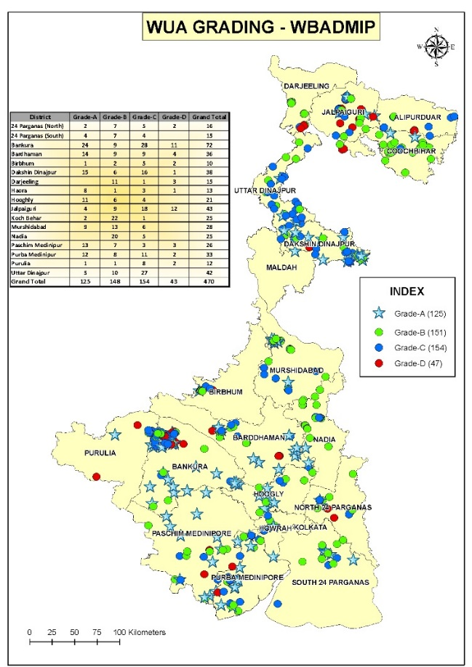
    - Operational WUAs: A total of 566 WUAs are operating and maintaining completed schemes and serving more than 46,650 beneficiaries and representing for 17,528 ha. A total of 398 schemes (handed over till Dec 2015) have been operational for last one year with more than 50% of WUAs performing satisfactorily or better. Western districts predominantly with surface structures need to work more on strengthening the WUAs. The well performing WUAs are managing their activities with regular meetings, good record keeping and appropriate corpus fund for O&M. Out of total beneficiaries, 30,940 farmers (30% of total) have paid water charges in the schemes which provided irrigation in earlier seasons.
    - Management Operation and Maintenance: Almost 22 WUAs are measuring the water levels and sharing with project through SMS while 10 70 WUA are practicing water budgeting. Almost 80% WUA have minimum funds required for operation and maintenance of schemes out of which 10% have already funded the maintenance as required.
    - Women based WUAs are piloted in five villages of Purulia which are being strengthened to implement small irrigation structures.
Figure 1:WUA performance (blue star and green circles are well perofrmaing)
Table 2: Summary of WUA progress
Formation of WUA | Dec 2015 | July 2016
No. of sites identified | 1899 | 3657
No. of WUAs formed | 1079 | 1206
No. of WUA registered | 513 | 763
No of WUA having bank A/c | 274 | 452
No of WUA collecting membership fees from the enrolled members | 431 | 664*
Percent of Women in executive committee | 2014 | 4487
No of operational Fisheries income groups strengthened | 26 | 144
No of WUAs operating schemes | 363 | 522
Number of WUA operating schemes satisfactorily | 124 | 235
No of WUAs mobilizing corpus fund | 268 | 396*
Amount of Corpus fund (INR lacs) | 10.91 | 64.42
No of WUA collecting annual revenue required in excess to O & M expenses | 64 | 346
*already reported by July 2016 for FY 2016-17.

Observations:

- Standardization of practices needed: Although project has made substantial progress in the formation of WUAs, improvement are required to transform these WUAs into “operational” with focus on water management. The project is yet to strengthen its training program, standardized various activities and documents. In absence of standardization, the WUA strengthening in various districts have been mixed. Substantial efforts are required particularly to change the attitude of engineering staff and give space to non-engineering staff and facilitate them to function effectively. Project has now engaged a consultancy for training and yet to be functional. WUAs needs to be involved more in monitoring of water levels (in all type of schemes); water budgeting, operation, and crop planning. They should be posting their achievements/performance on walls and share with PMUs on regular basis. They should also participate in supervision of construction. CSP who are required to work regularly with WUAs need to be trained and work with WUA on above activities.

- Delayed support to Women based WUA: The project has piloted formation of women based WUA in Purulia with the help of Pradhan NGO. They approach through SHG group and strengthen them to implement small structures. PRADAAN has formed all women WUA in five tribal villages of Purulia district with a total membership of 468. All the five WUAs have been registered and have opened their bank account with Rs.500, collected as a contribution from the community. Since, the project is yet to be sanctioned, no physical activity has taken place however participatory planning event and training in agriculture has been conducted. WUAs have been waiting for the project support for more than two years and it is requested that funds may be released by project at earliest. As it a reputational risk for the project.

- Potential convergence with National Rural Livelihood Mission: Almost all villages under the project have “Anandadhara” women self-help groups supported under the National Rural livelihoods mission (NRLM) working for a number of years on credit and thrift activities. These women SHG could be a good asset for the minor irrigation project particularly in operation and management (O&M) of tubewells/pump dug wells to scale up the PRADAAN model of Purulia to other districts. A workshop was arranged to explore convergence between WBADMI and WBSRLM on July 18th, 2016. During the workshop it was agreed that (i) an awareness program will be conducted for both SHGs of WBSRLM and WUAs to learn from each other; (ii) common blocks / GPs will be identified where interventions can be initiated; (iii) WBSRLM created Sangha and Mahasangha to participate in WUA meetings to explore possibilities of potential areas of convergence; (iv) women members of WUA will be made members of SHGs under WBSRLM; (v) SHG members can be involved in activities of WBADMI; and (vi) Sanga and Mahasangha members to act as service providers to WUAs. Once the arrangements are agreed between the two projects, A MOU may be signed to delineate the roles and responsibilities.

- Issues and actions: In order to make WUAs more engaged at various stages, following needs to be strengthened: i) increased supervision by WUA during construction and fill up QA/QC cards; ii) Preparer water budget and water distribution plan; iii) WUA prepare Wall paintings with the performance of schemes showing project key indicators seasonwise; iv) Standardized training, documents and templates including printed irrigation roster register, self-assessment cards and other record registers to ensure the consistency in the records at each DPMU;

Component B: Irrigation System Development

- The component is for developing new minor surface water and ground water irrigation schemes mainly in areas that are currently cultivated under rain fed conditions with the objective of improving availability of water for agriculture and fisheries. The minor irrigation schemes include surface flow irrigation systems (comprising river lift schemes, check dams and water detention structures), and minor ground water irrigation schemes (light duty tube wells, and pump dug wells). These schemes have a potential of irrigating 5 ha to 40 ha each. It means the size of a water users association (WUA) might range from approximately 40-200 farmers. The scheme implementation cycle under project including pre-planning, schemes development management plan including detailed design of schemes, procurement, implementation and hand over to WUAs for sustainable operation and maintenance.

- The component accounts for 90% of project cost with target schemes of around 2000 (with respect to revised budget). The pace of project has improved substantially with 566 completed schemes and 508 schemes under construction accounting for a total cost of more than 658 crore (USD 100 million). Based on the progress, the rating of this component is maintained as Satisfactory. While the project has streamlined planning and implementation to a great extent, there is a room to improve design with cost effective schemes, supervision and operation and management of schemes.

- The mission appreciates the overall improvement in designing and implementing path-breaking reforms in an otherwise conventional system of planning, design and implementation in the minor irrigation sector in the state. The major reform and innovations include: redefining the scope of project target area based on the spatial pattern of rainfed land (Figure 2), cluster based approach instead of scattered implementation, update of design of schemes and introduction of solar based energization. The project focus has shifted from south to Western part of the state for scheme construction while water management interventions are proposed in already developed southern districts. Cluster based approach is already showing the effective participation of communities during planning and implementation of schemes when compared with Batch 1 schemes which were implemented in scattered locations. The focus has shifted from groundwater and lift irrigation schemes to development of surface storage structures in western districts. Impressive progress has been made through enhanced institutional capacity to absorb innovations, and to translate the enhanced capacity into delivery of participatory irrigation services to small and marginal farmers.

- Project is progressing well: Overall the project is working on 1206 schemes with 566 completed, 508 under construction, 82 under bid evaluation process and 50 in bid preparation process with a total expenditure of USD 60 million and commitment of USD 40 million (Table 3). Overall the average speed of project has been around 250 schemes in a year. Average time taken to complete a scheme has improved from 2 years to less than 1 year. This can be partially attributed to reduction in electrified schemes which was highly time consuming process and early availability of land to work without any crop during non-monsoon season. There are still some schemes pending for Batch 2 and 3 due to rebidding processes.

- Development of Irrigation schemes lead to accelerated crop production in rainfed areas: The project has contributed to additional water harnessing of 85 MCM through 566 schemes. These schemes have a potential to irrigate almost 17,528 ha. Out of these, 398 were completed by December 2015. These schemes have benefitted 17,528 ha of net area and 33,000 ha with increase in cropping intensity from 90% to 178%. These schemes enabled the increased production during Kharif season and increase in cash crops during Rabi season or pre-Kharif season. The project also facilitated exposure to improved agricultural and water management practices. As a result, the proportion of vegetable area has increased from 10% to 28% while value of produce has increased from INR 41,558 per ha to INR 76,323 per Ha (based on index price of year of 2015). The increase in value of produce can be attributed to increase in paddy production during Kharif, additional cropped area of more than 50% during Rabi and Pre-Kharif and diversification of high value crops. During last monsoon, the monsoon in western districts (most vulnerable area of state), the schemes served in drought proofing where in the farmers were able to save their Kharif paddy with life saving irrigation in western districts.

- In Batch 2 and 3, around 127 schemes where works had not started, were dropped when it was noticed that these schemes were proposed for renovation of storage structures (SFMIS). On technical ground, while mission agrees that increased capacity of storage structure through renovation may also lead to similar benefits, it is not under the scope of project and it would require restructuring of the project. The project is advised not to select such schemes in future and SPMU in particular needs to ensure this.

- Out of 566 schemes handed over to WUAs, 22 schemes have been reported dysfunctional. As advised earlier, the project team should try to make them back to operation. However this practice should not encourage recurring expenditures.

Table 3. Status of scheme implementation
Description | No of schemes approved/ completed | Completed | Total cost  (Rs. Crores)
Batch 1 | 347 | 330 | 100.40
Batch 2 | 450 | 212 | 278.15
Batch 3 | 432 | 24 | 198.22
Batch 4 | 178 | 0 | 0
Total Number of schemes (a+b) | 1206 |  | 658.43
Number of schemes completed | 566 |  | 216.31
Number of schemes handed over to WUA (c) |  | 566 | 216.31
Number of schemes dropped* | 143 |  | 79.46
Not functional |  | 22 | 6.44
Number of schemes operational |  | 544
Percent of schemes with WUAs performing satisfactorily | 53%
Remaining Number of schemes (a+b-c) | 640 | 442.12
Schemes under preplanning stage | 178
Schemes for Administrative approval | Nil
Status of procurement
Bids under preparation (a) | 50 | 24
Tenders floated (b) | 1156 | 537.28
Contract awarded and work order issued (c + d ) | 1074 | 524.16
Schemes with work in progress (d) | 508 | 291.22
Civil Work Completed and awaiting energization | 27 | 11.36
Dropped* | 143
Projections by Dec 2017
Number of schemes handed over for more than 6 months | 434 | 149.65
Number of schemes handed over by Dec 2017 | 1400 | 700
Number of schemes remaining | 600 | 300
Expected to be completed by  Dec 2018 | 500 | 250
June 2019 | 100 | 50
* Dropped schemes are not included in the Total no of schemes
** Work Completed but awaiting handing over to WUA and Number of schemes completed are same, hence removed from the table

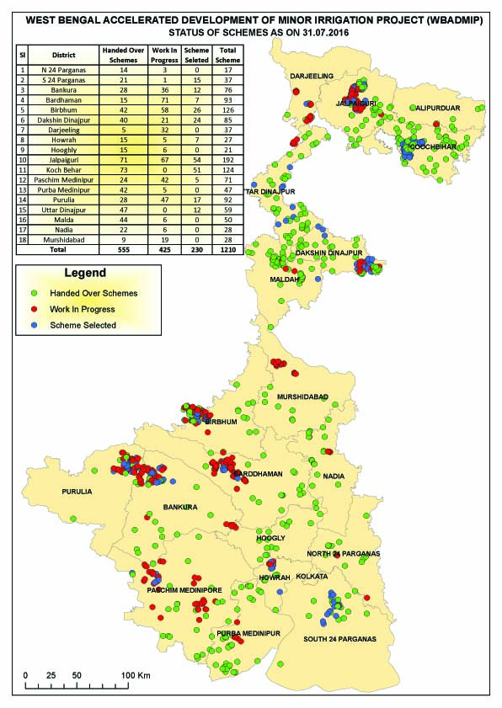

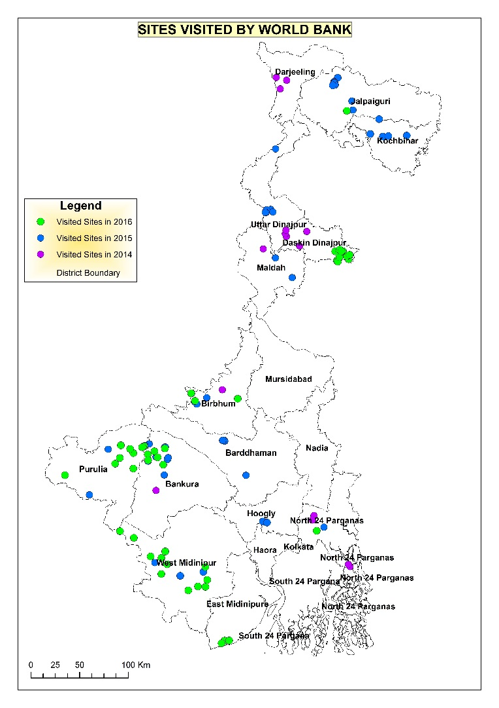

Figure 2: Status of Schemes and sites visited by the Mission

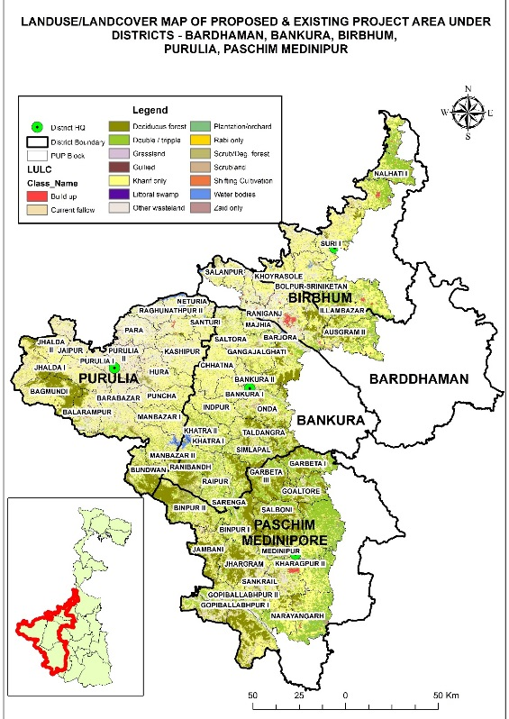
- Preplanning:

- The project has identified more than 600 schemes for Batch 4. These have been cleared with the condition that SPMU will ensure that proposed schemes are in intended areas. Project has further proposed to include additional blocks in western districts in order to reach more vulnerable areas (Figure 3). There is a proposal to include 64 additional blocks which would mean additional 6000 villages. During last few years, the cluster based approach has demonstrated benefits from social and management point of view. While mission agrees that project could spread to additional blocks, it may introduce ranking of watershed for selecting the deserving ones so that efforts could concentrate in those watersheds to demonstrate some significant impact. Some threshold may be set for minimum development in selected watersheds/sub-clusters so that spread of interventions is not too sparse to demonstrate the benefits. Since management of those schemes will also be equally challenging, it was agreed that expansion would take place only after assigning the appropriately trained and dedicated teams. In particular dedicated and accountable EE, AEs and additional support organization would be critical to implement the project successfully.
Figure 3: Additional blocks proposed under the project in Western Districts
- It was noticed that some districts were still proposing irrigated area or replacement of private tubewells. They are advised to avoid such sites as it would unnecessarily lead to rejection of schemes and delay in the process. The DWRIDD engineers have been experienced of implementing surface storage schemes that require a land size of more than one Ha which has been challenging to acquire. Considering the challenges with land availability, and site conditions it is advised that project could consider small size structures including seepage based storages (Happa) or 5% model (5% of land for storage) as shown by Pradaan during recent mission. In the past, many schemes have been simplified and made socially, technically and environmentally viable by reducing the size of schemes. So same strategy need to be acquired for both check dams and storage structures. The project team needs to focus on upland and small streams for check dams.

- Planning and design. The WRIDD engineers are implementing surface schemes for the first time at such a large scale and have been experiencing challenges in designing the structures in cost effective and technically viable manner. The SPMU should approve administratively only after checking for cost per unit of MCM of storage capacity of proposed structure (please note it should not account for refilling). The economic threshold is Rs 5 lakh per ham of storage and project should attempt to limit around that extent.

- Following was agreed during the mission:

    - Establish survey and Design Cell: A design cells needs to be established at SPMU where in DPMU engineers could work with SPMU engineers to standardize the designs of various structures proposed under the project. The modern survey equipment (DGPS) may be procured which will help in designing the surface schemes more effectively. Also the help of some modern survey companies may be employed to map all the important structures and accordingly plan to fill the gap.

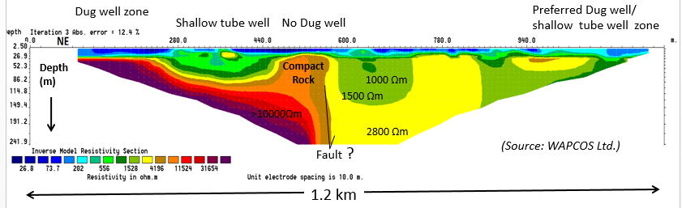
    - GW structures: The success rate of tubewell installation has improved drastically with the use of modern geo-resistivity, however it was noted that in some instances, intended aquifers are below the depth of drilling indicated in the bid. Similarly it has been noted that sometimes the pump capacity is not optimum with respect to discharge capacity of tubewell. The DPMUs were advised to design the bid to address these issues and make it flexible for both drilling depth and pump capacity. In Western districts, the construction of dug wells has delayed due to blasting requirement which is not permitted in these areas. The geo-physicist expert demonstrated how resistivity imaging could be used to locate the suitable sites for wells where blasting will not be required. Pumping test of tubewells needs to be linked with the final payments and report as one of the performance indicator. The monitoring team needs to assess and map the yield of aquifer for future development. These aquifer details should be translated for community use and should be shared with them for future development by drilling agency as well as the farmers.
Figure 5: Resistivity based imaging for locating the sites for dug well and tubewells
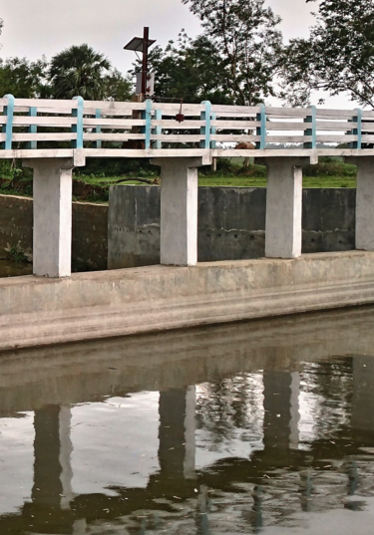
    - Improve Hydrological monitoring and assessment: The design team has always experienced challenges to estimate peak flood in absence of actual field data. After 3 years of follow up, finally around 16 sites in three districts (Purulia, Jalpiaguri and Birbhum) have been initiated and for remaining it is in progress. The mission noticed that the quality of installation could use some improvement particularly in terms of wiring and database management. Since the systems are being installed by different vendors in different districts, they need to ensure the integration of data in one platform. The project may use the web-based database management software already available (e-SWIS) with Central water commission which will support in validation as well. The DPMUs/SWID are encouraged to spread this monitoring beyond the project polygon area so that it could help in future development. In addition to automated or manual monitoring, SWID should work on calibrating with the discharge using instruments such as flow trackers. SWID and project need to work together in improved planning. SWID should provide historical information with the project and project should have the mechanism to share with SWID on real time basis all the knowledgebase being created under the project including geo-resistivity and borehole logging. As prime objective for these measurement was to contribute to aquifer mapping. SWID also needs to strengthen GW modelling capability and assess the potential for groundwater development in various complex regions of state. Particularly in Malda, they need to guide the project for further development in proposed polygon which is underdeveloped.
Figure 6: Check dam monitoring

    - Scheme Development and Management Plan (SDMP) could be basically village development plan with the layout of all the proposed structures in the village. The SDPMU should map/specify the locations for lead of earthwork in advance.

    - Revision in Schedule of Rates: It was noticed that SOR has some item rates which are significantly higher than in other ”developed” states and due to which cost of schemes is coming very high. The project team was advised to revisit and update accordingly. It seems they need to be updated for mechanical based implementation.

    - Revised Bid documents: The project should ensure to follow standard bid for various schemes with balanced responsibilities and accounting at both ends. Some suggestions/recommendations are shared in Annexure. In particular the final payment/defect liability should be after testing the surface schemes for one monsoon season. The extended warranty may be taken for various machineries and need be handed over to WUAs.
    - Solar based pumping systems: Project has piloted around 60 installations with solar based pumping out of which 40 have been installed and 19 are in the process. Majority are operating successfully however their performance in terms of discharge and its usage are to be documented. The GoWB also has net metering system which will allow farmers to supply excess energy into the grid and save net electricity cost. Based on the success of project, there is a proposal to upscale solar based pumping systems both in the project as well as in state run schemes. Majority of them have been installed at open wells and check dams. The installation at check dam would require more work towards strengthening of WUA as it is a common property. While mission very much welcome the upscaling of schemes, following observations may be considered to make program effective: i) sensitize reputed providers through a workshop; ii) engage an expert to guide in design and installation; iii) liaison with expert agency for regular training of field staff to design, supervise the installations.

- Implementation and Supervision: In order to ensure the quality control during implementation, the project needs to strengthen the supervision. It was surprising to note that the project is not even following the protocols of supervision which they follow in their own departmental schemes including site inspection register and pre and post survey verifications. The display boards or paintings of schemes need to be ensured during the construction (with details of contractor and schemes specs) and wall paintings on handed over schemes. The WUAs need to be made integral part of supervision including their training and distribution of relevant information sheets. The project has large number of contracted engineers which require a proper training for quality control.

- The Third party QA/QC is in place for independence quality control of 30% of sites in five districts where surface schemes are predominant. They have visited 72 sites and noticed 27 sites with major issues. Major issues noted were: i) technical team member was never provided from contractor side to supervise; ii) Bids with no provision for compaction of embankment; iii) Design of check dams. Some additional observations have also been noted by World Bank team in some structures during the visit. Although failure of schemes is very small, the project team should use these opportunity to learn from failures and introduce required measures.

- Supervision of implementation at the field including attention to environmental aspects continues to remain inadequate (in spite of the augmented staff of DPMU including 6 environmental specialists which was expected to improve site supervision). Even significant deviations, such as violation of environmental avoidance conditions, or indiscriminate disposal of excavated material (excavated muck is being dumped randomly, without minimum protection, sometimes upstream of water body itself) is noticed only through SPMU or World Bank mission, which could cover only a small sample of subprojects. It is reported that DPMU engineers visit the sites during construction (although there is no standard frequency of such visits), but are unaware of the quality control and environmental due diligence requirements (detailed in the “environmental codes of practice”) during construction. The 5 DPMUs who have environmental specialists have diverted them for other roles, and have not assigned any specific responsibilities for environmental management. Consequently, there has been no report on environmental supervision and compliance reporting from the DPMUs except Nadia, South 24 Paraganas and Purulia. Other DPMUs did not have the resources, and no information on environmental management during construction is available. The mission proposed that the SPMU engineers should undertake at least one visit per month during construction including two specific visits to ensure environmental due diligence and verification (one during initial stage of construction, and one prior to completion and release of final payment to contractors to ensure compliance to the environmental management plan as well as the environmental codes of practice). The mission also urged that final payment to a contractor is not made until environmental compliance report is available at the SPMU (made by the contractor, certified by the responsible DPMU engineer, and verified by SPMU). To make this work, it will however be required that (1) all 5 environmental specialists remaining with the project will work with the SPMU to ensure full compliance report for all current and upcoming subprojects; (2) the responsibility for environmental supervision will be made part of overall supervision requirements of any DPMU engineer; and (3) all responsible DPMU engineers are trained in the “environmental codes of practice” prepared for the project. SPMU agreed to impart such training.

- Institutionalize Quality Assurance and Quality Control: Mission would like to reiterate that it is critical to institutionalize quality control cell coordinated by SPMU and engineers in the field inducted. For GW schemes, the QA/QC is yet to be put in place. Considering the work load, the project may front load the role of third party QA/QC and assign them to supervise more schemes during this year. SPMU also needs to ensure the response time to recommendation made by QA/QC and also make correction in ongoing bid documents where serious concerns have been observed.

- Both supervision team and QA/QC need to ensure the compliance to bid documents. In order to ensure QA/QC, bid document should also make it mandatory to have core samples, photos, videos at various stages of construction and final capacity of structures based on post survey. As suggested during last missions, DPMUs need to be equipped with mobile material testing laboratory for testing the quality of construction and testing of raw materials used for construction.

Table 4. QA/QC status of schemes (type of defects)
S. No. |  |  |  | Status
1 |  | Number of Schemes Visited | 72
 |  |  | Major (Incomplete Concept Planning & Design) | Medium (Absence of technical representative of agencies) | Minor (Incomplete technical specifications)
2 |  | Number of schemes identified with Issues | 27 | 69 | 69
3 |  | Issues addressed or being addressed | 3 | 2 | 67
4 |  | Issues Pending | 24 | 67 | 2

Table 5. District wise status of QA/QC

S. No. | District | Number of schemes | Number of schemes  Visited | Number of schemes with major issues | Number of scheme where actions are taken | Number of scheme where actions are pending
1 | Bankura |  | 21 | 5 | 19 | 19
2 | Birbhum |  | 20 | 8 | 20 | 20
3 | West Midnapur |  | 5 | 0 | 5 | 5
4 | Purulia |  | 16 | 8 | 15 | 15
5 | S24 Paragana |  | 6 | 6 | 6 | 6
6 | Bardhaman |  | 4 | 0 | 4 | 4

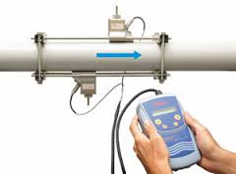
- Performance Monitoring of schemes: The monitoring of schemes need to start soon after commissioning of scheme to ensure that the structure has been commissioned as per design and final payment should be linked with the performance of scheme measured as: i) Storage developed in surface structures that has to be done with pre and post survey ii) the pumping tests of tubewells iii) the gauges in surface schemes, water meters in pumping system and energy meters in electrified or solar need to installed which are to be monitored on regular basis. Simultaneously during each season, the change in cropping pattern, and crop production are to be monitored while for some selected schemes the economic returns are to be monitored in details. For monitoring the pipe flow, now portable ultra-sonic meters are available that can be provided to each DPMU. The DPMU can calibrate against energy meter during each cropping season. In the bids, also, the bidders should be required to use similar devices for testing the performance of schemes and pumping tests and the reports should be submitted on real time basis in online system.
Figure 7: Ultrasonic flow meter

- Issues and Actions: i) SPMU to ensure the cost effective design of structures and update Schedule of rates; iii) DPMUs to improve bid for tubewell bids with flexibility for pump and drilling depth; iv) SPMU to standardize the bid and improve bids with commercial conditions to ensure the optimum performance and warranty of pumps and other parts.

Component C. Agricultural Support Services

- This component provides support to beneficiaries who have been provided with irrigation services and were not used of irrigated agriculture and aim to improve the economic water productivity for the farmers. The overall purpose of conducting technology and method demonstrations has been be to accelerate adoption of improved technology and practices within WUA members and beyond in the targeted villages. The handhold support for a couple of production cycles would be required to achieve good technology adoption and see productivity improvements.

- The major activities under this component included: i) Demos for innovative crop production practices & technologies ii) Introduction of innovative systems and farm machineries iii) Mobile based technical guidance to the farmers (through private sector service provider) iv) Convergence with Agriculture, Horticulture and Fishery departments; v) Farm water schools to expose the farmers to innovative practices and vi) introduction to good agricultural practices (bio village program). The design and approach for these interventions have been guided by a World Bank trust fund (Water partnership program) particularly through a value chain approach. The advanced approach was first focused in western priority districts and now has been upscaled in other districts. Based on the results so far, Component implementation is maintained at “Satisfactory”. The detailed strategy and approaches are provided in Annex C1 and the guideline for conducting are developed separately. During FY 2015-16, promising progress has been noted in introduction of advanced Horticulture, Agriculture and Fishery activities.

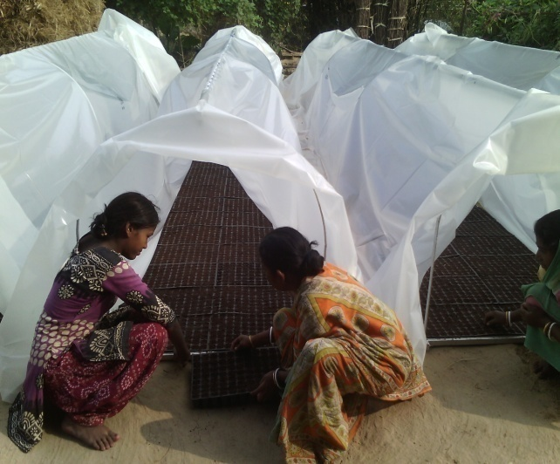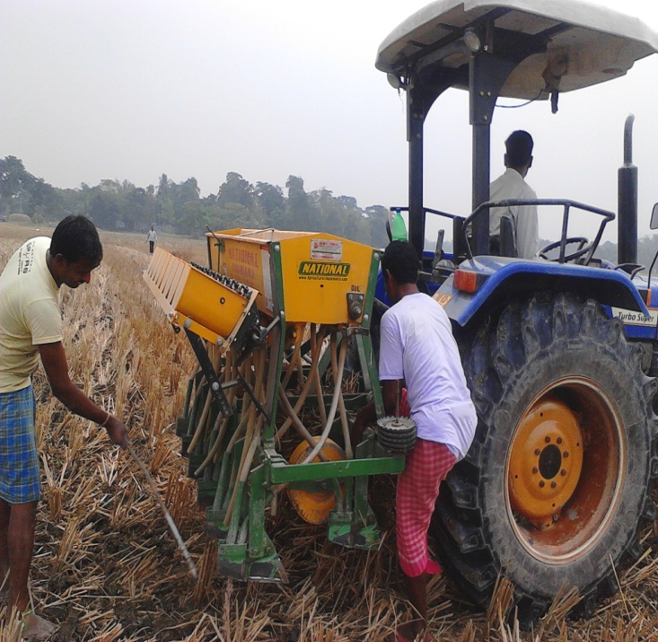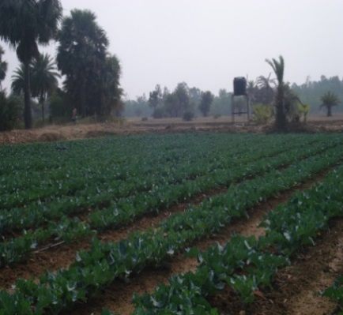

Figure 5. ASS Technology Demonstrations

Intensive technology demonstrations for enhancing productivity and farmer income:

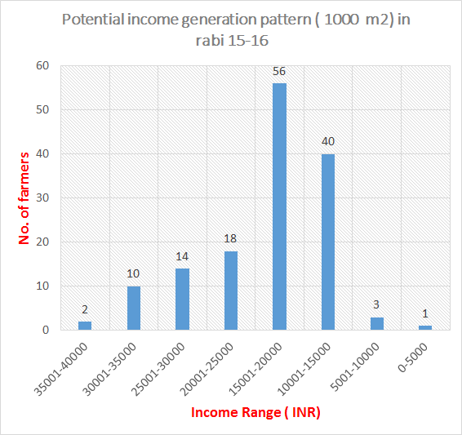
- In order to diversify and introduce water management practices, the project has supported 6,510 agriculture demonstrations covering 2670 Ha, 6865 horticulture demonstrations covering 731 Ha and 144 fisheries demonstrations. The demonstrations for various technologies and good practices primarily included, Paddy (improved seed/variety, line planting; input); Oilseed (introduction of Sunflower, Maize etc.); Pulses (Introduction of Red Gram); Vegetable (Improved nursery, drip irrigation, improved practices for productivity enhancement, market based production of high value vegetables, market linkages etc.); Mechanization (Power Tiller, Potato planter and digger, Zero till etc.); Fisheries (hatchery for Joel fish species, critical inputs for pond management and higher productivity) etc. The demos have facilitated in introduction of nurseries for vegetables, production practices for pulses and paddy plantation practices. The efforts towards convergence with other line departments for technology demonstrations viz., Black Pepper, Red Gram etc. is commendable. The demos indicated the potential of increase in productivity of various crops as well the income of farmers ranged from 52 % to 245 % over baseline (Table 7)

- During Rabi 2015-16 on pilot basis, the project worked with around 144 farmers in prioritized western districts on ‘Market based production system where the pattern of different commodity arrivals and prices in respective markets over different seasons, was carefully studied and based on market intelligence crop planning (Tomato, Cauliflower, Brinjal) was done. This helped the project to schedule the right mix of crops for WUA farmers and the returns realized (Average ~INR18,745 from 1,000 square meter per season of 120 days) was quite encouraging (Figure 8).
Figure 8: Potential Income generation through vegetable farming

Table 6: Summary of technology demonstration under Agricultural Support Services

Parameter | Target for Project Period | December 2015 | Kharif  2016 | July  2016 (Cumulative) | Achievement %age till date
Agriculture
Demonstration (#) | 12,600 | 3989 | 2093 | 6,510 | 48.80
Beneficiaries (#) | 40,000 | 7970 | 3372 | 12,148 | 30.35
Area (Ha) | 5,040 | 1595.6 | 837.2 | 2670 | 53.00
Horticulture
Demonstration (#) | 4800 | 3767 | 2648 | 6865 | 143
Beneficiaries (#) | 24,000 | 3767 | 2648* | 55286865 | 23.03*
Area (Ha) | 252 | 456 | 216 | 731915.3 | 290.0*
Fisheries
Fisheries Demonstration (#) | 600 |  | NA | 144 | 24.00
Female beneficiaries (#) | 1,080 |  | NA | 300 | 0.00
Tribal beneficiaries (#) | 780 |  | NA | 250 | 15.25
*Horticulture one beneficiary/DC; *Pre Kharif 2016 data not included

Table 7: Potential of income based on best demos

Crop | Sub Crop | Increase in income (%) | Value (Rs/Ha) |  | Net Income
 |  |  | Baseline | Demo | Baseline | Demo
Paddy |  | 51.7% | 34800 | 52800 | 5800 | 23800
Pulse |  | 140% | 27500 | 66000 | 10720 | 49220
Oilseed |  | 245% | 16000 | 55200 | 5000 | 44200
Vegetables | Cauliflower | 180% | 217500 | 428500 | 130000 | 324480
 | Brinjal | 148% | 187500 | 510000 | 112500 | 382000
 | Tomato | 161% | 75000 | 550000 | 120000 | 361700
Fisheries |  | 329 % | 20000 | 350000 | 35000 | 200000

- Good Agricultural Practice, GAP, Village (“Bio-Village”): The Bio Village initiative (one village each in each of the 6 agro-climatic zones in the state) started almost 2.5 years ago. Based on the initial success of work in the 6 villages of first batch, the program has now been extended to 40 more villages of 8 clusters. Whereas the first batch of 6 villages did not have strong linkages to the project’s targeted polygons, the 40 villages of 8 clusters in the second batch were selected from the project’s targeted polygons. This will ensure that other activities of the projects could also be implemented in these 40 villages, and this expected convergence among project activities will truly transform these villages. Further, the villages in each of the 8 clusters are contiguous, and therefore for demonstration purposes, there will be larger impacts.

- In first set of 6 villages, overall 30-40% of targeted beneficiaries have been covered who are familiar with bio-products and testing the recommended dose in their field. Similarly, work in second batch of villages have also started about 6 months ago (contracts were signed in October 2015, but work could effectively start in May 2016, except in one cluster where it started only in August), there has been some noticeable initial progress (see Annexure C1). Further, in these clusters, technology such as protected cultivation and SRI have been introduced; 51 azolla production units and 20 vermicomposting units have been already established.

- This program is about major change management in their agricultural practices and for improved adoption there is a need of improved attention and extension services with the expert who can think more holistically. The sustainability would depend on the accessibility to the product after the project. The linkages with providers and exposure to other bio-products is needed so that it doesn’t lead to any monopoly and accessibility is improved. In the past, mission team had indicated that scheme construction may be considered in bio-villages if necessary however it should not lead to wrong expectation of farmers. For instance in the Belia village (Jhargram) where mission visited, it was clear that farmers had their own arrangement of irrigation but they were indeed short of financial access that limited expansion of cash crops during Rabi. From interaction with the farmers, it has emerged that awareness about the certified seed and paddy varieties suited for the village needs to be improved and adoption of GAP practices need to be made more visible. It was agreed that SPMU will converge bio village activities with other ASS and will work with Neempeth to strengthen extension services. The mission therefore, appreciated the two short films prepared for Batch-1 villages; but recommended the partner agency add and edit the films to create on single documentary in January 2017, by adding additional evidences of expansion of the activities, and also create 5-minute summary bytes from this documentary. Once this is prepared, the SPMU should disseminate this summary and the entire documentary film through its portal and to the DPMUs and WUAs. A very informative recommended crop calendar is also produced by this GAP program, and SPMU agreed to print and distribute these to all WUAs.

Table 8. Progress of GAP Village Program (Batch 1)
Criteria | Total Target Group | 3rd Year Target (as on 31st Dec 2016`) | Current Achievement (as on 31st June 2016)
Number of farmers applying Recommended dose of fertilizers according to soil analysis report | 1776 | 1066 | 743
Number of farmers applying balanced dose of mixed fertilizer | 1776 | 799 | 635
Number of farmers adopting 25% replacement of chemical fertilizer by bio-inputs | 1776 | 533 | 555
Number of farmers avoiding the use of WHO Class 1A, 1B & Class 2 pesticides | 1776 | 888 | 727
Number of farmers practicing IPM | 1776 | 799 | 608
Number of villagers aware about safe transport, storage, handling, application and disposal of synthetic pesticides | 1776 | 888 | 724
Land area under this practice (ha) | 858.07 | 343 | 210

Component D. Project Management

Project Management

- Leadership at both SPMU and DPMU levels: Recently the charge of Project director has been given to new Secretary (Minor irrigation). This arrangement has completely revolutionized the environment as well as decision making process in the project which was major bottleneck. His dedicated support and vision to take this project to next level is highly commendable. An additional SE has also been assigned as additional project director. It was assured that dedicated teams will be provided in districts including EE and some staff from advanced districts will be moved to focus districts while AEs will also be decentralized to focus in their sub-divisions.

- SPMU: SPMU team consist of engineering staff from DWRID and the multi-dsciplinary team through consultancy (EGIS). The SPMUs need to be strengthened with some additional experts and cells including:

  - M&E: The monitoring in the project has been very weak and the incharge for each activities needs to monitor not only the quantity but also the quality of work.
  - Solar expert and firm; As project is planning to upscale in solar, there is a need of solar expert while they can also engage an agency for guiding the installation and training the field staff to supervise the installation and operation.
  - Design and quality control cells. The project also needs to setup design and quality control cell so that designs could be standardized and monitoring/supervision of construction could be improved. The SPMU may have some core staff and required software to guide the design while DPMU engineers could visit SPMU design cell and learn to standardize.

- SPMU consultancy is time based that has enabled in customizing the team formation and their involvement with respect to emerging needs of the project. As project has experienced revisions in the scope of activities, the role of various experts was revised to match with the project’s needs and utilize the support for expediting the implementation. When project was unable to engage some field staff for years, and the project was experiencing inordinate delays, senior management recommended to include SAEs and PPP (agriculture promoters) in this consultancy. Considering the critical role of these positions in implementation of project, World Bank supported the proposal as otherwise further delay in the project would have resulted in additional loss of time. During every mission, we have been informed that payments of firm has not been made which directly and indirectly has been affecting the project progress. Now mission was informed that the position of PPP will be discontinued with EGIS while the process of rehiring them is not clear. Project needs to ensure that trained staff is not lost and the ongoing activities in the field are not disturbed while project is left with hardly 1.25 years before closure. Agricultural support services is an important activity towards sustainability of handed over schemes and after lots of efforts this has picked only last year. With the loss of these trained PPP, this activity will be impacted very significantly.

- DPMUs multi-disciplinary staff: In DPMUs, the project has multi-disciplinary teams through a combination of staff employed directly or through a recruiting firm. There has been large turnover in the project for contract staff (gap of 100) which will be filled through a new recruiting firm which is yet to be appointed. The arrangement for recruiting contract staff needs to be done immediately so that there is continuity in the activities without losing trained staff. Further the project is planning to expand the scope in focus districts for which additional team for all the disciplines will be required. Project director shared his vision about strengthening the team in sub-divisions. The expansion of activities should take place only after new teams are placed and there are fully trained. The project took help of SPMU consultancy to provide some immediate needs of staff such as sub assistant engineers and project program promoters (PPP). Considering the urgent need of project it was approved by the bank, however it seems neither project has paid for those and nor they have made arrangements for long term. It is advised that project has already put lots of resources in training them and they should be transitioned so that continuity of their activities are maintained. Project needs to ensure that all the contract agencies are paid on time so that the staff working in the field is not affected. The pending staff at EGIS and required revisions to EGIS contract has been pending for long. The recruitment arrangements for staff who have left need to be made because the contract for previous recruiting agency is over.

- It is noted that the multi-disciplinary staff in DPMUs may be reorganized and layers may be minimized while their roles may be more focused in terms of regions/villages. All the staff in field should understand full process and should be able to fill in unless specialization requirement is needed. Currently DPMU contract staff is responsible for only coordination while they could also contribute in field work similar to NGO experts. Both NGO experts and DPMUs experts should be assigned villages to be accountable for end to end solution instead of divided responsibilities.

- Similarly the work load of environmental screening needs to be shifted to DPMU as otherwise it has been falling on SPMU specialist. During last mission, it was agreed that a Graduate in relevant Branches of Engineering (Civil/Chemical/Agricultural Engineering) could also be considered acceptable with a minimum relevant work experience of 3 years so that they can take up the full responsibilities of environmental screening and site supervision during implementation and prior to completion of 100% of the sub projects. That means substantially more responsibilities for environmental management need to be shifted to DPMU.
- Currently the project has four NGOs as support organizations for mobilizing WUAs. Following the increased focus in western districts, project will be required to organize additional support for mobilizing the WUAs. The project may like to adopt different models:

    - Strengthen DPMUS with all kind/level of staff through recruiting agencies (however challenges are there with them too for timely payments).
    - Additional SOs: There can be different models depending upon the potential of NGOs. One model could be inviting NGOs to adapt to project approach and philosophy. The other could be output based with a freedom of approach. The project may even invite proposals from the NGOs to suggest their approach and strategy to achieve required output (project output indicators). This may however require project to allow some community based procurement.

Table 6: Status of staff in SPMU and DPMU
PROJECT MANAGEMENT | Actual | Target
Number of DPMUs established (nos.) | 18 | 18
Number of site offices established | 2 | 10
Total Number of Staff SPMU | 37 | 43
- SPMU Govt staff* | 9 | 10
- SPMU through firm | 81 | 88
Number of contracted staff at DPMU | 192 | 292
Number of Govt staff at DPMU | 62 | 62
Support Organization staff | 153 | 156
Total Staff | 501 | 616
Number of workshops organized | 63 | 72
Number of project staff trained in project activities | 473 | 500
*Government staff at DPMU have not always been dedicated and have dual charge.

- Site Office and transport facilities at DPMU: Since last mission, the mobility of multi-disciplinary team has improved, however, with the increase in the number of schemes the mobility needs to be improved further. In order to minimize the mobility issue, project has proposed following: allocate sub-division offices with the sites; explore the probability of providing allowance for use of motorbikes and provide extra vehicles. The site offices may be also be established as needed. Burdhman has already done and other DPMUs are advised to act on this immediately. The DPMU are welcome to take private accommodation at competitive rates. The project needs to ensure that SO facilitate staff transport as their movement has also been limited.

- Continue orientation and capacity building to staff: It is important that the project staff are clear on project implementation processes, principles and implementation guidelines. A capacity building agency has been engaged for continued training and capacity building of staff. They are in the process of mobilization. All levels of staff including engineers, SO and CRPs require regular training. In addition some expert help from expert agencies such as solar, survey and design may also be employed.

- Collaboration with Research and academic Institute: The project is generating wealth of information and innovations. The impact and learning can be analyzed through collaboration with research and academia. The students may be invited to do some projects at various levels.

MIS and monitoring Framework:

- Project has very robust MIS and GIS based system and many GIS based planning tools have been introduced in the project. In particular the project has developed GIS and remote sensing based planning and monitoring tool which has completely revolutionized the planning in the department and is contributing towards e-governance. The project has set up an excellent example not only for the department but also for other projects and have been highly appreciated in various events, The system is however highly SPMU centric and DPMUs yet to find it useful for their own processing. In absence of DPMUs full participation, its update and quality of data has been limited. SPMU needs to make it mandatory to use the data, link with the fund releases and also monitor the quality of data input by DPMUs. In absence of non-functional MIS, the quality control during implementation and performance reporting for both management as well project impact has always been challenging. The MIS update needs to be made mandatory so that the team could be more efficient in planning and monitoring,

- Impact Assessment: Despite the challenges, the project has many successful stories emerged from various schemes and team work but due to poor monitoring and reporting system, they are yet to be bought to streamline. It is imperative that project now carries out assessment of project benefits in handed over schemes. The assessment should compare results with Mouza that are not covered under the project. The SPMU needs to prepare terms of reference to hire consultancy and initiate the process as soon as possible.

- MIS has now improved substantially. The linkages have been established with DPRs with provision of uploading BID document, BOQ, Drawings, Photographs, QA/QC report, scheme synopsis etc. Following however still need attention:

  - The inconsistency in some modules including agriculture and Finance need to be improved.
  - The results indicators are yet to be made LIVE and there is large discrepancy in the values. Presently modification in the dashboard, graphical interface are in progress and expected to be finished by Oct, 2016. GIS based scheme level monitoring system has been implemented.
  - Develop an online training mechanism by January 2017.
  - Ranking systems for DPMU and WUA and others need to be made real time rather than declaring the result during mission. This system would generate healthy competition and will guide DPMU to assess and perform. This should be made public so that everyone can track their ranking.
  - The online dynamic training modules can be developed as shown for National Hydrology Project (www.indiawrm.org). This will be shared with the project.
  - Integrate website with MIS so that the progress can be shared on website.
  - Agricultural module needs seamless integration between MIS and GIS so that various parameters could be shown in user friendly and also ensure the fast processing.
  - At Present MIS is working to define a consolidated QA/QC report which will be uploaded to the project MIS. The bank mission has suggested to use application program interface to sync the QAQC third party application data into MIS. At Present MIS is working to define a consolidated QA/QC report which will be uploaded to the project MIS. The bank mission has suggested to use application program interface to sync the QAQC third party application data into MIS.

- Maintain the monitoring and evaluation (M&E) system: The project has pioneered in GIS and RS based monitoring. They are in the process of collaborating with National remote sensing Center. The impact of schemes on land use, cropping intensity and yield are being monitored and are available online. However the integration of MIS (yield data) has been behind due to which the calibration has been slow. The project performance monitoring on day to day basis needs to be put in place starting from data quality to overall progress and quality. A milestone monitoring matrix and result chain have been developed alongwith progress milestones that clearly tracks progress and performance of different field units. Till restructuring of the project is finalized, two sets of monitoring frameworks are being maintained. One is based on PAD indicators and the other one with the proposed indicators (Annexure 1.a and. 1.b). The project has also introduced remote sensing based monitoring which could be made useful for field staff to monitor by themselves. A dashboard may be developed.

- Project website and Intranet are developed: To ensure that there is continuous interface and smooth flow of information between SPMU and the DPMUs, a project intranet has been developed with rights to access by all SPMU, DPMU and SO level staff. The project may give DPMU a space for having their own website as well.

- Storage and back up are being arranged: During earlier mission it has been suggested that a data retention policy be established in order to keep important and critical information in a cloud based server so that it could be searched and accessed whenever required which is still in process but not completed. MIS team has already initiated the development and secured cloud based server has been selected. The SPMU has agreed to launch the new secured integrated MIS website by January 2017.

Financial Management

- Disbursement Profile: Against the revised allocation of USD 30 million [post cancellation of USD 95 million] under IBRD 8090-IN, the disbursement as of 19-Sep-2016 stands unchanged at USD 1.225 million [4%] and reflects (a) front end fee of USD 0.313 million; and (b) documented reported project expenditures up to 31-Mar-2016 amounting to USD 0.912 million. The disbursement as of date against the signed amount of SDR 78.2 million for IDA-5014-IN stands at SDR 36.235 million [equivalent of USD 66.425 million at 46%] and (a) reflects the expenditures related to reinstatement of PPF and reported project expenditures up to 31-Mar-2016 amounting to SDR 31.660 million; and (b) unadjusted advance of USD 7.159 million. The undisbursed balance of approx. USD 87.35 million. Project has provisionally reported expend of INR 20.692 million [Bank share INR 20.257 million] during the quarter ended 30-Jun-2016 and will liquidate the advance by approx. USD 0.303 million when processed. At current exchange rates, the project will need expend of approx. INR 750 crores in the remaining project life in order to fully utilize the Loan/Credit.

Table 11. Financial summary [as on 19-Sep-2016]
 | IDA 5014 |  | IBRD 8090
 | SDR | USD | USD
Signed Amount | 78,200,000 | 125,000,000 | 125,000,000
Cancelled |  |  | 95,000,000
Disbursed | 36.234,858 | 66,425,474 | 1,224,958
- Expend documented | 31,289,844 | 44,316,948 | 912,458
- Front End Fee |  |  | 312,500
- PPF Reinstated | 370,531 | 569,950
- Designated Account Advance | 4.574,483 | 7,159,522
- Exchange Losses |  | 14,379,054
Percent disbursed | 46% |  | 4%
Available | 41,965,142 | 58,574,526 | 28,775,042

- Budget and Fund Flows: Against the project budget allocation of `360 crores for FY16-17, `113 crores has been placed at the disposal of DDOs through an allotment process using the e-bantan system. Delays in setting up the budget allocations at the start of the year meant that low levels of project expend have been reported in the first quarter of FY16-17.

- Project Expenditures: The project has reported a total expenditure of `193.332 crores during FY15-16 (and cumulative project expenditure of `350.788 crores). As per provisional financial reports, expend during FY16-17 [up to end-Aug 2016] stand at `46.105 crores and estimated to reach `300 crores by end-March 2016. A summary of expenditures is as per Table 3 below.

Table 12. Project expenditure by Project Components

Project Components/Sub Components (vide cost tab) |  | FY2011-12 | FY2012-13 | FY2013-14 | FY2014-15 | FY2015-16 | FY2015-16
 |  | 21-Dec-2011 to 31-Mar-2012 | 01-Apr-2012 to 31-Mar-2013 | 01-Apr-2013 to 31-Mar-2014 | 01-Apr-2014 to 31-Mar-2015 | 01-Apr-2015 to 31-Mar-2016 | 01-Apr-2016 to 31-Aug-2016 | Cumulative to Date
A. | STRENGTHENING OF COMMUNITY BASED INSTITUTIONS |  | 10,618,588 | 35,089,813 | 33,384,658 | 35,880,585 | 11,020,218 | 125,993,862
 |  |  |  |  |  | -
B. | IRRIGATION SYSTEM DEVELOPMENT & IMPROVEMENT |  | 1,637,505 | 299,797,056 | 838,013,395 | 1,563,541,614 | 381,027,383 | 3,084,016,953
 |  |  |  |  |  | -
C(I). | AGRICULTURE DEVELOPMENT |  | - | 1,447,362 | 17,801,800 | 39,330,675 | 1,632,389 | 60,212,226
 |  |  |  |  |  | -
C(II). | HORTICULTURE DEVELOPMENT |  | - | 1,192,379 | 3,461,947 | 23,710,666 | 3,927,323 | 32,292,315
 |  |  |  |  |  | -
C(III). | FISHERIES DEVELOPMENT |  | - | 119,778 | 3,259,388 | 9,060,208 | 2,370,536 | 14,809,910
 |  |  |  |  |  | -
D(I). | PROJECT MANAGEMENT - SPMU | 14,308,037 | 18,384,243 | 60,578,289 | 113,674,933 | 135,400,028
 |  |  |  |  |  | - | 61,068,925 | 651,602,341
D(II). | PROJECT MANAGEMENT - DPMU | 9,022,946 | 18,399,818 | 27,481,438 | 66,880,803 | 126,402,881
 |  |  |  |  |  | -
GRAND TOTAL |  | 23,330,983 | 49,040,154 | 425,706,115 | 1,076,476,924 | 1,933,326,657 | 461,046,774 | 3,968,927,607
All figures are in Indian Rupees

- Delays in submission of IUFRs: The project has not yet submitted IUFRs for the quarter ended 30-Jun-2016 [due on 15-Aug-2016]. This has been attributed to the delays in the finalization of State Accounts by AGs Office for FY15-16 and the ensuing delays in the reconciliation of the expend reported for the project. Given that the IUFRs report expend generated from IFMIS, it was agreed that the project will not wait for AG reports and submit IUFRs generated on the basis of IFMIS reports on a timely basis.

- Establishment of dedicated DPMUs and improvement in staffing of accounting function: In a significant effort to streamline project implementation, the project has established 18 dedicated District Project Management Units [DPMU], effective from 01-April-2016. Administrative approvals have also been obtained to engage retired Divisional Accountants to provide accounting support to DPMUs. A dedicated Drawing & Disbursing [DDO] has been appointed for SPMU and is functional from the same date. A full time Controller of Finance [West Bengal State Accounts cadre] has joined SPMU from Jan-2016.

- Deletion of expend on identified Excluded Schemes: Of the 127 schemes agreed to be excluded from the project, 26 schemes are presently under implementation. As per information provided, payments have however, only been made for 12 schemes under [no payments have yet been made for 14 schemes under implementation]. Post mission, these 12 schemes have been cleared on one time exception basis and have been allowed to include under the project funding. In the manner that expend are being presently reported, it has been difficult to establish if the expend on the excluded schemes are being reported and claimed from the Bank Loan/Credit. An exercise is required to be undertaken on an immediate basis to delete or flag the schemes in a manner that expend on these schemes are excluded from the project.

- Disconnect in expend reported in MIS/IFMIS: There is presently a significant disconnect in expend reported in the project MIS and IUFRs [generated from State IFMIS]. For the sake of integrity of the MIS data, it is imperative that expend entered in MIS are checked vis-a-vis IFMIS and reconciled. As per the quarterly scheme wise expenditure reports generated from the project MIS, the total expend up to 31-Aug-2016 is `282.574 crores as against `308.402 crores reported in IFMIS; MIS expend therefore stand under reported by `25.827 crores.

Scheme wise Expend [as on 31-Aug-2016]
 | MIS | IFMIS | Difference
Expend up to 31-Mar-2016 | 2,512,721,037 | 2,702,989,570 | (190,268,533)
Expend from 01-Apr-2016 to 31-Aug-2016 | 313,027,258 | 381,027,383 | (68,000,125)
Total Cumulative Expend reported | 2,825,748,295 | 3,084,016,953 | (258,268,658)
All figures in Indian Rupees

- Expend disallowed in Audit Report FY2014-15: In the annual audit report for FY 2014-15, the auditors have disallowed expend of `2.186 crores for various reasons. In addition, the auditors have certified expend of `109.098 crores, as against expend of `109.307 crores reported and claimed through the interim unaudited financial reports submitted during the year by the project. In this context, the Bank awaits the projects’ response on the disallowed expend as well as the difference of `20.82 lakhs in expend certified by the auditors.
- Overall, financial management performance remains unchanged at Moderately Satisfactory (MS). While the FM arrangements essentially remain mainstreamed into the state’s own accounting and financial reporting systems, persistent delays in submission of IUFRs affect the project’s ability to draw down on the Loan/Credit on a timely basis.

- Issues and Actions: a) An exercise to be undertaken on an immediate basis to delete or flag the excluded schemes in a manner that expend on these schemes are not included in the IUFRs – by Nov 15, 2016. b) Expend entered in MIS to be checked vis-a-vis IFMIS and reconciled (by Oct 30, 2016).; c) Submit reply to World bank‘s response on the review letter for audit report for FY14-15 – to be completed by Nov 15, 2016.

Procurement

- Mission reviewed the overall procurement in the light of the procurement plan dated 27th Nov 2015, cleared through SEPA. The estimated total cost of planned civil works is Rs.658 crores with current value of Rs 558 Crores after removing the dropped schemes by the World Bank. The estimated total cost for planned goods and consultancy services are Rs.45 crores and Rs.66 crores respectively. Total procurement planned is Rs. 669 crores which is approximately 48% of the project cost.

- Mission explained the project team about implementation of STEP (Systematic Tracking of Exchanges in procurement), which is mandatory for all projects. STEP will replace SEPA. STEP is the new procurement documentation management system, which will be used for submission of documents for review of the Bank, publication of procurement notices as well as for monitoring of progress on procurement. The advantages of STEP was explained to the project team and they welcome the system. The procurement team will schedule a training program for the project officials on STEP after due consultation with project.

- Mission noted that two procurement methods are included in the project restructuring paper: framework agreements and community procurement. However prior to restructuring, with the approval of APM, the project was advised to go ahead with the procurement process using framework agreement for procurement of solar panel systems, seed, sprinklers, drip systems and farm machinery etc. The project is yet to initiate the procurement activity in this regard.

- Contract management specially the way the projects are executed is a real issue and needs to be better organized. The mission stressed that the project team at the SPMU should review some contracts from each districts on monthly basis with suggested remedies to DPMUs and record exceptions in the monthly reports to the Bank. The Bank will conduct ex-post reviews of all contracts finalized between 1st July 2015 and 30th June 2016 either by Bank staff or its representative. The mission advised the project to extend all possible cooperation and provide required documents to the Bank representative for PPR17.

- Though some procurement progress has been made, many schemes still need to be planned and included in the procurement plan with follow-up action for early award of contracts. Therefore the procurement rating is retained as Moderately Satisfactory. Some procurements for NGOs and impact assessment are yet to be initiated. Similarly the civil work bid documents need to be improved and standardized.

Social and Environmental Management

Social Safeguards

- Farmer Participation: So far project has identified 3657 schemes and it has received 2265 applications from community for implementation of schemes. A total of 1292 WUAs have been mobilized with membership touching nearly 100,000. The involvement of beneficiary farmers in the quality check needs to be improved that will boost their confidence and morale for the continued irrigation management. There is a need to substantially improve the role of WUAs in planning and implementing agricultural support services.

- Land Donation: Mission was informed that 4,885 farmers have donated land for various schemes implemented of which 4803 are small and marginal farmers. Nearly 1500 land donors gave unconditional land where as others received some kind of facility from WUA towards land donation. (See details in Annexure D3). So far 3006 farmers have donated land for various schemes implemented of which 416 have been appointed as pump operator and another 614 gets free water. A large number of donors have not received any kind of gratitude for the land that they have donated.

- Percentage of land donated out of total land holding varies from less than one percent to 11%. In South 24 Paragana, all WDS and SFIS have been constructed on government land and hence there is no land donation. The mission was informed that in western districts such as Bankura, Purulia, Birbhum, West and East Medinipur where interventions are largely water retention structures, land is not donated or pledged to WUA. The land owners only provides right to easement for water usage. This might lead to conflict situation in future.

- Citizen Engagement: Though 1449 SDMPs have been submitted, 1206 have received administrative approval. Well performing WUA will be provided additional resources and activities to implement. To maximize project benefits several WUAs are providing irrigation water to non-members (including some outside the command area) and collecting user fees. In order to strengthen implementation of sub-projects apart from SOs, the project has identified small and marginal farmers who have successfully implemented irrigation services in their own villages as Community Service Providers (CSPs). A total 142 Community Service Provider has been appointed in 15 districts.

- Project now has an online grievance system. So far project has received 22 grievances of which only 3 have been resolved. Discussion with the community and project staff revealed that grievances related to land donation or entitlements do not come to SPMU as they generally resolved at the WUA level in consultation with SO representative and concerned IDS and Executive Engineer.

- Gender Actions: Gender based actions include: introduction of all women WUAs to construct, operate and maintain the irrigation schemes; inclusion as member in WUA by making spouse as eligible member, women (28% as governing council) as committee member in WUA, and as lead farmers for ASS demonstrations. The total number of women beneficiaries are little over 13% of the total beneficiaries.

- Project has not advanced much in terms of all women WUAs. So far five all women WUA has been formed by PRADAAN in Purulia district with a total membership of 468 from 555 households. The governing body comprises of 35 members. The project is also supporting 6013 woman-headed households, which is just 13% of the total households covered as beneficiaries in the command area. A total of 2513 women participated in various ASS activities that included 1378 in agriculture demonstration; 740 in horticulture demonstration and 332 in fishery demonstration.

- Tribal Beneficiaries: A total of 143 schemes have been implemented in 110 tribal mouzas across 26 blocks in 18 districts. So far 6,107 tribal households have benefited from the project. Project has spent nearly INR 450 million on tribal beneficiaries which is approximately 13% of the total project cost.

Environment Safeguards

- Overall, the environmental management systems and arrangements in the project continues to be “Moderately Satisfactory”. Momentum from planning, environmental screening and implementation of Batch III subprojects has continued, although further improvement expected did not fully materialize. Implementation of the third batch of sub-projects is ongoing. Environmental screening was completed for 557sub-projects in Batch-III. Out of which only 409 sub projects in batch III has received administrative approval due to various reasons and all were found to be of “low impact category”, with subprojects maintaining safe distance from environmentally sensitive areas. Notably, similar environmental screening was completed for 436 “Batch 2” subprojects; and during implementation the environmental screening results were found to be true for all except 1 subproject (command area of Majhirbundh surface flow minor irrigation subproject was found to be situated within 100m of Siartola forest). To strengthen environmental safeguard, 10th State level Steering Committee (SLTSC) in its meeting has taken decision to induct district forest officer of the representative district as a member of district level implementation committee (DLIC).
- Areas of improvement include continued use of the detailed screening formats for groundwater and surface-water subprojects; and the influence of environmental screening on selection of subprojects. Emphasis on surface water subprojects (against a preponderance of groundwater subprojects in Batch I) has been continued from Batch II (where 45% were surface water subprojects including check dams, water detention structures, surface flow, and river lift irrigation schemes) to Batch III, where 130 of the 409 subprojects (32%)are based on surface water. Earlier projection of 44 % of the proposed surface water based sub project has been reduced to 32 %, due to drop of surface water based sub projects in the Bankura district. All ground water based subprojects under Batch-III has obtained SWID recommendation/comments, which need to be complied with. In Batch II and Batch III, however, several check dams, retention ponds, and water detention structures were built or are proposed, where the project needs to ensure that they are designed appropriately and silt disposal sites are identified in advance. First two contracts (both involving one village each in each agro-climatic zone in the state) have progressed well. Although, performance varies among 6 villages slightly in each of the village second year targets (of the 4 year contracts have been achieved. Last 8 contracts (involving 5 villages in each contract) covering 40 villages has started from October 2015. Since then, inception reports and action plan has been submitted against 8 contracts.
- Study of bio-accumulation of persistent synthetic pesticides in popular food crops: Terms of reference for a systematic study on bio-accumulation of persistent synthetic pesticides in popular food crop was in September 2013, but the study is further delayed, as procurement of the required laboratory equipment at SWID is delayed. The mission discussed the options of SPMU procuring the required equipment, and placing it at the Calcutta University until space in the SWID premises is ready (when the instruments could be shifted to SWID), so that the team of Calcutta University can start the work. SPMU will discuss with SWID and inform the Bank whether this will be practical, or what other measures are being taken to minimize the delay.
- Water quality monitoring: Whereas, the plan for statewide monitoring of water quantity and quality (especially for smaller streams which are not covered under state or central monitoring programs) has started.. Regarding upgraded surface monitoring system at lift and surface irrigation schemes, work order for installation of 64 nos river gauges in Purulia, Bankura, Paschim Midnapore and Birbhum district with community based monitoring system has been issued. And installation of 3 nos gauges with telemetry system & GSM facilities at 3 nos river sites in Jalpaiguri districthas been completed and online data transmission started. SWID has also been strengthening with one geophysical borehole logger from Century Geophysical Corporation, USA. Also received training and demonstration conducted by the supplier. SWID has now been equipped with 13 in-situ water quality testing equipment, and the speed and coverage of tests are expected to increase. SPMU continuing monitoring quality and flow of water as of July 2016, a total 1317 water quality tests were undertaken for the sub projects (661 completed by Nov 2015 and 656 since then). Around 26.71 lacs Rupees has been estimated for further procurement of reagents and glassware in various lab under SWID. Water quality of the 3 districts i.e Coochbehar, Jalpaiguri and Darjeeling is affected by the renovation of the SWID lab in Jalpaiguri. After renovation, it is expected to pick up again in terms of water quality tests. Separately SPMU also has also started, on a pilot basis, groundwater level monitoring for 8 subprojects in South 24 Parganas, and has now mandated DPMUs to start flow monitoring for surface water subprojects (and a simple manual has been circulated to all DPMUs).
- The above, however, is not an adequate replacement of the expected state level monitoring of availability and quality of water (focusing on surface water and groundwater resources which are not covered by the established monitoring programs of the Central and the State government agencies). The mission urged SWID/SPMU to prepare a plan for such monitoring.

Governance and Accountability

- The project has a website (http://www.wbadmip.org/) and a toll-free number (with a dedicated officer) for grievance redress. Each DPMU also has one dedicated person for registering grievances, and the name and telephone number for grievances have been widely disseminated. DPMUs are maintaining records of all grievances including written complaints. Grievances at DPMU level are resolved within a month or escalated to APD level at SPMU. The aggrieved person has the option of approaching the judiciary if grievance remains un-resolved at SPMU level. To-date the project has received 35 grievances of which 30 are yet to be resolved. This year 26 complains were received in various districts while 4 are pending for previous years. Majority are related to breakage in pump/motor which need to be looked into and accordingly warranty and maintenance clauses may be looked into. The grievance system seems to be recording repeated complaints for same while those are just reminders in reference to their original complaints.

- The mission recommends preparation of a Governance and Accountability Action Plan at DPMU and SPMU levels, to be updated annually. These plans should be prepared in participation with project staff and shared once finalized. A grievance redress framework starting from WUA extending up to SPMU should be established. The mission recommends project adopt a zero tolerance to financial misappropriation at all levels.

- To facilitate anonymous feedback on schemes, the project has posted a list of schemes inviting specific comments. The project is encouraged to publicize the contact information for feedback at various levels.

List of Annexures and Figures

Annex Number | Description
1 | Agreed Actions
2 | Result Framework
B1 | Implementation of schemes
B2 | SWID
C.1 | Agricultural Support services
D.1 | MIS and M&E
D.2 | Environmental Safeguard
D.3 | Social Safeguard

Annexure 1. Agreed Actions September, 2016
(Green indicates good progress, yellow indicates some progress, white needs attention)

S. No | Action | By Whom | By When/ revised |  | Status (Sep 2016) | Revised/ follow on Action
Key Actions
 | Ensure Full time Project director, executive engineers and finance officer. | SPMU | Jan 2016/  Sep 2016 |  | New PD is providing full attention to the project.  District level leadership are yet to be worked out. | - Expedite payments and benefits to the contract staff and consultancies.
 | Expedite the Implementation of Schemes | DPMU/  SPMU | Ongoing |  | Speed has Improved | Quality of design and construction need to be improved.
 | Institutionalize design and QA/QC cells in the department. | SPMU | Immediately |  | Has been pending for long. | For surface scheme, third party QA/QC is in place.  Create a cell for overall QA/QC and assign SWID for design and quality control of GW schemes
 | Engage HR recruiting agency for DPMU staff | SPMU | Nov 30, 2016 |  | New activity | The contract expired for older ones and there is no arrangement to fill vacant positions.
 | Update MIS and M&E | SPMU/  DPMU | Ongoing |  | Improved a lot. Some modules are yet to be updated. | Monitoring by Farmer, WUA and DPMU need to be put in place.
- M | Hydrological monitoring of both Surface and groundwater | SWID/  SPMU | Ongoing |  | In 16 sites, it has commenced, however yet to integrate the system with SWID. | SWID needs to modernize both surface and groundwater to support ongoing development in the state.
 | Finalize Restructuring proposal | SPMU | Oct 2016 |  | Cancellation of USD 95 M was processed in Feb. | Result framework are yet to be updated in line with the revised budget.
S. No. | Action | By Whom | When/ revised | Status (Sep 2016) |  | Revised/follow on Action
Component wise detailed actions
Component 1: Strengthening Community based Institutions
 | Strengthen Management Operation and Maintenance in WUAs | DPMU/SO | Ongoing | MOM manual is ready and tested for WUA. It has been introduced partially in some districts. |  | Some WUA have started and need to be introduced in all the schemes.
 | Engage a lead Institution/NGO for strengthening Training program for project staff and WUAs. | SO/SPMU | June, 2015/March 2016 | Done and Training need assessment started. |  | They should pick resources agencies to support in development of modules.
 | Prepare QA/QC manual for WUAs. | SPMU | May 30, 2013/  immediately | Delayed. Update with third Party QA/QC support. Introduce OK card immediately. |  | The supervision has been weak by DPMU and WUA should learn to take the ownership of schemes and support in supervision.
 | Introduce water resources monitoring at schemes before and after handover through WUA. | WUA/SO  /DPMU | Immediately | Delayed substantially. Gauges have not been installed by DPMUs. Energy meters are being used in some but water monitoring through water meter has not picked up. |  | Provide water level tape, and install gauges in streams at correct locations. Streamline SMS based data collection system.
 | Self-monitoring by farmer and WUA | DPMU | Ongoing | Farmer card and WUA cards are ready. Self-assessment needs to be streamlined. |  | Wall paintings and other modes for performance reporting need to be streamlined.
 | Training of Community service providers (CSPs) | SPMU/  DPMU | Immediately | CSP have been inducted but they have no training. |  | CSP has been inducted and training provided in some district but not in all. SPMU have provided TOT for CSP training.
 | Support to Pradaan Women based WUAs | SPMU/  DPMU | 2013/Immediately | The financial support has been pending for more than two years. |  | DPMU should at least could do some work directly to maintain the credibility of project.
Component 2: Irrigation system development
 | Batch 4 schemes: 700 SDMP | SPMU  /DPMU/ DLIC | Ongoing | Selection is fast but preparation of SDMPs and integration with MIS have been behind. |  | Energization in 27 schemes is still pending.
 | Update specifications for surface schemes and make them cost effective. | DPMU | Sep 30, 2013/ | Refer AM and consult third party QA/QC. |  | Mandatory items for contract management need to be included in bid.
 | Establish Design Cell | SPMU | Nov 15 2016 | Design cell to standardize the design of schemes need to be strengthened at SPMU.
 | Update Schedule of rates | SPMU | Dec 31, 2016 | Update SOR in line with other state best practices and mechanized operation instead of manual which is leading to higher rates.
 | Procurement of Survey and design consultancy | SPMU | December 2016 | Rebidding proposed.
 | Quality control cell in SPMU and system at DPMU | DPMU  /WUA | June 2014 | Supervision needs to be improved. Quality has been poor in some schemes. |  | Mobile based and quality control needs to be put in place; Mobile quality control lab needs to be introduced and ok cards need to put in practice.
 | Set up protocol for response to third Party QA/QC | SPMU/DPMU |  | SPMU need to ensure that issues are raised with timeline. |  | The status should be escalated to Secretary level in MIS.
 | Solar based installation System | DPMU | June 2015 | Completed for around 60. Project is now proposing to scale up at large scale. |  | Quality of Installation needs to be improved. Training and expert were recommended during last mission. Their performance need to be monitored.
 | Performance Monitoring of schemes | DPMU | Ongoing | Delayed. Despite several reminders, correct report with Actual area irrigated, storage capacity and water availability have not been received. |  | Ensure Pumping test of GW and report here.
Component 3: Agricultural Support Services
- E | Ensure the continuity of PPP | SPMU /DPMU | April 2014/  October 2015 | Adhoc arrangements were made and regular plan was yet to be worked out.
 | Bio-Village program. | SPMU | Ongoing | Introduced in 6 village and now have been extended to additional 40 villages in polygon. |  | Monitor the contract progress more closely and converge with other ASS
Component 4: Project Management
 | Strengthen and manage SPMU consultancy with the required staff | SMPU /contract | Ongoing | Some key positions are vacant. |  | The payments for some positions have been pending to consultancy for long.
 | Dedicated Govt team at DPMU | SPMU | Immediately | Partially completed. Dedicated Team are yet to be put in place particularly for focused districts |  | Their induction and training would be critical to project implementation.
 | Induction training to new staff in overall project and their field of work. | SPMU | Ongoing | Some trainings conducted. For field staff it needs to be done immediately and regularly. The quality of training needs to be improved. |  | Training need to be more effective and frequent. Interstate and international exposures may be conducted.
 | Engage a recruitment firm for filling up vacant and additional positions required | SPMU | Nov 2016 | Delayed
 | Engage NGOs for additional areas | SPMU | Dec 2016 | New activity
 | Engage Solar firm for training and guidance | SPMU | Dec 2016 | New activity
Upgrades to f water information system at SWID
 | Upgrade surface water monitoring system at lift and surface irrigation schemes | SPMU /SWID | Ongoing | Started in some locations after a long delay. Set up combination of real time and community based monitoring. |  | Integrate data with CWC e-SWIS
 | Upgrade groundwater monitoring system | SPMU /SWID | Ongoing | A total of 200 stations with real time monitoring are under progress. |  | Start analyzing and prepare reports
 | Upgrade database management system in SWID: Prepare monitoring plan | SPMU /SWID | Oct, 2013/  Dec 2014 | Some GW based modelling software and .GIS softwares have been procured. |  | Collaborate with research and academia to make use of softwares procured.
 | Prepare a draft plan for comprehensive monitoring of water availability and water quality with estimates. | SWID /SPMU | Oct 31, 2013/ | Delayed. Please refer examples of Hydrology project states such as Andhra Pradesh, Gujarat who prepare monthly reports.
 | Update spatial database of old schemes with their status | SWID /SPMU | June 2014/  Dec 2016 | In progress
 | Organize and monitor all GW information generated in the project: geo-resistivity, Digital logging; and pumping test | SWID/SPMU | Immediately | SPMU and SWID to collaborate |  | Integrate all the data in SWID GRASP software.
MIS and M&E system
 | Develop web-based MIS for project immediately. | SPMU | Ongoing | Data is being updated. Each unit needs to monitor the quality of data. |  | Link MIS with financial release to ensure that field staff provides the data. The approval of scheme should be linked with update of SDMP data.
 | Update baseline data for both MIS and GIS platform with the details up to beneficiary/field level. | DPMU/  SPMU | Ongoing | Started but quality needs to be improved and report generation |  | Some attempts have been made but quality needs to be ensured.
 | Make GIS based mapping accessible to DPMU | SPMU | Ongoing | Very much in practice for selection of scheme however could be more user friendly. Train everyone irrespective of their positions. |  | Yet to make DPMU/WUA friendly using google products/wall maps for monitoring the impact.  .
 | Finalize M&E framework and link with result chain. | SPMU | Dec 2016 | Partially done but slow in generating the reports. |  | Partially Completed. Transform excel based data into MIS. Test for result chain.
 | Strengthen M&E at all levels upto WUA | SPMU/DPMU | March 2016 | Monitoring has been very weak and needs to be improved. |  | MIS needs to be now put to practice M&E. Farmer/WUA cards are prepared. Dashboard for reporting at web.
 | Intranet to link with DPMUs | SPMU | Jan 2016 | Done. Dashboards for each SPMU and DPMUs are prepared. Could be more user friendly. Even DPMU could be allowed to update their own webpage with success stories etc.
 | Financial management
 | Forecast of expenditures for next two quarters in IUFR 1B to be sent to World Bank. | SPMU | Ongoing (prior to each semester) | Submitted with delay. Yet to streamline for timely submission. |  | Forecast of expend for quarters ended 31-Dec-2015 and 31-Mar-2016 to be provided with IUFRs for quarter ended 30-Sep-2015
 | MIS and FMIS need to updated and reconciled. | SPMU /DPMU | March 2016 | MIS and financial MIS systems need to ensure the consistency.
 | Training to be provided to Divisional DWRID staff, including Divisional Accountants on the business processes and financial reporting requirements. | DPMU /SPMU | Ongoing | Conducted and in practice. |  | New IFMIS system is operational
 | Dedicated and full time DDO for SPMU to be functional; review status of accounting staff at DPMU level and take necessary corrective actions | SPMU/DPMU | January 31, 2016/Nov 2016 | Full time dedicated DDO has been appointed; full time dedicated DAO are now available at all DPMUs.
 | Finalize with deletion or flagging the excluded schemes in a manner that expend on these schemes are not included in the IUFRs. | SPMU | Nov 2016 | The list has been finalized and MIS and FMIS needs to compile the information.
 | Submit response to World Bank for Audit report FY 14-15. | SPMU | Nov 15, 2016
 | Procurement
 | Update procurement plan. | SPMU | Every mission | Update with Batch 4 proposed schemes |  | First ensure their technical feasibility.
 | Finalize procurement of Batch 4 schemes | SPMU /DPMU | March 2016 | Approval of 564 schemes given by World Bank. 176 schemes SDMPs are ready for submission. Expected to be awarded by March 2017.
 | Social Development
 | Issue Guidelines to SOs on addressing the issues related to Lands, Impacts and Tribal Development. | SPMU /SO | Ongoing | Ongoing activity. Keep updating the SOs as there is large turn over. |  | Continued.
 | Update information on actual land donation in all the batches prior to Admin approval | DPMU /SPMU | Ongoing | In case of easement arrangement, the charges need to be agreed with the owners.
 | Update Action Taken Report on implementing the TDP. | SPMU /DPMU | Ongoing | In progress.
 | Environment
 | Organize and complete training for DPMU staff and SO staff on environmental due diligence. | SPMU | Ongoing | Conducted and continued. |  | Field staff need to verify water availability and water quality.
- Si | Silt disposal | DPMUs | Ongoing | Identify the sites for silt disposal during DPR/SDMP and specify the location in the bid documents. Ensure disposal of silt at all the sites. |  | SPMU should verify the location with G  PS based photo and link with the final payment.
- T | Environment screening by DPMU | DPMUs | Ongoing | The DPMU staff/engineers need to be training in environment screening so that it is not delayed further. |  | SPMU has been responsible till date and it can not be done at SPMU level. This should be part of SDMP.
 | Finalize ToR, adopt approved selection procedure, and award contract for study on bio-accumulation of synthetic and persistent pesticides in food crops. | SPMU | Oct 31, 2013 | Not done.
 | Governance
 | Establish a grievance cell | SPMU | Ongoing | Partially done. Toll free and MIS in place. Out of 22 only 3 have been resolved. The response time needs to be improved. |  | Yet to put in full practice by sharing number with WUAs/community and dedicated person to it. Strengthened but still needs proactive disclosure. On web most of the Project information are shared.
 | Provision of display boards and project information system | SPMU /DPMU | Ongoing | In practice but need to be made mandatory. Contractor information need to be shared at site in all the schemes. |  | During construction and post construction, display boards are needed and mechanism for sharing scheme details with villagers needs to be practiced.

Annexure 2: Project Development Result framework (version 1)

No. | Indicator | Unit | Baseline | Previous | Current | End Target
PDO Indicators
1. | Water users provided with new/improved irrigation and drainage services | Nos. | 0 | 36262 | 46650 | 166000
2. | Water users provided with irrigation and drainage services – female | Nos. | 0 | 2949.00 | 5397 | 30000
3. | Operational water user associations created and/or strengthened * | Nos. | 0 | 1322 | 1161 | 4200
4. | Increase in yield of main agricultural crops (rice, oil seeds and vegetables) measured in MT/ha, with increases starting two years from the year of construction. | MT/ha
(i) | - Vegetables |  | 10.30 | 12.00 | 17.87 | 15.2
(ii) | - Oilseeds |  | 0.40 | 1.10 | 1.49 | 0.9
(iii) | - Rice |  | 2.9 | 4.00 | 4.43 | 4.2
5. | Number of female and male water users (defined as member of the WUA) provided with water delivery services. | Nos. | 0 |  |  | 0
(i) | - Number of female water users | Nos. | 0 | 2949 | 5397 | 30000
(ii) | - Number of male water users | Nos. | 0 | 33313 | 41253 | 136000
6. | The percentage of female WUA executive committee members | % | 0 | 20.00 | 28.32 | 25%
7. | Resources generated by user groups to manage, operate and maintain the developed schemes (as % of required resources, starting the year after completion; % shown are for first year schemes) | Nos. | 0 | 62 | 62 | 90
8. | Operational water users associations created | Nos. | 0 | 1322 | 1161 | 4200
Intermediate Results Indicators
9. | Clients who have adopted improved agricultural technologies promoted by the project | Nos. | 0 | 17000 | 17677 | 0
10. | Clients who adopted improved agricultural technologies promoted by project – female | Nos. | 0 | 3400 | 3400
11. | Area provided with irrigation and drainage services | Ha | 0 | 31000 | 32753 | 139000
(i) | - Area provided with irrigation and drainage services – New | Ha | 0 | 31000 | 32753 | 139000
12. | Area under SRI cultivation in scheme commands | Ha | 0 | 233 | 924 | 20000
13. | Farmers in project area adopting improved production techniques | Ha | 0 | 24 | 24 | 40
14. | WUAs maintaining appropriate cash books and water regulation registers | % | 0 | 70 | 78.59 | 80%
15. | WUAs holding regular General Body meetings | % | 0 | 70 | 70 | 80%
* Few schemes have been dropped during the period

The Mission comprised Mmes/Messrs. Anju Gaur (Sr. Water Resources Specialist & Task Team Leader), Raj Ganguly (Sr. Agri-business Specialist), Manvinder Mamak (Sr. Financial Management Specialist), Satyanarayan Panda (Procurement Specialist), Parthapriya Ghosh (Sr. Social Development Specialist), Tapas Paul (Sr. Environmental Specialist), Mahesh Patel (Irrigation engineer); Prabhat Chandra (Geophysicist), Vinay Tuli (Agriculture & value chain Specialist), Hitesh Thakur (MIS Specialist); and Jai Mansukhani (Program Assistant).

